IMMUNIZATION TOOLKIT
2022-2023 SCHOOL YEAR

DOH 348-873 April 2022 To request this document in another format, call 1-800-525-0127. Deaf or hard of hearing customers,
please call 711 (Washington Relay) or email civil.rights@doh.wa.gov.
TABLE OF CONTENTS
Overview ……………………………………………………………………………………………….. 3
Section 1: Parent Letters ……………………………………………………………………………. 4
Transitional-kindergarten immunization reminder letter ……………………………………….. 4
General immunization reminder letter ………………………………………..………………… 5
Section 2: Drop-In Articles ………………………………………..………………………………… 6
Back to school immunization reminder ………………………………………………………….. 6
Transitional kindergarten immunization requirements ………………………………………….. 6
Section 3: Mailer & Flyer …………………………………………..……………………..………….. 7
Transitional kindergarten immunization mailer ……………………………………….…………. 8
School vaccination clinic flyer …………………………………………………………………….. 9
Section 4: Social Media Text …………………………………..……………………………………. 10
Sample National Immunization Awareness Month messaging …………………;……………….. 10
Sample schedule immunization visits early messaging …………………………;……………….. 11
Sample 4-year-old school vaccine requirements messaging ……………………………………... 12
Sample school vaccine clinic reminders messaging ……..……………………………………….. 13
Sample general vaccine reminders messaging ……..……………………………………………. 14
Section 5: Social Media Graphics .……………………………..…………………………………… 16
Sample social media graphics ……..……………………………………………………………… 17
Section 6: Resources ………………………………………..………………………………………... 29

OVERVIEW
Schools in Washington face the important task of educating our children. As part of this responsibility, schools must educate and help families with school entry requirements. Immunization requirements play an important role in reducing the spread of disease and keeping children healthy and ready to learn. With the COVID-19 pandemic, schools need extra assistance to provide a supportive learning environment for students and families. This 2022-2023 School Immunization Toolkit supports school nurses and other school staff as they communicate to children and families for the upcoming school year.
This toolkit provides a variety of resources to help with communicating immunization requirements. There are sample parent letters, newsletter articles, mailers, posters, and social media to reduce the time that staff need to reach out to families over the summer.
There is one immunization change for the 2022-2023 school year. Preschool and transitional kindergarten students ages 4 years and older by September 1, 2022 must meet school immunization requirements. Transitional kindergarten is considered a kindergarten program by the Office of the Superintendent for Public Instruction (OSPI) and must meet state laws around school vaccination requirements. This change aligns with the Advisory Committee on Immunization Practices (ACIP) recommendations for childhood immunization.

HOW TO USE THE TOOLKIT
The toolkit was created in Microsoft Word to make resources simple and easy to use for a wide variety of audiences. You have the option to edit the resources within this toolkit or copy and paste content into another format.
For the school letters, we recommend copy pasting the content into a new document to avoid printing copies with the toolkit footer on it.
The text for the mailer and poster provided in the toolkit can be edited within the toolkit and printed without issues. You may also copy paste the poster and mailer into another document, but you may need to re-align the graphics and text.
Social media text is provided for a variety of social media platforms and is intended to be copied and pasted. We have also provided culturally appropriate translations of the social media text into Spanish.
Last, all social media images in this toolkit have their original sizes preserved. Because of how Word displays these full size images, the images may look cropped. In order to use an image, right click on the image you want to use in Word, and select “…Save as picture.” Save the image to your computer. Once saved, you can upload the images directly with your social media messaging, or you may add text to the images in a graphics editor program.

SECTION 1: PARENT LETTERS
Immunization Reminder – Students 4 Years of Age - SAMPLE LETTER

Dear Parent or Guardian of [INSERT CHILD’S FULL NAME]:

The Washington State Department of Health has updated guidance on immunization requirements for the 2022-2023 school year. Children entering transitional kindergarten (TK) or preschool must meet immunization requirements. This requirement now applies to children who are 4 years or older on September 1, 2022.
If your child will be 4 years of age on September 1, you will need to provide immunization records showing they received the following vaccines by the start of school:
- A booster dose of DTaP vaccine
- A booster dose of IPV vaccine
- A booster dose of MMR vaccine
- A booster dose of varicella (chickenpox) vaccine

If your child turns 4 near September 1, 2022, we strongly encourage you to schedule an immunization visit in advance with your doctor or health care provider so your child does not miss school.
If we do not receive paperwork showing your child meets immunization requirements for school entry by September 1, 2022, your child will be excluded from school, per Revised Code of Washington RCW 28A.210.120.
Valid documentation includes medical records showing vaccination, evidence of immunity, or a completed Certificate of Exemption (COE) form.
What do vaccines cost?
Clinics in the Vaccines For Children (VFC) program provide childhood vaccines at no cost in the state of Washington. Providers may charge an office visit fee and a fee to give the vaccine, called an administration fee. If you cannot pay the administration fee, you can ask your health care provider to waive the cost. Find VFC clinics by using this vaccine map at https://fortress.wa.gov/doh/vaccinemap.
Where do I get more information? Where do I get forms?
For more information about immunization requirements, including links to the forms mentioned above, visit https://www.doh.wa.gov/SCCI. You can reach us at [INSERT PHONE #] for help or more information.

Sincerely,
[INSERT NAME AND TITLE OF EMPLOYEE, AND NAME OF SCHOOL]

Student Immunization Reminder - SAMPLE LETTER

[INSERT DATE]

Dear Parent or Guardian of [INSERT CHILD’S FULL NAME]:

As your child returns to school, its important to make sure they are up to date on all their required vaccinations for the 2022-2023 school year.

To prepare, the Washington State Department of Health strongly encourages you to schedule your child’s immunization visit as early as possible with their doctor or health care provider so your child is up to date well before the first day of school.
According to the Washington Administrative Code WAC 246-105-030, any child attending school, preschool, or childcare in Washington State is required by law to be fully immunized against or have an exemption in place for the following diseases:
Measles (Rubeola) | Chickenpox (Varicella)
Mumps | Haemophilus influenzae type b disease (Hib)*
German measles (Rubella) | Hepatitis B
Diphtheria | Polio (Poliomyelitis)
Tetanus | Pneumococcal disease*
Whooping cough (Pertussis)
*not required for children age 5 years and older

You can schedule your child for school immunizations and their COVID-19 together. We also recommend children receive the influenza (flu) vaccine if they haven’t already.

Students who do not meet the immunization requirements for school entry will be excluded from school, per Revised Code of Washington RCW 28A.210.120.
What do vaccines cost?
Clinics in the Vaccines For Children (VFC) program provide childhood vaccines at no cost in the state of Washington. Providers may charge an office visit fee and a fee to give the vaccine, called an administration fee. If you cannot pay the administration fee, you can ask your health care provider to waive the cost. Find VFC clinics by using this vaccine map at https://fortress.wa.gov/doh/vaccinemap.

Where do I get more information? Where do I get forms?
For more information about immunization requirements, including links to the forms mentioned above, visit https://www.doh.wa.gov/SCCI. You can reach us at [INSERT PHONE #] for help or more information.

Sincerely,
[INSERT NAME, TITLE OF EMPLOYEE AND NAME OF SCHOOL]

SECTION 2: DROP IN ARTICLES

Immunization Requirements for Transitional Kindergarten
There are some changes to school immunization requirements for the 2022-2023 school year. Children who are 4 years of age and older entering pre-school or transitional kindergarten must meet immunization requirements for school entry.
Children who turn 4 years of age by September 1, 2022 will need to turn in immunization paperwork showing they’ve met school immunization requirements before they can be admitted to school. Given that many of the required vaccines are given at 4 years of age, children who have summer birthdays may have less time to get vaccinated before school starts. Please schedule your doctor or health care provider visits ahead of time so your child has everything they need to start school on time.
If you have questions about transitional kindergarten or pre-school immunization requirements, please contact us at <email or phone>.

School Immunization Reminder
It is important to make sure your child goes to their regularly scheduled wellness appointments which often include immunizations. The summer months are a great time to get your child caught up with immunization requirements before the 2022-2023 school year. Schedule your appointments early, as health care providers’ schedules quickly fill up in August and September. Make sure to turn in your updated immunization paperwork to the school by <school start date>.
This reminder is especially important if your child is transitioning to Preschool, Transitional Kindergarten, Kindergarten, or 7^{h} grade, as each of these grades has additional immunization requirements.

SECTION 3: MAILER AND FLYER
The text for the mailer and poster provided in the toolkit can be edited within the toolkit and printed without issues. You may also copy paste the poster and mailer into another document, but you may need to re-align the graphics and text.
The Preschool and Transitional Kindergarten Immunization Requirements mailer is a great half sheet handout or mailer for parents with children turning 4. The mailer highlights the immunization requirements for this age group entering preschool or transitional kindergarten, and a location for you to fill in contact information.
The school immunization clinic poster is a sample resource for schools looking to share immunization clinics tied to school vaccination requirements. The text within the poster may be filled in with immunization clinic details. If the text format does not work for your situation, feel free to delete the grid and insert your own text box.

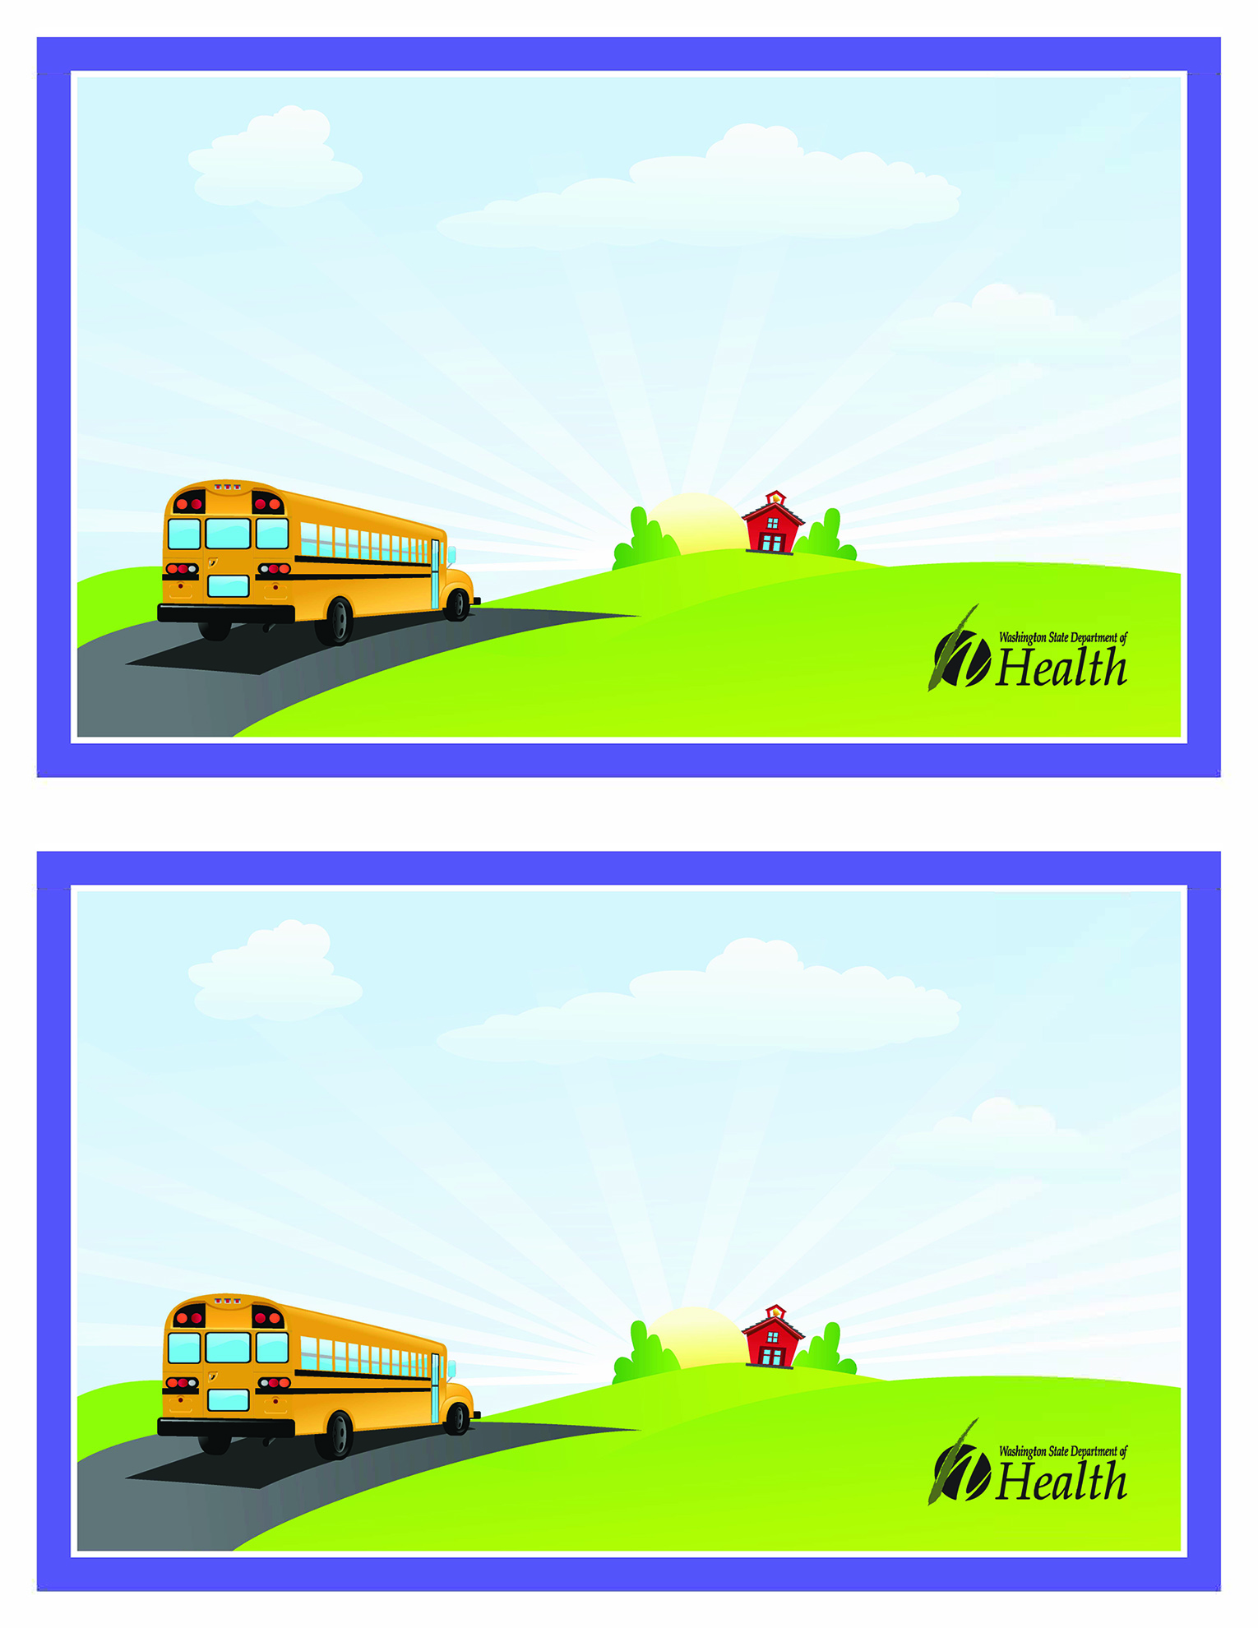
Is your child ready for the 2022-2023 school year?
Preschool and Transitional Kindergarten Immunization Requirements
All children who are 4 years and older by September 1, 2022, will need the following required immunizations for school entry:
- DTaP booster dose • IPV booster dose • MMR booster dose • Varicella booster dose
If your child is turning 4 years of age close to September 1, we encourage parents and guardians to schedule immunization appointments with their doctor or health care provider before school starts.
Make sure your child is up to date with immunizations, so they don’t miss the start of the school year. We look forward to helping your child learn and grow! If you have questions, please email us at:
XXX
DOH 348-873 April 2022
To request this document in another format,
call 1-800-525-0127. Deaf or hard of hearing customers,
please call 711 (Washington Relay) or email civil.rights@doh.wa.gov.

DOH 348-873 April 2022
To request this document in another format,
call 1-800-525-0127. Deaf or hard of hearing customers,
please call 711 (Washington Relay) or email civil.rights@doh.wa.gov.

Is your child ready for the 2022-2023 school year?
Preschool and Transitional Kindergarten Immunization Requirements
All children who are 4 years and older by September 1, 2022, will need the following required immunizations for school entry:
- DTaP booster dose • IPV booster dose • MMR booster dose • Varicella booster dose
If your child is turning 4 years of age close to September 1, we encourage parents and guardians to schedule immunization appointments with their doctor or health care provider before school starts.
Make sure your child is up to date with immunizations, so they don’t miss the start of the school year. We look forward to helping your child learn and grow! If you have questions, please email us at:
XXX
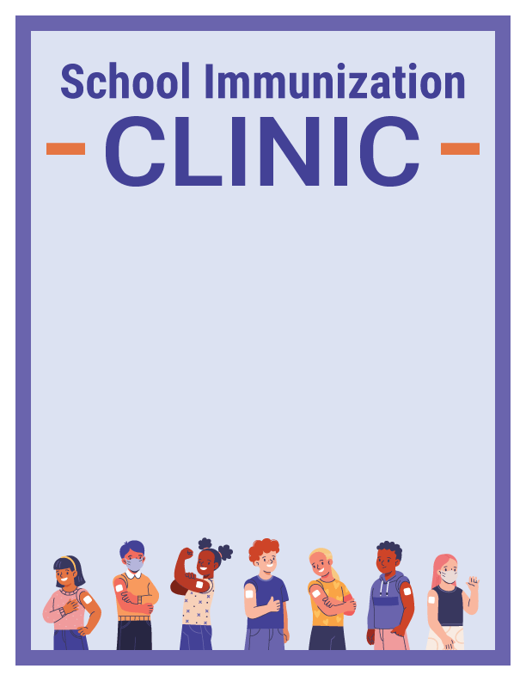
Is your child ready for the 2022-2023 school year? Make sure they’re caught up on their immunizations. Check out the immunization clinic schedule for school vaccinations below:
LOCATION | Address | DATE | TIME
ABC High School - Gym | 100 Smith Street | 4/22/2022 | 2:00 pm

Find required school immunization forms and information on the Department of Health’s webpage at doh.wa.gov/scci.

DOH 348-873 April 2022
To request this document in another format, call 1-800-525-0127. Deaf or hard of
hearing customers, please call 711 (Washington Relay) or email civil.rights@doh.wa.gov.

SECTION 4: SOCIAL MEDIA TEXT
National Immunization Awareness Month (NIAM) Posts
[ENGLISH COPY 1 - FACEBOOK]
Did you know that August is National Immunization Awareness Month? Make sure your child has all their vaccines for next school year. If you aren’t sure, go to https://MyIRmobile.com or schedule an appointment with your child’s healthcare provider.
[SPANISH COPY 1 - FACEBOOK]
¿Sabía que agosto es el Mes Nacional de Concientización sobre las Vacunas? Asegúrese de que su niño tenga todas sus Vacunas para el próximo año escolar. Si no está seguro, vaya a https://MyIRmobile.com o programe una cita con el proveedor de atención médica de su niño.
[ENGLISH COPY 1 - INSTAGRAM]
Did you know that August is National Immunization Awareness Month? Make sure your child has all their vaccines for next school year. If you aren’t sure, go to https://MyIRmobile.com or schedule an appointment with your child’s healthcare provider.
#NIAM #Vaccines
[SPANISH COPY 1 - INSTAGRAM]
¿Sabía que agosto es el Mes Nacional de Concientización sobre las Vacunas? Asegúrese de que su niño tenga todas sus vacunas para el próximo año escolar. Si no está seguro, vaya a https://MyIRmobile.com o programe una cita con el proveedor de atención médica de su niño.
#NIAM #Vacunas
[ENGLISH COPY 1 - TWITTER]
Did you know that August is National Immunization Awareness Month? Make sure your child has all their #vaccines for next school year. If you aren’t sure, go to https://MyIRmobile.com or schedule an appointment with your child’s healthcare provider. #NIAM
[ENGLISH COPY 1 - TWITTER]
¿Sabía que agosto es el Mes Nacional de Concientización sobre las Vacunas? Asegúrese de que su niño tenga todos sus #vacunas para el próximo año escolar. Si no está seguro, visite a https://MyIRmobile.com o programe una cita con el proveedor de atención médica de su niño. #NIAM
[ENGLISH COPY 2 - FACEBOOK]
With National Immunization Awareness Month coming up, now is a great time to check in with your child’s healthcare provider to make sure they are up to date on all their vaccinations.
[SPANISH COPY 2 - FACEBOOK]
Con la llegada del Mes Nacional de Concientización sobre las Vacunas, hoy es un buen momento para consultar con el proveedor de atención médica de su niño y asegurarse de que esté al día con todas sus vacunas.

[ENGLISH COPY 2 - INSTAGRAM]
With National Immunization Awareness Month coming up, now is a great time to check in with your child’s healthcare provider to make sure they are up to date on all their vaccinations.
#NIAM #Vaccine
[SPANISH COPY 2 - INSTAGRAM]
Con la llegada del Mes Nacional de Concientización sobre las Vacunas, hoy es un buen momento para consultar con el proveedor de atención médica de su hijo y asegurarse de que estén al día con todas sus vacunas.
#NIAM #Vacunas

[ENGLISH COPY 2 - TWITTER]
With National Immunization Awareness Month coming up, now is a great time to check in with your child’s healthcare provider to make sure they are up to date on all their #vaccinations.
#NIAM
[SPANISH COPY 2 - TWITTER]
Con la llegada del Mes Nacional de Concientización sobre las Vacunas, hoy es un buen momento para consultar con el proveedor de atención médica de su hijo y asegurarse de que estén al día con todos sus #vacunas.
#NIAM

Schedule Vaccine Appointments Early Posts
[ENGLISH COPY 1 - FACEBOOK]
Back to school may look a little different these days, but your child still needs all their routine vaccines. Schedule your child’s vaccine appointment early so they are ready to get back to the playground.
[SPANISH COPY 1 - FACEBOOK]
Aunque ahora el regreso a clases pueda ser un poco diferente, su niño aún necesita estar al día en todas sus vacunas. Programe la cita de vacunación de su niño con anticipación para que esté listo para regresar al patio de recreo.
[ENGLISH COPY 1 - INSTAGRAM]
Back to school may look a little different these days, but your child still needs all their routine vaccines. Schedule your child’s vaccine appointment early so they are ready to get back to the playground.
#Vaccine #BackToSchool
[SPANISH COPY 1 - INSTAGRAM]
Aunque ahora el regreso a clases pueda ser un poco diferente, su niño aún necesita estar al día en todas sus vacunas. Programe la cita de vacunación de su niño con anticipación para que esté listo para regresar al patio de recreo.
#Vacunas #RegresoAClasses #BackToSchool

[ENGLISH COPY 1 - TWITTER]
Back to school may look a little different these days, but your child still needs all their routine #vaccines. Schedule your child’s vaccine appointment early so they are ready to get back to the playground. #BackToSchool
[SPANISH COPY 1 - TWITTER]
Aunque ahora el regreso a clases pueda ser un poco diferente, su niño aún necesita estar al día en todas sus vacunas. Programe la cita de vacunación de su niño con anticipación para que esté listo para regresar al patio de recreo.
#RegresoAClasses #BackToSchool
[ENGLISH COPY 2 - FACEBOOK]
Don’t wait, vaccinate! Get your child caught up on routine vaccinations before the back to school rush.
[SPANISH COPY 2 - FACEBOOK]
¡No espere, vacúnelo! Asegúrese de poner a su niño al día con sus vacunas de rutina antes del regreso a la escuela.
[ENGLISH COPY 2 - INSTAGRAM]
Don’t wait, vaccinate! Get your child caught up on routine vaccinations before the back to school rush. #Vaccine #BackToSchool
[SPANISH COPY 2 - INSTAGRAM]
¡No espere, vacúnelo! Asegúrese de poner a su niño al día con sus vacunas de rutina antes del regreso a la escuela. #Vacune #RegresoALAEscuela
[ENGLISH COPY 2 - TWITTER]
Don’t wait, #vaccinate! Get your child caught up on routine vaccinations before the back to school rush. #BackToSchool
[SPANISH COPY 2 - TWITTER]
¡No espere, #vacúnelo! Asegúrese de poner a su niño al día con sus vacunas de rutina antes del regreso a la escuela. #RegresoALAEscuela

Sample School Vaccine Requirements For 4-year-olds Posts
[ENGLISH COPY 1 - FACEBOOK]
Do you have a child entering preschool or transitional kindergarten? All children 4 years and older by September 1, 2022 will need to meet school vaccine requirements. Schedule a visit with your health provider today!
[SPANISH COPY 1 - FACEBOOK]
¿Tiene un niño que ingresa al preescolar o al jardín de niños? Para septiembre 1 del 2022, todos los niños de 4 años en adelante necesitarán cumplir con los requisitos de vacunación escolar. ¡Haga una cita con su proveedor de salud hoy!

[ENGLISH COPY 1 - INSTAGRAM]
Do you have a child entering preschool or transitional kindergarten? All children 4 years and older by September 1, 2022 will need to meet school vaccine requirements. Schedule a visit with your healthcare provider today! #Vaccine #BackToSchool

[SPANISH COPY 1 - INSTAGRAM]
¿Tiene un niño que ingresa al preescolar o al jardín de niños? Para septiembre 1 del 2022, todos los niños de 4 años en adelante necesitarán cumplir con los requisitos de vacunación escolar. ¡Haga una cita con su proveedor de salud hoy!
#Vacuna #RegresoAClases
[ENGLISH COPY 1 - TWITTER]
Do you have a child entering preschool or transitional kindergarten? All children 4 years and older by September 1, 2022 will need to meet school vaccine requirements. Schedule a visit with your healthcare provider today! #BackToSchool
[SPANISH COPY 1 - TWITTER]
¿Tiene un niño que ingresa al preescolar o al jardín de niños? Para septiembre 1 del 2022, todos los niños de 4 años en adelante necesitarán cumplir con los requisitos de vacunación escolar. #RegresoAClases

Sample School Clinic Reminders Posts
[ENGLISH COPY 1 - FACEBOOK]
Is your child up to date on their vaccines? If not, visit our vaccine clinic happening on [Enter XX date, time, and location]. For more information visit the school website.
[SPANISH COPY 1 - FACEBOOK]
¿Está su niño al día con sus vacunas? Si no es así, visite nuestra clínica de vacunas el [Ingrese XX fecha, hora y ubicación]. Para obtener más información visite el sitio de internet de la escuela.
[ENGLISH COPY 1 - INSTAGRAM]
Is your child up to date on their vaccines? If not, visit our vaccine clinic happening on [Enter XX date, time, and location]. For more information visit the school website.
#Vaccine Clinic #BackToSchool
[SPANISH COPY 1 - INSTAGRAM]
¿Está su niño al día con sus vacunas? Si no es así, visite nuestra clínica de vacunas el [Ingrese XX fecha, hora y ubicación]. Para obtener más información visite el sitio de internet de la escuela. #Vacunas #RegresoAClases
[ENGLISH COPY 1 - TWITTER]
Is your child up to date on their vaccines? If not, visit our #VaccineClinic happening on [Enter XX date, time, and location]. For more information visit the school website. #BackToSchool

[SPANISH COPY 1 - TWITTER]
¿Está su niño al día con sus vacunas? Si no es así, visite nuestra clínica de vacunas el [Ingrese XX fecha, hora y ubicación]. Para obtener más información visite el sitio de internet de la escuela. #RegresoAClases
[ENGLISH COPY 2 - FACEBOOK]
Don’t forget! Our vaccine clinic is happening [Enter Date] at [Enter XX time, and location]. For more information visit the school website.
[SPANISH COPY 2 - FACEBOOK]
¡Recuerde! Nuestra clínica de vacunas está disponible el [Ingrese la fecha] en [Ingrese XX hora y ubicación]. Para obtener más información visite el sitio de internet de la escuela.
[ENGLISH COPY 2 - INSTAGRAM]
Don’t forget! Our vaccine clinic is happening [Enter Date] at [Enter XX time, and location]. For more information visit the school website. #VaccineClinic #BackToSchool
[SPANISH COPY 2 - INSTAGRAM]
¡Recuerde! Nuestra clínica de vacunas está disponible el [Ingrese la fecha] en [Ingrese XX hora y ubicación]. Para obtener más información visite el sitio de internet de la escuela. #ClinicaDeVacunas #RegresoAClases
[ENGLISH COPY 2 - TWITTER]
Don’t forget! Our #VaccineClinic is happening [Enter Date] at [Enter XX time, and location]. For more information visit the school website. #BackToSchool
[SPANISH COPY 2 - TWITTER]
¡Recuerde! Nuestra clínica de vacunas está disponible el [Ingrese la fecha] en [Ingrese XX hora y ubicación]. Para obtener más información visite el sitio de internet de la escuela. #RegresoAClases

Sample General Vaccine Reminders Posts
[ENGLISH COPY 1 - FACEBOOK]
As your child heads back to school, make sure they have everything they need, including all their vaccinations. Schedule your child’s wellness visit now to avoid the rush!
[SPANISH COPY 1 - FACEBOOK]
A medida que su niño regresa a la escuela, asegúrese de que tenga todo lo que necesita, incluidas todas sus vacunas. ¡Programe una visita de control de salud para su niño ahora para evitar las prisas!
[ENGLISH COPY 1 - INSTAGRAM]
As your child heads back to school, make sure they have everything they need, including all their vaccinations. Schedule your child’s wellness visit now to avoid the rush! #Vaccine #BackToSchool

[SPANISH COPY 1 - INSTAGRAM]
A medida que su niño regresa a la escuela, asegúrese de que tenga todo lo que necesita, incluidas todas sus vacunas. ¡Programe una visita de control de salud para su niño ahora para evitar las prisas! #Vacunas #RegresoALaEscuela
[ENGLISH COPY 1 - TWITTER]
As your child heads back to school, make sure they have everything they need, including all their #vaccinations. Schedule your child’s wellness visit now to avoid the rush! #BackToSchool
[SPANISH COPY 1 - TWITTER]
A medida que su niño regresa a la escuela, asegúrese de que tenga todo lo que necesita, incluidas todas sus #vacunas ¡Programe una visita de control de salud para su niño ahora para evitar las prisas! #RegresoALaEscuela
[ENGLISH COPY 2 - FACEBOOK]
Life is unpredictable these days, but one thing hasn’t changed: Vaccinations help protect your child from vaccine-preventable diseases. Talk to your child’s doctor to make sure they’re up to date on all vaccinations.
[SPANISH COPY 2 - FACEBOOK]
Últimamente la vida tiene muchos cambios, pero una cosa no ha cambiado: las vacunas ayudan a proteger a su niño de enfermedades que se pueden prevenir. Hable con el médico de su niño para asegurarse de que esté al día con todas sus vacunas.
[ENGLISH COPY 2 - INSTAGRAM]
Life is unpredictable these days, but one thing hasn’t changed: Vaccinations help protect your child from vaccine-preventable diseases. Talk to your child’s doctor to make sure they’re up to date on all vaccinations. #Vaccine
[SPANISH COPY 2 - INSTAGRAM]
Últimamente la vida tiene muchos cambios, pero una cosa no ha cambiado: las vacunas ayudan a proteger a su niño de enfermedades que se pueden prevenir al vacunarlo. Hable con el médico de su niño para asegurarse de que esté al día con todas sus vacunas. #Vacunas
[ENGLISH COPY 2 - TWITTER]
Life is unpredictable these days, but one thing hasn’t changed: #Vaccinations help protect your child from vaccine-preventable diseases. Talk to your child’s doctor to make sure they’re up to date on all vaccinations.
[SPANISH COPY 2 - TWITTER]
Últimamente la vida tiene muchos cambios, pero una cosa no ha cambiado: las vacunas ayudan a proteger a su niño de enfermedades que se pueden prevenir al vacunarlo. Hable con el médico de su niño para asegurarse de que esté al día con todas sus vacunas.

SECTION 5: SOCIAL MEDIA GRAPHICS

All social media images in this toolkit have their original sizes preserved. Because of how Word displays these full size images, the images may look cropped. In order to use an image, right click on the image you want to use in Word, and select “…Save as picture.” Save the image to your computer. Once saved, you can upload the images directly with your social media messaging, or you may add text to the images in a graphics editor program.
Banner style images may be more appropriate for Facebook, Twitter, and newsletters, whereas square style images may be more appropriate for Instagram and Twitter.
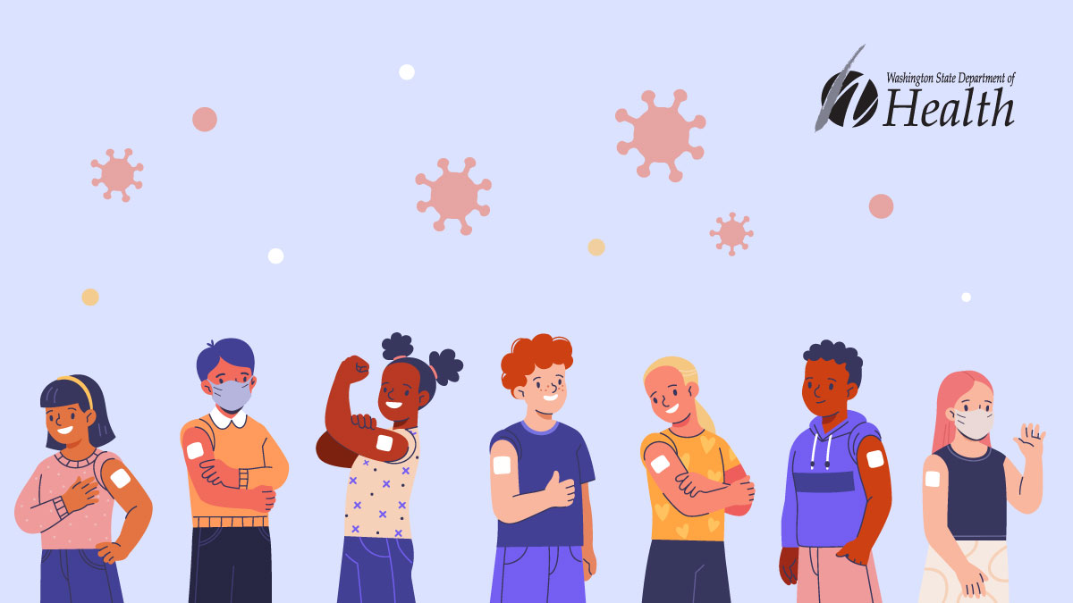
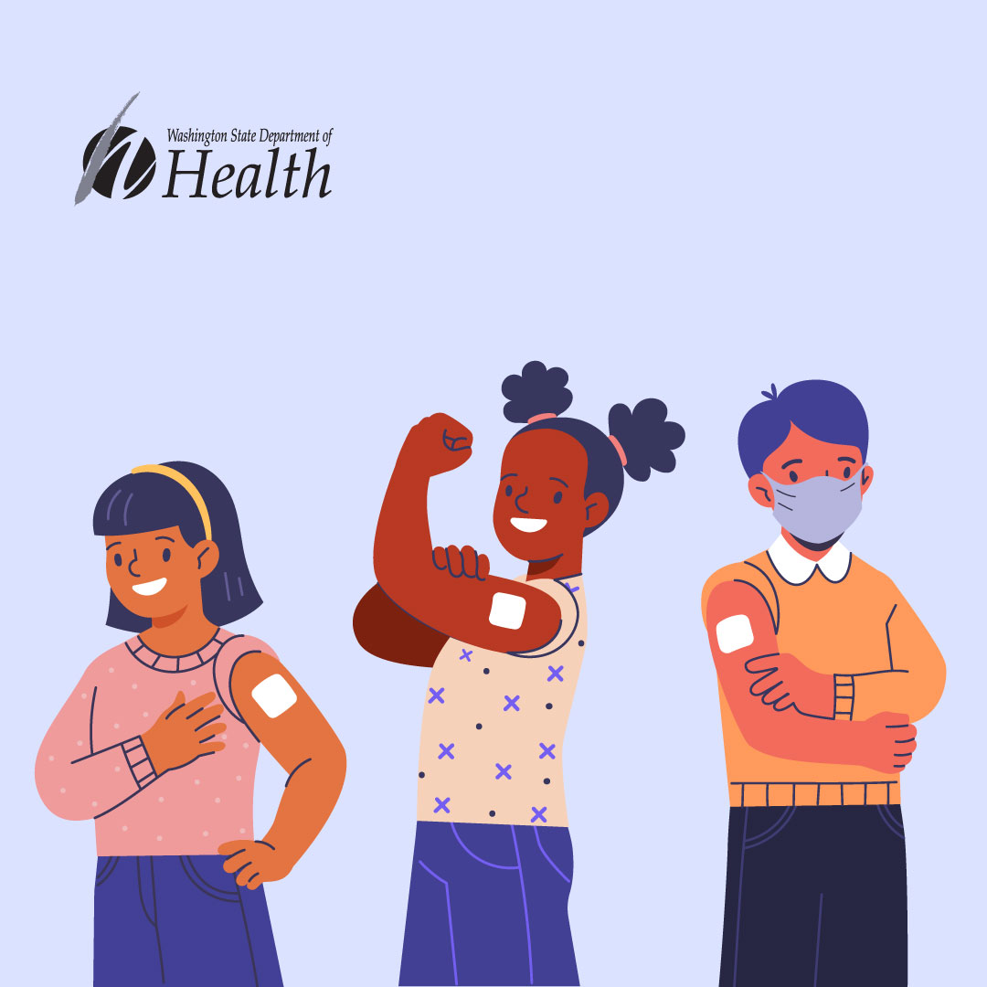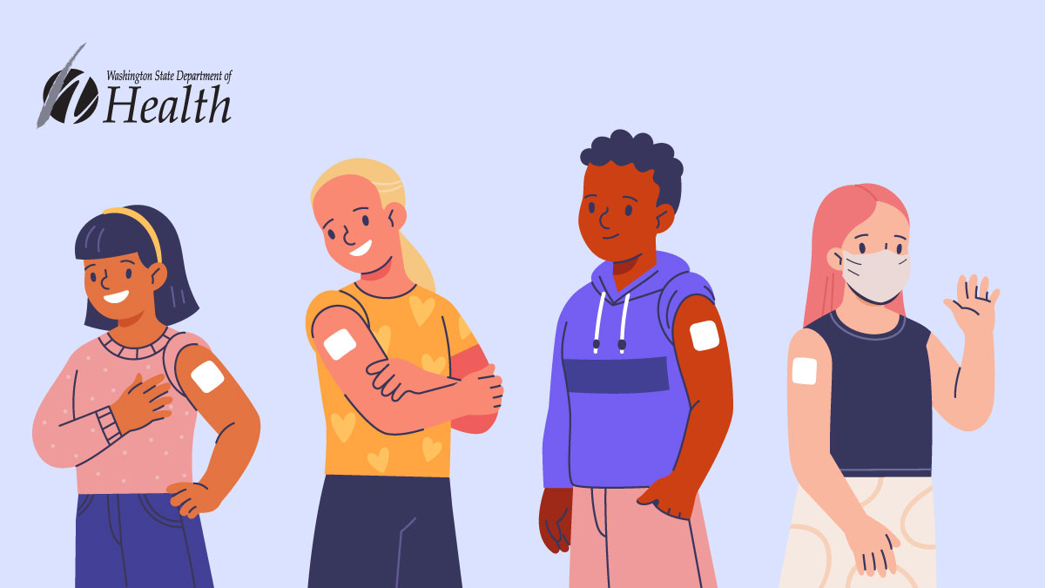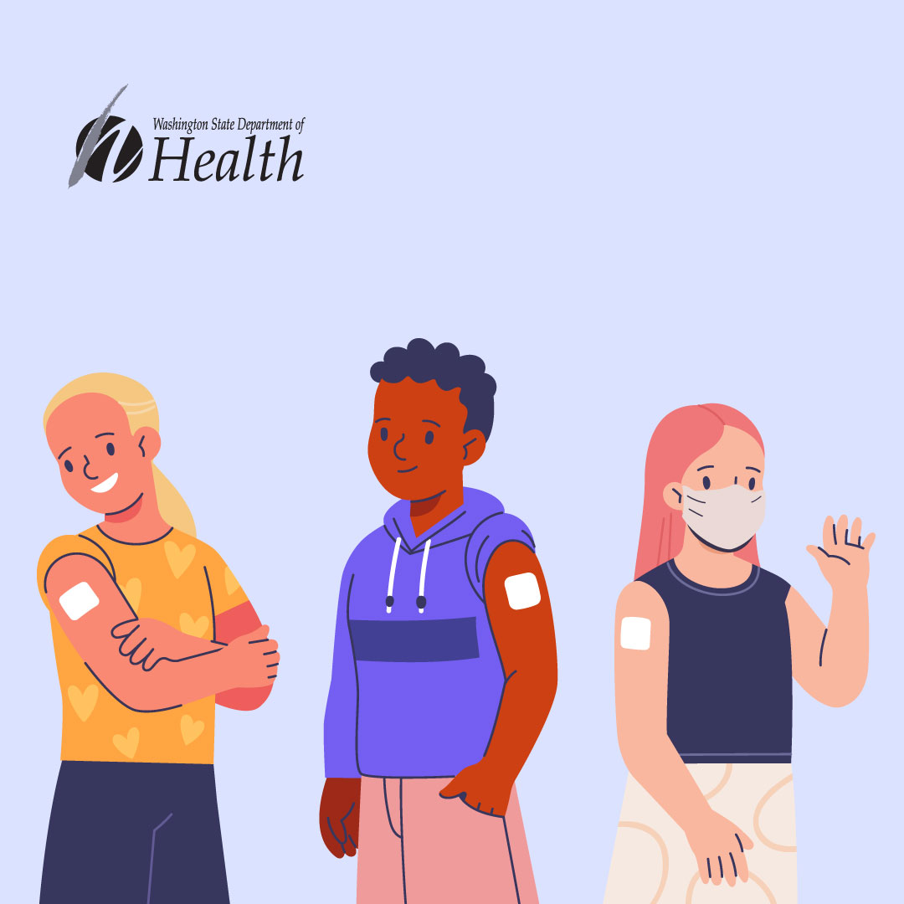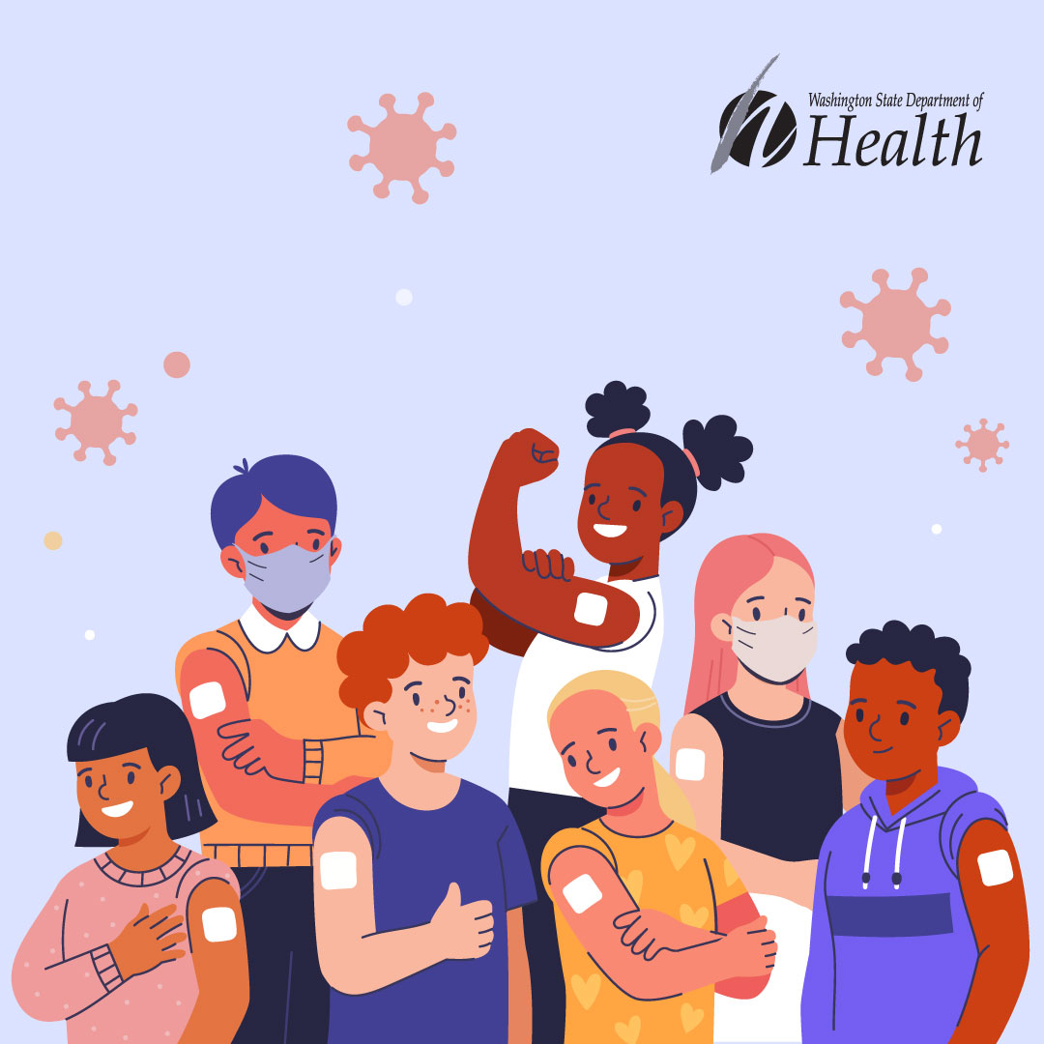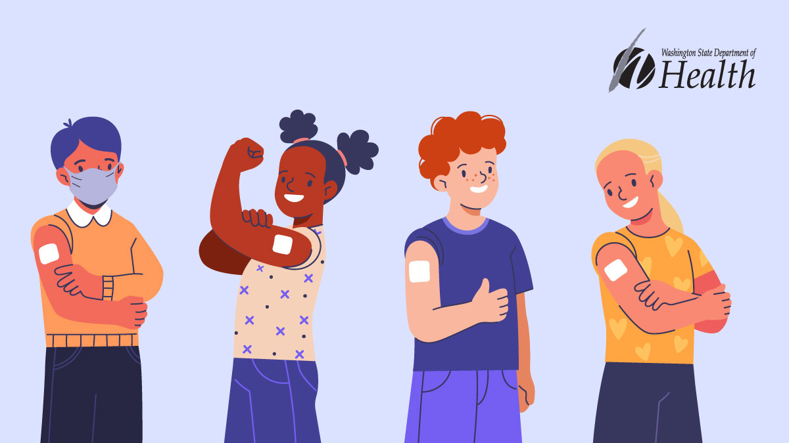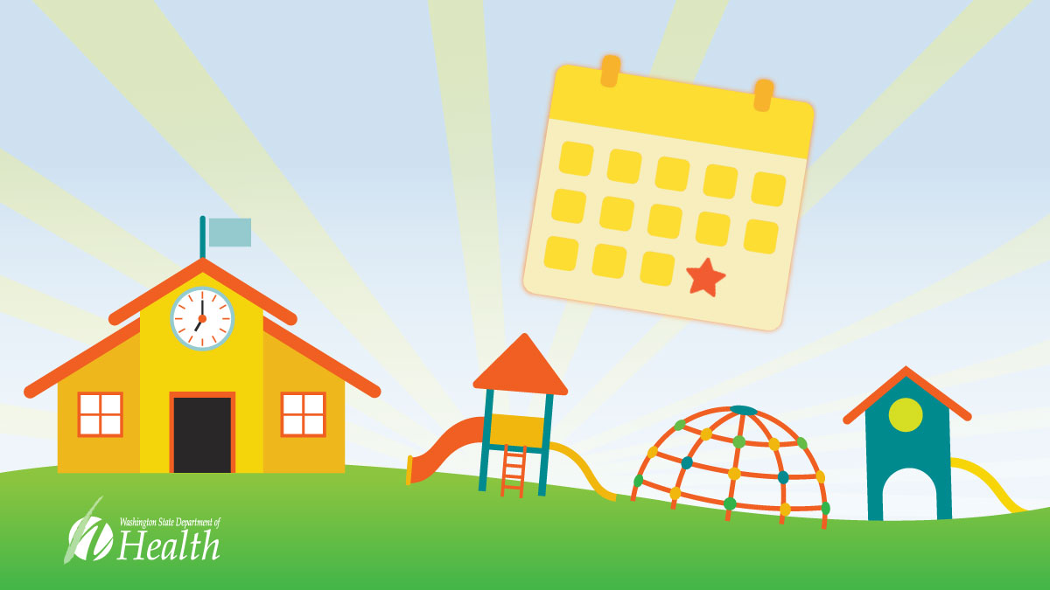
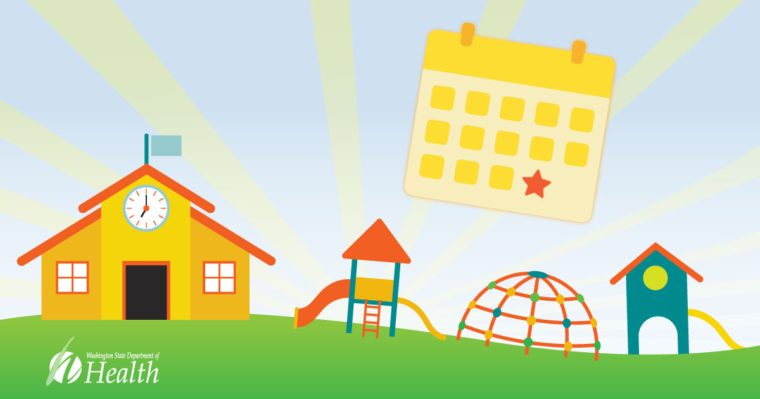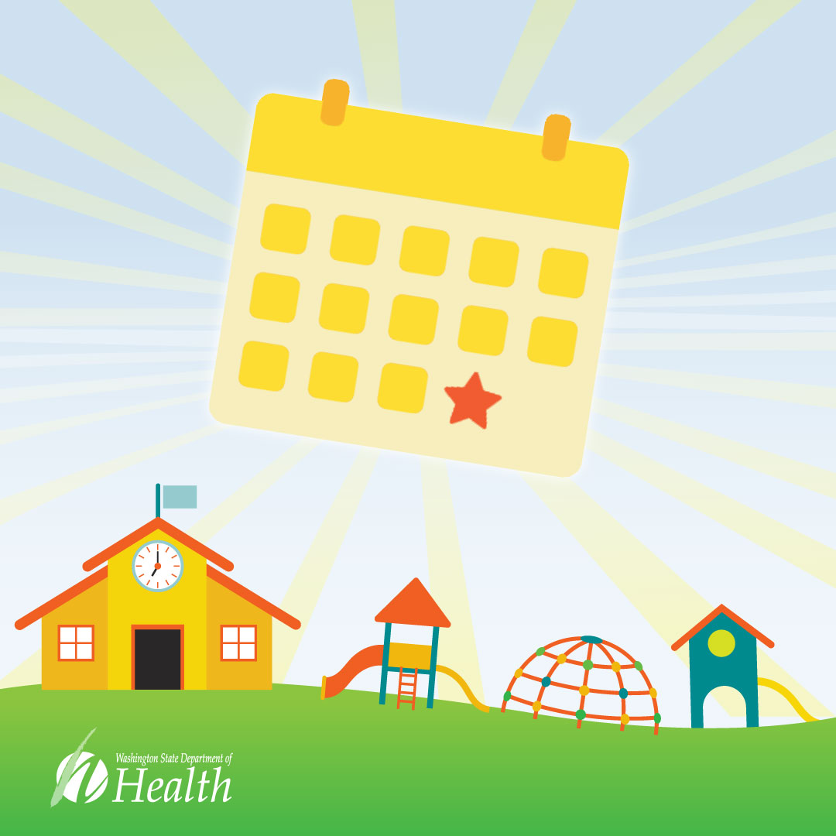
SECTION 6: RESOURCES
This section contains direct links to resources on the Department of Health’s School and Child Care Immunization page which may be helpful for school immunization work.
School and Child Care Immunization page
This page contains required immunization forms, materials and resources for school and child care immunization.
www.doh.wa.gov/scci
School Immunization Chart Changes PDF
This quick reference guide summarizes the school immunization requirement changes for the 2022-2023 school year.
https://doh.wa.gov/sites/default/files/2022-03/348-866-SchoolImmunizationChart2022-2023.pdf
2022-2023 School Immunization Requirement Charts for Parents
The school chart shows required immunizations for school entry based on a child’s age. The chart is translated into a variety of languages.
English (PDF) | Español (PDF) | Arabic (PDF) | Amharic (PDF) | Chinese (PDF) | Korean (PDF) | Marshallese (PDF) | Russian (PDF) | Somali (PDF) | Tagalog (PDF) | Vietnamese (PDF)
Certificate of Immunization Status
This is the form used to record childhood immunizations for school entry.
English (PDF) | Español (PDF) | Arabic (PDF) | Amharic (PDF) | Chinese (PDF) | Korean (PDF) | Marshallese (PDF) | Punjabi (PDF) | Russian (PDF) | Somali (PDF) | Tagalog (PDF) | Ukrainian (PDF) | Vietnamese (PDF)
School Registration Flowchart for Immunization Records
This document guides staff on how to screen immunization records for school entry.
https://doh.wa.gov/sites/default/files/legacy/Documents/Pubs/348-756-RegistrationFlowchartforImmunizationRecords.pdf
Vax to School page
The Vax 2 School page has resources for families looking to catch up on required school immunizations.
https://doh.wa.gov/you-and-your-family/immunization/school-and-child-care/vax-school
Conditional Status Parent Letter
This is a sample letter for parents informing them what to do when their child is in conditional status due to immunization requirements.
English:
https://doh.wa.gov/sites/default/files/legacy/Documents/Pubs//348-277-ConditionalImmunizationStatus.doc

Spanish:
https://doh.wa.gov/sites/default/files/legacy/Documents/Pubs//348-277-ConditionalImmunizationStatus-ES.doc
Incomplete Immunization Notice Parent Letter
This is a sample letter to inform parents their child is missing immunization records required for school entry.
English:
https://doh.wa.gov/sites/default/files/legacy/Documents/Pubs//348-754-IncompleteImmunizationatEnrollmentNotice.doc
Spanish
https://doh.wa.gov/sites/default/files/legacy/Documents/Pubs//348-754-InconpleteImmunizationEnrollmentNotice-es.docx
Medically Verified Immunization Records Document
This document explains what immunization records are considered valid for school and child care entry.
https://doh.wa.gov/sites/default/files/legacy/Documents/Pubs/348-755-MedicallyVerifiedImmunizationRecordsFlyer.pdf
7th Grade Vaccine Scheduling Reminder Insert
This is a printable mail insert to remind parents to schedule an appointment for vaccinations required in middle school.
English:
https://doh.wa.gov/sites/default/files/legacy/Documents/Pubs/348-693-6thGradeComboInsert.pdf
Spanish:
https://doh.wa.gov/sites/default/files/legacy/Documents/Pubs//348-693-6thGradeComboInsert-es.pdf
Tdap Notification Sample Letter
This is a sample letter to inform parents their child needs a booster dose of Tdap vaccine to meet school immunization requirements.
English:
https://doh.wa.gov/sites/default/files/legacy/Documents/Pubs//348-289_TdapVaccination6thGradersSampleLetter.doc
Spanish:
https://doh.wa.gov/sites/default/files/legacy/Documents/Pubs//348-693-6thGradeComboInsert-es.pdf
Child Care Immunization Resource Flyer
This document provides helpful information on vaccine requirements for early learning and child care programs.
English:
https://doh.wa.gov/sites/default/files/legacy/Documents/Pubs/348-849ChildCareImmunizationResourceFlyer.pdf

Spanish:
https://doh.wa.gov/sites/default/files/2022-02/348-849ChildCareImmunizationResourceFlyer-es.pdf
Childhood Vaccine Family Flyer
This document briefly explains how families can get childhood vaccines for free.
https://doh.wa.gov/sites/default/files/2022-03/348-864%20Childhood%20Vaccine%20Family%20Flyer.pdf

