Notice to Water System Users
We Water System, I.D. , located in County, are required to monitor your drinking water for specific contaminants on a regular basis. Results of regular monitoring indicate whether or not your drinking water meets health standards. We did not meet our monitoring requirements for the chemicals listed below for the specified time period, and therefore cannot be sure of the quality of your drinking water at that time.
Chemical Contaminant | Required From | Required To
☐ Nitrate
☐ Lead and Copper
☐ Total Trihalomethanes
☐ Haloacetic Acids
☐ Bromate
☐ Arsenic
☐ Complete Inorganic Contaminants (IOCs)
☐ Volatile Organic Contaminants (VOCs)
☐ Per- and Polyfluoroalkyl Substances (PFAS)
☐ Pesticides
☐ Herbicides
☐ Other
At this time:
☐ Our required samples for each contaminant listed above have been collected for this monitoring period.
☐ We will collect samples in the future as required.
☐ Other information for customers.
For more information, contact the owner or operator at phone or address .

This notice is sent to you by Water System on Pick Date .
Chemical Monitoring Public Notice Certification Form
This section must be completed by the water system. Signature below indicates notice contained all required elements.
Complete the following items (check all that apply):
☐ Notice mailed to all water customers on Pick Date .
☐ Notice hand delivered to all water customers on Pick Date .
☐ Notice included in annual Consumer Confidence Report (attach copy).
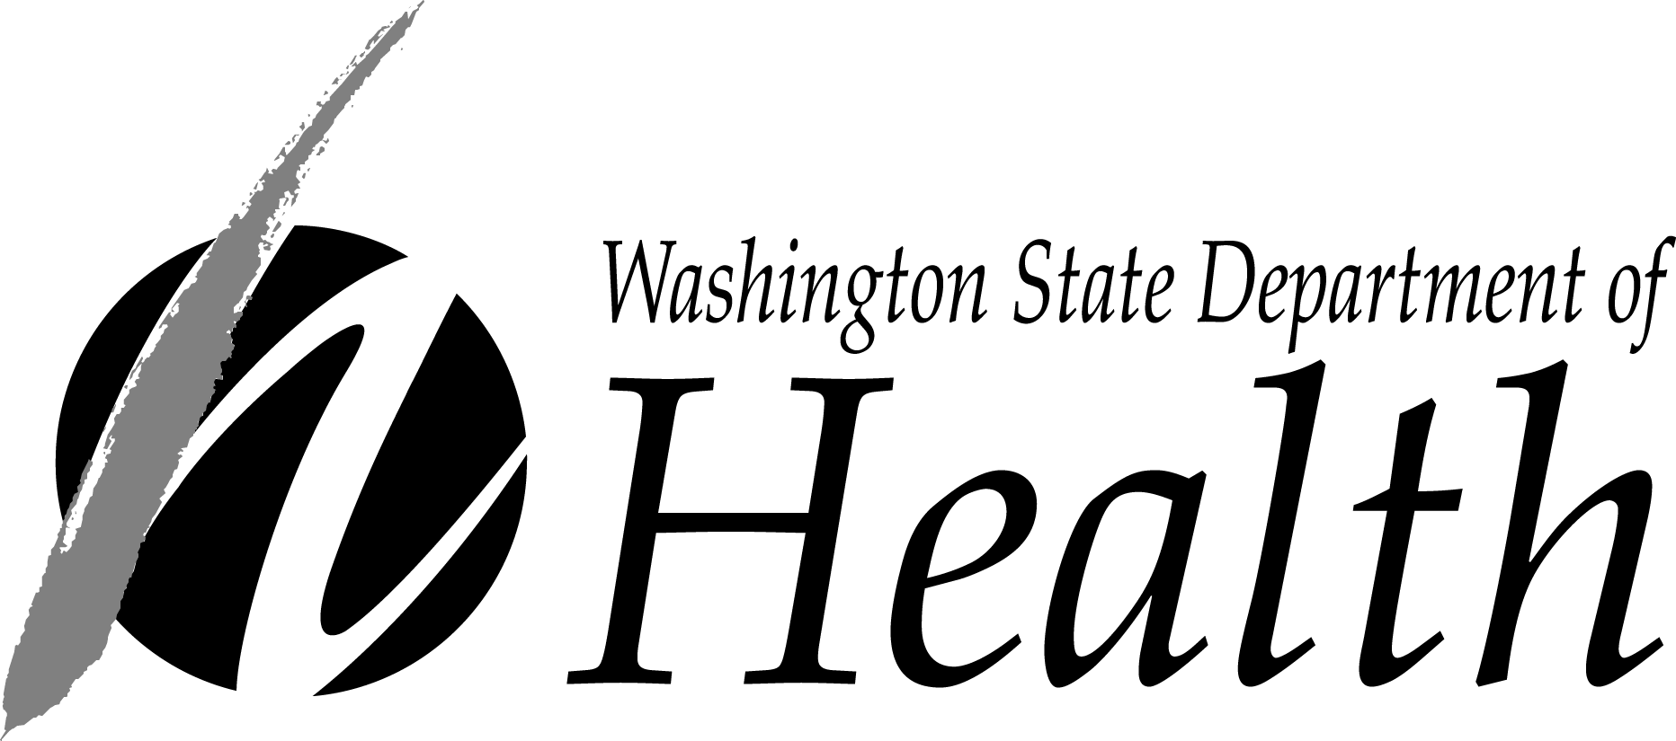
☐ Notice posted at on Pick Date .
(By Department Approval Only)

_______________________________________________ ________________________________________ Pick Date
Signature of owner or operator Position Date
Send copy of completed notification and certification to
Office of Drinking Water, Water Quality Section
PO Box 47822
Olympia, WA 98504-7822
FAX (360)236-2252
To request this document in another format, call 1-800-525-0127. Deaf or hard of hearing customers, please call 711 (Washington Relay) or email civil.rights@doh.wa.gov.

