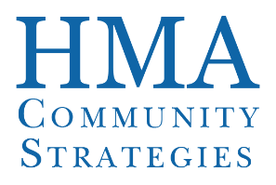

Washington Syndemic Planning Group Meeting
Minutes
Tuesday October 18, 2022
6:00 pm – 7:00 pm
Virtual Meeting Via Zoom Conference Call

MEMBERS PRESENT:
Amy Hernandez, Bridgette Young, Beth Crutsinger-Perry, Courtney Wettemann, James Sammuels, JJ Baker, Jsani Henry, William Cox, Yob Benami; Ann Mumford, Lisa Al-Hakim, Courteney Wettemann, Kurt Ragin, Lisa Al-Hakim, Monte Levine, , Reina Davis, Walter McKenzie

MEMBERS ABSENT; James Ludwig; Mike Ramirez III; Bjarke Mitchell; Michael LeClaire, Reina Davis, Viki Nikkila

HMA SUPPORT STAFF PRESENT: Brandin Bowden, Charles Robbins, Akiba Daniels

DOH SUPPORT STAFF PRESENT: Emalie Huriaux, Starleen Majaraj-Lewis, Zandt Bryan, Lydia Guy Ortiz

TOPIC | FINDINGS, CONCLUSIONS & RECOMMENDATIONS | ACTIONS & FOLLOW-UP | PERSON RESPONSIBLE
I. Call to Order | The meeting was called to order by JJ Baker.
II. Welcome by Tri-chairs | - Starleen shared the agenda on screen  - Review and approve agenda – the group approved the agenda  - Story of interpretation services – Charles shared that he went to an HIV conference in Puerto Rico recently and all of the workshops were in Spanish with English interpterion available. This was a wonderful benefit on behalf of the conference and gave insight into being the person not of the dominant language and the challenges needing to navigate the interpretation services.
III. HIV Integrated Care Planning DOH & HMA (10 Minutes) | - Discuss purpose of meeting – Charles  - This is a special meeting to seek concurrence. Everyone received a 1-pager that provides the components of the seven sections of the integrated plan.  - Integrated Plan Section Overview – Brandin  - Seven sections total in the integrated plan document, starting with executive summary; community engagement and planning process; data sets and assessments; situational analysis; goals and objectives for 22’-26’; Integrated planning implementation, monitoring and follow-up and ending with the letters of concurrence  - In today’s conversation we will be responding to this. The copy that everyone currently has is still a draft.  - Charles reviewed the levels of concurrence. There is concurrence, concurrence with reservations or non-concurrence.  - Being non-concurrence is an option but requires the DOH to develop an action plan to get to concurrence. This would not hold up the application process.
IV. Consensus on HIV Priorities HMA (30 minutes) | - Starleen shared the Goals and Objectives table on screen  - The goals and objectives were translated into Spanish and this copy was sent to the group last week. The Office of Health Equity at DOH was able to support this effort very quickly  - Starleen opened it up to the group for questions and comments about the goals  - Ann: confusion around the acronyms and need to spell those out  Goal 1 comments:  - Yob: Appreciates the need to have this information in Spanish but is wondering about other languages and the deaf community. Is any outreach planned for other communities?  - Lydia: As far as HIV, she has looked at the top 10 languages in the state. Spanish was the greatest need but as funds are available, they will translate in the order of language spoken. Any publication we produce, it is provided in an alternative format for those with disabilities. This is a normal process that happens through center for public affairs.  - As a follow up, this table also outlines data we have on spoken language:  - 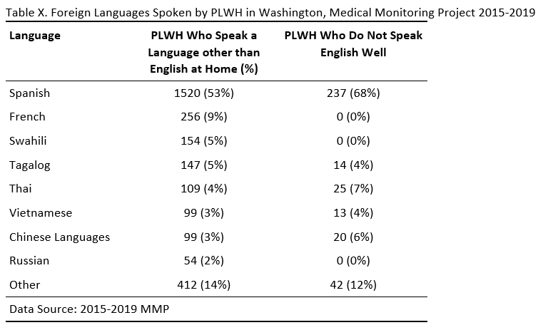  Goal 2 comments:  - None  Goal 3 comments:  - Members are happy to see that increasing collaboration is a part of the goal  - William Cox: regarding transgender piece for goal 3, appreciate this but will we be working with providers to educate them on this?  - Lydia: the plan is to convene members of the transgender community. Vanessa Granberry will lead this process (may involve providers and may be another group)  Goal 4 comments:  - JJ: have noticed that one of the biggest barriers was having to have pre-authorization for HIV meds. Individuals couldn’t take the meds when they wanted to take them.  - Emalie: the prior authorization piece is really important. Learned from Hep C that Medicaid took away prior auth; this is important but by itself is not sufficient. Biggest struggle has been around navigation, case management, on-site. For HIV there is a lot of infrastructure for services such as case management.  - Lydia: different things have different target timelines. The timeline for this goal is 2024 b/c we expect to have to negotiate challenges that everyone is bringing up  - Yob: this is going to save lives; I really like it and it is awesome. Too many people are dying and not getting the help they need due to barriers so let’s get rid of those. Bravo.  Goal 5 comments:  - William: this is a really great thing to see in general because not all providers take accountability for how they treat patients  - JJ: some providers who are major hubs for HIV care are not telling their clients about services that exist such as medication assistance, insurance coverage, etc.  Goal 6 comments:  - None  Goal 7 comments:  - None  Goal 8 comments:  - None  Goal 9 comments:  - James Sammuels: I see all of the 13 goals but still think we can consolidate. There is no verbiage in the goals about stable housing.  - Lydia: within the HIV services program there are dollars/funding to cover those services.  - Beth: in the Office we have housing dollars for those living with HIV but there are not enough dollars provided for housing as it relates to our other epidemics. When looking at our funding structures we should look at the other epidemics as well.  - Zandt: housing as health care issues; there are proposals out there to seek funding for broader support for those who don’t have HIV and do have other conditions or are in need of support. We don’t have case management in the same way as those with STIs or Hep C.  Goal 10 comments:  - None  Goal 11 comments:  - OTP is opioid treatment program and that used to be called “methadone clinic”  Goal 12 comments  - None  Goal 13 comment:  - None  Charles opened the floor to ask if anything was missing that doesn’t pertain to the 13 goals, or any pressing comments.  - Jsani: is there a goal around PrEP?  - Lydia: there is not a goal around this, but we could expand a goal to include it. We wouldn’t necessarily call it out. This is a plan that is submitted under CDC grant. For this plan, we try to make it as holistic as possible but something HRSA would count as a funding source.  - Zandt: These are specific goals within our larger scope of work; PrEp expansion is an overarching goal and we’ll be taking these to our syndemic planning.  - Emalie: for the next meeting, we should bring the advisory group report to walk through it  - Charles asked for a final call on comments related to the goals and asked for thumbs up reaction to proceed with anonymous poll. Majority members add a thumbs up.  - Charles launched the poll.  - 93% selected concurrence  - 7% selected concurrence with reservation  - Question to the tri-chairs: would they be okay moving forward with concurrence based on percentages.  - The group said yes, can move forward with concurrence.  - As a group, the letter of concurrence will be attached to section 7 | Tri-chairs will sign the letter of concurrence for HRSA Integrated Plan submission
X. Closing Thoughts/ Adjourn | - Beth provided an update that she sent a message out last Tuesday to a distribution list to let them know we went over budget on a program in first 3 months of fiscal year and she was needing to consider closing the program with a possible date of end of November. This still stands at this point, but she wanted to let this group know there have been multiple conversations about pending closure and are working diligently at the health department, pharmacy partners and clinical partners to see if there is a way to change the process to keep the program viable fiscally. They have found some additional dollars but not sure how far that will go. Beth hopes to have information by end of this week or early next week. Participants have not been notified yet because this is an ever-evolving situation. There are about 300 participants enrolled in the PrEp deck program. Beth will keep the group informed and provide in-depth information at next meeting.  - JJ shared this is on the minds of prevention teams and case managers and appreciative of the update.  - Starleen thanked the workgroups in development with internal committees as well as the four caucuses. We will find a work around so the group should stay tuned.  The Tri-chairs thanked everyone, and JJ adjourned the meeting. | Send slide deck  Send draft Minutes for review | Charles  Akiba
Minutes prepared by: Akiba Daniels
Minutes reviewed by: Charles Robbins
Minutes respectfully submitted by: Starleen Maharaj-Lewis
Minutes reviewed and approved by Tri-Chairs: JJ Baker, Monte Levine, Beth Crutsinger-Perry

