Screening for Critical Congenital
Heart Defects in Newborns

Every newborn should be screened for heart defects

Congenital Heart Defects
Up to 1 in 100 babies are born with a congenital heart defect. (Congenital means they have it at birth.) These defects may affect the shape of a baby’s heart, the way it works, or both. Some heart defects don’t need treatment or can be fixed easily, but other defects cause serious health problems.
The most severe defects are called Critical Congenital Heart Defects (CCHD). About 1 in 1,000 babies are born with CCHD. Sometimes babies with CCHD appear healthy at first. However, if not diagnosed very soon, babies with CCHD may suffer dangerous complications, or even death, in the first few days or weeks of life.
Fortunately, there is a test that can identify many newborns with CCHD. Once identified, these babies can receive immediate treatment, which may include surgery and medication.

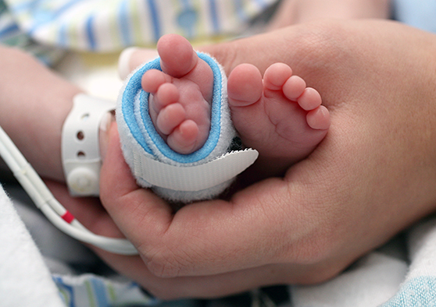
Pulse Oximetry Screening
Pulse oximetry screening (sometimes called “pulse ox”) is a quick and painless test. It measures the amount of oxygen in the baby’s blood. Low blood oxygen can be a sign of a serious heart or lung problem.
During the test, soft sensors are gently wrapped around your baby’s hand and foot. On one side, they give off light. On the other side, they read the light passing through the skin. They have no needles and do not draw blood.
If your baby passes the screening test, your baby has good blood oxygen levels and is unlikely to have a serious heart problem. (Your baby still should have regular checkups so your primary care provider can evaluate your baby’s overall health, including heart health.)
If your baby does not pass the screening test, your baby has low blood oxygen levels. This doesn’t always mean your baby has a heart problem, but further evaluation is needed. Your baby’s health care provider may repeat the screening or order additional tests. If a heart defect is found, a doctor who specializes in children’s hearts will talk with you about the findings and treatment options. There should be a plan in place to address the abnormal screen before your baby leaves the hospital.
Washington State law requires hospitals and midwives to screen all newborn babies for CCHD. If a baby is born outside of a hospital, and the midwife does not have the proper equipment to perform the pulse oximetry screening, the midwife must notify the parents or guardian that the baby should be screened.
If you have any questions or concerns about your baby’s screening or the results, talk with your baby’s health care provider.
Please see the other side for your baby’s screening result.

Result of CCHD Screening for Your Baby
CCHD screening was performed. The result was:
Your baby passed the CCHD screening test.
Your baby did not pass the CCHD screening test. Further evaluation is being arranged.
CCHD screening was not performed. A healthcare provider should screen your infant no sooner than
24 hours, but no later than 48 hours, after birth. Below are local providers who offer CCHD screening:

Provider name | Phone number | Cost of CCHD screening
Click here to enter text. | Click here to enter text. | Click here to enter text.
Click here to enter text. | Click here to enter text. | Click here to enter text.
Click here to enter text. | Click here to enter text. | Click here to enter text.

For more information

Search for “congenital heart defects” on any of these websites:

American Heart Association: www.heart.org
March of Dimes: www.marchofdimes.org
Mary Bridge Children’s Hospital: www.multicare.org/mary-bridge-hospital

Providence Spokane Heart Institute: washington.providence.org
Seattle Children’s Hospital: www.seattlechildrens.org

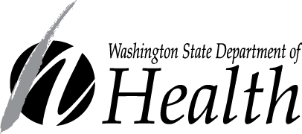
DOH 344-058 May 2018
