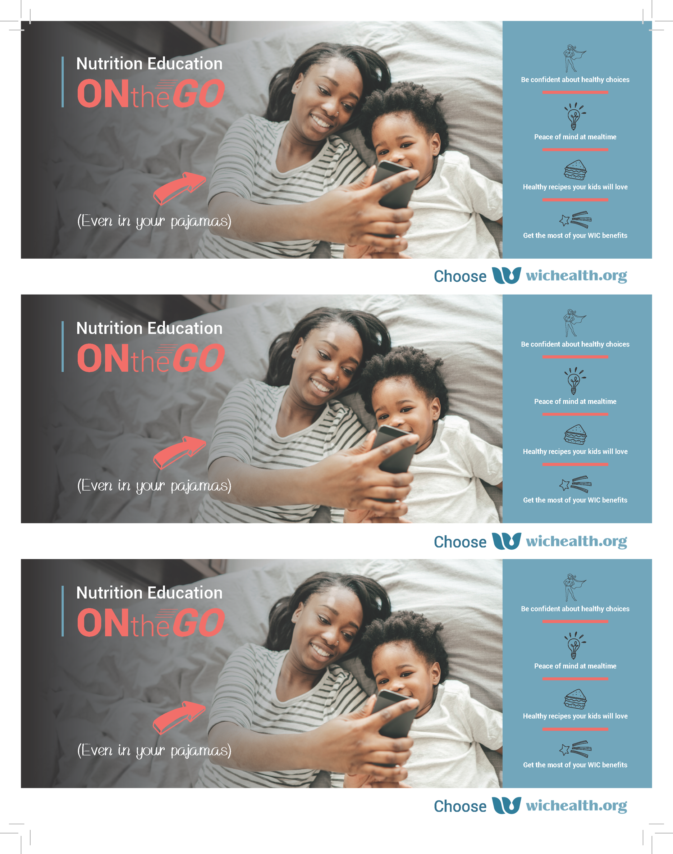

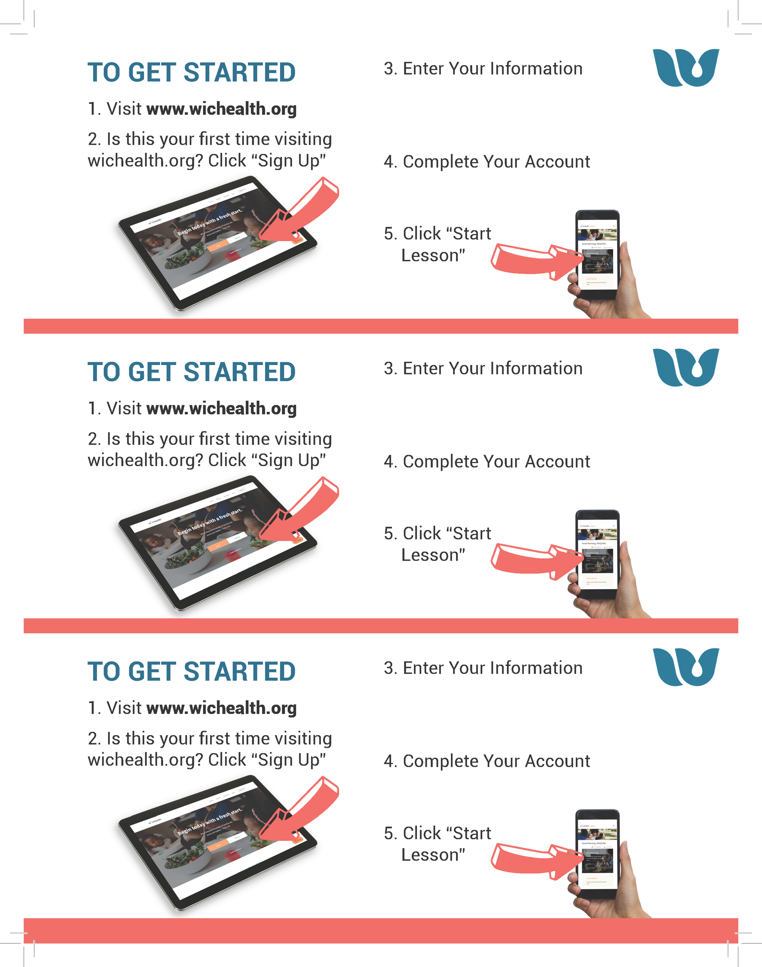

**Username:**

**Password:**

**Username:**

**Password:**

**Username:**

**Password:**

**Agency:**

**Clinic:**

**WIC ID:**

**Agency:**

**Clinic:**

**WIC ID:**

**Agency:**

**Clinic:**

**WIC ID:**