Drinking Water Health Advisory
The public water system, ID , located in County has high levels of manganese.

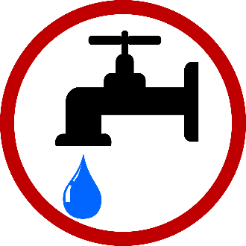
DO NOT DRINK THE WATER, DO NOT USE IT TO MAKE INFANT FORMULA, DO NOT USE IT IN COOKING.
Sample results received on Click or tap to enter a date. showed manganese levels of mg/L. This level is above the Environmental Protection Agency’s (EPA’s) health advisory of 1 mg/L for adults and children seven months and older. This health advisory is EPA’s recommended limit for manganese in drinking water consumed for one to ten days.
Manganese naturally occurs in soil, water, and air. It is commonly found in the food we eat, including nuts, legumes, seeds, grains, and green leafy vegetables, and in drinking water. Our bodies require small amounts of manganese to stay healthy. Adults and children get enough manganese from the foods we eat. Infants get enough manganese from breast milk, food, or formula.
Too much manganese can increase the risk of health problems. Adults drinking water with high levels of manganese for many years may experience neurological effects, resulting in behavioral changes and impaired coordination, including slow and clumsy movements. Some studies have shown that too much manganese during childhood may also have effects on the brain, which may affect learning and behavior.
Infants are more at risk than older children and adults because they absorb and hold onto manganese more easily. Formula-fed infants get enough manganese from formula to meet their dietary needs. However, they may get too much manganese (above the recommended amount for nutrition) in their bodies when formula is mixed with water that contains manganese. To protect this more sensitive group EPA recommends no more than 0.3 mg/L of manganese in water fed to infants who are 6 months old or younger.
This health advisory is being provided because EPA identified health risks from short-term exposure to manganese above this level in the general population.

What should I do?
DO NOT GIVE TAP WATER TO INFANTS. Formula and other food preparations for infants should not be prepared with tap water. Use bottled water or alternative sources of water for infants. Making formula or foods with water containing manganese levels above the health advisory can increase an infant’s risk of health problems.
DO NOT GIVE TAP WATER TO CHILDREN OR ADULTS. Use bottled water or an alternative source of water for drinking and food preparation for children and adults. Water containing manganese levels above the health advisory may cause possible neurological effects.
DO NOT BOIL THE WATER. Boiling, freezing, or letting water stand does not reduce manganese. Boiling can increase levels of manganese because manganese remains behind when the water evaporates.
Adults and children of all ages can continue to bathe and shower, brush their teeth, and wash clothes, food, and dishes in tap water.
If you have specific health concerns or concerns about your child’s health, discuss your concerns with your healthcare provider.

What happened? What is being done?
Describe corrective actions being taken.
Click here to enter text
We anticipate resolving this problem by . We will notify you when the manganese levels are again below the health advisory level.
For more information, please contact at or .
Please share this information with anyone who drinks this water, especially those who may not have received this notice directly (for example people in apartments, nursing homes, schools, and businesses). You can do this by posting this notice in a public place or distributing copies by hand or mail.
This notice is being sent to you by . State Water System ID# .
Date distributed: .

