SOCIAL GRAPHICS (JPEG) – SPANISH AND ENGLISH
Summer
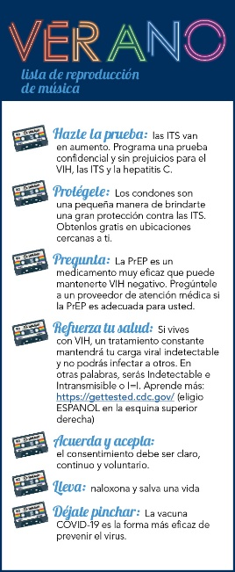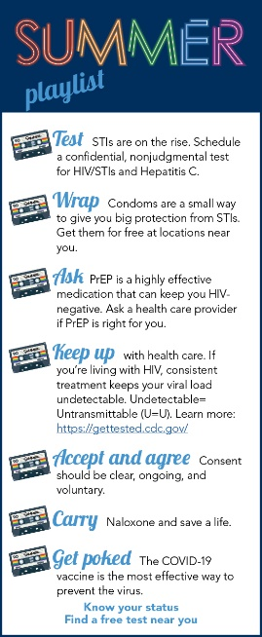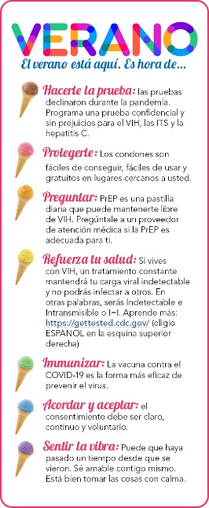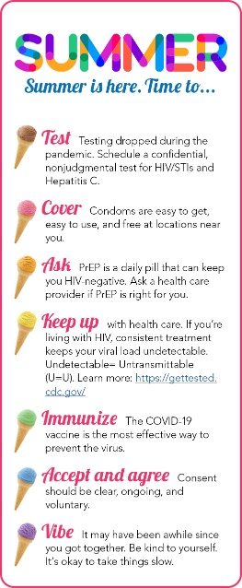
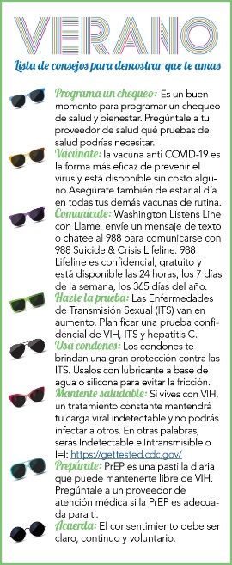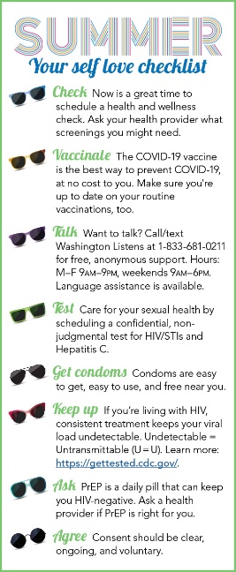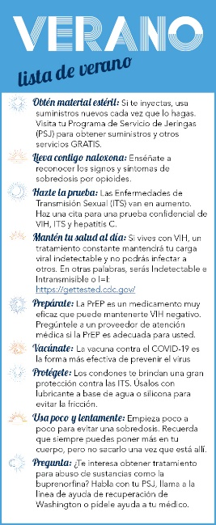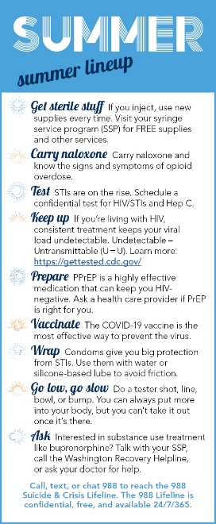

Winter
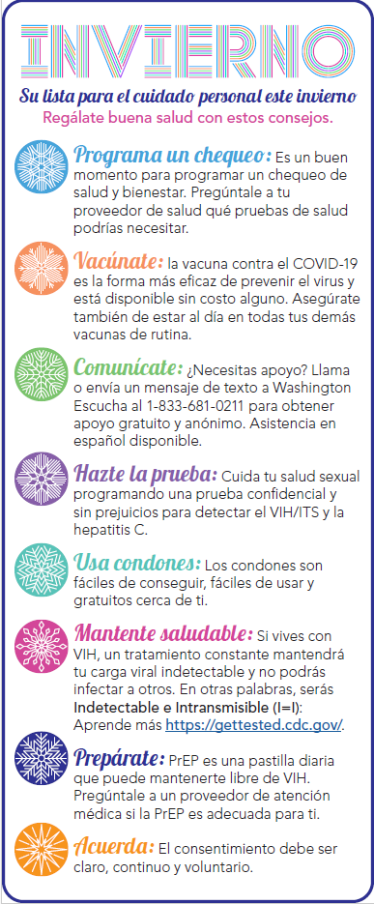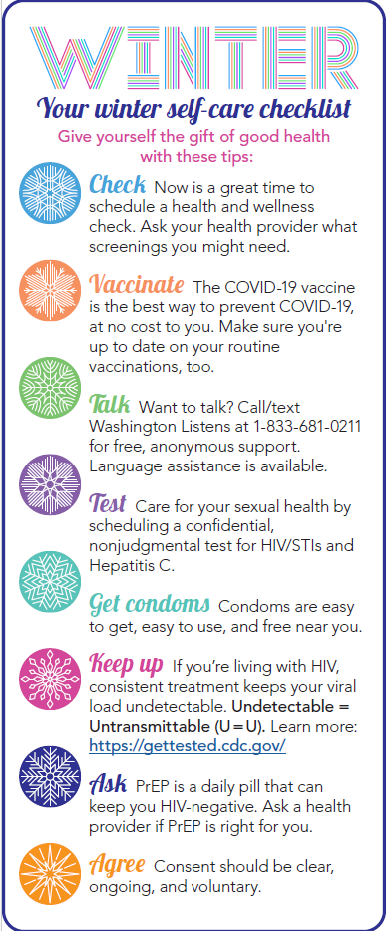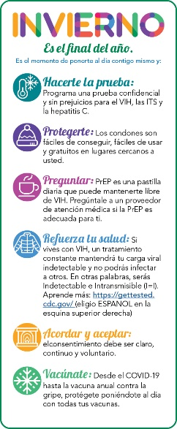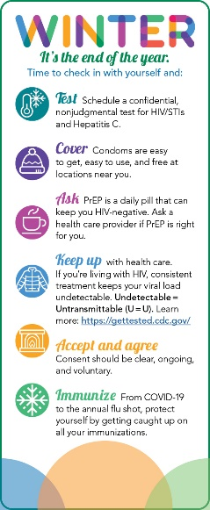

Suggested use for social media:
- Create a new post.
- Choose your graphic.
- Add links to local resources your clients use: testing, free condoms, PrEP providers, COVID-19 vaccines, medical care, etc.
PRINT READY CHECKLISTS - SPANISH AND ENGLISH
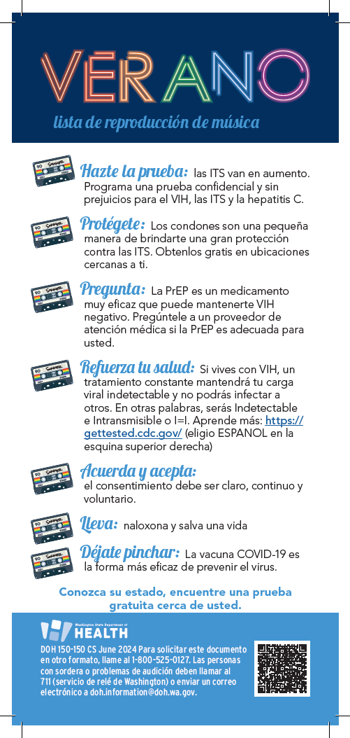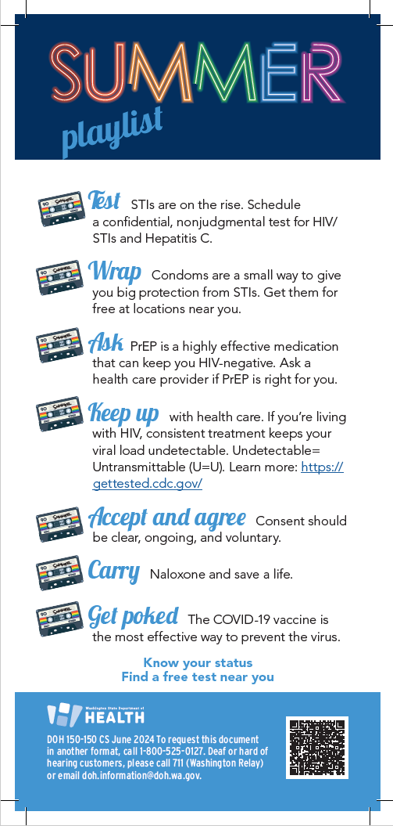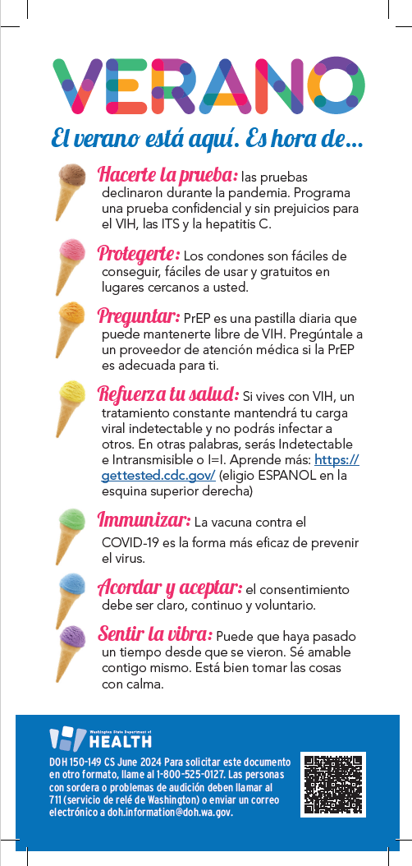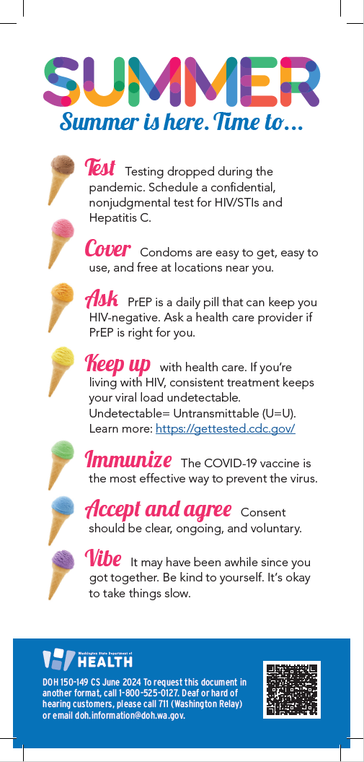
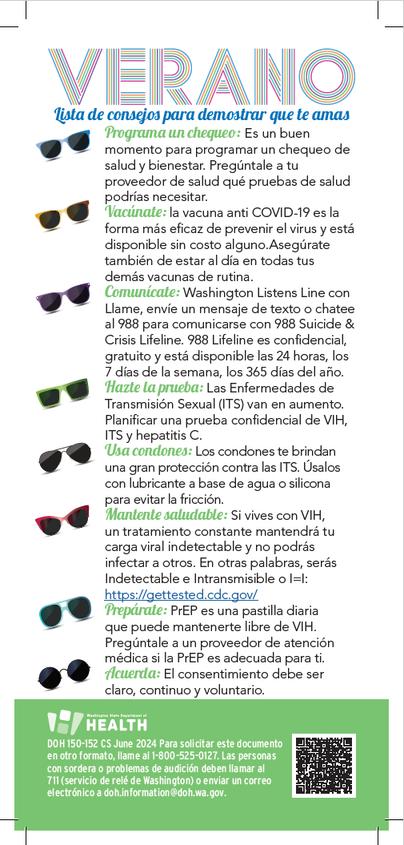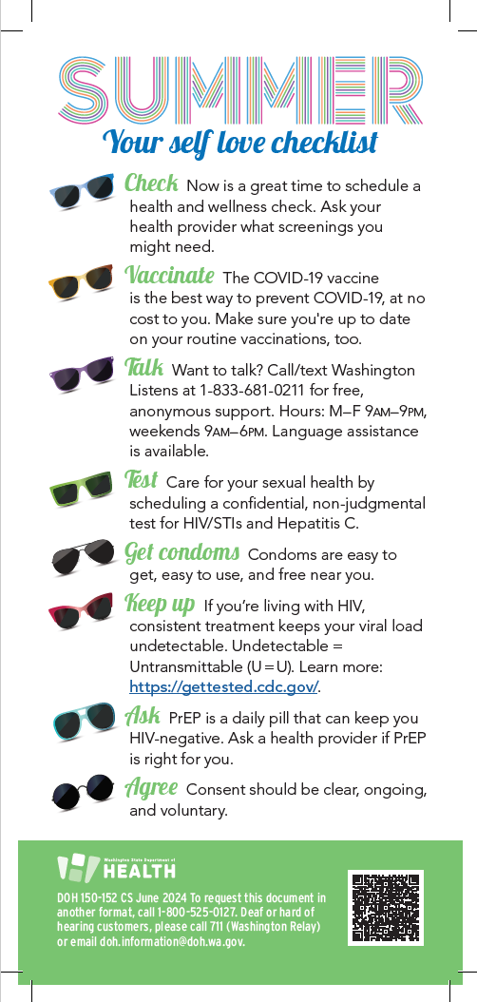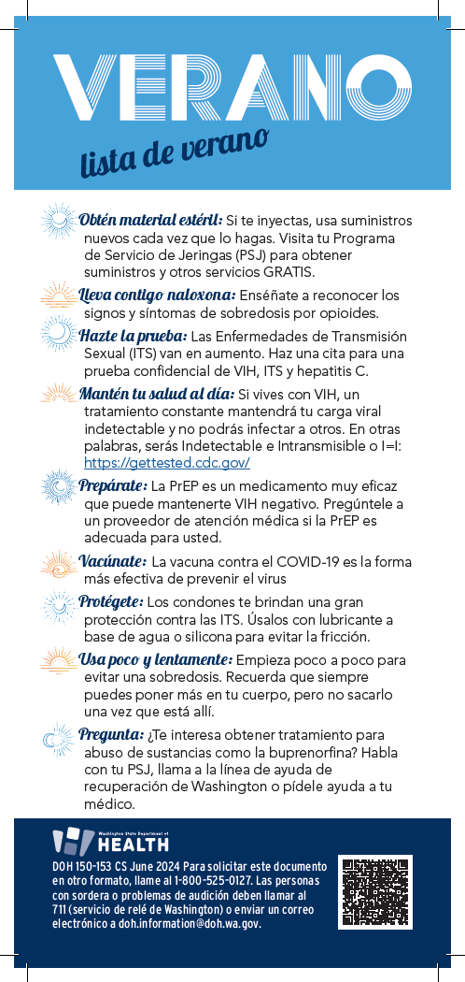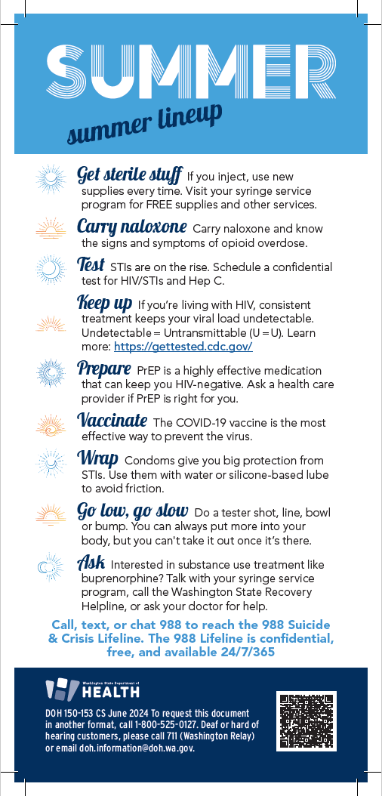

Winter
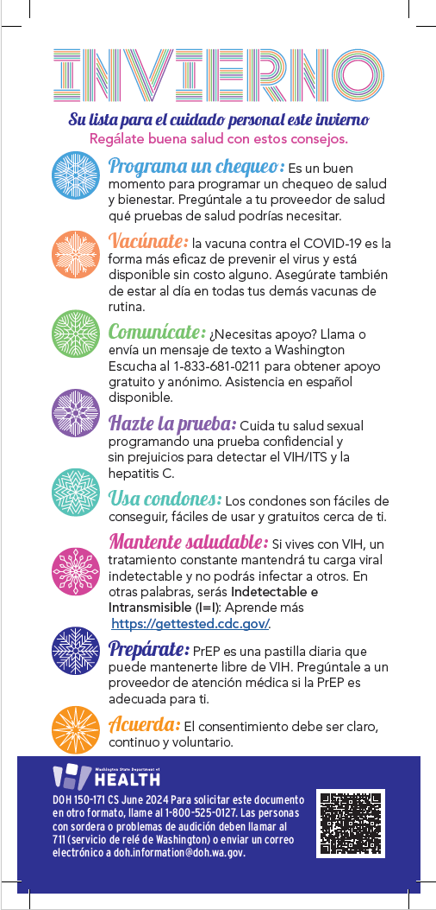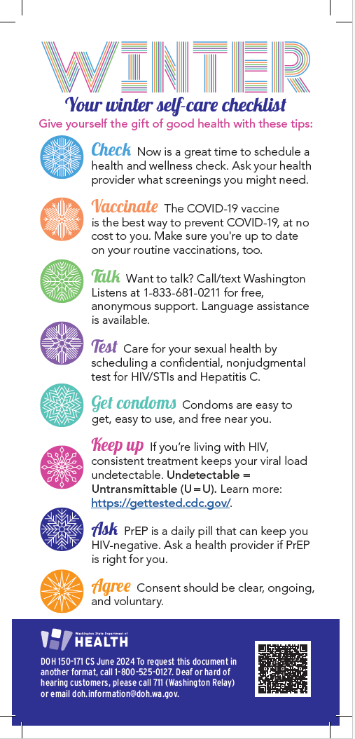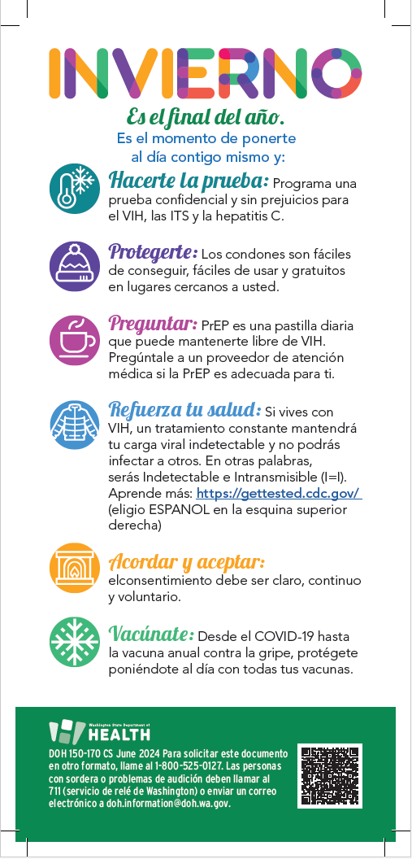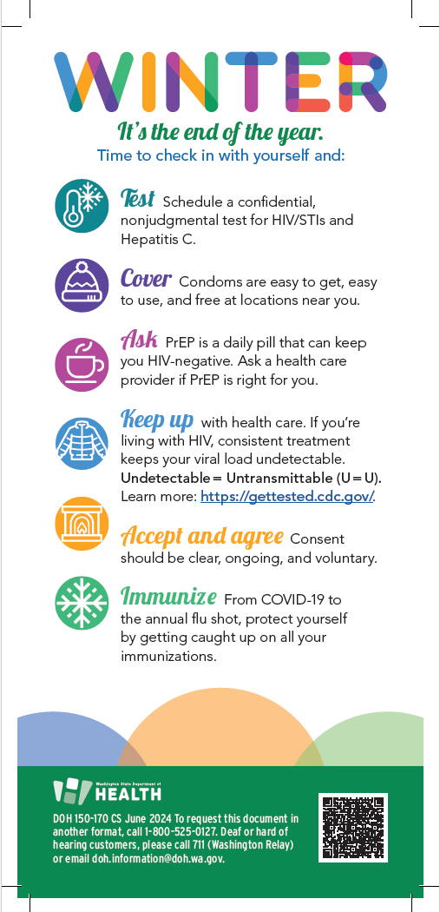

Suggested use for printed checklists:
- Send the files to your local print shop. These checklists are in CMYK color and include printer’s trim and bleed marks.
- Display in your setting such as waiting areas, consultation rooms, dining areas, recreational and seasonal message boards, other public spaces.
- Add your local resources:
  - Add sticker labels to the backside of the checklists with links to local resources your clients use, like testing, free condoms, PrEP providers, COVID-19 vaccines, medical care, etc.; or
  - Print out resource lists and hand out with the checklists.
- Use as interactive PDFs with clickable links
  - These are formatted for social media layout style.
  - Share these by email or post to your website (note: you cannot share PDFs on social media platforms).
  - Add your local resources in the e-mail or add as accompanying text to your website:
    - Link to local resources your clients use, like testing, free condoms, PrEP providers, COVID-19 vaccines, medical care, etc.

DOH 150-176 June 2024 To request this document in another format, call 1-800-525-0127. Deaf or hard of hearing customers, please call 711 (Washington Relay) or email civil.rights@doh.wa.gov.

