PART 2: DESIGN AND CONSTRUCTION STANDARDS
Subpart F: Decks and Equipment
NEW SECTION
WAC 246-261-408010 General standards for all decks (2023 MAHC 4.8.1). (1) Lifeguard placement and safety considerations. DECKS shall be designed to allow for QUALIFIED LIFEGUARD placement per the zone of BATHER surveillance in WAC 246-261-603010 and safety areas and equipment in WAC 246-261-408050.
(a) Access points. Access points shall be provided to QUALIFIED LIFEGUARDS to transit to QUALIFIED LIFEGUARDS positions.
(b) Deck clearance. DECKS shall have a minimum clearance from AQUATIC VENUE edge to fencing or other obstruction as specified in WAC 246-261-408015 for PERIMETER DECKS for POOLS and WAC 246-261-4012XX for other AQUATIC VENUES.
(i) DECK clearances between AQUATIC VENUES must be at least six feet wide.
(ii) AQUATIC VENUES 1,500 square feet or more, DECK surfaces must be at least 16 square feet per BATHER. To determine THEORETICAL PEAK OCCUPANCY, see WAC 246-261-XXXXXX.
(iii) If the owner provides STADIUM SEATING, THEORETICAL PEAK OCCUPANCY may be used in lieu of the required DECK surfaces as described under (b)(ii) of this subsection.
(2) Joints or gaps. Conditions between adjacent DECK materials, components, and concrete pours shall not have horizontal open joints or gaps larger than 3/16 inches wide (4.8 mm).
(a) Vertical elevation. Any change in vertical elevation between adjacent DECK materials, components, and concrete pours exceeding 1/4 inches (6.4 mm) shall be considered an edge condition and shall be treated according to (b) or (c) of this subsection.
(b) Fillers. Open joints or gaps larger than 3/16 inches (4.8 mm) wide or with vertical elevations exceeding 1/4 inches (6.4 mm) shall be rectified using appropriate fillers.
(c) Sealants. The use of fillers such as caulk or sealant in joints or gaps shall be permitted for expansion and contraction.
(d) No violation. The use of fillers such as caulk or sealant in joints or gaps shall not be in violation of this subsection.
(3) Rounded edges. All DECK edges shall be beveled, rounded, or otherwise relieved to eliminate sharp corners.
(4) Minimize cracks. Joints in DECK shall be provided to minimize the potential for CRACKS due to a change in elevation, for movement of the slab and for shrinkage control.
(5) Concrete decking. Where concrete is used as a DECK material, it shall be installed in accordance with the latest edition of the American Concrete Institute (ACI) Standards and in accordance with applicable local, state, territorial, federal, and tribal building CODES.
(6) Access hatches. Any access hatches located within the surface of the DECK shall be lockable, SLIP RESISTANT, and designed to maintain acceptable surface temperatures to allow barefoot traffic.
[]
NEW SECTION
WAC 246-261-408012 Standards for perimeter decks (2023 MAHC 4.8.1.2). (1) Impervious. Finish materials for the PERIMETER DECK shall be suitable for the POOL environment, nontoxic, and substantially impervious.
(2) Watertight expansion. Continuous watertight EXPANSION JOINT material shall be provided between PERIMETER DECKS and POOL coping.
(a) Expansion joint. Where applicable, the EXPANSION JOINT shall be designed and constructed so as to protect the coping and its mortar bed from damage as a result of movement of adjoining DECK.
(b) Watertight expansion. All conditions between adjacent concrete PERIMETER DECK pours shall be constructed with watertight EXPANSION JOINTS.
(c) Joint measurements. Joints shall be at least 3/16 inches (5 mm) in continuous width.
(d) Vertical differential. The maximum allowable vertical differential across a joint shall be 1/4 inches (6.5 mm).
[]
NEW SECTION
WAC 246-261-408013 Drains (2023 MAHC 4.8.1.3). Refer to WAC 246-261-4011XX for additional guidance on drains.
(1) Slope. DECKS shall be sloped away from the AQUATIC VENUE and in accordance with Table 408013.1 4.8.1.3 below.
Table 408013.1 Minimum Slopes for Drainage
Surface | Minimum Slope
Smooth finishes  (Such as tile, hand-finished concrete, and lightly-broomed concrete) | 1/8 inch per foot  (3.2 mm/30.5 cm)
Moderately textured finishes  (Such as exposed aggregate or medium-broomed concrete) | 1/4 inch per foot  (6.4 mm/30.5 cm)
Heavily textured finishes  (Such as brick, where permitted) | 3/8 inch per foot  (9.5 mm/30.5 cm)
(a) Accessible routes. Where DECK areas or portions thereof serve as ACCESSIBLE ROUTES, slopes in any direction shall not exceed ADA requirements. Heavily textured finishes per Table 408013.1 may not be a part of an ACCESSIBLE ROUTE.
(b) All water. All water that touches areas defined as DECK, including water originating in the AQUATIC VENUE, shall drain effectively to either perimeter areas or to DECK drains.
(c) Remove wastewater. Drainage shall remove AQUATIC VENUE water that splashes outside of the AQUATIC VENUE and beyond a POOL gutter system, DECK cleaning water, and rain water without leaving standing water.
(2) Placement. The placement of DECK drains, where provided, shall effectively carry water away from the AQUATIC VENUE and off the DECK without ponding.
(3) Cross-connection control. There shall be no direct connection between the DECK drains and the sanitary or storm sewer system.
(4) Discharge to sewer or other ground water. If the AHJ requires an outdoor POOL to have DECK drains that discharge to a storm sewer system, ground surface, or holding pond, the POOL shall be plumbed through an air-gap, BACKFLOW preventer, or other approved device as allowed by the AHJ.
(5) No drain. DECK drains shall not drain to the POOL, POOL gutter, or RECIRCULATION SYSTEMS.
(6) Drain bodies. Drain receptacles shall consist of noncorrosive or corrosion-resistant materials.
(7) Drain covers. Drain covers shall be suitable for bare foot traffic with openings no greater than 1/2 inch (1.3 cm) and easily removable with a simple tool to facilitate regular cleaning.
[]
NEW SECTION
WAC 246-261-408014 Materials/slip resistant (2023 MAHC 4.8.1.4). (1) General. PERIMETER DECK and POOL DECK shall be constructed with a uniform and easily cleaned surface such as concrete, tile, manufactured, or acrylic surfaces.
(2) Slip resistant. All DECKS shall have SLIP-RESISTANT, textured finishes, which are not conducive to slipping under contact of bare feet in wet or dry conditions.
(3) Carpet. Carpet and artificial turf shall be prohibited materials for PERIMETER DECK and POOL DECK.
(4) Wood. Wood shall be a prohibited material for use as PERIMETER DECK.
(5) Dry deck. DRY DECK shall be easily maintained and not create a public health hazard.
(a) Not required. DRY DECK shall not be required to be hard-paved or impervious.
(b) Wood decking. Wood DECKING may be permitted for DRY DECK.
(6) Landscaping. Loose plant material or bedding shall not be permitted within PERIMETER DECKS. Stable materials are permitted.
[]
NEW SECTION
WAC 246-261-408015 Deck size/width (2023 MAHC 4.8.1.5). (1) Perimeter decks. PERIMETER DECKS for all POOLS are subject to the following:
(a) Pools less than 1,500 square feet. For POOLS less than 1,500 square feet, PERIMETER DECKS must be at least four feet wide around the entire perimeter of pools and including:
(i) Six feet wide at the shallow end of a POOL; and
(ii) Six feet wide on a minimum of 25 percent of the deck space of an irregular shaped POOL.
(b) Pools greater than 1,500 square feet. For POOLS 1,500 square feet or larger, PERIMETER DECKS must be at least six feet wide:
(i) Around the entire perimeter of outdoor POOLS;
(ii) On 50 percent of the perimeter of indoor POOLS; and
(iii) The remaining 50 percent perimeter of the indoor POOL must be a minimum of four feet wide.
(c) Circulation path. Perimeter DECK may serve as part of the CIRCULATION PATH.
(d) Flush with pool wall. PERIMETER DECK areas shall be flush with POOL walls/copings except where special conditions exist, such as elevated beam or parapet, raised transfer walls, or as permitted by other sections of this chapter.
(e) Perimeter decking. PERIMETER DECKS shall be provided around 100 percent of the AQUATIC VENUE perimeter except where special conditions exist as permitted by other sections of this chapter.
(f) Spectator seating. Refer to WAC 246-261-406010 for more information on spectator areas.
(2) Fixed equipment.
(a) Unobstructed deck. Unobstructed DECK area four feet (1.2 m) minimum in width shall be provided for access around:
(i) Diving equipment;
(ii) Special feature stairways (such as a WATERSLIDE);
(iii) Lifeguard stands;
(iv) Diving boards;
(v) Similar DECK equipment;
(vi) ADA access equipment; and
(vii) Structural columns.
Exception. DECKS not less than four feet (1.2 m) in width may be provided on the sides and rear of any diving, ADA access, lifeguard stands, and similar DECK equipment.
(b) Circulation path. This unobstructed area may overlap the CIRCULATION PATH.
(c) Queuing space. Where reasonably anticipated, queuing space shall be provided at applicable equipment to minimize encroachment into the CIRCULATION PATH.
(d) Free space. Free area around equipment may consist of PERIMETER DECK and/or POOL DECK, as applicable.
(3) Circulation path.
(a) Conformance. A continuous and unobstructed CIRCULATION PATH shall be provided in conformance with ADA requirements for an ACCESSIBLE ROUTE.
(b) Equipment and furniture. DECK furniture locations shall be designed not to intrude upon any CIRCULATION PATH.
(c) Connect. CIRCULATION PATHS shall connect all site amenities, entrances, and exits as required by ADA.
(d) Deck types. CIRCULATION PATHS may consist of any combination of permitted DECK types.
[]
NEW SECTION
WAC 246-261-408016 Wing walls or peninsulas (2023 MAHC 4.8.1.6). (1) No perimeter. Deck WING WALLS or PENINSULAS less than 18 inches (45.7 cm) in width shall not be considered a part of the PERIMETER DECK.
(a) Use by lifeguards. A WING WALL or PENINSULA greater than 18 inches (45.7 cm) wide but less than 48 inches (1.2 m) wide may be used by QUALIFIED LIFEGUARD personnel but shall not be considered as part of the PERIMETER DECK.
(b) Slip resistant. Any WING WALL or PENINSULA shall be constructed of SLIP-RESISTANT materials.
(2) Perimeter overflow system. If it is impractical to design a perimeter overflow system into the WING WALL or PENINSULA due to width or height, then the overflow system may bypass the WING WALL or PENINSULA engineering justification must be provided by the DESIGN PROFESSIONAL and approved by the AHJ.
(3) Pool perimeter and calculation. WING WALLS and PENINSULAS shall be considered part of the POOL. WING WALLS and PENINSULAS shall not be accounted for in calculating the POOL perimeter.
(4) Normal operating water level. WING WALLS and PENINSULAS shall be at or above the normal operating water level of the POOL.
(5) Deck drainage. DECK drainage shall not be required for WING WALLS or PENINSULAS as they are considered part of the POOL. The tops shall be crowned to prevent standing water and sloped to the POOL or overflow system.
(6) Vertical depth markers. Vertical depth markers shall be provided around WING WALLS and PENINSULAS in accordance with WAC 246-261-405019.
[]
NEW SECTION
WAC 246-261-408017 Islands (2023 MAHC 4.8.1.7). (1) Minimum width. An ISLAND not more than 18 inches (45.7 cm) in width shall be designed to discourage a person from walking on the ISLAND by not providing stairs, ladders, or bridges to the ISLAND.
(2) Slip resistant. The surface of ISLANDS shall be SLIP RESISTANT.
(3) Lifeguards. An ISLAND 18 inches (45.7 cm) to 48 inches (1.2 m) wide may be allowed for use only by QUALIFIED LIFEGUARDS.
(4) Vertical depth markers. Vertical depth markers shall be provided around ISLANDS in accordance with WAC 246-261-405019 and visible from all sides.
(5) Horizontal depth markers and warning signs. Horizontal depth markings and warning signs shall also be required per WAC 246-261-405019 if the ISLAND is designed for BATHER use. If the ISLAND is not designed for BATHER use, warning signs stating "No Entry" shall be required.
(6) Bridge or stairway. An ISLAND designed for BATHER traffic shall be accessible by bridge, ramp, ladder, or stairway from the POOL.
(7) Minimum clearance. All bridges spanning a POOL or any other structures not intended for INTERACTIVE WATER PLAY AQUATIC VENUE shall have a minimum clearance of four feet (1.2 m) from the POOL surface to any structure overhead.
(8) Guard rails. Any bridge shall have a minimum 42 inch (1.1 m) high BARRIER on both sides that prohibit a four-inch sphere passing through.
[]
NEW SECTION
WAC 246-261-408018 Heated decks (2023 MAHC 4.8.1.8). (1) Freeze protection. Where heated DECKS are provided for the purpose of freeze protection, the extent of heated area shall minimally include the entire required PERIMETER DECK and required CIRCULATION PATH(s).
(2) Clearly delineated. Heated DECK paths shall be clearly delineated with respect to unheated DECKS.
[]
NEW SECTION
WAC 246-261-408019 Hose bibbs (2023 MAHC 4.8.1.9). (1) General. Domestic water hose bibbs shall be provided in sufficient quantity, spacing, and type to wash down PERIMETER DECK and POOL DECK areas using a hose of no longer than 100 feet (30.5 m).
(2) Backflow prevention. All hose bibbs shall be equipped with BACKFLOW prevention devices.
[]
NEW SECTION
WAC 246-261-408020 Diving boards and platforms (2023 MAHC 4.8.2). (1) Diving envelope.
(a) Competitive diving. Diving boards shall be permitted only when the diving envelope conforms to the most current version of STANDARDS for the certifying agency that regulates competitive diving at the AQUATIC FACILITY. Such certifying agencies include:
(i) NCAA;
(ii) NFHS;
(iii) FINA; or
(iv) U.S.A. Diving, Inc.
(b) Noncompetitive diving. If the AQUATIC VENUE does not have competitive diving, then the diving envelope shall conform to the diving envelope STANDARDS of:
(i) Table 408020.1 of this section;
(ii) Table 408020.2 of this section;
(iii) Figure 408020.3 of this section; and
(iv) Figure 408020.4 of this section.
(2) Steps and guardrails.
(a) Higher than 21 inches. Diving stands higher than 21 inches (53.3 cm) measured from the DECK to the top of the butt-end of the board or platform shall have steps or a ladder and handrails.
(b) Self-draining treads. Steps or ladder treads shall be self-draining, corrosion resistant, SLIP RESISTANT, and designed to support the maximum expected load.
(c) Short platforms. Diving stands or platforms that are one meter (3.4 ft) or higher shall be protected with guard rails at least 30 inches (76.2 cm) above the board, extending at least to the edge of the water along with intermediate rails.
(d) Tall platforms. Diving stands or platforms that are two meters (6.6 ft) or higher shall have guard rails with the top rail at least 36 inches (0.9 m) above the board and a second rail approximately half the distance from the platform to the upper rail.
Table 408020.1: Diving Board Height and Dimensions
Diving Board Height | 1.64 ft  (0.5 m) | 2.46 ft  (0.75 m) | 3.28 ft  (1.0 m) | 9.84 ft  (3.0 m)
Diving Board Length | 10.0 ft  (3.05 m) | 12.0 ft  (3.66 m) | 16.0 ft  (4.88 m) | 16.0 ft  (4.88 m)
Diving Board Width | 20.0 in  (50.8 cm) | 20.0 in  (50.8 cm) | 20.0 in  (50.8 cm) | 20.0 in  (50.8 cm)
Table 408020.2: Minimum Dimensions of Components Related to Diving Wells by Diving Board Height
(Note: Letters below refer to Figures 408020.3 and 408020.4)
 |  | Minimum Dimensions
 | Diving Board Height | 0.5 meter | 0.75 meter | 1.0 meter | 3.0 meter
A | Distance from plummet back to pool wall | 3.0 ft  (0.91 m) | 4.5 ft  (1.37 m) | 6.0 ft  (1.83 m) | 6.0 ft  (1.83 m)
B | Distance from plummet to pool wall at side | 10.0 ft  (3.05 m) | 10.0 ft  (3.05 m) | 10.0 ft  (3.05 m) | 11.5 ft  (3.51 m)
C | Distance from plummet to adjacent plummet | 8.83 ft  (2.69 m) | 8.83 ft  (2.69 m) | 8.83 ft  (2.69 m) | 8.54 ft  (2.60 m)
D | Distance from plummet to pool wall ahead | 26.0 ft  (7.92 m) | 27.83 ft  (8.48 m) | 29.58 ft  (9.02 m) | 33.67 ft  (10.26 m)
E | Height, diving board to ceiling at plummet and distances F and G | 16.0 ft  (4.88 m) | 16.0 ft  (4.88 m) | 16.0 ft  (4.88 m) | 16.0 ft  (4.88 m)
F | Clear overhead distance behind and each side of plummet | 8.0 ft  (2.34 m) | 8.0 ft  (2.34 m) | 8.0 ft  (2.34 m) | 8.0 ft  (2.34 m)
G | Clear overhead distance ahead of plummet | 16.0 ft  (4.88 m) | 16.0 ft  (4.88 m) | 16.0 ft  (4.88 m) | 16.0 ft  (4.88 m)
H | Depth of water at plummet | 9.5 ft  (2.90 m) | 10.75 ft  (3.28 m) | 12.0 ft  (3.66 m) | 12.5 ft  (3.81 m)
J | Distance ahead of plummet to depth K | 12.0 ft  (3.66 m) | 14.25 ft  (4.34 m) | 16.5 ft  (5.03 m) | 19.75 ft  (6.02 m)
K | Depth at distance J ahead of plummet | 8.75 ft  (2.67 m) | 10.0 ft  (3.05 m) | 11.28 ft  (3.44 m) | 12.17 ft  (3.71 m)
L | Distance at each side of plummet to depth M | 8.0 ft  (2.34 m) | 8.13 ft  (2.48 m) | 8.25 ft  (2.51 m) | 9.92 ft  (3.02 m)
M | Depth at distance L on each side of plummet | 9.08 ft  (2.77 m) | 10.33 ft  (3.15 m) | 11.63 ft  (3.54 m) | 12.17 ft  (3.71 m)
N | Maximum slope to reduce height E | 30˚ | 30˚ | 30˚ | 30˚
P | Maximum floor slope to reduce depth ahead of K, to the sides of M, or back to pool wall behind H | 3:1 | 3:1 | 3:1 | 3:1
Figure 408020.3 Diving Platform Longitudinal Section: Side View
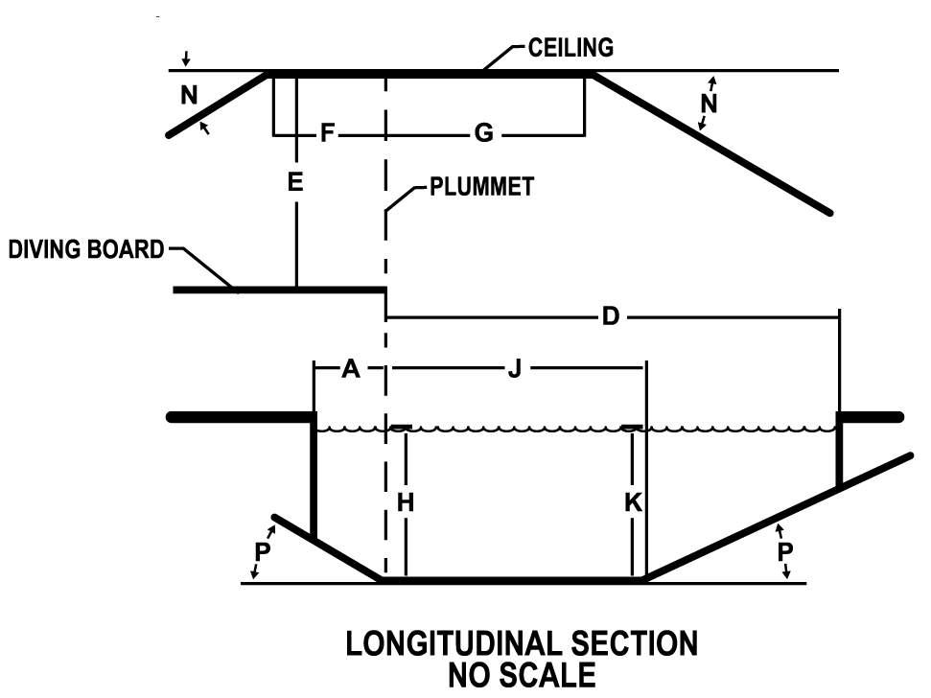
Figure 408020.4 Diving Platform Cross-section: Front View
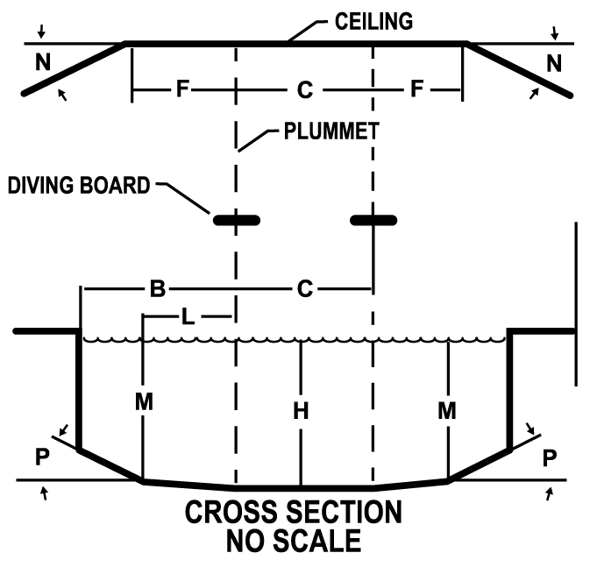
[]
NEW SECTION
WAC 246-261-408030 Starting platforms (2023 MAHC 4.8.3). (1) Conform to standard codes. Starting platforms shall be installed and conform to applicable SAFETY STANDARDS established by:
(a) FINA;
(b) U.S.A. Swimming;
(c) NCAA;
(d) NFHS;
(e) YMCA; or
(f) Other sanctioning body.
(2) Minimum water depth. Starting platforms shall be installed in a minimum water depth of four feet (1.25 m), except for new construction, where starting platforms shall be installed in a minimum water depth of six feet (1.8 m).
(3) Leading edge. The leading edge of starting platforms shall have a maximum height of 30 inches (76.2 cm) above the water surface.
(4) Slip resistant. Starting platforms shall have SLIP-RESISTANT tread surfaces.
(5) Secure and stable. Starting platforms shall be installed and secured per manufacturer's recommendations at all times when in use.
[]
NEW SECTION
WAC 246-261-408050 Lifeguard—Safety-related equipment (2023 MAHC 4.8.5). (1) Safety equipment required at all aquatic facilities.
(a) Emergency communication equipment. The AQUATIC FACILITY or each AQUATIC VENUE, as necessary, shall have a functional telephone or other communication device that is hard wired and capable of directly dialing 911 or function as the emergency notification system.
(b) Conspicuous and accessible. The telephone or communication system or device must be conspicuously provided and accessible within the AQUATIC VENUE ENCLOSURE and no more than 100 feet walking distance of each AQUATIC VENUE.
(c) Alternate communication systems. Alternate systems, devices, or communication processes are allowed with approval of the AHJ in situations when a telephone is not logistically sound, and an alternate means of communication is available, which meet the requirements of WAC 246-261-50805X.
(d) Internal communication. The AQUATIC FACILITY design shall include a method for staff to communicate in cases of emergency.
(e) Signage. A sign shall be posted at the telephone providing dialing instructions, address and location of the AQUATIC VENUE location, and the telephone number.
(2) Safety equipment required at facilities with lifeguards.
(a) Lifeguard chair and stand placement. The designer shall coordinate with the owner and/or an aquatic consultant to consider the impact on BATHER surveillance zones for placement of chairs and stands designed to be permanently installed so as to provide an unobstructed view of the BATHER surveillance zones.
(b) Lifeguard chair and stand design. The chairs/stands shall be designed:
(i) With no sharp edges or protrusions;
(ii) With sturdy, durable, and UV–resistant materials;
(iii) To provide enough height to elevate the lifeguard to an eye level above the heads of the BATHERS; and
(iv) To provide safe access and egress for the lifeguard.
(c) UV protection for chairs and stands. Where provided, permanently installed chairs/stands, where QUALIFIED LIFEGUARDS can be exposed to UV radiation, shall include protection from such UV radiation exposure.
[]
NEW SECTION
WAC 246-261-408060 Barriers and enclosures (2023 MAHC 4.8.6). (1) General requirements.
(a) Enclosure. All AQUATIC FACILITIES, CHEMICAL STORAGE SPACES, and AQUATIC VENUE mechanical spaces shall be located in an ENCLOSURE to prevent unauthorized entry.
(b) Enclosures. The ENCLOSURE may consist of any combination of building envelopes, site walls, or fencing as provided for in this section.
(c) Patron accessibility. An ENCLOSURE shall be provided between CHEMICAL STORAGE SPACES, POOL, mechanical spaces, and areas accessible to the public, in accordance with applicable local, state, territorial, federal, and tribal building CODES.
(2) Construction requirements.
(a) Discourage climbing. BARRIERS or ENCLOSURES shall discourage climbing by providing a 3-foot clearance to nearby structures to simplify climbing over it, such as: Light poles, site furnishings, overhanging tree limbs, or other obvious footholds or handholds.
(b) Horizontal members. Where the ENCLOSURE is composed of horizontal and vertical members:
(i) Horizontal members shall be located on the AQUATIC VENUE side of the ENCLOSURE.
(ii) Where there are decorative cutouts within vertical members, spacing within the cutouts shall not exceed 1 3/4 inches (44 mm) in width.
(iii) When the distance between the tops of the horizontal members is less than 45 inches (1143 mm), spacing between vertical members shall not exceed 1 3/4 inches (44 mm) in width.
(iv) When the distance between the tops of the horizontal members is 45 inches (1143 mm) or more, spacing between vertical members shall not exceed four inches (102 mm) and prevent the passage of a four-inch diameter sphere with the application of 50 pounds of force.
Figure 408060.1 Horizontal members less than 45"
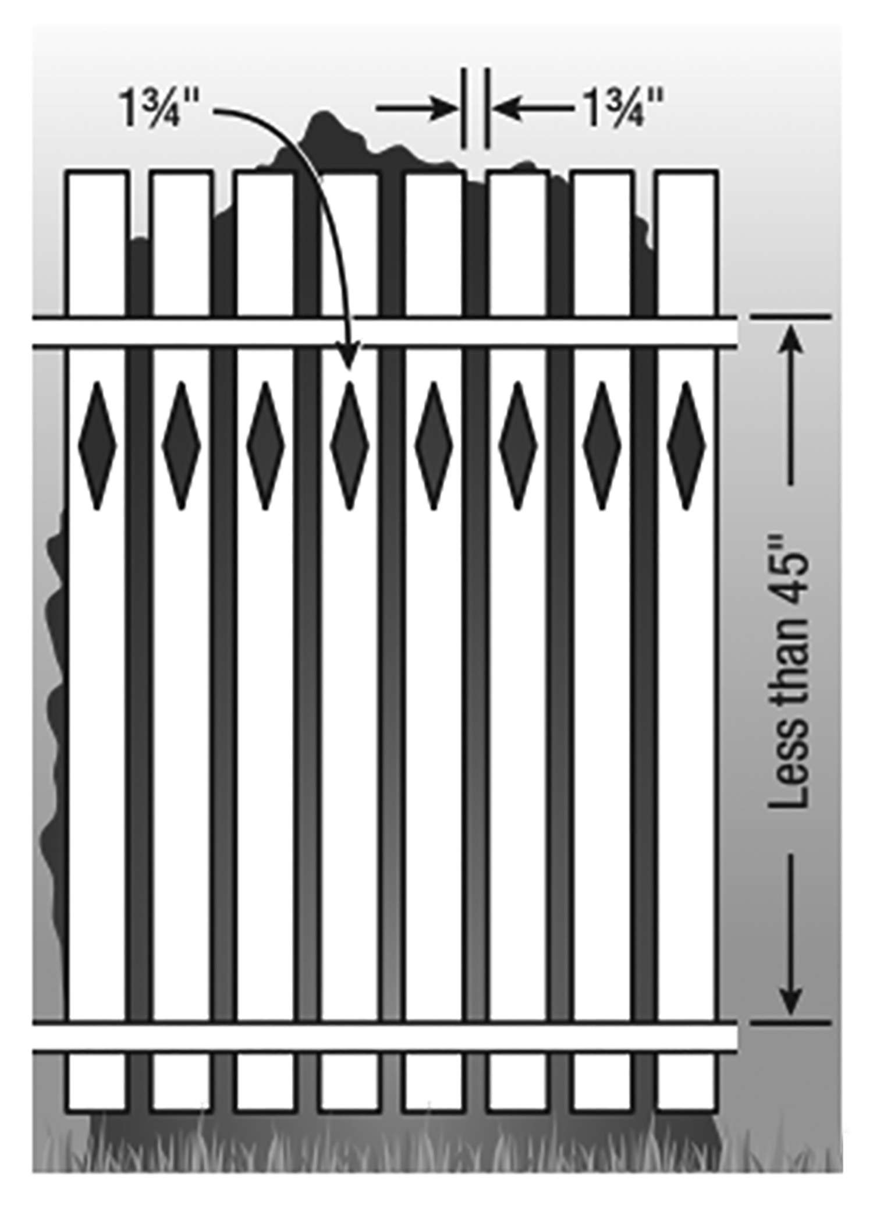
Figure 408060.2 Horizontal members greater than 45"
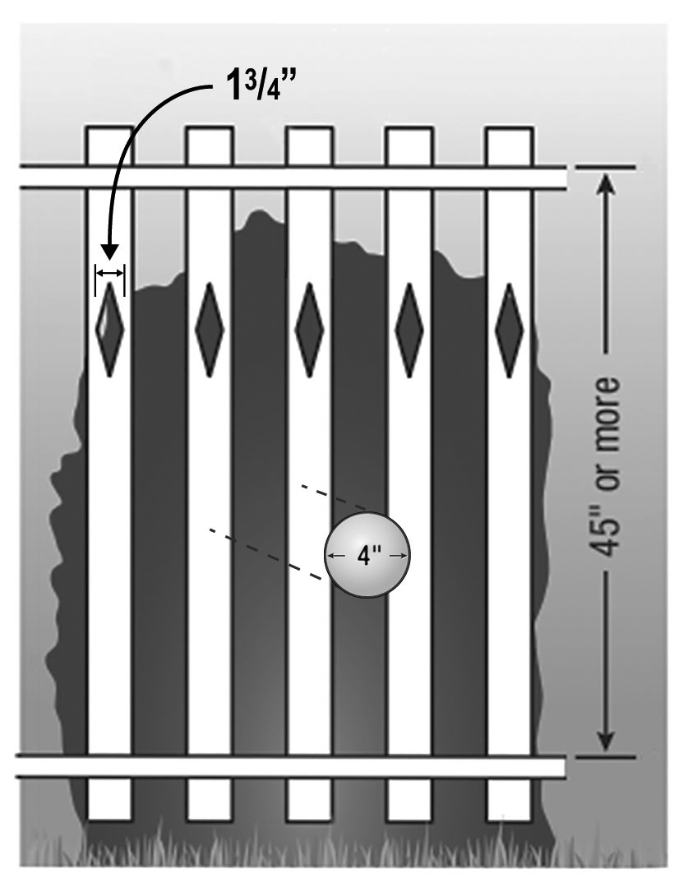
(c) Mesh fencing. The mesh size for chain-link fencing may not exceed 1 1/4 inches (31.7 mm) unless slats, fastened at the top or bottom of the fence, are used to reduce the mesh openings to no more than 1 3/4 inches (44.4 mm).
Figure 408060.3 Mesh fencing
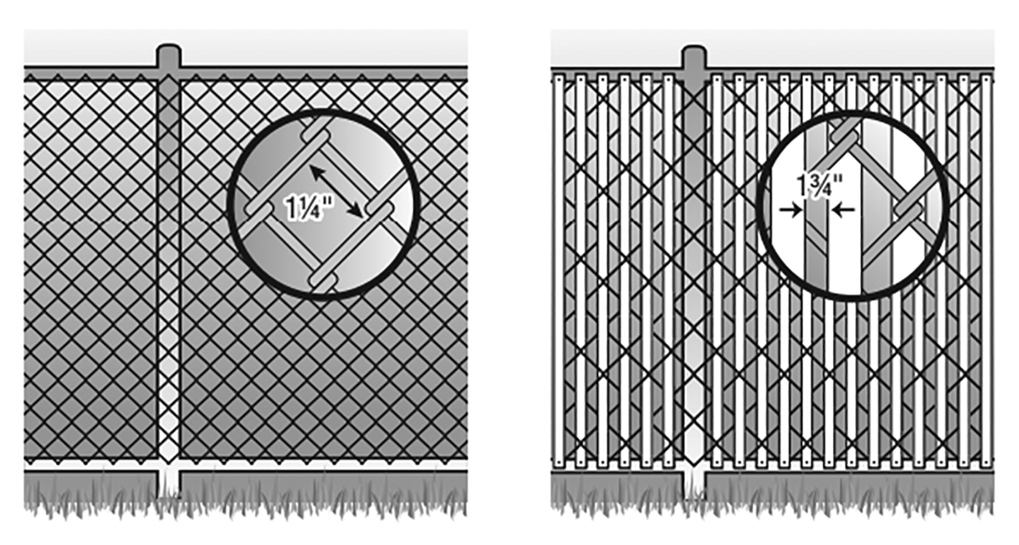
(d) Solid surfaces. Where the enclosure is composed of a solid surface, such as masonry or stone walls, no indentations or protrusions shall be present, other than normal construction tolerances and masonry joints. Such indentations shall not be deeper than 0.375 inches (10 mm).
Figure 408060.4 Solid surfaces
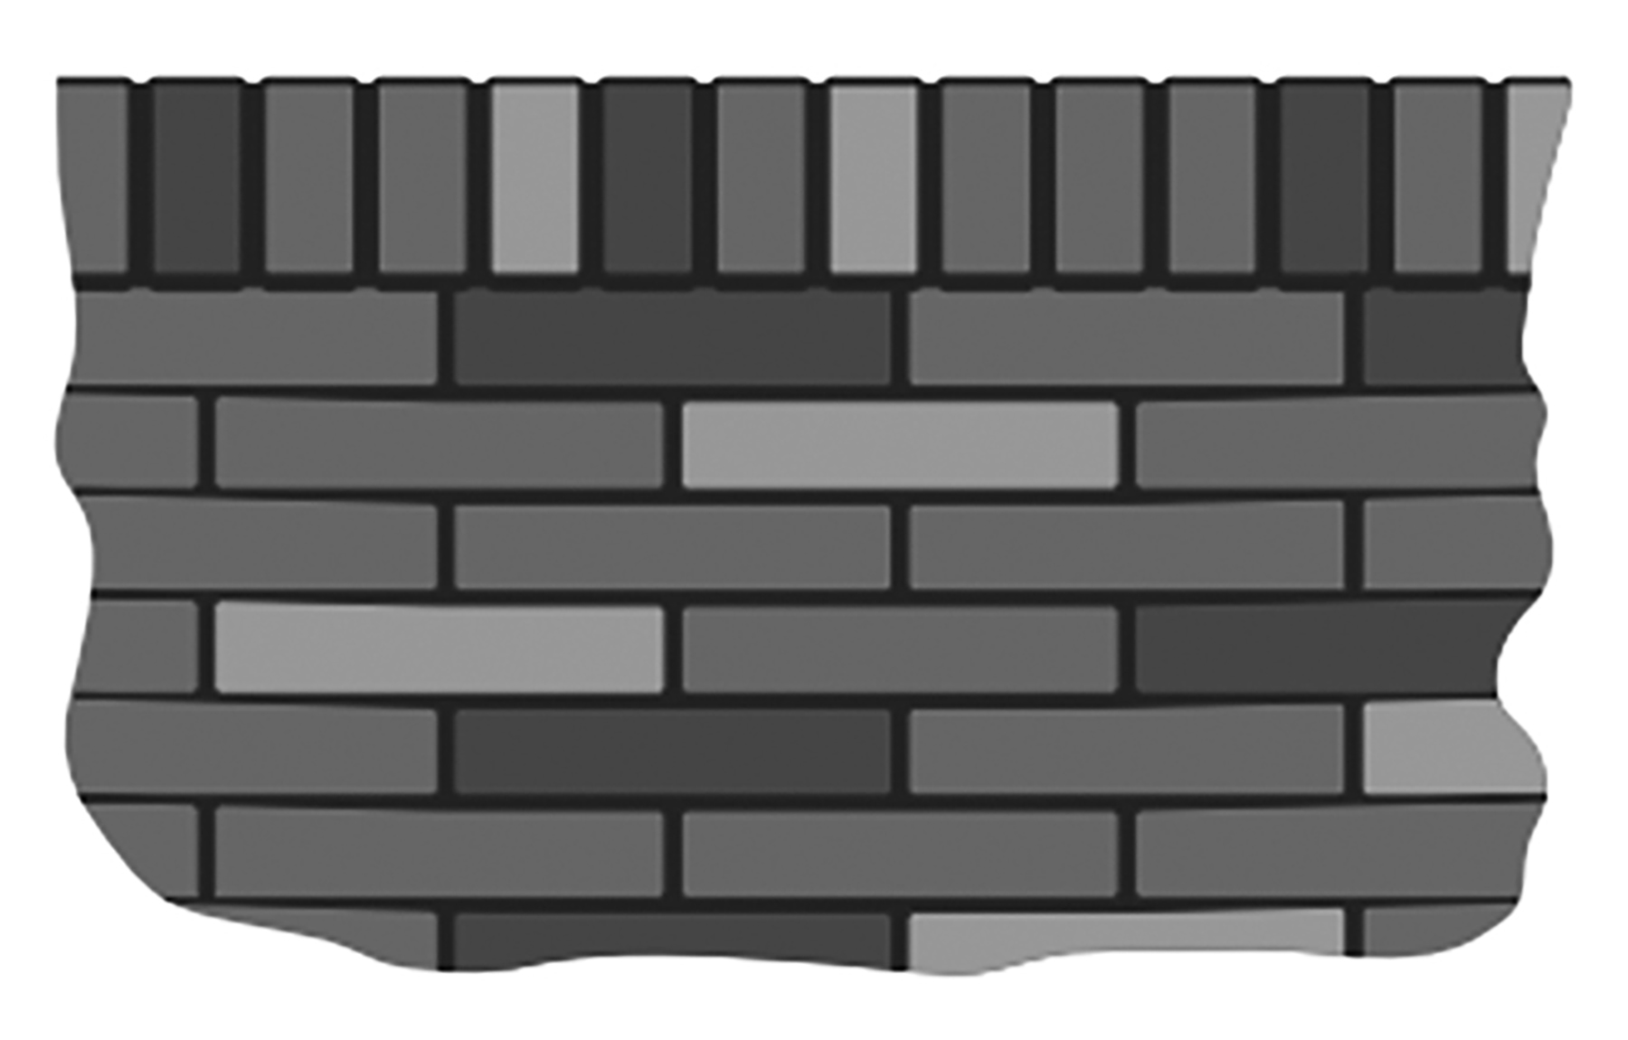
(e) Emergency exit paths. ENCLOSURES for AQUATIC VENUES shall not block or encumber a required emergency egress path from other structures, nor shall emergency egress from other structures not a part of the AQUATIC FACILITY lead into or access an ENCLOSURE for an AQUATIC VENUE.
(f) Windows. Windows having a sill height of less than 72 inches above the pool deck on a building that forms part of an ENCLOSURE around an AQUATIC VENUE shall have a maximum opening width not to exceed four inches (102 mm) and prevent passage of a four-inch diameter sphere with the application of 50 pounds of force. If designed to be opened, windows shall also be provided with a nonremovable screen. A building wall that forms part of an ENCLOSURE around an AQUATIC VENUE shall not have living units on the interior of the ENCLOSURE wall.
(g) Openings. Openings in a BARRIER or ENCLOSURE must not allow the passage of a four-inch diameter sphere with the application of 50 pounds of force.
Figure 408060.5 Openings
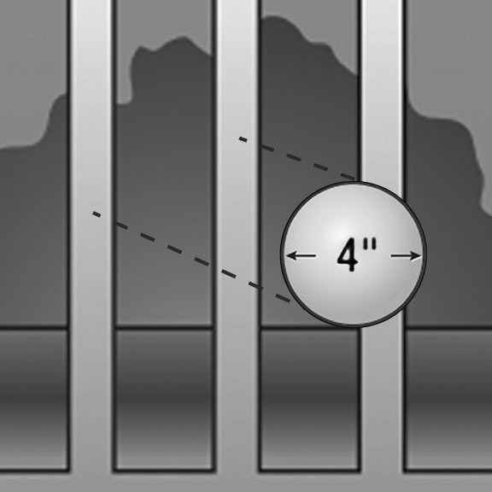
(h) Height. ENCLOSURES shall be no less than six feet (1.83 m) in height.
(i) Change in grade. Where a change in grade occurs at an ENCLOSURE, height shall be measured from the uppermost grade to the top of the ENCLOSURE.
(ii) Fencing requirements. Height shall be measured from the finished grade to the top of the ENCLOSURE on the side outside of the ENCLOSURE surrounding an AQUATIC VENUE.
(iii) Other barriers not serving as part of an enclosure. Except where otherwise noted, all other BARRIERS not serving as part of an AQUATIC FACILITY ENCLOSURE shall not be less than 42 inches (1.1 m) in height.
(i) Clearance above grade. The maximum vertical clearance at the bottom of the AQUATIC VENUE or AQUATIC FACILITY ENCLOSURE when measured on the side of the ENCLOSURE facing away from the enclosed space, shall not exceed:
(i) Two inches (5.1 cm) above grade when the ENCLOSURE rests on a nonsolid surface, including grass or gravel; or
(ii) Four inches (10.2 cm) above grade and prevents the passage of a four-inch diameter sphere when the ENCLOSURE rests on a solid surface.
Figure 408060.6 Clearance above grade
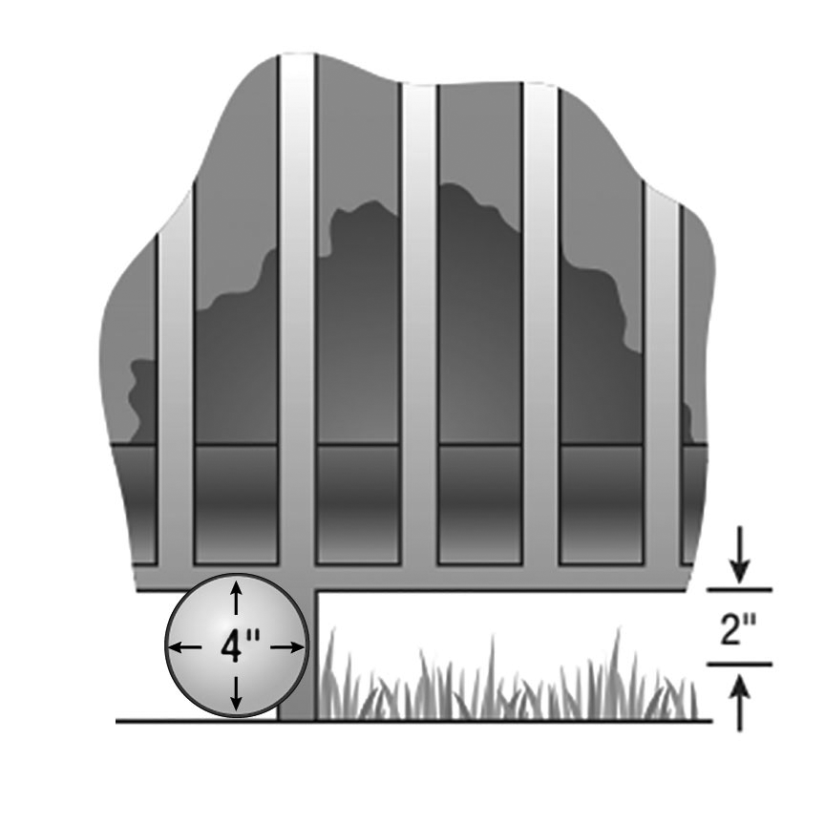
(3) Gates and doors. All gates and doors serving as part of an AQUATIC FACILITY or AQUATIC VENUE are subject to the following:
(a) Self-closing and latching. All public access gates or doors serving as part of an AQUATIC FACILITY ENCLOSURE or AQUATIC VENUE ENCLOSURE shall be self-closing and self-latching from any open position.
(b) Accessible routes. All public access gates or doors serving as part of an AQUATIC FACILITY or AQUATIC VENUE ENCLOSURE and an ACCESSIBLE ROUTE shall be the self-locking type such as where the lock is operated by means of a key, electronic opener, or the entry of a combination into an integral combination lock.
(c) Release latch height and locking requirements. Operable parts of the release latch on:
(i) Self-latching devices that self-lock, the lock operation control and the latch release shall be located not less than 34 inches and not greater than 48 inches above finished grade; and
(ii) Self-latching devices that do not self-lock shall be located a minimum of 60 inches above finished grade from the bottom of the latch release.
(d) Inoperable by children. Self-latching devices shall not be operable by small children on the outside of the ENCLOSURE around the AQUATIC VENUE. A BARRIER is required around a latch less than 60 inches high to prevent activating the latch from outside the ENCLOSURE. The BARRIER must have a minimum 18 inch radius of material around the latch and the material shall not have any openings that exceed 1/2 inch in any dimension.
Figure 408060.7 Inoperable by children
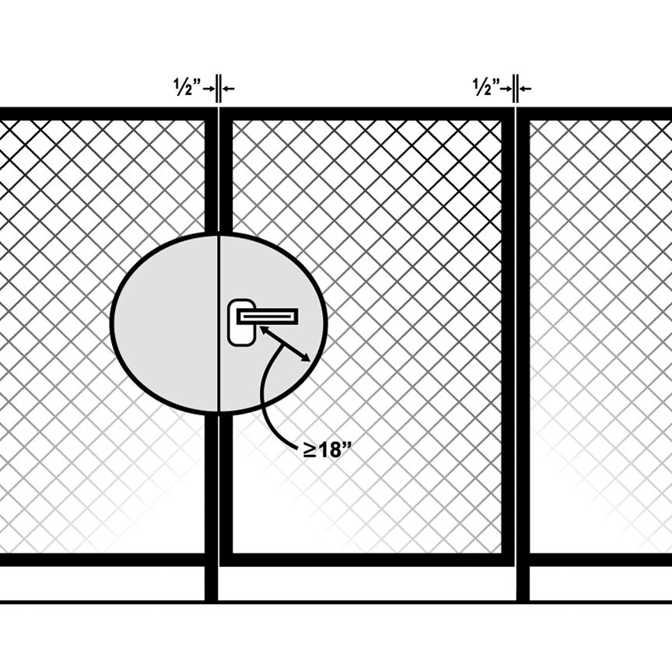
(e) Self-locking device. Self-locking devices must latch and lock automatically when the door or gate returns to a closed position.
(f) Locked. All gates or doors shall be capable of being locked from the exterior.
(g) Emergency egress. Gates or doors shall be designed in such a way that they do not prevent egress in the event of an emergency.
(h) Unauthorized entry. EXIT GATES or doors shall be constructed so as to prevent unauthorized entry from outside of the ENCLOSURE around the AQUATIC VENUE.
(i) Exceptions. The requirements of (a) through (h) of this subsection do not apply when the gate or door of an AQUATIC FACILITY or AQUATIC VENUE ENCLOSURE is part of the AQUATIC VENUE(S) and has a QUALIFIED LIFEGUARD(S) conducting PATRON surveillance at all times, the AQUATIC VENUE(S) is open and the gate or door is locked at all times, the AQUATIC FACILITY or AQUATIC VENUE is not open to the public.
(j) Gates. Gates shall be at least equal in height at top and bottom to the ENCLOSURE of which they are a component.
(k) Turnstiles. Turnstiles shall not form a part of an AQUATIC FACILITY ENCLOSURE.
(l) Exit gates. EXIT GATES shall be conspicuously marked on the inside of the AQUATIC VENUE or AQUATIC FACILITY.
(i) Quantity, location, and width. Quantity, location, and width(s) for EXIT GATES shall be provided consistent with all applicable local, state, territorial, federal, and tribal building and fire CODES and applicable accessibility guidelines.
(ii) Swing outward. EXIT GATES shall swing away from the AQUATIC VENUE ENCLOSURE.
(iii) Absence of building codes. Where local, state, territorial, federal, and tribal building CODES do not otherwise govern, at least one 36-inch (91.4 cm) wide EXIT GATE shall be required for emergency access to each logical AQUATIC VENUE area including individual POOLS or grade levels or both.
(4) Indoor aquatic venues.
(a) Enclosure. Building walls enclosing an INDOOR AQUATIC FACILITY may be designated as the AQUATIC FACILITY ENCLOSURE.
(b) Securable. Indoor AQUATIC VENUES shall be securable from unauthorized entry from other building areas or the exterior.
(c) Indoor and outdoor aquatic venues. Where separate indoor and outdoor AQUATIC VENUES are located on the same site, an AQUATIC VENUE ENCLOSURE shall be provided between them except where all AQUATIC VENUES are operated continuously 12 months a year on the same schedule.
(d) Wall separating. For a passage through a wall separating the indoor portion of an AQUATIC VENUE from an outdoor portion of the same AQUATIC VENUE, the overhead clearance of the passage to the AQUATIC VENUE floor shall be at least six feet eight inches (2.0 m) to any solid structure overhead.
(5) Multiple aquatic venues.
(a) One enclosure. Except as otherwise required in this chapter, one ENCLOSURE may surround multiple AQUATIC VENUES at one facility.
(b) Wading pools. WADING POOLS shall not require separation from other WADING POOLS by a BARRIER. Refer to WAC 246-261-4012XX for additional guidance about WADING POOLS.
[]
NEW SECTION
WAC 246-261-408070 Aquatic venue cleaning systems (2023 MAHC 4.8.7). (1) No hazard. The cleaning system provided shall not create an entanglement or suction entrapment hazard or interfere with the operation or use of the AQUATIC VENUE.
(2) Integral vacuum systems. Use of integral vacuum systems, meaning a vacuum system that uses the main circulating pump or a dedicated vacuum pump connect to the POOL with PVC piping and terminating at the POOL with a flush-mounted vacuum port fitting, shall be prohibited.
[]

