****NOTE: For floatation tanks and artificial lagoons, we are considering the standards found in the 2024 Model Aquatic Health Code - Code Language (5th edition): 7.0 Special Venues. If you are interested in helping us develop floatation tank rules, please contact us at waterrecreation@doh.wa.gov by August 15, 2025.

Chapter 246-261 WAC
Aquatic Facilities

SUBPART A. PURPOSE & DEFINITIONS
WAC 246-261-100 Purpose and scope. (1) The purpose of this chapter is to protect the health, safety, and welfare of users at aquatic facilities.
(2) This chapter does not apply to:
(a) Any aquatic facility for the exclusive use of residents and invited guests at a single family dwelling;
(b) Any aquatic facility for the exclusive use of residents and invited guests of a duplex owned by the residents;
(c) Therapeutic aquatic facilities operated exclusively for physical therapy or rehabilitation under the supervision of a licensed medical practitioner; and
(d) Steam baths and saunas.
(e) Inflatable equipment operated at a temporary event that do not pool water more than 6 inches deep and do not recirculate water.
(3) Requirements for bathing beaches are found in chapter 246-260 WAC.
WAC 246-261-105 Design and construction standards. Aquatic facilities and aquatic venues constructed or altered after the effective date of these rules must comply with the design and construction standards outlined in WAC 246-261-175 through 246-261-520.
WAC 246-261-110 Less than 15 living units. (1) The following sections of this chapter do not apply to an aquatic facility intended for the exclusive use of residents in residential communities that have less than 15 living units, including any apartment house complex, group of rental housing units, mobile home park, condominium complex, or group or association of less than 15 homeowners:
(a) WAC 246-261-125, Construction permits;
(b) WAC 246-261-130 through 246-261-170;
(c) WAC 246-261-525, Operating permits;
(d) WAC 246-261-735, Inspections; and
(e) WAC 246-260-9901, Fees.
(2) All remaining sections of this chapter do apply.
WAC 246-261-115 Definitions. The definitions in this section apply throughout this chapter unless the context clearly indicates otherwise.
(x) “Accessible route” means access and egress standards as defined by 2010 ADA Standards for Accessible Design.
(x) “Activity pool” See “Pool.”
(x) “ADA” means Americans with Disabilities Act.
(x) “Agitated water” means an aquatic venue with mechanical means to discharge, spray, or move the water's surface above or below the static water line of the aquatic venue so people are standing or playing vertically. Where there is no static water line, movement is considered above the deck plane. Recirculation through either floor or wall inlets is not considered agitated water.
(x) “Air delivery rate” means the supply cubic feet per minute of the air handler system(s) comprised of a combination of outside air and return air minus any exhaust air if exhausted within the air handler itself.
(x) “Air handling system” means equipment that brings in outdoor air into a building and removes air from a building for the purpose of introducing air with fewer contaminants and removing air with contaminants. The system contains components that move and condition the air for temperature, humidity, and pressure control, and transport and distribute the air to prevent condensation, corrosion, and stratification, provide acceptable indoor air quality, and deliver outside air to the breathing zone.
(x) “Alteration” means any modification made to an aquatic venue, aquatic facility, or aquatic feature regulated by this chapter.
(x) “ANSI” means American National Standards Institute.
(x) “ASTM” means ASTM International (formerly American Society for Testing and Materials).
(x) “ASHRAE” means the American Society of Heating, Refrigerating and Air-Conditioning Engineers.
(x) “Aquatic facility” means a physical place that contains one or more aquatic venues and support infrastructure. Steam baths and saunas are not aquatic facilities.
(x) “Aquatic feature” means an individual component within an aquatic venue.
(x) “Aquatic venue” means an artificially constructed structure or modified natural structure where the general public is exposed to water intended for recreational purposes and where the primary intended use is not watering livestock, irrigation, water storage, fishing, habitat for aquatic life or ornamental use. Such structures do not necessarily contain standing water, so water exposure may occur via contact, ingestion, or aerosolization. Types of aquatic venues include, but are not limited to:
(a) Pools;
(b) Spas;
(c) Lazy rivers;
(d) Increased risk aquatic venues; and
(e) Interactive water play aquatic venues.
(x) “Artificial lagoon” means a large format aquatic venue. The artificial lagoon is designed to mimic a natural water body and consists of one or more designated swimming areas with the remainder of the lagoon designated for water sports and non-traditional uses, including: Kayaking, Paddle-boarding, Windsurfing, Boating, and SCUBA diving training.
(x) “Automated controller” means a system of at least one chemical probe, a controller, and auxiliary or integrated component that senses the level of one or more water parameters and provides a signal to other equipment to maintain the parameters within a user-established range.
(x) “Average sound absorption coefficient” means the weighted average sound absorption coefficient for a room calculated by weighting the sound absorption coefficients of the individual surfaces in the room according to their respective areas and taking the arithmetic average as follows (especially in the 500 Hz and 1,000 Hz frequencies): And m² (or ft²); where areas of the individual sound absorptive surfaces, m² (or ft²) respective individual absorption coefficients (dimensionless). A sound absorption coefficient is of a surface, in a specified frequency band, the fraction of the randomly incident sound power which is absorbed (or otherwise not reflected) by a material metric: sabin/m².
(x) “Backflow” means a hydraulic condition caused by a difference in water pressure that causes an undesirable reversal of the flow as the result of a higher pressure in the system than in its supply.
(x) “Backpressure” means a type of backflow where the hydraulic condition, caused by a difference in water pressure, causes an undesirable reversal of the flow as a result of a higher water pressure in the system than in its supply.
(x) “Barrier” means an obstacle intended to deter direct access from one point to another.
(x) “Bather” means a person at an aquatic venue who has contact with water either through spray or partial or total immersion. The term bather as defined, also includes staff members, and refers to those users who can be exposed to contaminated water as well as potentially contaminate the water.
(x) “Bather count” means the number of bathers in an aquatic venue at any given time.
(x) “Bather load” means the theoretical peak occupancy for an aquatic venue or the maximum number of bathers allowed in an aquatic venue at one time.
(x) “Bulkhead” means a movable partition that physically separates a pool into multiple sections.
(x) “Certified, listed, and labeled” means equipment, materials, products, or services included in a list published by an ANSI—accredited certification organization where said equipment, material, product, or service is evaluated against specific criteria and whose listing either states that it meets identified standards or has been tested and found suitable for a specified purpose.
(x) “CDPH/EHLB” means California Department of Public Health Environmental Health Laboratory Branch.
(x) “CFM” means cubic feet per minute.
(x) “Chemical storage space” means an area in an aquatic facility used for the storage of pool chemicals such as acids, salt, or corrosive or oxidizing chemicals.
(x) “Chlorine” means an element that at room temperature and pressure is a heavy greenish yellow gas with a characteristic penetrating and irritating smell; it is extremely toxic. It can be compressed in liquid form and stored in heavy steel tanks. When mixed with water, chlorine gas forms hypochlorous acid (HOCl), the primary chlorine-based disinfecting agent, hypochlorite ion, and hydrochloric acid. HOCl dissociation to hypochlorite ion is highly pH dependent. Chlorine is a general term which refers to HOCl and hypochlorite ion in aqueous solution derived from chlorine gas or a variety of chlorine-based disinfecting agents. Chlorine includes:
(a) “Available chlorine” means the amount of chlorine in the +1 oxidation state, which is the reactive, oxidized form. In contrast, chloride ion (Cl–) is in the -1 oxidation state, which is the inert, reduced state. Available Chlorine is subdivided into Free Available Chlorine and Combined Available Chlorine. Pool chemicals containing Available Chlorine are both oxidizers and disinfectants. Elemental chlorine (Cl₂) is defined as containing 100% available chlorine. The concentration of Available Chlorine in water is normally reported as ppm (mg/L) “as Cl₂”, that is, the concentration is measured on a Cl₂ basis, regardless of the source of the Available Chlorine;
(b) “Combined Available Chlorine” means the concentration of available chlorine present in the form of inorganic or organic chloramines. Combined available chlorine is less reactive than free available chlorine and organic chloramines are generally less reactive oxidizers than the inorganic chloramines. Combined chlorine is determined by taking the difference between the Total Chlorine (TC) and DPD-FC concentrations. CC = TC – DPD-FC;
(c) “Free Available Chlorine” means the portion of the total available chlorine that is not “combined chlorine” or “cyanurate-bound available chlorine” and is primarily present as hypochlorous acid (HOCl) or hypochlorite ion (OCl-). Molecular chlorine (Cl₂), trichloride (Cl₃-), and chlorine monoxide (Cl₂O) are also present at very low concentrations, depending on chlorine ion concentration, and these compounds are also counted as free available chlorine. The pH of the water determines the relative amounts of HOCl and OCl-. HOCl is a very effective biocide and is the active biocide in pool water. OCl- is also a biocide but acts more slowly than HOCl. Thus, chlorine is a more effective biocide at low pH than at high pH. A free chlorine residual must be maintained for adequate disinfection; and
(d) “DPD Free Chlorine” means the free chlorine concentration from DPD-based test methods. The DPD-based test result for FC includes cyanurate-bound available chlorine as well as HOCl and OCl-, that is, DPD-FC = FAC CBC. The terms DPD-FC and FAC would be interchangeable only in the absence of cyanuric acid.
(x) “CIE” means the International Commission on Illumination.
(x) “Circulation path” means an exterior or interior way of passage from one part of an aquatic facility to another for pedestrians, including, but not limited to walkways, pathways, decks, and stairways.
(x) “Climate control system” means a combination of the pieces of equipment designed to control the temperature, humidity, introduce ventilation air and maintain building negative pressure.
(x) “Combustion device” means any appliance or equipment using fire. These include, but may not be limited to:
(a) Gas or oil furnaces;
(b) Boilers;
(c) Pool heaters; and
(d) Domestic water heaters.
(x) “Contaminant” means a substance that soils, stains, corrupts, or infects another substance by contact or association.
(x) “Contamination response plan” means a plan for handling contamination from formed-stool, diarrheal-stool, vomit, and blood.
(X) “Contrasting color” means a visual contrast provided by a difference in light reflectance values of adjacent colored surfaces of 70 points or more on a 100-point scale calculated as follows:
(A – B)/A X 100
A = CIE Y* value for the lighter color; and
B = CIE Y* value for the darker color.
(x) “Cross-connection” means a connection or arrangement, physical or otherwise, between a potable water supply system and a plumbing fixture, tank, receptor, equipment, or device, through which it may be possible for non- potable, used, unclean, polluted, and contaminated water, or other substances to enter into a part of such potable water system under any condition.
(x) “CT inactivation value” means the concentration of a particular disinfectant (C) multiplied by the contact time in minutes (T) needed for inactivation of a particular microorganism. The CT value is approximately constant; therefore, the higher the concentration of the disinfectant, the shorter the contact time required for inactivation. The CT inactivation value applies to a given level of inactivation, for example a 3-log (99.9%) reduction and can vary with pH or temperature so these values must also be supplied to allow comparison between values.
(x) “Deck” means surface areas serving the aquatic venue, including:
(a) “Dry deck” means all pedestrian surface areas within the aquatic venue enclosure not subject to frequent splashing or constant wet foot traffic. The dry deck is not perimeter deck or pool deck. Landscape areas are not included in this definition;
(b) “Perimeter deck” means the hardscape surface area immediately adjacent to the edge of the swimming pool;
(c) “Pool deck” means surface areas serving the aquatic venue, beyond perimeter deck, which is expected to be regularly trafficked and made wet by bathers. The pool deck connects the pool to adjacent amenities, entrances, and exits; and
(d) “Wet deck” means the sum of the perimeter deck and pool deck.
(x) “Department” means department of health.
(x) “Design professional” means:
(a) An architect licensed under chapter 18.08 RCW; or
(b) A registered professional engineer licensed under chapter 18.43 RCW.
(x) “Diaper-changing station” means a hygiene station that includes a diaper-changing unit, handwashing sink, soap and dispenser, a means for drying hands, trash receptacle, and disinfectant products to clean after use.
(x) “Disinfection” means a treatment that kills or irreversibly inactivates microorganisms. In water treatment, a chemical or physical process can be used.
(x) “Disinfection byproduct” means a chemical compound formed by the reaction of a disinfectant with a precursor in a water system.
(x) “Diving pool” See “Pool.”
(x) “Drop slide” See “Slide.”
(x) “Dry deck” See “Deck.”
(x) “Equipment room” means a space within a building that is enclosed or partitioned off and intended for the operation of pool pumps, filters, heaters, and controllers. This space is not intended for the storage of hazardous pool chemicals.
(x) “Enclosure” means an uninterrupted constructed feature or obstacle used to surround and secure an area that is intended to effectively prevent unpermitted, uncontrolled, and unfettered access. It is designed to resist climbing and to prevent passage through it and under it. Enclosure can apply to aquatic facilities or aquatic venues.
(x) “Exercise spa” means a type of aquatic venue used primarily for stationary swimming.
(x) “Exit gate” means an emergency exit, which is a gate or door allowing free exit at all times.
(x) “Expansion joint” means a watertight joint provided in a pool vessel used to relieve flexural stresses due to movement caused by thermal expansion/contraction.
(x) “FINA” means the Fédération Internationale de Natation Amateur.
(x) “Flat water” means an aquatic venue in which the water line is static except for movement made by users usually as a horizontal use as in swimming. Diving spargers do not void the flat water definition.
(x) “Floatation tank” means a tub that contains a saturated solution of magnesium sulfate having a specific gravity of 1.23 to 1.3, provides a light and sound reduced environment, and is maintained at a temperature of approximately 92–96°F / 33.3–35.6°C.
(x) “Flood-level rim” means the top edge of a receptor from which water overflows.
(x) “Flume” means the riding channels of a waterslide which accommodate riders using or not using mats, tubes, rafts, and other transport vehicles as they slide along a path lubricated by a water flow.
(x) “GFCI” means Ground-Fault Circuit Interrupter, a device for protection of personnel that de-energizes an electrical circuit or portion thereof in the event of excessive ground current.
(x) “Handwashing station” means a location which has a handwashing sink, adjacent soap with dispenser, hand drying device or paper towels and dispenser, and trash receptacle.
(x) “Hot water” means an aquatic venue with a water temperature over 90°F (32°C).
(x) “Hygiene facility” means a structure or part of a structure that contains toilet, shower, diaper-changing unit, handwashing station, and dressing capabilities serving bathers and patrons at an aquatic facility.
(x) “Hyperchlorination” means the intentional and specific raising of free available chlorine concentrations for a prolonged period of time to inactivate pathogens following a fecal or vomit release in an aquatic venue.
(x) “IESNA” means Illuminating Engineering Society of North America.
(x) “Imminent health hazard” means a substantial threat or danger to health that is considered to exist when there is evidence sufficient to show that a product, practice, circumstance, or event creates a situation that requires immediate correction or cessation of operation to prevent injury based on the number of potential injuries and the nature, severity, and duration of the anticipated injury or illness.
(x) “Increased risk aquatic venue” means an aquatic venue which due to its intrinsic characteristics and intended users has a greater likelihood of affecting the health of the bathers of that venue by being at increased risk for microbial contamination or being used by people that may be more susceptible to infection. Increased-risk aquatic venues include:
(a) Interactive water play aquatic venues;
(b) Wading pools; and
(c) Other aquatic venues designed for children ages less than 5 years.
(x) “Indoor aquatic facility” means a physical place that contains one or more aquatic venues and the surrounding bather and spectator/stadium seating areas within a structure that meets the definition of “Building” per the International Building Code (IBC). Indoor Aquatic Facility does not include equipment, chemical storage, or bather hygiene rooms or any other rooms with a direct opening to the aquatic facility.
(x) “Infinity edge” means a pool wall structure and adjacent perimeter deck that is designed in such a way where the top of the pool wall and adjacent deck are not visible from certain vantage points in the pool or from the opposite side of the pool. Water from the pool flows over the edge and is captured and treated for reuse through the normal pool filtration system.
(x) “Inlet” means wall or floor fittings where treated water is returned to the pool.
(x) “Innovative design feature” means a piece of equipment, device, or operative procedure not specifically covered in this chapter.
(x) “Integral vacuum system” means a vacuum system that uses the main circulating pump or a dedicated vacuum pump connected to the pool with PVC piping and terminating at the pool with a flush-mounted vacuum port fitting.
(x) “Interactive water play aquatic venue” means any indoor or outdoor installation that includes sprayed, jetted, or other water features where water contacts bathers, whether recirculated or non-recirculated (also known as “single pass”), and not incorporating standing or captured water as part of the bather activity area. Interactive water play aquatic venues include:
(a) Splash pads; and
(b) Spray pads.
(x) “Interior space” means any substantially enclosed area having a roof and having a wall or walls which might reduce the free flow of outdoor air. Ventilation openings, fans, blowers, windows, doors, etc., cannot be construed as allowing free flow of outdoor air.
(x) “Island” means a structure inside a pool where the perimeter is completely surrounded by the pool water and the top is above the surface of the pool.
(x) “Landing pool” See “Pool.”
(x) “Lazy river” means an aquatic venue with a channeled flow of water of near−constant depth in which the water is moved by pumps or other means of propulsion to provide a river−like flow that transports bathers over a defined path. A lazy river may include play features and devices.
(x) “Lifeguard supervisor” means an individual responsible for the oversight of lifeguard performance and emergency response at an aquatic facility, who has successfully completed a lifeguard supervisor training course that meets the requirements of this chapter, and who holds a valid certificate for such training.
(x) “Local health officer” has the same meaning as in RCW 70.05.110 and may include the local health officer’s designee.
(x) “LRV” means light reflectance value and is the same as the CIE Y* value.
(x) “Moisture removal capacity” means the amount of condensate produced by the climate control equipment which includes the effects of reheat coils, circulating fans and other components in the air stream; excluding supplementary heating, cooling, or outdoor air; and expressed in pounds of moisture/hour.
(x) “Moisture removal efficiency” means a ratio of the moisture removal capacity in pounds of moisture/hour to the power input values in kilowatts at any given set of Rating Conditions expressed in pounds of moisture/kilowatt hour.
(x) “Monitoring” means the regular and purposeful observation and checking of systems or facilities and recording of data, including system alerts, excursions from acceptable ranges, and other facility issues. Monitoring includes human or electronic means.
(x) “Moveable floors” means a pool floor whose depth varies through the use of controls.
(x) “NCAA” means National Collegiate Athletic Association.
(x) “NFHS” means National Federation of State High School Associations.
(x) “No diving marker” means a sign with the words “No Diving” and the universal international symbol for “No Diving” pictured as an image of a diver with a red circle with a slash through it.
(x) “Noise criterion” means the single number rating that is somewhat sensitive to the relative loudness and speech interference properties of a given noise spectrum. The method consists of a family of criterion curves extending from 63 to 8,000 Hz and a tangency rating procedure. The criterion curves define the limits of octave band spectra that must not be exceeded to meet occupant acceptance in certain spaces.
(x) “Non-recirculated” means that the water used to fill an aquatic venue or to feed aquatic features is not recirculated through a treatment system for filtration and disinfection, but rather is sourced from an approved water supply used only once in/on the aquatic venue and gets disposed of with a proper wastewater disposal method.
(x) “Oxidation reduction potential” means a measure of the tendency for a solution to either gain or lose electrons; higher oxidation reduction potential indicates a more oxidative solution.
(x) “Patron” means a bather or other person or occupant at an aquatic facility who may or may not have contact with aquatic venue water either through partial or total immersion. Patrons may not have contact with aquatic venue water but could still be exposed to potential contamination from the aquatic facility air, surfaces, or aerosols.
(x) “Perimeter deck” See “Deck.”
(x) “Perimeter gutter system” means a weir or trough around the perimeter of a swimming pool that is used to skim the surface of the water and return the water to the treatment system.
(x) “pH” means the negative log of the concentration of hydrogen ions. When water ionizes, it produces hydrogen ions (H+) and hydroxide ions (OH-). If there is an excess of hydrogen ions the water is acidic. If there is an excess of hydroxide ions the water is basic. pH ranges from 0 to 14. Pure water has a pH of 7.0. If pH is higher than 7.0, the water is said to be basic, or alkaline. If the water’s pH is lower than 7.0, the water is acidic. As pH is raised, more hypochlorous acid (HOCl) ionization occurs and chlorine disinfectants decrease in effectiveness.
(x) “Plumbing fixture” means a receptacle, fixture, or device that is connected to a water supply system or discharges to a drainage system or both and may be used for the distribution and use of water. Plumbing fixtures include:
(a) Toilets;
(b) Urinals;
(c) Showers; and
(d) Hose bibbs.
(x) “Pool” means a subset of aquatic venues designed to have standing water for total or partial bather immersion, excluding spas. Pools include:
(a) “Activity pool” means a water attraction designed primarily for play activity that uses constructed features and devices including pad walks, flotation devices, and similar attractions;
(b) “Diving pool” means a pool used exclusively for diving;
(c) “Landing pool” means an aquatic venue or designated section of an aquatic venue located at the exit of one or more waterslide flumes. The body of water is intended and designed to receive a bather emerging from the flume for the purpose of terminating the slide action and providing a means of exit to a deck or walkway area;
(d) “Skimmer pool” means a pool using a skimmer system;
(e) “Surf pool” means any pool designed to generate waves dedicated to the activity of surfing on a surfboard or analogous surfing device commonly used in the ocean and intended for sport as opposed to general play intent for wave pools;
(f) “Wading pool” means any pool used exclusively for wading and intended for use by young children where the depth does not exceed two feet (0.6 m); and
(g) “Wave pool” means any pool designed to simulate breaking or cyclic waves for purposes of general play. A wave pool is not the same as a surf pool, which generates waves dedicated to the activity of surfing on a surfboard or analogous surfing device commonly used in the ocean and intended for sport as opposed to general play intent for wave pools.
(x) “Pool deck” See “Deck.”
(x) “Pool slide” See “Slide.”
(x) “Purge” means to introduce a large volume of outdoor air to flush the interior space.
(x) “Qualified lifeguard” means a person who:
(a) Has successfully completed a department-recognized lifeguard training course offered by a department-recognized training agency, holds a current certificate for such training;
(b) Has met the pre-service requirements; and
(c) Is participating in continuing in-service training requirements of the aquatic facility.
(x) “Qualified operator” means a person responsible for the operation and maintenance of the water and air quality systems and the associated infrastructure of the aquatic facility and who has successfully completed a department-recognized operator training course to operate an aquatic facility offered by a department-recognized training agency and holds a current certificate for such training.
(x) “Recessed steps” means a way of ingress and egress for a pool, similar to a ladder but the individual treads are recessed into the pool wall.
(x) “Recirculation system” means the combination of the main drain, gutter or skimmer, inlets, piping, pumps, controls, surge tank or balance tank to provide pool water recirculation to and from the pool and the treatment systems.
(x) “Reduction equivalent dose bias” means a variable used in ultraviolet system validation to account for differences in UV sensitivity between the ultraviolet system challenge microbe and the actual microbe to be inactivated.
(x) “Re-entrainment” means a situation where the exhaust(s) from a ventilated source such as an indoor aquatic facility is located too close to the air handling system intake(s), which allows the exhausted air to be recaptured by the air handling system, so it is transported directly back into the aquatic facility.
(x) “Resident” means a person residing at a specific location with the intention to make it their permanent home for longer than 30 days.
(x) “Residential community” means a place where people live. It does not include short term rentals as defined in chapter 64.37 RCW, or other properties like hotels, motels, resorts, and vacation rentals that offer lodging to transient tenants as defined in WAC 458-20-166 where people stay for less than 30 days.
(x) “Responsible supervisor” means an individual onsite that is responsible for water treatment operations when a qualified operator is not onsite at an aquatic facility.
(x) “Reverberation” means the persistence of sound in an enclosed or partially enclosed space after the source of sound has stopped due to repeated reflections from the room surfaces; by extension, in some contexts, the sound that so persists.
(x) “Rinse shower” See “Shower.”
(x) "Rope and float line" means a continuous line not less than 1/4" (6 mm) in diameter and that is supported by buoys spaced no more than five feet apart to provide a visual and physical separation of the pool areas.
(x) “Runout” means that part of a waterslide where riders are intended to decelerate or come to a stop, or both. The runout is a continuation of the waterslide flume surface.
(x) “Safety” means a design standard intended to prevent inadvertent or hazardous operation or use.
(x) “Safety plan” means a written document that has procedures, requirements, and standards related to safety which the aquatic facility staff shall follow.
(x) “Safety team” means any employee of the aquatic facility with job responsibilities related to the aquatic facility’s emergency action plan.
(x) “Safety vacuum release system” means a vacuum release system capable of providing vacuum release at a suction outlet caused by a high vacuum occurrence due to a suction outlet flow blockage. A safety vacuum release system may be a mechanical device installed on the exposed single main suction pipe before a filtration or feature pump or an electrical device located as an attachment to the filtration or feature pump control system or is integral with the filtration or feature pump or motor itself.
(x) “Sanitize” means reducing the concentration of microbes to that considered safe by public health standards.
(x) “Saturation index” means a mathematical representation or scale representing the ability of water to deposit calcium carbonate, or dissolve metal, concrete, or grout.
(x) “Secondary treatment” means those disinfection processes or systems installed in addition to the standard systems required on all aquatic venues, which are required to be used for increased risk aquatic venues.
(x) “Shower” means a device that sprays water on the body and includes:
(a) “Cleansing shower” means a shower located within a hygiene facility using warm water and soap. The purpose of these showers is to remove contaminants including perianal fecal material, sweat, skin cells, personal care products, and dirt before bathers enter the aquatic venue; and
(b) “Rinse shower” means a shower typically located in the pool deck area with ambient temperature water. The main purpose is to remove dirt, sand, or organic material prior to entering the aquatic venue to reduce the introduction of contaminants and the formation of disinfection byproducts.
(x) “Skimmer” means a device installed in the pool wall whose purpose is to remove floating debris and surface water to the filter. A skimmer includes a weir to allow for the automatic adjustment to small changes in water level, maintaining skimming of the surface water.
(x) “Skimmer pool” See “Pool.”
(x) “Skimmer system” means periodic locations along the top of the pool wall for removal of water from the pool’s surface for treatment.
(x) “Slide” means an aquatic feature where users slide down from an elevated height into water. Slides include:
(a) “Drop slide” means a slide that drops bathers into the water from a height above the water versus delivering the bather to the water entry point;
(b) “Pool slide” means a slide similar in construction to a playground slide used to allow users to slide from an elevated height to a pool. Pool slides include:
(a) Children’s slides; and
(b) All other non- flume slides that are mounted on the pool deck or within the basin of a public swimming pool; and
(c) “Waterslide” means a slide that runs into a landing pool or runout through a fabricated channel with flowing water.
(x) “Serious injury” means an injury:
(a) Requiring emergency service response where a person requires medical treatment as determined by the emergency medical response personnel; or
(b) Resulting in a person seeking medical attention at a medical facility, hospital emergency room, or admittance to a hospital.
(x) “Slip resistant” means surfaces that have a minimum dynamic coefficient of friction at least equal to the requirements of ANSI A326 for that installation as measured by the dynamic coefficient of friction AcuTest.
(x) “Sound absorption” means:
(a) The process of dissipating sound energy; and
(b) The property possessed by materials, objects, and structures, such as rooms, for absorbing sound energy.
(x) “Spa” means a structure intended for either warm or cold water where prolonged exposure is not intended. Spa structures are intended to be used for bathing or other recreational uses and are not usually drained and refilled after each use.
(x) “Stadium seating” means an area of high-occupancy seating provided above the pool level for observation.
(x) “Superchlorination” means the addition of large quantities of chlorine-based chemicals to kill algae, destroy odors, or improve the ability to maintain a disinfectant residual.
(x) “Supplemental treatment” means those disinfection processes or systems which are not required on an aquatic venue for health and safety reasons. Supplemental treatment may be used to enhance overall system performance and improve water quality.
(x) “Surf pool” See “Pool.”
(x) “Theoretical peak occupancy” means the anticipated peak number of bathers in an aquatic venue or the anticipated peak number of occupants of the decks of an aquatic facility. This is the lower limit of peak occupancy to be used for design purposes for determining services that support occupants. Theoretical peak occupancy is used to determine the number of showers. For aquatic venues, the theoretical peak occupancy is calculated around the type of water use or space.
(x) “Total bromine” means the amount of bromine in the +1 oxidation state, which is the reactive, oxidized form. Commercially available test kits are not capable of distinguishing free bromine (Br₂, HOBr, OBr-) from combined bromine (bromamines). The bromine value specified in test results is the concentration of total bromine.
(x) "Turnover" means the period of time, usually expressed in hours, required to circulate a volume of water equal to the capacity of the aquatic venue.
(x) “UL” means Underwriters Laboratories.
(x) “Underwater bench” means a submerged seat with or without hydrotherapy jets.
(x) “Underwater ledge” means a continuous step in the pool wall that allows swimmers to rest by standing without treading water.
(x) “Wading pool” See “Pool.”
(x) “Waterslide” See “Slide.”
(x) “Water quality testing device” means a product designed to measure the level of a parameter in water. A water quality testing device includes a device or method to provide a visual indication of a parameter concentration and may include one or more reagents and accessory items.
(x) “Water replenishment system” means a way to remove water from the pool as needed and replace with make- up water to maintain water quality.
(x) “Wave pools” See “Pool.”
(x) “Wet deck” See “Deck.”
(x) “Wing wall” means a structural projection into a pool intended to provide separation within the body of water.
(x) “Zero depth entry” means a sloped entry into a pool from deck level into the interior of the pool as a means of access and egress.
WAC 246-261-120 Relationship to other regulations. (1) The owner shall obtain all applicable local building, plumbing, mechanical, or other required permits from the local authority having jurisdiction.
(2) The owner shall ensure access to the aquatic facility, aquatic venue, and all appurtenances are compliant with current ADA standards.
(3) A person designing, constructing, altering, repairing, or operating and maintaining an aquatic facility shall comply with all applicable local ordinances and codes, federal and state statutes, and rules including, but not limited to, this chapter and chapter 70.90 RCW.

SUBPART B. CONSTRUCTION PERMITS
WAC 246-261-125 Construction permits. (1) The owner shall obtain a construction permit from the department or local health officer before construction or alteration of an aquatic facility.
(2) To obtain a construction permit, the owner shall submit a complete plan to the department or local health officer for review and approval.
(3) The complete plan must:
(a) Include all necessary construction documents, including but not limited to:
(i) The name, address, and contact information for the owner, design professional, and builder, at the time of submission;
(ii) Site information, including the location of all utilities, wells, topography, natural water features, and potential sources of surface drainage and pollution;
(iii) A plot plan, as outlined in WAC 246-261-130;
(iv) Drawings for each aquatic venue, as outlined in WAC 246-261-135;
(v) Designs, as outlined in WAC 246-261-140; and
(vi) Technical specifications, as outlined in WAC 246-261-145;
(b) Contain the following statements certifying that:
(i) Proposed work will conform with approved plans; and
(ii) Deviation from the approved plans will not occur unless plans for such deviation are submitted to and approved by the department or local health officer; and
(c) Include the applicable fee.
(4) Construction documents listed in (3)(a) of this section must:
(a) Provide sufficient clarity indicating the location, nature, and extent of proposed work;
(b) Show, in detail, that the proposed work meets the requirements of this chapter; and
(c) Be prepared, stamped, and signed by a design professional, with the exception of a minor alteration that does not have the potential to affect system hydraulics, air quality, structural integrity, or patron health or safety, in which case the owner may apply to the department or local health officer for a variance from requirements for plan preparation by a design professional.
(5) For alterations to an existing aquatic facility or aquatic venue, the owner may contact the department or local health officer for consultation to review proposed changes prior to submitting a plan.
(6) For equipment replacements, the owner shall submit technical verification to the department or local health officer that the replacement equipment is equivalent to the originally approved and installed equipment.
(7) Repair and maintenance of aquatic facility components may be performed without review from the department or local health officer, provided that these actions either maintain or restore the original condition of the aquatic facility components.
(8) Only plans deemed complete by the department or local health officer may be considered for construction permit issuance or denial.
(9) The department or local health officer shall review complete plans to ensure health and safety requirements of this chapter are met and either:
(a) Provide written approval and issue a construction permit within 30 business days; or
(b) Provide a written statement describing construction plan deficiencies and deny a construction permit within business 30 days.
(10) A construction permit may be withheld, suspended, revoked, or denied by the department or local health officer for noncompliance with the requirements of this chapter. The department or local health officer shall provide the owner:
(a) Specific reasons for the action taken and procedure for resubmittal;
(b) Notice of the rights to appeal and procedures for requesting an appeal; and
(c) The application reviewer’s name, signature, the date of review, and the action taken.
(11) The department or local health officer has sole discretion to approve or deny an application for variance.
(12) Construction permits are valid for 18 months. The department or local health officer may extend the construction permit by up to 12 months if a request is submitted in writing to the department or local health officer by the owner or owner’s representative.
(13) Once a construction permit expires, the owner shall resubmit an application for a construction permit.
WAC 246-261-130 Plot plans. (1) A complete plot plan must include:
(a) A general map of the aquatic facility; and
(b) An aquatic facility site plan or floor plan.
(2) The aquatic facility site plan or floor plan must include detailed locations of all:
(a) Aquatic venues;
(b) Aquatic features;
(c) Hygiene facilities;
(d) Water supply facilities;
(e) Sources of drinking water;
(f) Public or private sewers;
(g) Walkways, including relative elevations; and
(h) Equipment room floor with elevations of storm and sanitary sewer inverts and street grade.
(3) All drawings must be drawn to scale.
WAC 246-261-135 Aquatic venue drawings and attributes. (1) Drawings for an aquatic venue must include:
(a) Dimensional drawings for each individual aquatic venue;
(b) A proposal of anticipated operating conditions and intended use for each type of aquatic venue accepted by both the design professional and the owner or operator; and
(c) Dimensional drawings for each individual aquatic venue attribute.
(2) Dimensional drawings for each aquatic venue must include:
(a) An area plan;
(b) A layout plan; and
(c) Dimensional longitudinal and transverse cross-sections.
(3) Dimensional drawings for each individual aquatic venue attribute must include the location and type for the following:
(a) Inlets;
(b) Overflows;
(c) Drains, including one or more cross-sections through the main drain;
(d) Suction outlets;
(e) Overflow gutters or devices;
(f) Piping;
(g) Pool design waterline;
(h) Aquatic venue basins, including bottom and sidewalls;
(i) Aquatic features;
(j) Lighting;
(k) Pool markings; and
(l) Surface materials.
(4) All drawings must be drawn to scale.
WAC 246-261-140 Designs. (1) Design plans must include:
(a) Area design drawings;
(b) Aquatic venue recirculation and treatment designs;
(c) Schematic layout of the equipment room showing accessibility for installation and maintenance;
(d) Schematic layout of the chemical storage space(s); and
(e) Hygiene facility design, including the location and number of available hygiene facilities provided, including dressing rooms, lockers, showers, lavatory, toilet fixtures, and diaper-changing stations.
(2) Area design drawings must include:
(a) Design of enclosure, including walls, fencing, entry and exit doors and gates, self-closing and latching hardware, and locks;
(b) Detailed view of the equipment room layout;
(c) Design of deck, including paving materials, deck slope, and deck drains;
(d) Paved walkways and other hardscape features;
(e) Locations of slip resistant flooring;
(f) Type of aquatic venue area finishes;
(g) Area lighting, including photometric plans; and
(h) Locations of:
(i) Drinking fountains or other sources of drinking water;
(ii) Entries and exits;
(iii) Hose bibs; and
(iv) Telephones.
(3) Aquatic venue recirculation and treatment designs must include a flow diagram showing the location, plan, elevation, and schematics for the following:
(a) Filters;
(b) Pumps;
(c) Chemical feeders and interlocks;
(d) Chemical controllers and interlocks;
(e) Secondary treatment;
(f) Supplemental disinfection systems;
(g) Ventilation devices and air handling systems;
(h) Heaters;
(i) Surge tanks, including operating levels;
(j) Backflow prevention assemblies and air gaps;
(k) Valves;
(l) Piping;
(m) Flow meters;
(n) Gauges;
(o) Thermometers;
(p) Test cocks;
(q) Sight glasses; and
(r) Drainage system for the disposal of aquatic venue water and filter wastewater.
(4) All drawings must be drawn to scale.
WAC 246-261-145 Technical specifications. (1) Technical specifications for the aquatic facility must include:
(a) Water temperatures for each aquatic venue;
(b) Effective surface area of each aquatic venue;
(c) Space design including the length, width, and height of each room;
(d) Designed dry bulb and dew point temperatures;
(e) Designed relative humidity;
(f) Type of water treatment;
(g) Wet deck area;
(h) Water sources;
(i) Water surface area and volume for each aquatic venue and associated water features, if applicable;
(j) Theoretical peak occupancy;
(k) Equipment characteristics and rating;
(l) Recirculation rate and turnover time for each aquatic venue;
(m) Filter media for each aquatic venue;
(n) Safety equipment specifications;
(o) Designs for risk management;
(p) Information specific to indoor aquatic facilities;
(q) Air filter media suitable for elevated humidity levels; and
(r) Any additional information requested by the department or local health officer for the purposes of the project.
(2) To calculate the theoretical peak occupancy for:
(a) Each aquatic venue or area, divide the surface area in square feet of the aquatic venue by the density factor (D) that fits the specific aquatic venue being considered using Table 145; and
(b) The aquatic facility, add the theoretical peak occupancy of each aquatic venue together with patron-related occupancies using Table 145. Theoretical peak occupancy for each aquatic venue may be adjusted if the aquatic venue’s surge capacity is less than the amount of water displaced by the calculated peak occupancy or bather load.
theoretical peak occupancy = aquatic venue surface area/D
Table 145. Density factors (D) for specific aquatic venues.
Aquatic venue- related
Deep water | 30ft² (2.79m²) per bather
Shallow water | 25ft² (1.9m²) per bather
Spa | 10ft² (0.9m²) per bather
Surf pool | Manufacturer-established capacity at any given time or 1000ft² (92.9m²) per bather for constructed surf pools
Patron- related
Deck and non-deck occupied areas | 15ft² (4.6m²) per patron
Stadium seating | 6.6ft² (0.6m²) per bather or patron

(3) Equipment characteristics and rating must include:
(a) Detailed information on the type, size, operating characteristics, and rating of all mechanical and electrical equipment;
(b) Hydraulic computations for head loss in all piping and recirculation equipment;
(c) Pump curves that demonstrate the selected recirculation pumps are adequate for the calculated required flows;
(d) Documentation that demonstrates an indoor aquatic facility, if applicable, is designed to meet:
(i) The acoustic design criteria contained in WAC 246-261-300; and
(ii) The air handling system design criteria contained in WAC 246-261-150; and
(e) Documentation to demonstrate that the selected disinfectant feeders and equipment are of sufficient size and capacity, including evaluation of the chlorine demand factors in WAC 246-261-345.
(4) Designs for risk management must include:
(a) Layout for zones of patron surveillance; and
(b) Features or design configurations that may impact patron surveillance.
(5) Information about indoor aquatic facilities must specify climate control system including, but not limited to:
(a) Sensible cooling capacity;
(b) Sensible heating capacity;
(c) Moisture removal capacity (in pounds/hour);
(d) Moisture removal efficiency;
(e) Outside air (in CFM);
(f) Exhaust air (in CFM);
(g) Supply air (in CFM):
(h) Voltage;
(i) Power requirements; and
(j) Design temperature and humidity.
(6) Construction details not shown on the plan that relate to the aquatic facility must be shown on the plans for each aquatic venue.
(7) A design criteria document, signed by the owner and design professional, showing that the ventilation and climate control systems for indoor aquatic facilities meet the:
(a) Intended use,
(b) Type of aquatic venue, and
(c) Intended typical operation, including:
(i) Water temperatures;
(ii) Space air temperature; and
(iii) Relative humidity.
WAC 246-261-150 Additional information required for indoor aquatic facilities. (1) Air handling system plan drawings and documentation must include the following:
(a) Building layout identifying the geographic location of the indoor aquatic facility;
(b) Indoor aquatic facility size, including area in square feet and height;
(c) The surface area for dry deck, perimeter deck, pool deck, pool water surface, and stadium seating sections;
(d) Theoretical peak occupancy per aquatic venue, spectator, and deck spaces;
(e) Placement of:
(i) Air handling system and other building outdoor air intakes exterior to the building;
(ii) Air handling system and other building exhaust vents exterior to the building;
(iii) Return air intakes within the indoor aquatic facility; and
(iv) Supply air locations within the indoor aquatic facility;
(f) Identify system capabilities, if provided, to automatically or manually modulate the amount of outdoor air for the purpose of reducing the number of cfm or outdoor air when occupancy in stadium seating sections is lower than theoretical peak occupancy;
(g) Identify system design to maintain negative air pressure in the indoor aquatic facility relative to the indoor areas external to it, or to the outside of the facility; and
(h) Heating, cooling, and dehumidification load calculations including:
(i) Design envelope sensible cooling loads;
(ii) Envelope heating loads;
(iii) Ventilation sensible and latent loads;
(iv) Spectator sensible and latent loads; and
(v) Pool evaporation loads.
(2) Air handling system design must address:
(a) Chemical storage spaces, mechanical rooms, toilets, showers, and dressing rooms for their effects on performance requirements including, but not limited to:
(i) Maintaining negative pressure;
(ii) Temperature differences; and
(iii) Contribution to the air volume of the indoor aquatic facility; and
(b) Obstacles such as support columns, architectural structures, and aquatic features that may affect the distribution of supply air and distribution of exhaust or return air.
WAC 246-261-155 Innovative design features. (1) An owner may submit a plan proposing an aquatic facility that incorporates innovative design features that are not specifically covered by this chapter.
(2) The owner shall present their proposal at a preliminary design conference with the department or local health officer at least 30 days prior to the development of final plans.
(3) The proposal must address the following:
(a) Health and safety issues;
(b) Maintenance and operation of the proposed innovative design; and
(c) Good engineering practice.
(4) The owner shall provide adequate documentation to meet the requirements of this chapter including, but not limited to:
(a) Protection from drowning, diving injury, entrapment, impact falling hazards, tripping or slipping hazards;
(b) Maintenance of water and air quality, including equivalent disinfection, filtration, control of pH, physical water conditions, water clarity and prevention of contamination to preclude illness; and
(c) Age appropriate designs and means to control these features for the appropriate range of users.
(5) The department or local health officer may require additional information, review, or justification before approving or denying an innovative design feature plan.
(6) A plan for an innovative design feature may not be approved unless, notwithstanding a noncompliant design, the health and safety purposes behind the requirements of this chapter would be met.
WAC 246-261-160 Plan approval. (1) The department or local health officer shall coordinate plan review with the owner, or their representative, and design professionals associated with the construction.
(2) The department or local health officer shall clearly state in the plan approval the limitations of their approval. This approval is independent of any other required approvals or permits.
(3) The department or local health officer shall provide a plan review report to the owner containing the following:
(a) Categorical items identified as unsatisfactory or insufficient;
(b) A comment section, detailing unsatisfactory or insufficient findings;
(c) Indication of the department or local health officer approval status of the plans;
(d) In the case of denial, the specific reasons for the action taken and procedure for resubmittal; and
(e) Reviewer’s name, signature, and date of review.
WAC 246-261-165 Compliance certificate. (1) The owner shall submit a certificate of construction compliance to the department or local health officer upon completion of construction or alteration.
(2) The certificate of construction compliance must:
(a) Be prepared, stamped, and signed by a design professional within their scope of practice;
(b) Include a statement that the aquatic facility or aquatic venue, all equipment, and appurtenances have been constructed or installed in accordance with approved plans; and
(c) Include any commissioning or testing reports for lighting, air handling, recirculation, filtration, or disinfection.
WAC 246-261-170 Preoperational inspections. (1) Operation of the aquatic facility or aquatic venue may not occur until:
(a) An inspection by the department or local health officer shows compliance with the requirements of this chapter and approved plans;
(b) The department or local health officer approves opening for operation; and
(c) The owner has obtained an operating permit in accordance with WAC 246-261-525.
(2) The owner shall contact the department or local health officer at least five working days in advance to schedule a preoperational inspection of the aquatic facility or aquatic venue.

SUBPART C. DESIGN AND CONSTRUCTION STANDARDS
WAC 246-261-175 Material standards – Aquatic venues. (1) Aquatic venues must be constructed of impervious and structurally sound materials that provide a smooth, easily cleaned, watertight structure capable of withstanding the anticipated stresses and loads for full and empty conditions taking into consideration climatic, hydrostatic, and seismic conditions.
(2) All materials must be inert, nontoxic, resistant to corrosion, impervious, enduring, and resistant to damage related to environmental condition of the installation region.
(3) Aquatic venues and appurtenances located in areas subject to freezing must be designed to protect against damage due to freezing.
(4) Competitive or lap pools must have lane markings and end wall targets installed in accordance with FINA, NCAA, USA Swimming, NFHS, or another standard recognized by the department or local health officer.
(5) Aquatic venues must be designed in such a way to maintain their ability to retain the designed amount of water.
(6) All vertical walls must have a durable smooth finish suitable for regular scrubbing and cleaning at the waterline and be designed so that:
(a) The finish will withstand daily cleaning in accordance with the manufacturer’s recommendations;
(b) Skimmer pools have a six-inch (152mm) to 12-inch (305mm) high waterline;
(c) Gutter and perimeter overflow systems have a minimum waterline finish of two inches (51mm); and
(d) Colors darker than those outlined in WAC 246-261-245 do not extend more than 12 inches (305mm) below the waterline.
(7) Aquatic venue floors in areas less than five feet (1.5m) deep must have a slip resistant finish in accordance with ANSI/APSP/ICC-1 2014.
(8) Stainless steel, vinyl, PVC-P, or PVC panel and liner pool finish systems must be installed on top of approved materials.
(9) Wood, sand, or earth is not permitted as an interior finish.
WAC 246-261-180 Material standards – Indoor aquatic facilities. (1) The interior finish of an indoor aquatic facility must be designed for an indoor relative humidity of not less than 80 percent.
(2) Indoor aquatic facilities’ building envelop construction must include a vapor-retarder or insulation arrangement to assist in preventing the condensation of water on inside pool room envelope building surfaces and within any wall, ceiling, glass, or floor structure under the coldest outdoor conditions based on the ASHRAE climate data for the project locale or nearest reporting city and the highest design indoor relative humidity. The ASHRAE dehumidification weather data for the facility geographical location must be used when calculating the effects of the ventilation air to the space it is being introduced. This will be added to the evaporation load of all water surfaces, and occupant (includes spectators, swimmers, and non-swimmers on the deck) latent moisture when sizing the climate control system.
(a) Where a paint or coating serves as a vapor retardant of an indoor aquatic facility, the paint or coating must be applied so as to produce a permeability rating of 0.2 U.S. perm (11.4 ng·s-1·m-2·Pa-1) or less. All paints and coatings applied inside the air barrier of a facility must meet the requirements of UL 2818-2013 through testing of products to CDPH/EHLB/Standard Method v1.1 or UL 2818-2013.
(b) The paint or coating must be applied according to the manufacture’s recommendations for use as a vapor retarder.
(c) Where a perforated interior-finish material is used in an indoor aquatic facility, as for acoustic effects, the perforated material must not be considered to be a vapor retarder unless it has a listed permeability rating less than 0.2 U.S. perm (11.4 ng·s−1·m−2·Pa−1).
(3) Indoor aquatic facility air pressure should be relative to the areas external to it (such as adjacent indoor spaces or adjacent outdoor spaces). The aquatic facility air handling system design, construction, and installation must comply with the negative pressure recommendations as outlined in the 2019 ASHRAE Applications Handbook on Indoor Pool Design and the ASHRAE Standard 62.1, Ventilation for Acceptable Indoor Air Quality. Chemical storage space air handling system must not be interconnected with the indoor aquatic facility's air handling system.
(4) Where air ducts are required, the air ducts must be resistant to corrosion from the airborne chemicals. Any system duct work located in an area not being conditioned must be insulated on the exterior of the duct with a mold-resistant material where the surface temperature of the duct is capable of being less than the airstream temperature within the duct.
(8) Filters for outdoor air intake must be moisture resistant.
(9) Indoor aquatic facility doors:
(a) Must be constructed of corrosion-resistant materials or have a covering or coating to withstand humid and corrosive environments;
(b) Which may be exposed to temperatures below the indoor aquatic facility air dew point, must have thermal breaks, insulation, or glazing as necessary to minimize the risk of uncontrolled condensation. Other doors may be acceptable, subject to approval by the department or local health officer, where heating systems are so arranged as to maintain such doors above the maximum design dew point of the indoor aquatic facility air;
(c) Must not contribute to the growth of biological contaminants;
(d) Must be equipped with seals and gaskets to minimize air leakage when the door is closed; and
(e) Used by pedestrians around the perimeter of the indoor aquatic facility must be equipped with:
(i) An automatic door closer capable of closing the door completely without human assistance against the specified difference in air pressure between the indoor aquatic facility and other interior spaces; and
(ii) A self-latching device designed to engage and keep the door closed without human assistance.
(10) Indoor aquatic facility window frames must:
(a) Be constructed of suitable materials or have a suitable covering or coating to withstand the expected conditions;
(b) Must not contribute to the growth of biological contaminants; and
(c) Have thermal breaks or be otherwise constructed to minimize the risk of uncontrolled condensation.
WAC 246-261-185 Equipment standards. (1) All equipment and materials used or proposed for use in aquatic facilities must be suitable for their intended use and be installed in accordance with this chapter, as certified, listed, and labeled to a specific standard by an ANSI-accredited certification organization where applicable, and as specified by the manufacturer.
(2) Where standards do not exist, technical documentation must be submitted to the department or local health officer to demonstrate acceptability for use in aquatic facilities.
(3) The department or local health officer may require tests as proof of acceptability.
WAC 246-261-190 Design for risk management. (1) Design of aquatic facilities and aquatic venues should address operational considerations such as the layout of zones of patron surveillance, age-appropriate design, and means to control aquatic features for the appropriate range of users.
(2) Aquatic venue shape must provide for:
(a) The safety of swimmers;
(b) The thorough and complete circulation of water;
(c) The ability to clean and maintain the aquatic venue; and
(d) The effective supervision and surveillance of bathers and patrons.
(3) A permanent tile used as a reference must be installed in the deepest part of the pool to test water clarity.
(a) For pools:
(i) Ten feet deep or less, a four-inch by four-inch (10.2cm x 10.2cm) is required; and
(ii) Ten feet deep or more, an eight-inch by eight-inch (20.3cm x 20.3cm) is required.
(b) The reference tile must be visible at all times from any point on the deck up to 30 feet (9.1m) away in a direct line of sight from the tile or main drain. For spas, this test should be performed when the water is in a non-turbulent state and bubbles have dissipated.
(c) The reference tile must contrast with the pool bottom by no more than 30 points.
(d) Where finish materials do not allow for the installation of a water clarity reference tile, an alternative means of observing water clarity must be provided.
(4) Aquatic venues structures must not exceed the tolerances listed in Table 190.
Table 190. Construction tolerances for aquatic venues not intended for competitive use.
Design Aspect | Construction Tolerance*
Depth deep area, including diving area | +3 inches (7.62 cm)
Depth shallow area | +2 inches (5.08 cm)
Length – overall | +3 inches (7.62 cm)
Stair treads | + ½ inches (1.27 cm)
Stair risers | + ½ inches (1.27 cm)
Wall slopes | +/- 3 degrees
Skimmers | +/- ¼ inches (0.63 cm)
Gutters | +/- ¹/₁₆ inches (0.15 cm)
Width – overall | +3 inches (7.62 cm)
All dimensions not specified therein | +2 inches (5.08 cm)
*Aquatic venues intended for competitive use must not exceed construction tolerances in accordance with the recognized standard for the intended competition.
WAC 246-261-200 Bottom slope. (1) In water depths:
(a) Under five feet (1.5 m), the slope of the floor of all pools must not exceed one foot (30.5 cm) vertical drop for every 12 feet (3.7 m) horizontal; and
(b) Five feet (1.5 m) and greater, the slope of the floors of all pools shall not exceed one foot (30.5 cm) vertical to three feet (0.9 m) horizontal. However, pools designed and used for competitive diving should be designed to meet the standards of sanctioning organizations such as NFHS, NCAA, USA Diving, or FINA.
(2) Pool bottoms must slope downward to the main drain location(s). Main drains must be located at aquatic venue low points.
WAC 246-261-205 Pool access. (1) Each pool must have a minimum of two means of access, with one located within 10 feet (3.0 m) of the shallowest end, and one located within 10 feet of the deepest end of the pool, where applicable, except for:
(a) Waterslide landing pools,
(b) Waterslide runouts, and
(c) Wave pools.
(2) Acceptable means of access includes stairs, handrails, grab rails, recessed steps, ladders, ramps, and zero-depth entries.
(3) For pools:
(a) Wider than 30 feet (9.1 m), access must be provided on each side of the pool, not more than 75 feet (22.9 m) apart; and
(b) Deeper than four feet, access must be provided at a minimum of one for every 75 feet of pool perimeter deeper than four feet.
WAC 246-261-210 Stairs. (1) Where provided, stairs must be constructed with slip-resistant materials.
(2) The leading horizontal and vertical edges of stair treads must be outlined with a continuous, slip-resistant marking of not less than one inch (25.4 mm) and not greater than two inches (50.8 mm). Outlined edges must be of contrasting color.
(3) Stairs must be recessed in:
(a) Pool areas designed for lap swimming;
(b) Pools that provide wave action; and
(c) Water depths greater than five feet (1.5 m) as to not protrude into the swimming area of the pool. The lowest tread cannot be less than four feet (1.2 m) below normal water level.
(4) Stairs must have a minimum:
(a) Uniform horizontal tread depth of 12 inches (30.5 cm), and
(b) Unobstructed tread width of 24 inches (61.0 cm); or
(c) Surface area of 288 square inches (731.5 cm) and, if non-rectangular, may exceed the required dimension T-1 in Table 4540 for the top stair tread only.
(5) Dimensions of stair treads for other types of stairs must conform to requirements of:
(a) Table 210,
(b) Figure 210.1, and
(c) Figure 210.2.
Table 210. Required dimensions for stair tread and risers.
Dimensions | T-1 Standard | T-2 | W-1 | H-1
Minimum | 12 inches  (30.5 cm) | T-1 | 24 inches  (61.0 cm) | 6 inches  (15.2 cm)
Maximum | 18 inches  (45.7 cm) | T-1 | N/A | 12 inches  (30.5 cm)
Figure 210.1 Stair treads and risers – Side view.
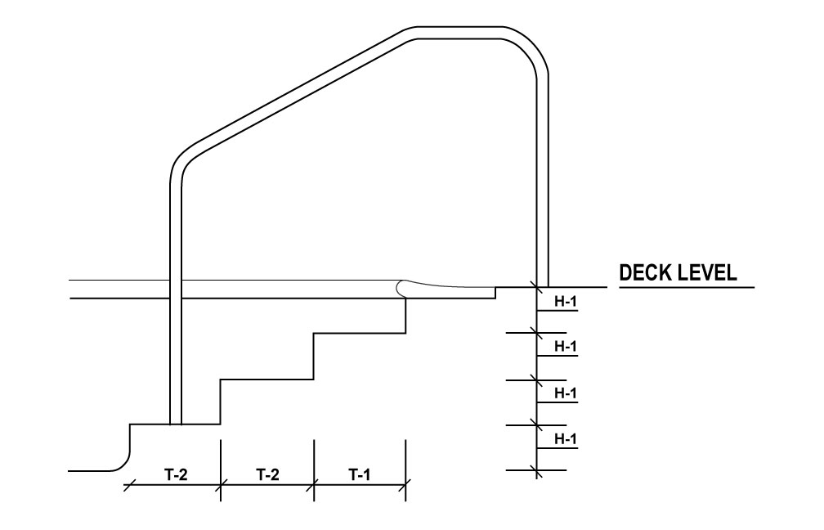
Figure 210.2 Stair treads – Front view.
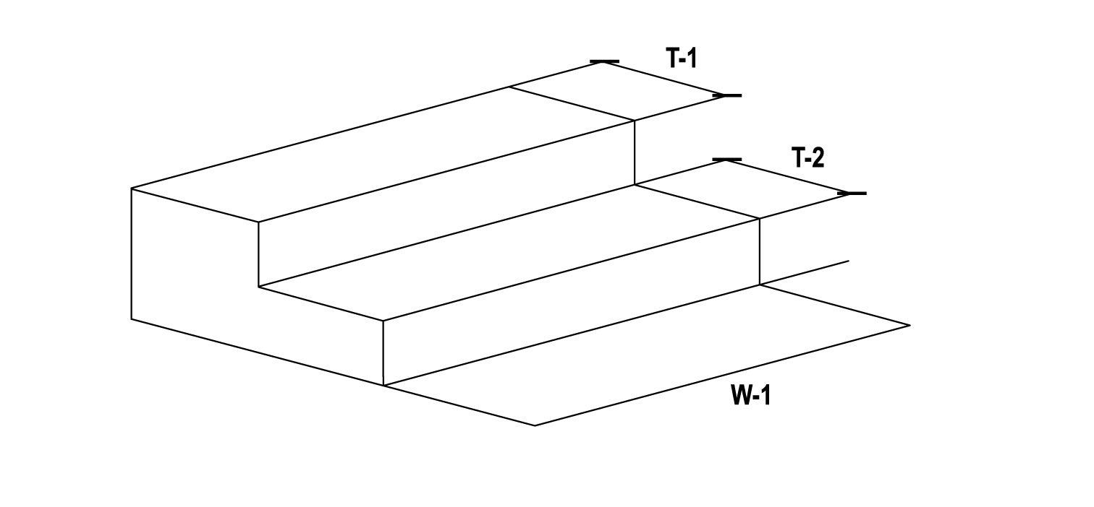
(6) Stair risers must have a minimum uniform height of six inches (15.2 cm) and a maximum height of 12 inches (30.5 cm). Riser construction may vary no more than ½ inch from uniform riser height.
(7) Stairs must not be used underwater to transition between two sections of pool of different depths. The bottom riser may vary due to potential cross slopes with the pool floor; however, the bottom step riser may not exceed the maximum allowable height required by this section.
WAC 246-261-215 Handrails. Handrails must be:
(1) Provided for each set of stairs;
(2) Constructed of corrosion-resistant materials;
(3) Provided on either side of stairs wider than five feet (1.5 m) and spaced not more than every 12 feet (3.7 m) apart across the entire stair width;
(4) Designed to:
(a) Resist a load of 50 pounds (22.7 kg) per linear foot applied in any direction and independently a single concentrated load of 200 pounds (90.7 kg) applied in any direction at any location; and
(b) Transfer these loads through the supports to the pool or deck structure; and
(5) Anchored securely. If handrails are anchored in the pool, they must anchor on a stair tread; and
(6) In conformance with the dimensions in:
(a) Table 215; and
(b) Figure 215.1.
Table 215 Stair handrail dimensions.
Dimensions | T-1 | H-1
Minimum | 3 inches  (7.6 cm) | 34 inches  (86.4 cm)
Maximum | N/A | 38 inches  (96.5 cm)

Figure 215.1 Stair handrails – Side view.
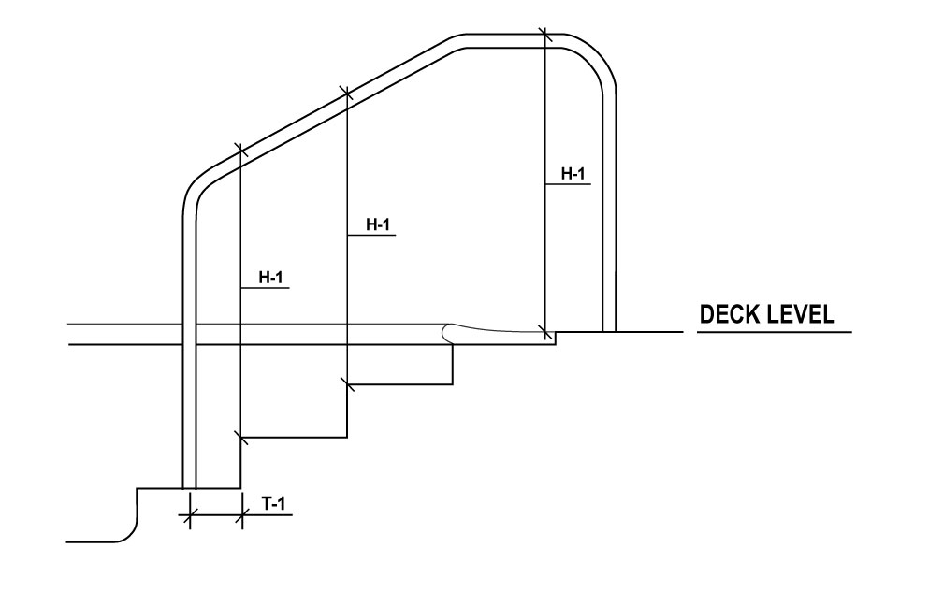
WAC 246-261-220 Grab rails. (1) Grab rails must be:
(a) Constructed of corrosion-resistant materials;
(b) Securely anchored;
(c) Provided at both sides of recessed steps; and
(d) Designed to:
(i) Resist a load of 50 pounds (22.7 kg) per linear foot applied in any direction and independently a single concentrated load of 200 pounds (90.7 kg) applied in any direction at any location; and
(ii) Transfer these loads through the supports to the pool or deck structure.
(2) The horizontal clear space between grab rails must not be less than 18 inches (45.7 cm) and not more than 24 inches (61.0 cm).
(3) The upper railing surface of grab rails must extend above the pool coping or deck a minimum of 28 inches (71.1 cm).
WAC 246-261-225 Recessed steps. Recessed steps must:
(1) Be slip-resistant;
(2) Be designed to be easily cleaned;
(3) Drain into the pool;
(4) Be uniformly spaced not less than six inches (15.2 cm) and not more than 12 inches (30.5 cm) vertically along the pool wall; and
(5) Conform to the dimensions in:
(a) Table 225;
(b) Figure 225.1; and
(c) Figure 225.2.
Table 225. Recessed step dimensions.
Dimensions | H-1 | H-2 | W-1 | D-1 | D-2
Minimum | 6 inches  (15.2 cm) | 5 inches  (12.7 cm) | 12 inches  (30.5 cm) | 5 inches  (12.7 cm) | N/A
Maximum | 12 inches  (30.5 cm) | N/A | N/A | N/A | 2.5 inches  (6.5 cm)

Figure 225.1 Recessed step dimensions – Side view.
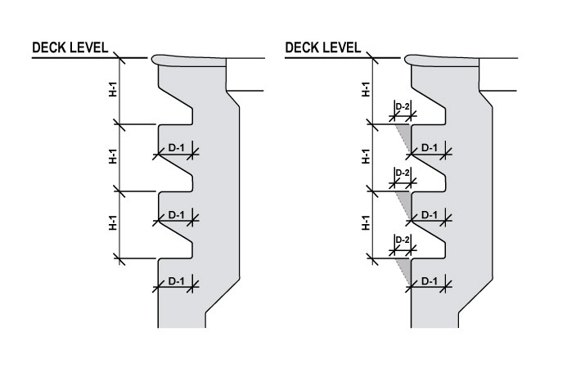
Figure 225.2 Recessed step dimensions – Front view.
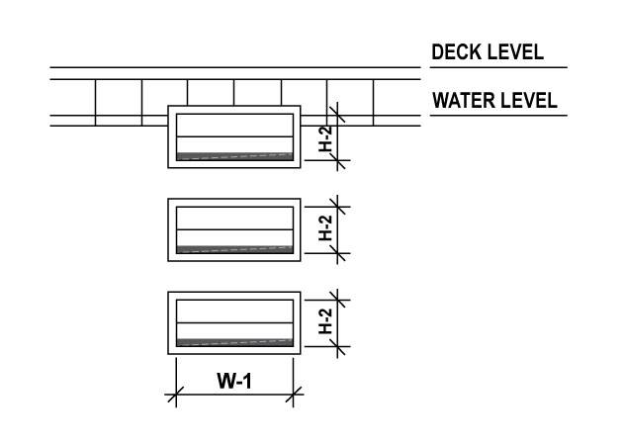
WAC 246-261-230 Ladders. Ladders must:
(1) Be constructed of corrosion-resistant materials;
(2) Be anchored securely to the deck;
(3) Not protrude into lap lanes in pools designed for lap swimming;
(4) Have two handrails with the:
(a) Horizontal clear space between the handrails measuring at least 17 inches (43.2 cm) but not more than 24 inches (61.0 cm);
(b) Upper railing surface extending above the pool coping or deck a minimum of 28 inches (71.7 cm); and
(c) Clear space between the handrails and the pool wall measuring not less than three inches (7.6 cm) and not more than four inches (10.2 cm) between the pool wall and the ladder.
(5) Be designed to:
(a) Resist a load of 50 pounds (22.7 kg) per linear foot applied in any direction;
(b) Independently resist a single concentrated load of 200 pounds (90.7 kg) applied in any direction at any location; and
(c) Transfer loads through the supports to the pool or deck structure; and
(6) Have slip-resistant tread:
(a) With a minimum horizontal tread depth of 1.5 inches (3.8 cm);
(b) A distance between the horizontal tread depth and the pool wall not greater than four inches (10.2cm);
(c) Uniformly spaced not less than seven inches (17.8 cm) and not more than 12 inches (30.5 cm) vertically at the handrails; and
(d) With the top surface of the upmost ladder tread located not more than 12 inches (30.5 cm) below the pool coping, gutter, or deck.
WAC 246-261-235 Zero depth (sloped) entries. (1) Where zero-depth entries are provided, the zero depth entries must:
(a) Be constructed with slip-resistant materials;
(b) Have a maximum floor slope of 1:12; and
(c) Have gutter drains at the waterline to facilitate surface skimming. The gutter may be flat or follow the slope of the zero depth entry.
(2) Handholds must not create a trip hazard along the zero depth entry.
(3) Except for wave pools, surf pools, and waterslide landing pools, where the bottom of the pool slopes from a zero depth entry to water depths greater than three feet (0.9 m) and includes an area for young non-swimmers to wade an play, a rope and float line must be installed at the three foot (0.9m) depth to provide a visual and physical separation.
WAC 246-261-240 Pool lifts. Pool lifts must be certified, listed, and labeled in accordance with UL 60335-2-1000, and be installed and used in accordance with the manufacturer’s installation instructions and ICC/ANSI A117.1.
WAC 246-261-245 Color and finish. (1) Below the waterline, floors and walls must be white or light pastel in color.
(2) The finish of the pool surface must meet one of the following:
(a) Pool surface materials with manufacturer supplied wet color values:
(i) A wet LRV of 64 percent or more;
(ii) A wet Munsell Color Value of 8.36 or more; or
(iii) A wet CIE L* value of 84 percent or more;
(b) Pool surface materials without manufacturer supplied wet color values:
(i) A dry LRV of 70 percent or more;
(ii) A dry Munsell Color Value of 8.67 or more; or
(iii) A dry CIE L* value of 87 percent or more;
(c) If the manufacturer does not provide any of the values in subsection (2) of this section, such products must:
(i) Not be used; or
(ii) Be tested in a laboratory to produce numerical values that meet subsection (2) of this section. Testing must be done in accordance with ASTM E1477 or in a manner approved by the department or local health officer; or
(d) If a manufacturer provides color values in multiple scales, at least one value must meet the criteria in subsection (2) of this section.
(3) The following components are exempt from the requirements listed in subsection (2) of this section:
(a) Competitive lane markings;
(b) Dedicated competitive diving well floors;
(c) Step, bench, ledge, or shelf edge markings;
(d) Pools shallower than 24 inches (61.0 cm);
(e) Water line tiles;
(f) Wave pool and surf pool depth change indicator tiles;
(g) Graphics used inside the pool during an event and are removed at the conclusion of the event; and
(h) Spas with less than 100 square foot surface area.
WAC 246-261-250 Walls. (1) Pool walls must be plumb within a +/- 3 degree tolerance unless the wall design requires structural support ledges and slopes below to support the upper wall. The pool wall does not include the floor-wall transition area or the coving of the wall to the floor.
(2) Contrasting color must be provided on the edges of any support ledge.
(3) All corners created by adjoining walls must be rounded or have a radius in both the vertical and horizontal dimensions to eliminate sharp corners.
(4) No protrusions, extension, means of entanglement, or other obstructions that may cause entrapment, injury, or interference with proper pool operations may exist.
(5) Pool sidewalls must not curve or intrude into the pool beyond the vertical more than 12 inches at 3.5 feet and 18 inches at a depth of five feet. The radius of the curvature of wall-floor junctions may not exceed the maximum radius as determined by the formula:
Maximum Radius of Curvature (in inches) = (1/3)DEPTH (in inches) – 2.
(6) Radius of coving must not intrude into pool within diving envelope.
WAC 246-261-255 Handholds. (1) Every pool must have handholds around the perimeter where the water depth at the wall exceeds 24 inches (61.0 cm). Handholds must be installed not greater than nine inches (22.9 cm) above, or three inches (7.6 cm) below static water level.
(2) Horizontal recesses may be used for handholds provided:
(a) They are a minimum of 24 inches (61.0 cm) long, a minimum of four inches (10.2 cm) high, and between two inches (5.1 cm) and three inches (7.6 cm) deep;
(b) Drain into the pool; and
(c) Need not be continuous, but consecutive recesses should be separated by no more than 12 inches (30.5 cm) of wall.
(3) Where perimeter gutter systems are not provided, a coping or cantilevered decking of reinforced concrete or material equivalent in strength and durability, with rounded, slip-resistant edges must be provided:
(a) The horizontal overhang must not be less than one inch (2.5 cm) or greater than two inches (5.1 cm) from the vertical plane of the pool wall; and
(b) The vertical thickness must not exceed 2.5 inches (6.4 cm) for the horizontal overhang.
WAC 246-261-260 Infinity edges. (1) Infinity edges must:
(a) Not make up more than 50 percent of the pool perimeter;
(b) Be no more than 30 feet (9.1 m) long; and
(c) Provide handholds meeting the requirements in WAC 246-261-255.
(2) Troughs, basins, or capture drains must:
(a) Be designed to receive the overflow from the infinity edge;
(b) Be watertight and free from structural cracks;
(c) Be constructed of reinforced concrete or other impervious and structurally rigid material designed to withstand the loads imposed by pool water, bathers, and adjacent soils or structures; and
(d) Have a non-toxic, smooth, cleanable, and slip-resistant finish.
(3) The maximum height of the wall outside of the infinity edge must not exceed 30 inches (76.2 cm) to the adjacent grade and capture drain.
WAC 246-261-265 Underwater benches. (1) Underwater benches must:
(a) Be constructed with slip-resistant materials;
(b) Have the leading horizontal and vertical edges outlined in contrasting color of not less than one inch (2.5 cm) and not greater than two inches (5.1 cm);
(c) Not be installed in areas that exceed a pool water depth of five feet (1.5 m);
(d) Be recessed into the pool wall and not protrude into the pool;
(e) Not be submerged more than 20 inches (50.8 cm) measured from the water line;
(f) Not exceed 20 percent of the length of the pool wall it is located on;
(g) Be labeled with “NO DIVING” markers on the deck above the bench; and
(h) Not be located in any areas designed for lap swimming.
(2) Underwater benches may have hydrotherapy jets in spas only.
WAC 246-261-270 Underwater ledges. Underwater ledges:
(1) Must be constructed with slip-resistant materials;
(2) For resting must:
(a) Only be provided within areas of the pool with water depths of five feet (1.5 m) or greater;
(b) Start no earlier than four lineal feet (1.2 m) to the deep side of the five-foot (1.5 m) slope break; and
(c) Be at least four feet (1.2 m) below static water level;
(3) For structural support must:
(a) Fall within a plane sloped at a maximum of 1:5 or 11 degrees from the water line down to a water depth of five feet (1.5 m). See Figure 270.1; and
(b) Be installed at a water depth of three feet (0.9 m) or deeper;
(4) Must be outlined with a continuous, slip-resistant, contrasting color marking of not less than one inch (2.5 cm) and not greater than two inches (5.1 cm). If underwater ledges project past the plane of the pool wall, the edges must be clearly visible from the deck; and
(5) Must have a maximum uniform horizontal tread depth of four inches (10.2 cm). See Figure 270.1.
Figure 270.1 Structural support ledges.
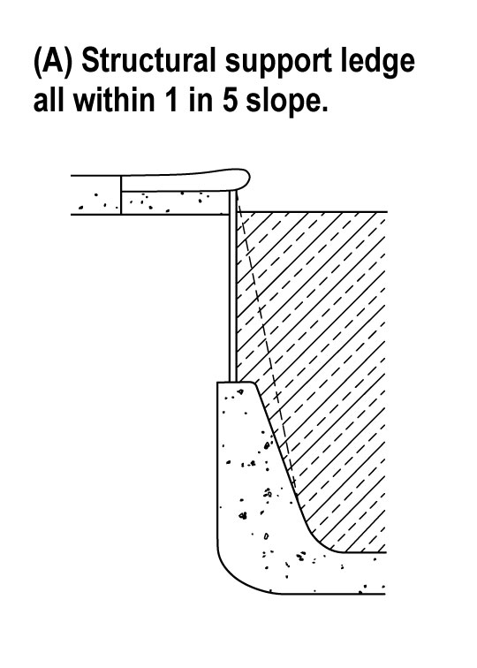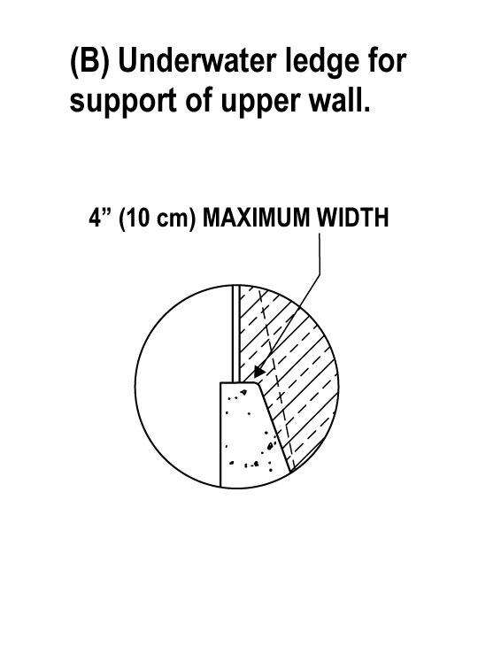
WAC 246-261-280 Underwater shelves. (1) Underwater shelves are intended to be used for lounging in very shallow water and not as wading areas for small children. Pools with underwater shelves must include the management of the shelf in their operation plans to ensure that any children who may incidentally use the shelf are effectively supervised.
(2) Underwater shelves must:
(a) Not be immediately adjacent to water deeper than 24 inches;
(b) Must be outlined with a continuous, slip-resistant, contrasting color marking of not less than one inch (2.5 cm) and not greater than two inches (5.1 cm). on both the top of horizontal edges and leading vertical edges and should be clearly visible from the deck or from underwater;
(c) Have a maximum depth of 12 inches (61.0 cm); and
(d) Conform to ADA standards as approved by the Department of Justice.
WAC 246-261-285 Ballet rails. Ballet rails may be used in pools limited to exercise and training and must:
(1) Be constructed of corrosion-resistant materials;
(2) Be securely anchored;
(3) Be designed to:
(a) Resist a load of 50 pounds (22.7 kg) per linear foot applied in any direction;
(b) Resist a single concentrated load of 200 pounds (90.7 kg) applied in any direction at any location;
(c) Transfer loads through the supports of the pool or deck structure; and
(d) Not cause entrapment, pinching, or collision hazards.
WAC 246-261-290 Deck markings. (1) Pool water depths must be clearly and permanently marked at the following locations:
(a) Minimum depth;
(b) Maximum depth;
(c) On both sides and at each end of the pool;
(d) At all major deviations in shape; and
(e) At the break in floor slope between the shallow and deep portions of the pool.
(2) Depth markers must be:
(a) Located on the:
(i) Pool wall, above the water line, and positioned to be read from within the pool. Where depth markings cannot be placed on the vertical wall, other means must be used so that the markings are plainly visible to persons in the pool;
(ii) Pool coping or deck within 18 inches (45.7 cm) of the pool structural wall or perimeter gutter and positioned to be read while standing on the deck facing the pool; and
(b) Installed at intervals of not more than 25 feet (7.6 m) around the pool perimeter edge, however for water less than five feet (1.5 m) in depth, the depth must be marked at one foot (30.5 cm) depth intervals;
(c) Constructed of durable material resistant to local weather conditions;
(d) Slip-resistant when located on horizontal surfaces;
(e) Marked in units of feet and inches. Letters and numbers must be a:
(i) Minimum height of four inches (10.2 cm); and
(ii) Contrasting color with the background; and
(f) Located to indicate water depth to the nearest three inches (7.6 cm) as measured from the pool floor three feet (0.9 m) out from the pool wall to the gutter lip, mid-point of surface skimmers, or surge weirs.
(3) For pool water depths of five feet (1.5 m) or shallower, “NO DIVING” markers, meeting the requirements in subsections (2)(b) through (e) of this section must be provided. Wading pools with water depth of six inches (15.2 cm) or less are not required to have depth markers or “NO DIVING” markers.
(4) For pools deeper than five feet (1.5 m):
(a) A line of contrasting color, not less than two inches (5.1 cm) and not more than six inches (15.2 cm) in width, must be clearly and permanently installed on the pool floor at the shallow side of the break in the floor slope, and extend up the pool walls to the waterline; and
(b) A rope and float line must be installed, extending across the pool surface, one foot (30.5 cm) to the shallower side of the break in floor slope and extend across the pool surface. The rope and float line must have an attachment receptacle either recessed into the wall or constructed so as not to constitute a safety hazard when the rope and float line is removed. Wave pools, surf pools, and waterslide landing pools do not require rope and float lines at the break in slope.
(5) Symmetrical aquatic venue designs with the deep point at the center may be allowed by providing a dual depth marking system which indicates the depth at the wall as measured in WAC 246-261-290(2)(f) and at the deep point.
(6) When access to an aquatic venue is controlled by a lifeguard, feature operator, attendant, or supervisor, depth markers must be provided on a sign at points of entry.
(7) Depth markers must be posted at aquatic venues with moveable floors indicating:
(a) That the aquatic venue has a varied depth; and
(b) The current water depth from the water level to the floor, taken three feet (0.9 m) from the wall.
(8) A minimum of two depth markers, conspicuously visible from all points of entry, must be provided at spas.
WAC 246-261-295 Lighting design. (1) The minimum maintained light levels required in Table 295 must be met when open for use.
Table 295 Minimum lighting levels*.
Location | Minimum Lighting Level
Indoor water surface | 30 horizontal foot candles (323 lux)
Outdoor water surface (with underwater lighting) | 10 horizontal foot candles (108 lux)
Outdoor water surface (without underwater lighting) | 15 horizontal foot candles (161 lux)
Pool deck | 10 horizontal foot candles (108 lux)
Hygiene facilities, equipment rooms, chemical storage areas | 30 horizontal foot candles (323 lux)
*Where overhead lighting is adjustable to accommodate higher lighting levels for different activities, the minimum lighting level setting must ensure the minimum lighting levels are maintained as required at the pool water surface and deck whenever the lighting is on.
(2) Natural lighting methods may be used to meet light levels provided one of the following is in place to ensure lights turn on when natural lighting no longer meets the requirements in Table 295:
(a) Automatic lighting controls based on light levels or time of day; or
(b) Written operations procedures where manual controls are used.
(3) Artificial lighting must be provided at all aquatic venues used at night or which do not have adequate natural lighting.
(4) Artificial lighting must render colors as closely to natural daylight as possible, in the color temperature range of 3,500 Kelvins to 6,500 Kelvins, and with a Color Rendering Index (CRI) of 80 or greater according to CIE 13.3-1995: Method of measuring and specifying color rendering properties of light sources. The department or local health officer may accept a light source tested and proven to provide color rending properties equivalent to the CRI system.
(5) Artificial lighting, windows, and features providing natural light must be designed to reduce glare on the pool water surface.
(6) Lighting must illuminate all parts of the:
(a) Aquatic venue floor;
(b) Deck area and walkways;
(c) Safety equipment, signs, and depth markers;
(d) Restrooms; and
(e) Entrances and exits.
(7) Underwater lighting, where provided, must:
(a) Not be less than eight initial rated lumens per square foot of pool water surface;
(b) Be located, in conjunction with other lighting sources, to provide illumination to all portions of the aquatic venue, including the bottom and drain(s). Higher level underwater lights may be necessary in deeper water to achieve this; and
(c) Not be dimmable.
(8) Lighting, meeting the requirements in Table 295, must be provided at outdoor aquatic venues open for use 30 minutes before sunset to 30 minutes after sunrise, or during periods when natural illumination is below the levels required in Table 295.
(9) Lighting controls must be inaccessible to patrons or bathers.
(10) Lighting fixtures above deck areas and walkways must be installed with a shatterproof, protective shielding.
WAC 246-261-300 Indoor aquatic facility acoustics. (1) Indoor aquatic facilities must be designed, constructed, and installed:
(a) With an average sound absorption coefficient of 0.20 or greater, except for those primarily used by children, elderly persons, or persons with hearing difficulties must have an average sound absorption coefficient of 0.25 or greater; and
(b) So that noise generated by the air handling system does not exceed a noise criterion of 45 (NC-50) or 55 dBA at any time while the facility is open for use.
(2) Acoustical materials used for sound absorption that are part of the interior finish must meet WAC 246-261-180.
(3) Indoor aquatic facilities with a concave shape must be designed by a design professional to address sound focusing, reverberation, and echoes that may interfere with speech intelligibility.
WAC 246-261-305 Indoor aquatic facility ventilation design. (1) Indoor aquatic facility air handling systems must be designed, constructed, and installed in accordance with ASHRAE standard 62.1 2019, Ventilation for Acceptable Indoor Air Quality. The ASHRAE dehumidification weather data for the facility geographical location shall be used when calculating the effects of the ventilation air to the space it is being introduced. This shall be added to the evaporation load of all water surfaces when sizing the climate control system. Air handling systems must:
(a) Maintain homogeneous air quality, space temperature, relative humidity, and negative space pressure;
(b) Deliver outside air to the breathing zone of bathers and patrons;
(c) Provide low velocity air flow across the water surface(s) to prevent buildup of disinfection byproducts;
(d) Assist in removing disinfection byproducts from the space; and
(e) Provide a comfortable environment for occupants in all zones of the aquatic facility, with an emphasis on bathers.
(2) Mechanical systems or engineered openings for natural ventilation are required to provide temperature and humidity control.
(3) Mechanical fans used to push air within a space may be used in the calculation for air delivery rate but must not be considered as part of the outdoor air calculations for the indoor aquatic facility.
(4) Air handling system design may include natural ventilation calculated in accordance with ASHRAE Handbooks to substitute the corresponding portion of mechanical ventilation only if all the calculated exterior openings will be continuously controlled open during all times the indoor aquatic facility is in use.
(5) Air handling systems must be designed to:
(a) Supply no less than the minimum outdoor air requirements using ASHRAE Standard 62.1 2019, Ventilation for Acceptable Indoor Air Quality. The minimum outdoor air requirements may be higher than the amount calculated as determined by a design professional;
(b) Provide system alarm to notify the operator if the outdoor air flow rate entering the indoor aquatic facility is below 0.48cfm/ft² (1.8m³/h) or the minimum amount as designated by the design professional for each applicable mode of operation;
(c) Use the ASHRAE 62.1 2019 Area Outdoor Air Rate of 0.06 cfm/ft² (0.10m³/h) and the People Outdoor Air Rate of 7.5cfm/person based on the theoretical peak occupancy for stadium seating and 0.48cfm/ft² (1.8m³/h) for all other areas. If a method to determine real-time actual occupancy is available for stadium seating areas, then the system may modulate to reduce outdoor air cfm to meet the requirement for the actual occupancy in those areas for the associated time frame. Supply an air delivery rate consistent with ASHRAE Handbook – HVAC Applications 2019, Indoor Pool Design. The air delivery rate must be sufficient to meet the latent and sensible cooling loads and the heating loads of the space and meet the requirements of this section;
(d) Provide constant air flow through all parts of the indoor aquatic facility;
(e) Maintain relative humidity in the space consistent with ASHRAE Handbook – HVAC Applications 2019, Chapter 6;
(f) Maintain the dew point as defined by the design profession in technical specifications, WAC 246-261-145;
(g) Inhibit condensation and mold, maintain homogeneous space conditions, and flush the outside walls and windows;
(h) Maintain negative air pressure in the indoor aquatic facility relative to the areas external to it;
(i) With sufficient return/exhaust air intakes placed near aquatic venue surfaces such that they draw air across the water surfaces and pull in the highest concentration of airborne DBPs;
(j) Provide low velocity air flow across aquatic venue water surfaces to remove the highest concentration of disinfection by-product. Air velocities must not exceed 30 fpm (0.15 mps) unless adjustments are made to the evaporation rate in accordance with the empirical Equation 1 Evaporation Formula as listed in the ASHRAE 2019 Applications Handbook;
(k) Ensure that outdoor air intakes are located to avoid re-entrainment of exhaust air and contaminants from building systems including air handling system exhaust back into the facility;
(l) Limit physical or electronic access to HVAC system controls to the qualified operator;
(m) Meet a purge capacity equal to or greater than two times the ASHRAE Standard 62.1 2019 level. The air handling system must be able to:
(i) Purge through manual activation; and
(ii) Heat or condition outdoor air delivered during the purge to a temperature and humidity established by the HVAC design professional; and
(n) Include filters for outdoor air and recirculated air with a MERV rating of at least eight.
(9) When a source capture exhaust system is provided, it must be designed to move the air at the water surface towards exhaust intakes and exhaust air must not mix with any return airflow in the air handling system.
(10) The contractor installing the indoor aquatic facility air handling system shall provide the aquatic facility owner with an operations and maintenance manual.
(11) A qualified, licensed professional shall commission the air handling system to verify that the installed system is operating properly in accordance with the system design. The following must be verified and documented in a written statement of commissioning:
(a) The cfm outdoor air flowing into the indoor aquatic facility during all modes of operation;
(b) The exhaust air cfm flowing through the system during all modes of operation;
(c) The supply air cfm flowing into the space and resulting in air changes per hour during all modes of operation; and
(d) Air velocity measurements at six different locations around the pool deck area at 12 inches above the deck surface.
WAC 246-261-310 Electrical systems and components. (1) Electrical conduits must not enter or pass through an interior chemical storage space, except as required to service devices integral to the function of the room. Where required, the electrical conduit in an interior chemical storage space must be sealed and made of materials that will not interact with any chemicals in the chemical storage space.
(2) Lamps, including fluorescent tubes, installed in interior chemical storage spaces must be protected against breakage with a lens or other cover or be otherwise protected against the accidental release of hot materials.
(3) Electrical devices or equipment must not occupy an interior chemical storage space, except devices or equipment integral to the function of the room, such as pumps, vessels, controls, lighting, and safety devices.
WAC 246-261-315 Pool water heating. (1) Pool heating equipment must be designed to prevent bather exposure to water temperatures above 104°F (40°C).
(2) Heater thermostat switches must be inaccessible to bathers.
(3) Where pool water heaters use combustion and are located inside a building, the space in which the heater is located is considered an equipment room and must comply with the requirements in WAC 246-261-450. A carbon monoxide detector with local alarming, certified, listed, and labeled in accordance with UL 2075, must be installed in these equipment rooms, all rooms immediately adjacent to them, and all rooms immediately adjacent to any vents carrying products of combustion.
WAC 246-261-320 First aid area. Design and construction of new aquatic facilities must include a dedicated space for first aid treatment and storage of equipment.
WAC 246-261-325 Drinking fountains. (1) A drinking fountain must be provided inside an aquatic facility, common use building, or area adjacent to the aquatic facility entrance. The drinking fountain must:
(a) Be certified, listed, and labeled to NSF/ANSI 61-2020 and, if electric, UL 399; and
(b) Located where it is readily accessible to users.
(2) The drinking fountain must not be located in a shower or toilet area.
WAC 246-261-330 Spectator areas. (1) Spectator areas located within the aquatic facility enclosure must provide egress width for the spectators in addition to the width required in WAC 246-261-440. The additional width must be consistent with the egress requirements in the applicable building code based on the theoretical peak occupancy of the aquatic facility served with a minimum width of four feet (1.2 m) and have either a barrier or demarcation line on the deck separating the deck used by spectators and the deck used by bathers.
(2) Spectator areas located on a balcony within 15 feet (4.5 m) of or overhanging any portion of an aquatic venue must be designed to prevent jumping or diving into the aquatic venue.
WAC 246-261-335 Recirculation systems. (1) Recirculation systems and filtration system components must be installed in accordance with the designer’s and manufacturer’s recommendations.
(2) Except at non-recirculating aquatic venues, a recirculation system consisting of one or more pumps, pipes, return inlets, suction outlets, tanks, filters, and other necessary equipment must be provided.
(3) Multiple aquatic venues may not be combined such that they share a common recirculation system,
(4) The recirculation system must be designed to achieve a hydraulic apportionment that will ensure:
(a) Effective distribution of treated water; and
(b) Maintenance of a uniform disinfectant residual and pH throughout the aquatic venue.
(5) Alternative designs may be allowed based on adequate engineering justification which may include utilizing a computation fluid dynamics model of the pool design that documents in-pool circulation without any dead zones.
(6) Effective distribution of treated water must be accomplished by means of directionally adjustable inlets adequate in design, number, and location or a continuous perimeter overflow system with integral inlets.
(7) Pools must use wall or floor inlets or both to provide adequate mixing.
(8) For pools greater than 50 feet (15.2 m) wide, floor inlets are required. These may be provided in combination with wall inlets.
(9) Floor inlets must be:
(a) Located and spaced to effectively distribute treated water throughout the pool;
(b) Installed at a distance no greater than 20 feet (6.1 m) from each other; and
(c) Installed such that a row of inlets is located within 15 feet (4.6 m) from each side wall, or, where used in combination with wall inlets, 25 feet (7.6 m) from the nearest side wall.
(10) Wall inlets must:
(a) Effectively mix water;
(b) Be directionally adjustable to provide effective distribution of water, except where wall inlets are part of a manufactured gutter system in which the filtered water conduit is contained within the gutter structure;
(c) Be spaced not greater than 20 feet (61.m) apart;
(d) Placed within five feet (1.5 m) of each corner of a pool;
(e) Placed at least five feet (1.5 m) from a skimmer; and
(f) Be placed in each recess or isolated area in the aquatic venue.
(11) All pools must be designed to provide skimming for the entire pool surface area with engineering rationale provided by the design professional.
(12) Perimeter overflow systems and gutters must:
(a) Extend around the entire perimeter of the pool, except where noted in this chapter or otherwise approved by the department or local health officer. Where a perimeter overflow system cannot be continuous in a zero-depth entry, the ends of each section must terminate as close as practical to each other;
(b) Be designed to allow continuous removal of water from the pool’s upper surface at a rate of at least 125 percent of the total design recirculation flow rate;
(c) Be easy to inspect, clean, and repair;
(d) Be designed to prevent flooding and backflow of skimmed water into the pool and handle at least 125 percent of the total design recirculation flow rate; and
(e) Be designed with effective net surge capacity of not less than one gallon for each square foot (40.7 L/m²) of pool surface area. Surge must be provided within a surge tank, gutter, or filter above the normal operating level, or elsewhere in the system. Surge tanks must:
(i) Be marked at the minimum, maximum, and normal pool operating levels in a readily visible location;
(ii) Have overflow pipes to convey excess water to waste via an air gap or other approved backflow prevention device; and
(iii) Be fitted with isolation valves and must be capable of being completely drained for maintenance.
(13) Gutters must be level with the water level within a tolerance of +/- 16 inches (1.6 mm) around the perimeter of the aquatic venue.
(14) Automatic makeup water supply equipment must be provided to maintain continuous skimming of pools with perimeter overflow systems. Makeup water must be supplied through an air gap or other approved backflow prevention device.
(15) Where skimmers are used, the following must be met:
(a) Skimmers are used in accordance with the manufacturer’s recommendations;
(b) At least one skimmer must be provided for each 500 square feet (46 m²) of surface area or fraction thereof;
(c) Hybrid systems that incorporate surge weirs in the overflow gutters to provide for in-pool surge must meet the requirements for overflow gutters in subsection (12) of this section, except (12)(e) if the net surge capacity is alternatively met by the in-pool surge capacity;
(d) The number of surge weirs provided must be based on the individual surge weir capacity and the operational apportionment of the total design recirculation flow rate. Surge weirs must be uniformly spaced in gutter sections;
(e) The skimmer system must be designed to handle up to 100 percent of the total design recirculation flow rate;
(f) Pools with skimmers must not exceed 30 feet (9.1 m) in width;
(g) Skimmers must be located to provide effective skimming of the entire water surface;
(h) The flow rate for the skimmers must comply with manufacturer data plates or NSF/ANSI 50 – 16a 2017 including Annex K;
(i) Each skimmer must have a weir that adjusts automatically to variations in water level over a minimum range of four inches (10.2 cm);
(j) Each skimmer must be equipped with a trimmer valve capable of distributing the total flow between individual skimmers; and
(k) The base of each skimmer must be level with all other skimmers in the pool within a tolerance of +/- ¼ inch (6.4 mm).
(16) Submerged suction outlet fitting assemblies (SOFAs) must be:
(a) Certified, listed, and labeled to the requirements of ANSI/APSP/ICC-16 2017 and must be installed in accordance with the SOFA specific installation instructions, including minimum sump depth, pipe size(s), adapters frames, structural supports, and fasteners;
(b) Located on the bottom or side wall. Maintenance drains and SOFAs used to drain the pool must be located on the bottom and at the deepest point to drain the pool without leaving standing water;
(c) Connected to a single main suction pipe by branch line pipe that is not valved so it can operate independently;
(d) Spaced at a minimum distance of 36 inches (0.9 m) measured center to center between the two outmost sumps or on two different planes and within the minimum and maximum separation distances specified by SOFA specific installation instructions and spaced as specified by the design professional for aesthetic and engineering reasons; and
(e) Designed so if gravity outlets are used, the main drain outlet shall be connected to a surge tank, collection tank, or balance tank.
(17) Blockable SOFAs must be installed with a minimum of two fittings for any pumped water recirculating system.
(18) Unblockable SOFAs must be installed with one or more fitting. Any single fitting must also be installed with one of the following means of secondary entrapment protection:
(a) Safety vacuum release system;
(b) Suction limiting vent system;
(c) Gravity drainage system; or
(d) Other system as approved by the department or local health officer.
(19) Flow rating for SOFAs must be calculated as the sum of the installation specific SOFA flow ratings minus the flow rating of one SOFA.
(20) Flow rating for unblockable SOFAs must be calculated as the sum of the installation specific flow rating.
(21) SOFA piping must be designed at a minimum to handle the total design recirculation flow rate.
(22) SOFAs with two main drain outlets must be designed so the branch pipe from each main drain outlet can carry 100 percent of the total design recirculation flow rate.
(23) SOFAs with three or more main drains connected by a branch pipe must be designed so the flow through each SOFA and branch pipe from each main drain outlet is as follows:
(a) Qmax for each drain= Q (total design recirculation flow rate) / (number of drains less one); and
(b) Qmax=Qtotal / (N-1).
(24) SOFAs with a single main drain suction pipe to the pump must be equipped with a proportioning valve(s) to adjust the flow distribution between the main drain piping and the surface overflow system piping.
(25) Piping and piping components must be:
(a) Non-toxic materials suitable for potable water contact, resistant to corrosion, able to withstand operating pressures, chemicals, and temperatures;
(b) Certified, listed, and labeled to NSF/ANSI 14-2016b, NSF/ANSI 50-16a 2017, and NSF/ANSI 61 2020, as applicable;
(c) Designed such that:
(i) Water velocities do not exceed 10 feet (2.4 m) per second on the discharge side of the recirculation pump;
(ii) Suction piping is sized so that the water velocity does not exceed six feet per second (1.8 m/s); and
(iii) Gravity piping is sized with consideration of available system head or as demonstrated by detailed hydraulic calculations at the total design recirculation flow rate;
(d) Designed to accommodate expansion and contraction of pipes due to temperature variation;
(e) Capable of being completely drained; and
(f) Supported continuously or at sufficiently close intervals to prevent sagging and settling.
(26) All filter recirculation pumps, except those used for vacuum filter installations, must have a strainer on the suction side to protect the filtration and pumping equipment. Strainers must be certified, listed, and labeled to NSF/ANSI 50-16a 2017.
(27) Variable frequency drives and variable speed pumps, where used, must have a display screen allowing for on-site inspection of the pump settings.
(28) Recirculation pumps must have adequate capacity to meet the total design recirculation flow rate at the maximum total dynamic head required by the entire recirculation system under the most extreme operating conditions. The pump must be designed to maintain total design flow rate under all conditions.
(29) Where vacuum filters are used, a vacuum limit switch or device with similar functionality must be provided on the pump suction line. The vacuum limit switch must be set for a maximum vacuum of 18 inches (45.7 cm) of mercury.
(30) All recirculation pumps must be self-priming or flooded-suction and meet the minimum net positive suction head requirement for the system.
(31) A compound vacuum-pressure gauge must be installed on the pump suction line as close to the pump as possible. A vacuum gauge must be used for all pumps with suction lift. A pressure gauge must be installed on the pump discharge line adjacent to the pump. Gauges must be easily read and equipped with valves to allow for servicing.
(32) Flow meters must be provided for each filtration system. Flow meters must be certified, listed, and labeled to NSF/ANSI 50-16a 2017 and have an accuracy listing of L2 or L1.
(33) All pumps must be installed with a manual adjustable discharge valve to provide a backup means of flow control and system isolation.
(34) All aquatic venues must comply with the maximum allowable turnover times in Table 334. Turnover times must be calculated as such:
Turnover time = Total volume of water*
Total design recirculation flow rate through the filtration system**

*Total volume = aquatic venue + surge tank
**Does not include unfiltered water withdrawn and returned to the aquatic venue for an aquatic feature by a pump separate from the filtration system. Where water is withdrawn from the aquatic venue to supply water to aquatic features, the water may be reused prior to filtration provided the disinfectant concentration and pH of the supply water are maintained at required levels.
Table 334. Aquatic venue maximum allowable turnover times.
*Requires secondary treatment
Type of Pools | Turnover Maximum
Activity Pools | 2 hours or less
Diving Pools (used exclusively for diving) | 8 hours or less
Interactive Water Play (recirculated)* | 0.5 hours or less
Lazy River | 2 hours or less
Runout Slide | 1 hour or less
Wading Pools * | 1 hour or less
Wave Pools | 2 hours or less
All Other Pools | 6 hours or less
Surf Pools | Submit engineering justification from equipment manufacturer
Spas and Exercise Pools
Temperatures | Load | Turnover Maximum
≤ 72⁰– ≤93⁰F (22⁰–34⁰C) | > 2,500 gals/person (9.46 m³) | 4 hours or less
 | > 450 gals/person (1.7 m³) | 2 hours or less
 | ≤ 450 gals/person (1.7 m³) | 1 hour or less
≥ 93°– ≤104⁰F (34⁰–40⁰C) | All | 0.5 hours or less

(35) The flow rate ratio of recirculated interactive water play aquatic venue water to filtered water must be no greater than 3:1 to maintain the efficiency of the filtration system.
(36) Systems designed to incorporate flow rate turndown must not be reduced to less than 75 percent of the design flow rate as specified by the design professional and approved by the department or local health officer. Flows must not be reduced when the aquatic venue is occupied. Flows must not be reduced if turbidity levels exceed 0.5 NTU or water clarity is impacted. Flows must not be reduced if disinfectant concentration and pH are not maintained at required levels at all times.
WAC 246-261-340 Filters. (1) Filtration is required for all aquatic venues that recirculate water.
(2) All filters and filter media must be certified, listed, and labeled to NSF/ANSI 50-16a 2017.
(3) Filters must use the appropriate filter media as recommended by the manufacturer for maximum clarity and cycle length.
(4) Filter systems must have valves and piping to allow isolation, venting, complete drainage, backwashing, and cleaning of individual filters.
(5) Filters must be installed with adequate clearance and facilities for ready and safe inspection, maintenance, disassembly, and repair. Filter media must be easily removed.
(6) Granular filters:
(a) Must contain the following accessories:
(i) Influent pressure gauge;
(ii) Effluent pressure gauge;
(iii) Backwash sight glass or other means to view backwash water clarity; and
(iv) Manual air relief system;
(b) Must be designed to operate at no more than 15 GPM per square foot (37 m/h) when a minimum bed depth of 24 inches (61 cm) of media depth as measured from the top of the filter media bed without flow to the top of the laterals, nozzles, or similar system of retaining media inside the filter. When a bed depth is less than 24 inches (61 cm) of media depth, as measured from the top of the filter media bed without flow to the top of the laterals, nozzles, or similar system of retaining media inside the filter, filters must be designed to operate at no more than 12 GPM per square foot (29 m/h);
(c) Must be designed to backwash each filter at a rate of at least 15 GPM per square foot (37 m/h) of filter bed surface area, unless explicitly prohibited by the filter manufacturer and approved at an alternate rate as specified in their NSF/ANSI 50-16a 2017 listing;
(d) Filter media cannot be less than the minimum depth specified by the manufacturer;
(e) Influent and effluent pressure gauges must be capable of measuring up to 20 pounds per square inch (138 KPa) increase in the differential pressure across the filter bed in increments of one pound per square inch (6.9 Kpa) or less; and
(f) Using coagulant feed systems must be installed with the injection point located before the filters and contain electrical interlocks.
(7) Vacuum precoat filters must contain an effluent vacuum gauge.
(8) Pressure precoat filters must contain the following accessories:
(a) Influent pressure gauge;
(b) Effluent pressure gauge;
(c) Discharge sight glass or other means to view discharge water clarity; and
(d) Manual air relief system.
(9) Filtration rate designs must be such:
(i) For vacuum precoat filters, no greater than two GPM per square foot (4.9 m/h) or 2.5 GMP per square foot (6.1 m/h) when used with a continuous precoat media feed; and
(ii) For pressure precoat filters, no greater than two GPM per square foot (4.9 m/h) of effective filter surface area. The filtration surface area is based on the outside surface area of the media with the manufacturer's recommended thickness of precoat media and consistent with their NSF/ANSI 50 listing and labeling.
(10) Precoat filter:
(a) Pipe systems must be capable of closed-loop precoating to minimize the potential for filter media or debris to be returned to the pool; and
(b) Valves and piping must be configured so that flow through the precoat filter is not interrupted when switching from precoat mode to filtration mode. If equipment is provided for the continuous feeding of filter media to the filter influent, the equipment must be used in accordance with the manufacturer’s specifications.
(11) All discharged filter media from precoat filters must be handled in accordance with applicable laws and rules.
(12) Cartridge filters must contain the following accessories:
(a) Influent pressure gauge;
(b) Effluent pressure gauge or an alternative gauge(s) for monitoring backpressure on filters; and
(c) Manual air relief system.
(13) Filtration rate designs for cartridge filters must not exceed 0.30 GMP per square foot (0.20 L/s/m²).
(14) Cartridge filters must be:
(a) Supplied and sized in accordance with the manufacturer’s recommendations for aquatic venue use. One complete set of spare cartridges must be maintained onsite in a clean, dry condition; and
(b) Cleaned in a manner that disposes of wastes and wastewater in accordance with all applicable laws and rules. Facilities using cartridge filters must have space and appurtenances that facilitate this process.
WAC 246-261-345 Disinfection and pH control. (1) Disinfection and pH control chemicals must be automatically introduced through the recirculation system. An automated controller must be provided and used for monitoring and controlling all disinfectant and pH feed equipment. A set point must be used to target the disinfectant concentration and pH.
(2) Chemical feed equipment and automated controllers must be:
(a) Certified, listed, and labeled to NSF-ANSI 50-16a 2017. Flow-through chemical feeders must only be used with the chemical formulation, brand, size, and shape specified by the chemical feeder manufacturer;
(b) Provided with an automatic means to disable all chemical feeders for each aquatic venue or portion of, in the event of a low flow or no flow condition. Existing facilities must maintain existing interlocks such that chemical feeders only feed under positive pressure in the recirculation system;
(c) Installed according to the manufacturer’s recommendations. Chemical feeders must not be installed directly over chemical storage containers or electrical equipment. A physical barrier must be installed between chemical feed pumps supplying acid or liquid hypochlorite solution and other pool components to shield staff and equipment from chemical sprays from leaking connections; and
(d) Capable of supplying disinfectant and pH control chemicals to the aquatic venue to maintain levels at all times in accordance with this chapter.
(3) An electrical interlock must consist of at least two of the following:
(a) Recirculation pump power monitor;
(b) Flow meter/flow switch in the return line; or
(c) Flow meter/flow switch at the chemical controller;
(4) The electrical interlock system must be installed according to the manufacturer’s instructions and must never be altered. For new installations and replacement equipment, if the feeder is disabled through the electrical interlock, a visual alarm or other indication must be initiated that will alert staff onsite for bather evacuation.
(5) All chlorine dosing and generating equipment, including erosion feeders, or in line electrolytic and brine/batch generators, must be designed with a capacity to meet the demand necessary to maintain the minimum required DPD-free chlorine concentrations specified in WAC 246-261-665 during operation. Sizing of the chlorine dosing and generating equipment must be based on the following chlorine demand factors:
(a) Aquatic venue surface area;
(b) Aquatic venue volume;
(c) Type of use:
(i) Flat water;
(ii) Agitated water; or
(iii) Hot water;
(d) Aquatic venue type;
(e) Indoor or outdoor including maximum hours of sunlight exposure;
(f) Anticipated maximum water temperature;
(g) Anticipated maximum number of bathers per day;
(h) Cyanuric acid used;
(i) Anticipated typical water loss; and
(j) Anticipated exposure to vegetation and airborne debris.
(6) The injection point of disinfection chemicals must be located before any pH control chemical injection point with sufficient physical separation of the injection points to reduce the likelihood of mixing of these chemicals in the piping during periods of interruption of recirculation system flow. Means of injection must not allow backflow into the chemical system from the pool system. Coagulants must be metered and injected through a pump system prior to filters according to the manufacturer’s recommended rate.
(7) The use of compressed chlorine is prohibited.
(8) Liquid solution feeders:
(a) Must include positive displacement pumps such as peristaltic pumps, diaphragm pumps, and piston pumps;
(b) Rates must be locally adjusted on the pumps and on/off controlled using an automated controller; and
(c) Chemical tubing in areas where staff work must be routed in PVC piping to support the tubing and protected to prevent leaks. Double containment PVC pipe must be of sufficient size to allow for easy replacement of tubing. Any necessary turns in the piping must be designed to prevent kinking of the tubing.
(9) Erosion feeders may be pressure, pressure differential, or spray erosion types. Feeders must:
(a) Use dry chemicals in the form of granules or tablets;
(b) Have isolation valves on each side of the feeder to be closed before opening the unit; and
(c) Use aquatic venue water post-filtration as the source water unless approved by the feeder manufacturer.
(10) Gas feed systems must:
(a) Be either carbon dioxide or ozone;
(b) Have proper ventilation; and
(c) Be equipped with a monitor and alarm to alert patrons and operators of high CO₂ or low O₂ levels where CO₂ cylinders are located indoors.
(11) Halogen generator equipment:
(a) Must be marked with an EPA establishment number;
(b) For in-line generators, only pool-grade salt may be used and dosed into the aquatic venue to produce and introduce chlorine into the aquatic venue treatment loop through an electrolytic chamber;
(c) For brine generators, chlorine must be produced through an electrolytic cell composed of pool-grade salt. Electrolytic generators must have a total dissolved solids or salt readout and a low salt indicator;
(d) Feed rate must be adjustable from zero to full range;
(e) Units must be certified, listed, and labeled to UL 1081;
(f) Must be interlocked; and
(g) Must be installed according to the manufacturer's instructions. The saline content of the pool water must be maintained in the required range specified by the manufacturer.
(12) Feeders for pH adjustment are required and must:
(a) Be adjustable from zero to full range; and
(b) Have reservoirs clearly marked and labeled with contents.
WAC 246-261-350 Secondary treatment. (1) Secondary treatment is required at the following increased risk aquatic venues designed primarily for children under five years old including:
(a) Wading pools;
(b) Interactive water play aquatic venues with no standing water; and
(c) Aquatic play toy equipment.
(2) Secondary treatment must be:
(a) Certified, listed, and labeled to NSF-ANSI 50-16a 2017 and marked with an EPA establishment number;
(b) Designed to achieve a minimum 3-log (99.9%) reduction in the number of infective Cryptosporidium oocysts per pass through the secondary treatment for interactive water play aquatic venues and a minimum 2-log (99%) reduction per pass for all other aquatic venues. Each secondary treatment may be composed of multiple treatment processes or steps that result in the total required reduction in the number of infective Cryptosporidium oocysts per pass through the secondary treatment;
(c) Located in the treatment loop (post filtration) and treat a portion (up to 100%) of the filtration flow prior to return of the water to the aquatic venue or aquatic feature, except on interactive water play aquatic venues. For interactive water play aquatic venues, the secondary treatment must be located downstream from the feature pump to treat 100% of the water prior to reaching the bathers; and
(d) Installed according to the manufacturer's directions.
(3) Flow rate (Q) through the secondary treatment must be determined based upon the total volume of the aquatic venue or aquatic feature (V) and a prescribed dilution time (T) for theoretically reducing the number of assumed infective Cryptosporidium oocysts from an initial total number of 100 million (10⁸) oocysts to a concentration of one oocyst /100 mL. The dilution time is the lesser of nine hours or 75 percent of the uninterrupted time an aquatic venue is closed in a 24-hour period.

Q = V x {[14.8 – ln (V)] / (r x 60 x T)}
Q = Secondary treatment flow rate (GPM)
V = Total water volume of the aquatic venue or aquatic feature, including surge tanks, piping, equipment, etc. (gals)
r = Efficiency of the system (r = 0.999 for 3-log reduction, r = 0.99 for 2-log reduction)
T = Dilution time (hrs.)
(4) Where a secondary treatment is installed, a means must be installed to confirm the required flow rate to maintain a minimum required log inactivation of infective Cryptosporidium oocysts at the minimum flow rate calculated in subsection (3) of this section.
(5) Ultraviolet systems must:
(a) Be installed to avoid lamp breakage according to the guidelines in EPA 815-R-06-007 Appendix E;
(b) Be validated by a third party in accordance with the practices outlined in the:
(i) EPA Ultraviolet Disinfectant Guidance Manual dated November 2006, publication number EPA 815-R-06-007; or
(ii) For interactive water play aquatic venues, in accordance with the practices for wastewater treatment equipment outlined in the Water Environment Federation/International Ultraviolet Association (WEF/IUVA) WEF/IUVA publication "Ultraviolet Disinfection for Wastewater" dated April 2015, ISBN: 978-1-57278- 312-6;
(c) Be suitable for their intended use and installed according to the manufacturer’s recommendations;
(d) Be installed downstream of the filtration and before the addition of primary disinfectant except for interactive water play aquatic venues. A bypass pipe that is valved on both ends must be installed to allow maintenance on the ultraviolet unit while the recirculation pump is running. For interactive water play aquatic venues, the ultraviolet system must be located downstream of the feature pump to treat 100 percent of the water prior to reaching the bathers. When the features are off, the ultraviolet must continue to circulate a minimum amount of water back through the tank, if required by the manufacturer for warm-up and cool-down purposes;
(e) Be labeled with the following design specifications:
(i) Maximum flow rate,
(ii) Minimum transmissivity,
(iii) Minimum intensity, and
(iv) Minimum dosage;
(f) Be installed with an inline strainer after the ultraviolet unit to capture broken lamp glass or sleeves;
(g) Be electrically interlocked with:
(i) The feature pumps or automated feature supply valves, such that when the ultraviolet equipment fails to produce the required dosage as measured by automated sensor, the water features do not operate; and
(ii) The recirculation pump so that power to the ultraviolet system is interrupted when there is no water flow to the ultraviolet unit;
(h) Have an ultraviolet alarm or interlock with a setpoint such that it ensures that the minimum required dose is delivered under all possible conditions of water ultraviolet transmittance and lamp output at the actual flow rate;
(i) Not operate if the recirculation system is not operating;
(j) Be complete with calibrated ultraviolet sensors, which record the output of all the ultraviolet lamps installed in a system. Where multiple lamps are fitted, sufficient sensors must be provided to measure each lamp. If the design utilizes fewer sensors than lamps, the location of lamps and sensors must be such that the output of all lamps is adequately measured;
(k) Be provided with an automated shut down of the ultraviolet equipment that initiates a visual alarm or other indication which will alert staff onsite or remotely; and
(l) Include documentation indicating the dose at which the required log inactivation is guaranteed for the system in question. This dose must be inclusive of validation factors and reduction equivalent dose bias. System performance curves that do not include such factors are not considered validated systems. Validation records must include the graph indicating the minimum intensity reading required at the operational flow for the minimum reduction equivalent dose required to achieve the required log reduction. Where systems are validated to a specific dose, the graph must show the minimum intensity reading required at the operational flow for that dose.
(6) Ozone disinfection must:
(a) Provide the required inactivation of Cryptosporidium in the full flow of the secondary treatment after any side-stream has remixed into the full flow of the secondary treatment;
(b) Be designed to measure the concentration of ozone at a minimum of two sampling locations to determine the CT inactivation value achieved in the treatment system prior to return of the water to the aquatic venue or aquatic feature recirculation treatment loop;
(c) Be suitable for the intended use and installed according to the manufacturer’s recommendations and comply with the NFPA 1 Fire Code or the International Fire Code;
(d) Be a complete system consisting of the following installed as specified by the manufacturer to maintain the required system validation in subsection (6)(i) of this section:
(i) Ozone generator;
(ii) Injector and injector manifold;
(iii) Reaction tank and mixing tank and degas tower;
(iv) Degas valve, if applicable;
(v) Ozone destruct;
(vi) Oxygen reduction potential monitor and controller;
(vii) Ambient ozone monitor and controller;
(viii) Air flow meter and controller; and
(ix) Water backflow prevention device in gas delivery system;
(e) Be designed, sized, and controlled utilizing an oxygen reduction potential monitor whereas:
(i) The minimum oxygen reduction potential reading is no less than 600 mV measured directly after [one to 5 feet (30.5 cm to 1.5 m)] the ozone side-stream remixes into the full flow of the recirculation system; and
(ii) The maximum oxygen reduction potential reading is no greater than 900 mV;
(f) Be equipped with an injection point located in the aquatic venue return line after the filtration and heating equipment, prior to the primary disinfectant injection point. The injection and mixing system must not prevent the attainment of the system’s required recirculation rate required elsewhere in this chapter;
(g) Be equipped with an ambient ozone gas monitor/controller located adjacent to the ozone reactor/contact tank to disable the ozone system and sound an alarm in the event of an ozone gas leak;
(h) Automatically shut down under any condition that would result in the ozone system not operating within the established parameters needed to achieve the required log inactivation of Cryptosporidium. The equipment must be electrically interlocked with aquatic venue pump(s) or automated feature supply valves, such that when the ozone equipment fails to produce the required dosage as measured by oxygen reduction potential, the aquatic venues do not operate. If the oxygen reduction potential reading for the ozone system drops below 600 mV (regardless of the cause), a visual alarm or other indication must be initiated that will alert staff onsite or remotely; and
(i) Must include documentation indicating the required operating parameters at which the required log inactivation is guaranteed for the system in question. This dose must be inclusive of validation factors. System performance curves that do not include such factors are not considered validated systems.
(8) Filtration systems used in secondary treatment for Cryptosporidium reduction in increased risk aquatic venues must be certified by at least one of the following methods:
(a) NSF-certified to confirm that the filtration systems provide the specified log reduction of Cryptosporidium oocysts or a conservative surrogate using realistic aquatic venue water quality values and operating conditions;
(b) An ANSI-accredited third-party testing and certification organization confirmation that the filtration systems provide the specified log reduction of Cryptosporidium oocysts or a conservative surrogate using realistic aquatic venue water quality values and operating conditions; or
(c) Peer-reviewed literature values with specified log reduction of Cryptosporidium oocysts or a conservative surrogate using realistic aquatic venue water quality values and operating conditions.
WAC 246-261-355 Supplemental treatment. (1) Aquatic venues that do not require secondary treatment may install supplemental treatment systems for the purpose of enhancing overall system performance and improving water quality.
(2) The aquatic facility operations plan must clearly note that these supplemental treatment systems do not meet the requirements of a secondary treatment, and as such, are only considered supplemental treatment systems.
(3) Supplemental treatment systems must meet all of the requirements of this chapter, except:
(a) They do not need to achieve the minimum log inactivation of Cryptosporidium parvum; and
(b) They do not need to be able to reduce the total number of infective oocysts to one oocysts per 100 mL.
(4) Each system must be clearly labeled, “Supplemental Water Treatment System—Does Not meet the requirements for Secondary Disinfection.”
(5) When ultraviolet is used as a supplemental treatment system, the requirements of WAC 246-261-350(5)(d) through (g) must be met. Water features do not require shut off if the supplemental ultraviolet system does not produce the required dosage.
(6) When ozone is used as a supplemental treatment system, the requirements of WAC 246-261-350(6)(c) through (g) must be met. The maximum oxygen reduction potential reading must be no greater than 900 mV.
(7) Copper or silver ion systems must:
(a) Be EPA-registered for use as disinfectants in aquatic venues;
(b) Be suitable for their intended use; and
(c) Be installed in accordance with all applicable requirements and manufacturer’s instructions.
(8) Ultraviolet light and hydrogen peroxide combination systems are prohibited for use in aquatic facilities.
WAC 246-261-360 Water replenishment system. (1) A water replenishment system, consisting of a means to intentionally discharge and measure or calculate the volume of both discharged aquatic venue water and filter backwash wastewater must be provided. An alternate system, capable of removing an equivalent amount of turbidity, total dissolved organic carbon, and total nitrogen) containing compounds may be acceptable in lieu of discharging aquatic venue water. When an alternate system is used, the return water from the alternate system must maintain turbidity, total organic carbon, and total nitrogen concentrations that are less than or equal to the aquatic venue water supply.
(2) The water replenishment system must be designed to discharge aquatic venue water at a rate of at least four gallons (15 L) per bather per day per aquatic venue.
WAC 246-261-365 Fill spout. (1) If a fill spout is used at an aquatic venue, the fill spout must be located so that it is not a safety hazard to bathers.
(2) The open end of fill spouts must not have sharp edges or protrude more than two inches (50.8 mm) beyond the edge of the pool.
(3) The open end must be separated from the water by an air gap of at least 1.5 pipe diameters measured from the pipe outlet to the flood rim pool.
WAC 246-261-370 Cross-connection control. The potable water supply serving an aquatic venue must be protected against backflow consisting of either of the following:
(1) An acceptable air gap consisting of a vertical distance of not less than two pipe diameters of the water supply pipe or six inches (15.2 cm), whichever is greater, over the flood-level rim of the receiving pipe, tank, or vessel. Splash guards that are open to the atmosphere may be used around the air gap; or
(2) Where permitted or required by the department or local health officer, a backflow preventer compliant with Uniform Plumbing Code section 603.3.
OR…
(1) The potable water supply serving an aquatic venue must be protected against backflow in accordance with Table 370.
Table 370. Minimum air gaps for water distribution⁴.
Fixtures | Where not affected by sidewalls¹ (inches) | Where affected by sidewalls² (inches)
Effective openings³ not greater than ½ of an inch in diameter | 1 | 1 ½
Effective openings³ not greater than ¾ of an inch in diameter | 1 ½ | 2 ¼
Effective openings³ not greater than 1 inch in diameter | 2 | 3
Effective openings³ greater than 1 inch in diameter | Two times the diameter of effective opening | Three times the diameter of effective opening
For SI units: 1 inch = 25.4mm
Notes:
¹Sidewalls, ribs, or similar obstructions do not affect air gaps where spaced from the inside edge of the spout opening a distance exceeding three times the diameter of the effective opening for a single wall, or a distance exceeding four times the effective opening for two intersecting walls.
²Vertical walls, ribs, or similar obstructions extending from the water surface to or above the horizontal plane of the spout opening other than specified in Footnote 1 above. The effect of three or more such vertical walls or ribs has not been determined. In such cases, the air gap shall be measured from the top of the wall.
³The effective opening shall be the minimum cross-sectional area at the seat of the control valve or the supply pipe or tubing that feeds the device or outlet. Where two or more lines supply one outlet, the effective opening shall be the sum of the cross-sectional areas of the individual supply lines or the area of the single outlet, whichever is smaller.
⁴Air gaps less than 1 inch (25.4 mm) shall be approved as a permanent part of a listed assembly that has been tested under actual backflow conditions with vacuums of 0 to 25 inches of mercury (85 kPa).
WAC 246-261-375 Deck drains and rinse showers. (1) The walkway or deck around an aquatic venue must be sloped to deck drains or to the edge of the deck to prevent the accumulation of standing water.
(2) Deck drains must be discharged to the sanitary or storm sewer or as otherwise allowed by the department or local health officer and in accordance with applicable plumbing codes. Deck drains may be either area drains or linear drains.
(3) Rinse shower drains must be discharged to the sanitary or storm sewer as allowed by the department or local health officer and in accordance with applicable plumbing codes.
WAC 246-261-380 Sanitary waste. Wastewater from all plumbing fixtures in the entire aquatic facility must be discharged to a municipal sanitary sewer system, if available. If a municipal sanitary sewer system is not available, all wastewater must be disposed to an on-site sewer system that is properly designed to receive the entire wastewater capacity.
WAC 246-261-385 Pool wastewater. (1) Wastewater from an aquatic venue, including filter backwash water, must be discharged to a sanitary sewer system, having sufficient capacity to collect and treat wastewater or to an onsite sewage disposal system designed for this purpose.
(2) Wastewater may not be directed to storm water systems or surface waters without appropriate permits or written approval from the EPA or department of ecology.
(3) Wastewater discharge must include backflow prevention means such as air gaps, backwater valves, backflow preventers, or others to prevent cross connection between aquatic venue and wastewater receiving utility. Backflow prevention means must comply with all applicable laws and rules.
WAC 246-261-390 Deck standards. (1) Decks must be designed to allow for qualified lifeguard placement according to the zone of patron surveillance in WAC 246-261-540 and safety areas and equipment in WAC 246-261-550. Access points must be provided to qualified lifeguards to transit to positions.
(2) Joints in deck must be provided to minimize the potential for cracks due to a change in elevation, for movement of the slab, and for shrinkage control. Conditions between adjacent deck materials, components, and concrete pours must not have horizontal open joints or gaps larger than 3/16 inches wide (4.8 mm). Open joints or gaps larger than 3/16 inches (4.8 mm) wide or with vertical elevations exceeding 1/4 inches (6.4 mm) must be rectified using appropriate fillers, such as caulk or sealant.
(3) All deck edges must be beveled, rounded, or otherwise relieved to eliminate sharp corners.
(4) Where concrete is used as a deck material, it must be installed in accordance with the latest edition of the American Concrete Institute (ACI) Standards and in accordance with applicable laws and rules.
(5) Any access hatches located within the surface of the deck must be lockable, slip resistant, and designed to maintain acceptable surface temperatures to allow barefoot traffic.
(6) Perimeter deck and pool deck must be constructed with a uniform and easily cleaned surface such as concrete, tile, manufactured, or acrylic surfaces.
(7) All decks must have slip resistant, textured finishes that are not conducive to slipping under contact of bare feet in wet or dry conditions.
(8) Dry decks must be easily maintained and not create a public health hazard. Dry decks may be constructed with wood decking but are not required to be hard-paved or impervious to water.
(9) Perimeter decks must meet the following:
(a) Finish materials for the perimeter deck must be suitable for the pool environment, nontoxic, and substantially impervious to water;
(b) Carpet and wood are prohibited as part of a perimeter deck;
(c) Continuous watertight expansion joint material provided between perimeter decks and pool coping. Where applicable, the expansion joint must be designed and constructed to protect the coping and its mortar bed from damage because of the movement of the adjoining deck. All conditions between adjacent concrete perimeter deck pours must be constructed with watertight expansion joints. The maximum allowable vertical differential across a joint is 1/4 inches (6.5 mm); and
(d) Loose plant material or bedding is prohibited within perimeter decks. Stable plant and bedding materials are permitted.
WAC 246-261-395 Deck size. (1) Decks must have the following minimum clearances:
(a) Between aquatic venues must be at least six feet (1.8 m) wide; and
(b) At aquatic venues 1,500 square feet (139.3 square meters) or larger, decks must be at least 16 square feet per bather calculated based on theoretical peak occupancy. If the owner provides stadium seating, that theoretical peak occupancy may be used in lieu of the required deck surface.
(2) Perimeter decks must be provided around 100 percent of the aquatic venue perimeter.
(3) Perimeter deck widths:
(a) At pools less than 1,500 square feet (139.3 square meters) must be:
(i) At least four feet (1.2 m) around the entire perimeter of the pool;
(i) Six feet (1.8 m) at the shallow end of the pool; and
(ii) Six feet (1.8m) on a minimum of 25 percent of the deck space of an irregular shaped pool;
(b) At outdoor pools 1,500 square feet (139.3 square meters) or larger must be six feet (1.8 m) around the entire perimeter;
(c) At indoor pools 1,500 square feet (139.3 square meters) or larger must be:
(i) Six feet (1.8 m) around 50 percent of the perimeter; and
(iii) A minimum of four feet (1.2 m) around the remainder of the perimeter.
(4) At least four feet (1.2 m) of unobstructed deck space must be provided for access around:
(a) Diving equipment;
(b) Special feature stairways;
(c) Lifeguard stands;
(d) Diving boards;
(e) Similar deck equipment;
(f) ADA access equipment; and
(g) Structural columns.
(5) Decks not less than four feet (1.2 m) in width may be provided on the sides and rear of any diving, ADA access, lifeguard stands, and similar deck equipment.
(6) Free area around equipment may consist of perimeter deck or pool deck, as applicable.
(7) A continuous and unobstructed circulation path must be provided in conformance with ADA requirements for an accessible route, connecting all site amenities, entrances. The circulation path:
(a) May consist of any combination of permitted deck types;
(b) Must be designed so furniture does not intrude upon it; and
(c) Must be designed to minimize encroachment from queuing space into the circulation path.
WAC 246-261-400 Deck drains. (1) Decks must be sloped away from the aquatic venue in accordance with Table 400.
Table 400 Minimum slopes for drainage.
Surface | Minimum Slope
Smooth finishes  (Such as tile, hand-finished concrete, and lightly-broomed concrete) | 1/8 inch per foot  (3.2 mm/30.5 cm)
Moderately textured finishes  (Such as exposed aggregate or medium-broomed concrete) | 1/4 inch per foot  (6.4 mm/30.5 cm)
Heavily textured finishes  (Such as brick, where permitted) | 3/8 inch per foot  (9.5 mm/30.5 cm)

(2) Where deck areas or portions thereof serve as accessible routes, slopes in any direction must not exceed ADA requirements. Heavily textured finishes according to Table 400 may not be a part of an accessible route.
(3) The placement of deck drains, where provided, must effectively carry water away from the aquatic venue and off the deck without ponding.
(4) There must be no direct connection between the deck drains and the sanitary or storm sewer system. If the authority having jurisdiction requires a pool to have deck drains that discharge to a storm sewer system, ground surface, or holding pond, the pool must be plumbed through an air-gap, backflow preventer, or other approved device as allowed by the authority having jurisdiction.
(5) Deck drains must not drain to the pool, pool gutter, or recirculation systems.
(6) Drain receptacles must consist of noncorrosive or corrosion-resistant materials.
(7) Drain covers must be suitable for bare foot traffic with openings no greater than 1/2 inch (1.3 cm) and easily removable with a simple tool to facilitate regular cleaning.
WAC 246-261-405 Wing walls or peninsulas. (1) Deck wing walls or peninsulas less than 18 inches (45.7 cm) in width are not considered a part of the perimeter deck. A wing walls or peninsula greater than 18 inches (45.7 cm) wide but less than 48 inches (1.2 m) wide may be used by qualified lifeguard personnel but is not considered as part of the perimeter deck.
(2) Any wing wall or peninsula shall be constructed of slip resistant materials.
(3) If it is impractical to design a perimeter overflow system into the wing wall or peninsula due to width or height, then the overflow system may bypass the wing wall or peninsula. Engineering justification must be provided by the design professional and approved by the department or local health officer.
(4) Wing walls or peninsulas must be considered part of the pool but must not be accounted for in calculating the pool perimeter. Wing walls or peninsulas must be at or above the normal operating water level of the pool.
(5) Deck drainage is not required for wing walls or peninsulas as they are considered part of the pool. The tops must be crowned to prevent standing water and sloped to the pool or overflow system.
(6) Vertical depth markers must be provided around wing walls and peninsulas in accordance with WAC 246-261-290.
WAC 246-261-410 Islands. (1) An island not more than 18 inches (45.7 cm) in width must be designed to discourage a person from walking on the island by not providing stairs, ladders, or bridges to the island. An island 18 inches (45.7 cm) to 48 inches (1.2 m) wide may be allowed for use only by qualified lifeguards.
(2) Island surfaces must be slip resistant.
(3) Vertical depth markers must be provided around islands in accordance with WAC 246-261-290 and visible from all sides. Horizontal depth markings and warning signs must also be required according to WAC 246-261-290 if the island is designed for bather use. If the island is not designed for bather use, warning signs stating "No Entry" are required.
(4) An island designed for bather traffic must be accessible by bridge, ramp, ladder, or stairway from the pool. All bridges spanning a pool or any other structures not intended for interactive water play aquatic venue must have a minimum clearance of four feet (1.2 m) from the pool surface to any structure overhead. Any bridge must have a minimum 42 inch (1.1 m) high barrier on both sides that prohibit a four-inch sphere from passing through.
WAC 246-261-420 Heated decks. (1) Where heated decks are provided, the extent of the heated area must minimally include the entire required perimeter deck and required circulation path.
(2) Heated deck paths must be clearly delineated with respect to unheated decks.
WAC 246-261-425 Hose bibbs. Domestic water hose bibbs must be provided in sufficient quantity, spacing, and type to wash down perimeter deck and pool deck areas using a hose of no longer than 100 feet (30.5 m).
WAC 246-261-430 Diving boards and platforms. (1) Diving boards are permitted only when the diving envelope conforms to the most current version of:
(a) NCAA;
(b) NFHS;
(c) FINA; or
(d) U.S.A. Diving, Inc.
(2) If the aquatic venue does not have competitive diving, then the diving envelope must conform to:
(a) Table 430.1;
(b) Table 430.2;
(c) Figure 430.3; and
(d) Figure 430.4.
(3) Diving stands:
(a) Higher than 21 inches (53.3 cm) measured from the deck to the top of the butt-end of the board or platform must have steps or a ladder and handrails;
(b) One meter (3.4 ft) or higher must be protected with guard rails at least 30 inches (76.2 cm) above the board, extending at least to the edge of the water along with intermediate rails; and
(c) Two meters (6.6 ft) or higher must have guard rails with the top rail at least 36 inches (0.9 m) above the board and a second rail approximately half the distance from the platform to the upper rail.
(4) Steps or ladder treads must be self-draining, corrosion resistant, slip resistant, and designed to support the maximum weight load.
Table 430.1: Diving board height and dimensions.
Diving Board Height | 1.64 ft  (0.5 m) | 2.46 ft  (0.75 m) | 3.28 ft  (1.0 m) | 9.84 ft  (3.0 m)
Diving Board Length | 10.0 ft  (3.05 m) | 12.0 ft  (3.66 m) | 16.0 ft  (4.88 m) | 16.0 ft  (4.88 m)
Diving Board Width | 20.0 in  (50.8 cm) | 20.0 in  (50.8 cm) | 20.0 in  (50.8 cm) | 20.0 in  (50.8 cm)

Table 430.2: Minimum dimensions of components related to diving wells by diving board height.
(Note: Letters below refer to Figures 430.3 and 430.4)
 |  | Minimum Dimensions
 | Diving Board Height | 0.5 meter | 0.75 meter | 1.0 meter | 3.0 meter
A | Distance from plummet back to pool wall | 3.0 ft  (0.91 m) | 4.5 ft  (1.37 m) | 6.0 ft  (1.83 m) | 6.0 ft  (1.83 m)
B | Distance from plummet to pool wall at side | 10.0 ft  (3.05 m) | 10.0 ft  (3.05 m) | 10.0 ft  (3.05 m) | 11.5 ft  (3.51 m)
C | Distance from plummet to adjacent plummet | 8.83 ft  (2.69 m) | 8.83 ft  (2.69 m) | 8.83 ft  (2.69 m) | 8.54 ft  (2.60 m)
D | Distance from plummet to pool wall ahead | 26.0 ft  (7.92 m) | 27.83 ft  (8.48 m) | 29.58 ft  (9.02 m) | 33.67 ft  (10.26 m)
E | Height, diving board to ceiling at plummet and distances F and G | 16.0 ft  (4.88 m) | 16.0 ft  (4.88 m) | 16.0 ft  (4.88 m) | 16.0 ft  (4.88 m)
F | Clear overhead distance behind and each side of plummet | 8.0 ft  (2.34 m) | 8.0 ft  (2.34 m) | 8.0 ft  (2.34 m) | 8.0 ft  (2.34 m)
G | Clear overhead distance ahead of plummet | 16.0 ft  (4.88 m) | 16.0 ft  (4.88 m) | 16.0 ft  (4.88 m) | 16.0 ft  (4.88 m)
H | Depth of water at plummet | 9.5 ft  (2.90 m) | 10.75 ft  (3.28 m) | 12.0 ft  (3.66 m) | 12.5 ft  (3.81 m)
J | Distance ahead of plummet to depth K | 12.0 ft  (3.66 m) | 14.25 ft  (4.34 m) | 16.5 ft  (5.03 m) | 19.75 ft  (6.02 m)
K | Depth at distance J ahead of plummet | 8.75 ft  (2.67 m) | 10.0 ft  (3.05 m) | 11.28 ft  (3.44 m) | 12.17 ft  (3.71 m)
L | Distance at each side of plummet to depth M | 8.0 ft  (2.34 m) | 8.13 ft  (2.48 m) | 8.25 ft  (2.51 m) | 9.92 ft  (3.02 m)
M | Depth at distance L on each side of plummet | 9.08 ft  (2.77 m) | 10.33 ft  (3.15 m) | 11.63 ft  (3.54 m) | 12.17 ft  (3.71 m)
N | Maximum slope to reduce height E | 30˚ | 30˚ | 30˚ | 30˚
P | Maximum floor slope to reduce depth ahead of K, to the sides of M, or back to pool wall behind H | 3:1 | 3:1 | 3:1 | 3:1

Figure 430.3 Diving platform longitudinal section: side view.
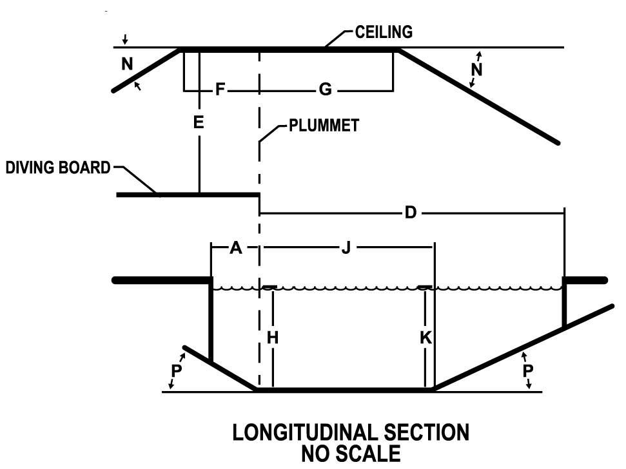

Figure 430.4 Diving platform cross-section: front view.
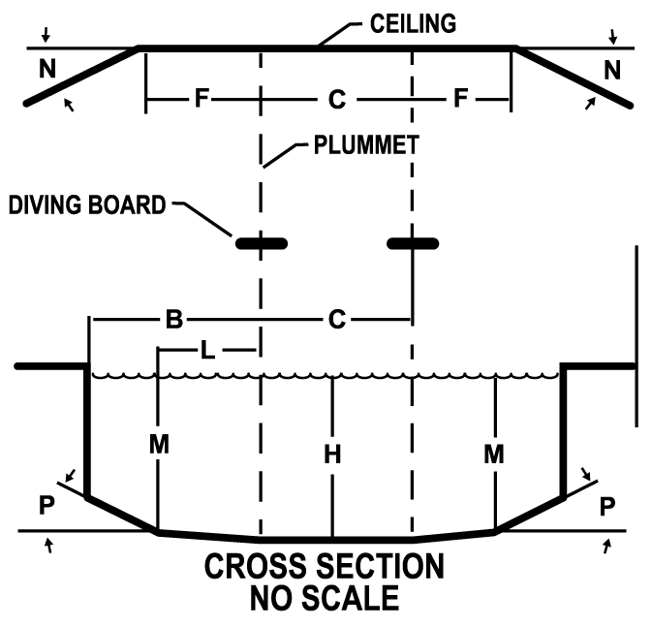
WAC 246-261-435 Starting platforms. (1) Starting platforms must be installed and conform to applicable safety standards established by:
(a) FINA;
(b) U.S.A. Swimming;
(c) NCAA;
(d) NFHS;
(e) YMCA; or
(f) Other sanctioning body.
(2) Starting platforms must:
(a) Be installed at a minimum water depth of four feet (1.25 m), except for new construction, where starting platforms must be installed at a minimum water depth of six feet (1.8 m);
(b) Have the leading edge a maximum height of 30 inches (76.2 cm) above the water surface;
(c) Be slip resistant; and
(d) Installed and secured according to the manufacturer's recommendations at all times when in use.
WAC 246-261-440 Barriers and enclosures. (1) All aquatic facilities, chemical storage spaces, and aquatic venue mechanical spaces must be in an enclosure to prevent unauthorized entry. The enclosure may consist of any combination of building envelopes, site walls, or fencing as provided for in this section.
(2) Barriers and enclosures must discourage climbing by providing a three-foot clearance to nearby structures to simplify climbing over it.
(3) Where the enclosure is composed of horizontal and vertical members, the following must be met:
(a) Horizontal members must be located on the aquatic venue side of the enclosure;
(b) Where there are decorative cutouts within vertical members, spacing within the cutouts must not exceed 1 3/4 inches (44 mm) in width;
(c) When the distance between the tops of the horizontal members is less than 45 inches (1143 mm), spacing between vertical members must not exceed 1 3/4 inches (44 mm) in width; and
(d) When the distance between the tops of the horizontal members is 45 inches (1143 mm) or more, spacing between vertical members must not exceed four inches (102 mm) and prevent the passage of a four-inch diameter sphere with the application of 50 pounds of force.
Figure 440.1 Horizontal members less than 45".

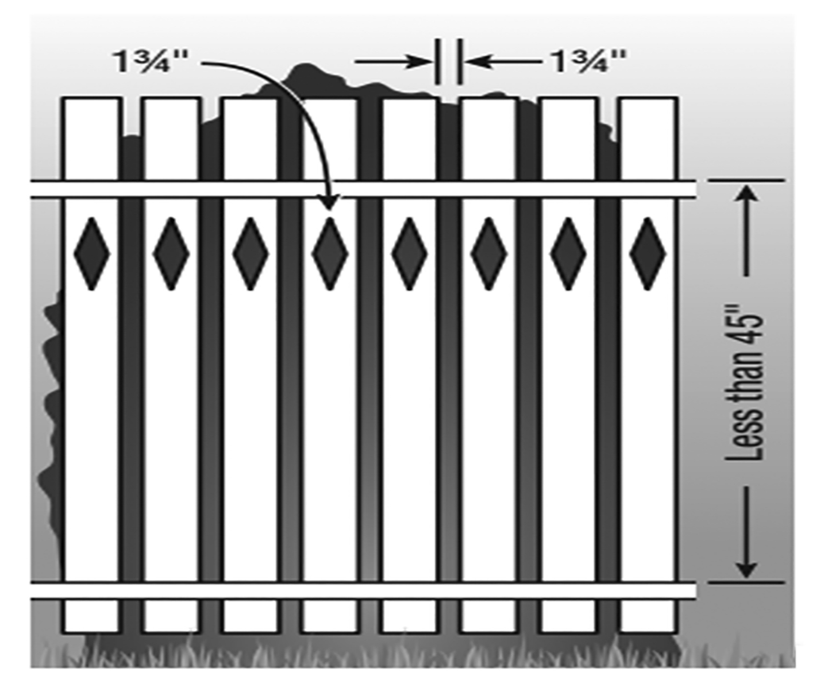
Figure 440.2 Horizontal members greater than 45".
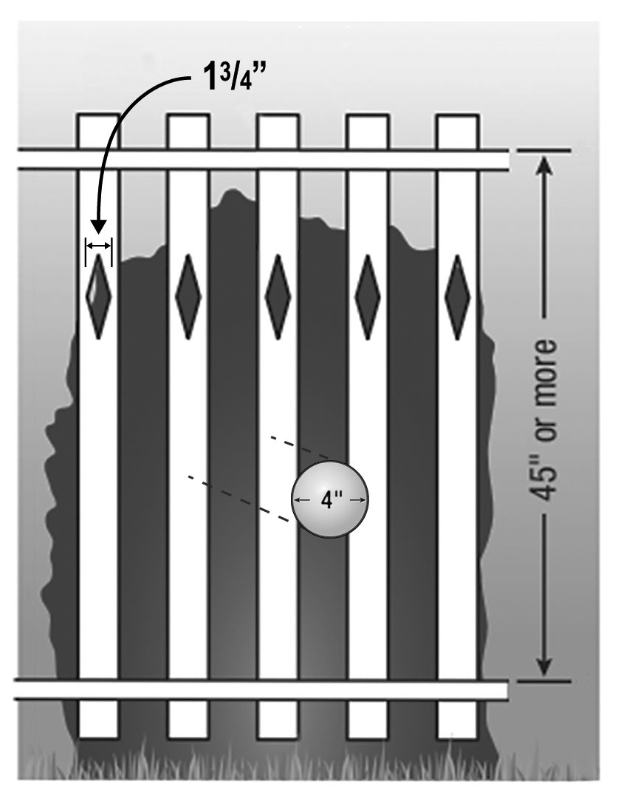
(4) The mesh size for chain-link fencing may not exceed 1 1/4 inches (31.7 mm) unless slats, fastened at the top or bottom of the fence, are used to reduce the mesh openings to no more than 1 3/4 inches (44.4 mm).
Figure 440.3 Mesh fencing.
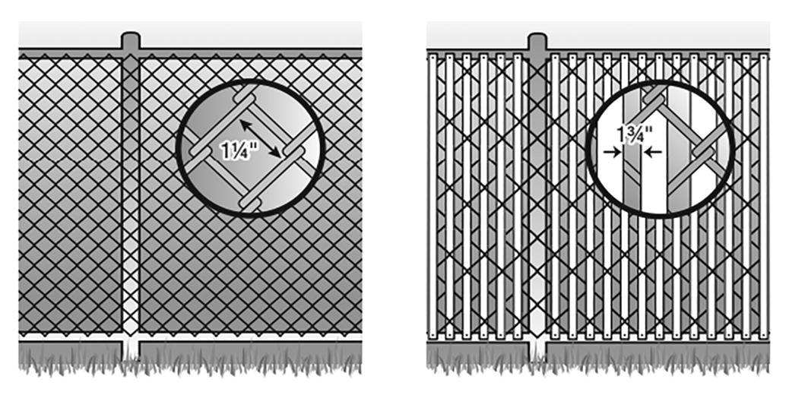
(5) Where the enclosure is composed of a solid surface, such as masonry or stone walls, no indentations or protrusions may be present, other than normal construction tolerances and masonry joints. Such indentations cannot be deeper than 0.375 inches (10 mm).
Figure 440.4 Solid surfaces.
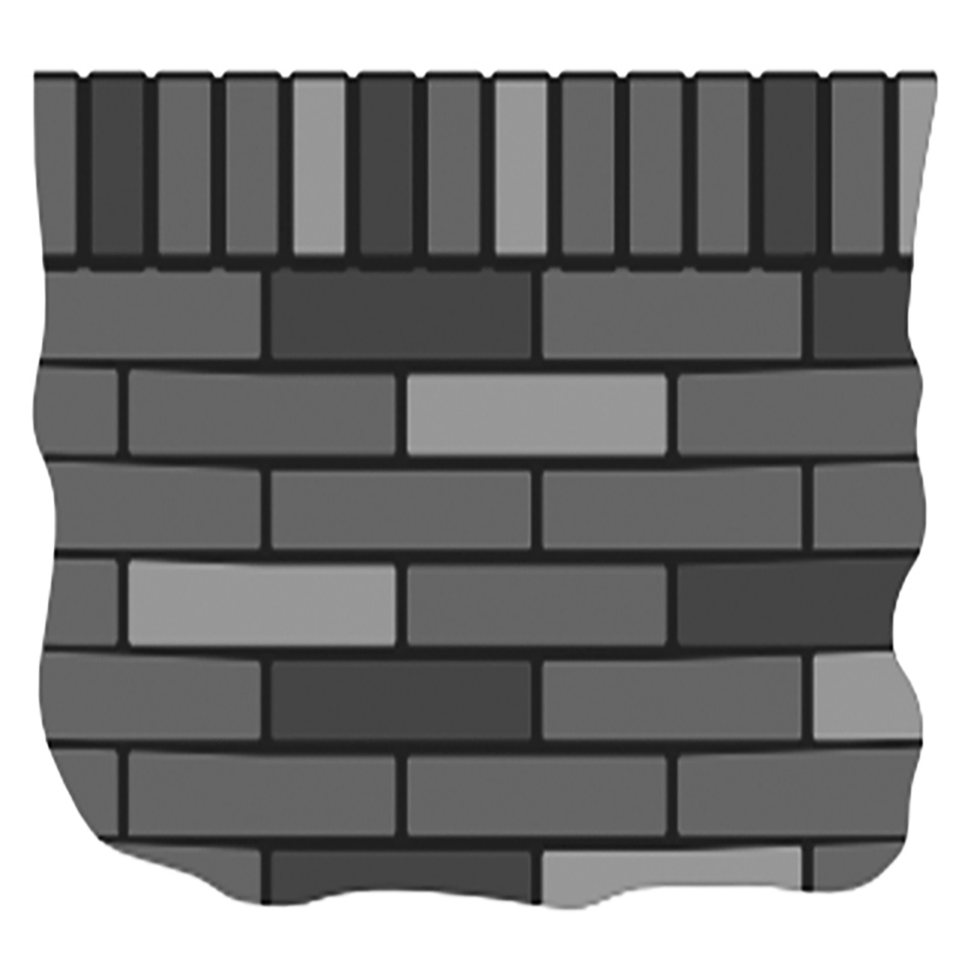
(6) Enclosures for aquatic venues must not block or encumber a required emergency egress path from other structures, nor should emergency egress from other structures not a part of the aquatic facility lead into or access an enclosure for an aquatic venue.
(7) Windows having a sill height of less than 72 inches above the pool deck on a building that forms part of an enclosure around an aquatic venue must have a maximum opening width not to exceed four inches (102 mm) and prevent passage of a four-inch diameter sphere with the application of 50 pounds of force. If designed to be opened, windows must also be provided with a nonremovable screen. A building wall that forms part of an enclosure around an aquatic venue must not have living units on the interior of the enclosure wall.
(8) Openings in a barrier or enclosure must not allow the passage of a four-inch diameter sphere with the application of 50 pounds of force.
Figure 440.5 Openings.
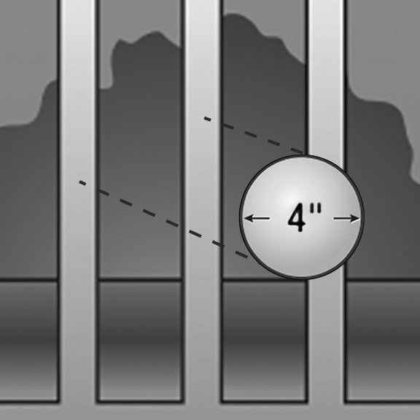
(9) Enclosures must be no less than six feet (1.83 m) in height. Height must be measured from the finished grade to the top of the enclosure on the side outside of the enclosure surrounding an aquatic venue. Where a change in grade occurs at an enclosure, height must be measured from the uppermost grade to the top of the enclosure.
(10) Except where otherwise noted, all other barriers not serving as part of an aquatic facility enclosure must not be less than 42 inches (1.1 m) in height.
(11) The maximum vertical clearance at the bottom of the aquatic venue or aquatic facility enclosure when measured on the side of the enclosure facing away from the enclosed space, must not exceed:
(a) Two inches (5.1 cm) above grade when the enclosure rests on a nonsolid surface, including grass or gravel; or
(b) Four inches (10.2 cm) above grade and prevents the passage of a four-inch diameter sphere when the enclosure rests on a solid surface.
Figure 440.6 Clearance above grade.
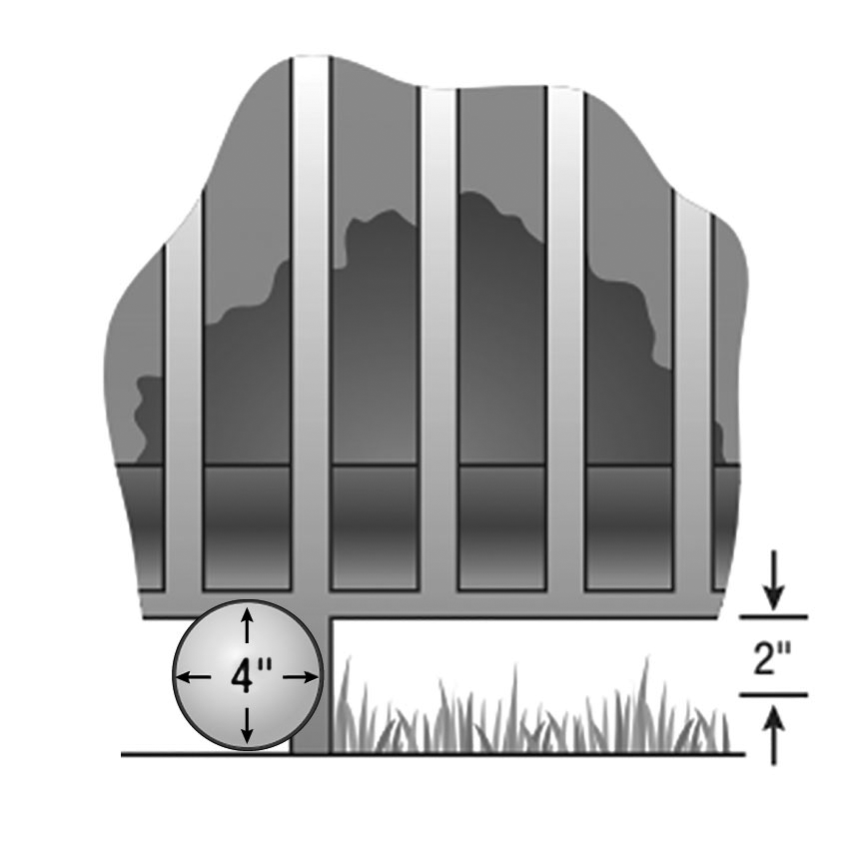
(12) All gates and doors serving as part of an aquatic facility or aquatic venue are subject to the following:
(a) All public access gates or doors serving as part of an aquatic facility enclosure or aquatic venue enclosure must be self-closing and self-latching from any open position;
(b) All public access gates or doors serving as part of an aquatic facility or aquatic venue enclosure and an accessible route must be the self-locking type such as where the lock is operated by means of a key, electronic opener, or the entry of a combination into an integral combination lock;
(c) Operable parts of the release latch on:
(i) Self-latching devices that self-lock, the lock operation control and the latch release must be located not less than 34 inches and not greater than 48 inches above finished grade; and
(ii) Self-latching devices that do not self-lock must be located a minimum of 60 inches above finished grade from the bottom of the latch release;
(d) Self-latching devices must not be operable by small children on the outside of the enclosure around the aquatic venue. A barrier is required around a latch less than 60 inches high to prevent activating the latch from outside the enclosure. The barrier must have a minimum 18 inch radius of material around the latch and the material must not have any openings that exceed 1/2 inch in any dimension;
Figure 440.7 Inoperable by children.
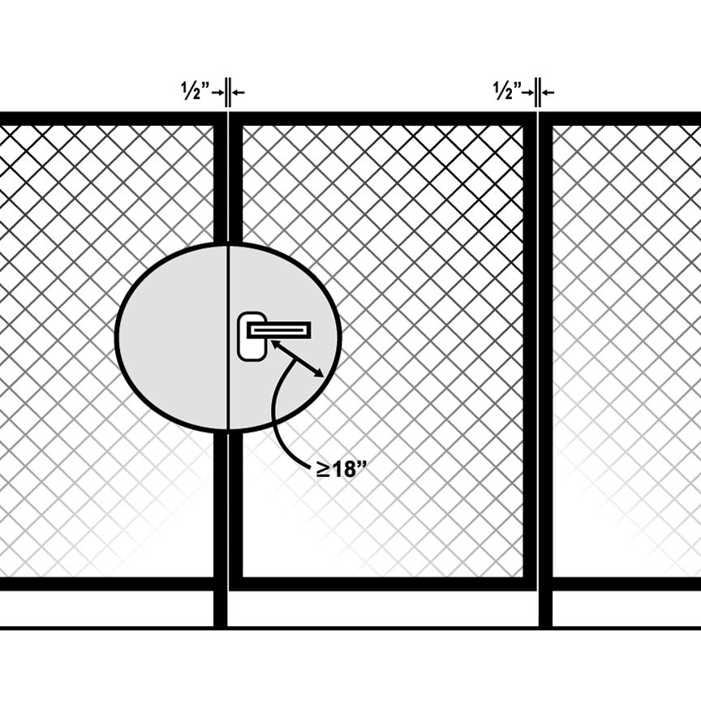
(e) Self-locking devices must latch and lock automatically when the door or gate returns to a closed position;
(f) All gates or doors must be capable of being locked from the exterior;
(g) Gates or doors must be designed in such a way that they do not prevent egress in the event of an emergency; and
(h) Exit gates or doors must be constructed so as to prevent unauthorized entry from outside of the enclosure around the aquatic venue.
(13) The requirements of (a) through (h) of this subsection do not apply when the gate or door serves as part of an aquatic facility or aquatic venue enclosure and the aquatic venues therein have at least one qualified lifeguard conducting patron surveillance when the aquatic venues are open, and the gate or door is locked when the aquatic facility or aquatic venue is not open to the public.
(14) Gates must be at least equal in height at top and bottom to the enclosure of which they are a component.
(15) Turnstiles must not form a part of an aquatic facility enclosure.
(16) Exit gates must:
(a) Be conspicuously marked on the inside of the aquatic venue or aquatic facility;
(b) Swing away from the aquatic venue enclosure; and
(c) Be provided in quantity, location, and width consistent with applicable laws and rules. Where other laws or rules do not otherwise govern, at least one 36-inch (91.4 cm) wide exit gate must be required for emergency access to each logical aquatic venue area including individual pools or grade levels or both.
(17) Indoor aquatic venue must be securable from unauthorized entry from other building areas or the exterior. Building walls enclosing an indoor aquatic facility may be designated as the enclosure.
(18) Where separate indoor and outdoor aquatic venues are located on the same site, an aquatic venue enclosure must be provided between them except where all aquatic venues are operated continuously 12 months a year on the same schedule.
(19) For a passage through a wall separating the indoor portion of an aquatic venue from an outdoor portion of the same aquatic venue, the overhead clearance of the passage to the aquatic venue floor must be at least six feet eight inches (2.0 m) to any solid structure overhead.
(20) Except as otherwise required in this chapter, one enclosure may surround multiple aquatic venues at one facility.
WAC 246-261-445 Aquatic venue cleaning systems. (1) Cleaning systems must not:
(a) Create an entanglement or suction entrapment hazard; or
(b) Interfere with the operation or use of the aquatic venue.
(2) Use of integral vacuum systems is prohibited.
WAC 246-261-450 Equipment room requirements. (1) Equipment rooms must:
(a) Be separated from chemical storage spaces;
(b) Be designed so no ducts, grilles, pass-throughs, or other openings connect the equipment room to the indoor aquatic facility;
(c) Have an independent exhaust system;
(d) Not have gaps between walls or floors. Any gaps must be permanently sealed against air leakage;
(e) Be designed to minimize exposure of combustion equipment, air-handling equipment, and electrical equipment from air contaminated with corrosive chemical vapors or mists;
(f) Have a door or opening that allows access to all equipment;
(g) Have working space around each piece of equipment within the equipment room. Working space must be:
(i) Compliant with manufacturers’ recommendations; and
(ii) No less than three feet (0.9 m) of clear space above and to at least one side of each piece of equipment. The requirement for three feet of clear space may be reduced if equipment is located to ensure easy access to all serviceable components;
(h) Have adequate storage space without reducing working space;
(i) Be constructed of concrete or other suitable material having a smooth, slip-resistant finish;
(j) Contain floors that have positive drainage to floor drains and be sloped toward the floor drain to prevent standing water at all times;
(k) Include lighting to provide 30 foot candles (323 lux) of illumination at floor level in accordance with IESNA guidelines; and
(l) Contain at least one hose bibb within the room or accessible to it, so that a hose can service the entire equipment room.
(2) The equipment room door or opening must not be installed in a wall between the equipment room and an interior chemical storage space.
(3) The equipment room door may be installed in a wall between an equipment room and an indoor aquatic facility if:
(a) The door is equipped with:
(i) An automatic closer to ensure the door closes completely and latches without human assistance;
(ii) An automatic lock:
(A) Restricting access from the indoor aquatic facility side, by way of a key or combination; and
(B) Allows access from the equipment room side using one hand without the use of a key or tool;
(iii) Permanent signage warning against unauthorized entry; and
(iv) Gaskets installed on each side of the door preventing the passage of air, vapors, or mists when the door is closed; and
(b) The floor of the equipment room is sloped into the equipment room to prevent any spills from running under the door into the aquatic facility. This requirement may be met by:
(i) A floor, all of which is at least four inches (10.2 cm) below the level of the nearest part of the indoor aquatic facility floor; or
(ii) A continuous dike not less than four inches (10.2 cm) high located entirely within the equipment room.
(4) Piping, including but not limited to, feeds, lines, and tubes that convey liquids or gas, within equipment rooms must be:
(a) Permanently labeled in a conspicuous location by its use and the aquatic venue or aquatic feature it serves; and
(b) Marked with directional arrows to determine typical operational flow direction.
(5) Valves must be:
(a) Clearly identified by number with a brass tag, plastic laminate tag, or permanently affixed alternative; and
(b) Be described as to their function and referenced identification number in the operating instruction manual.
(6) A water-resistant, easily read, and readily available piping diagram must be furnished inside the equipment room. The piping diagram must include valve numbers matching the operating instruction manual.
WAC 246-261-455 Chemical storage space requirements. (1) A separate space dedicated to chemical storage must be provided for each chemical used in the pool area.
(2) If pool chemicals, acids, salt, oxidizing cleaning materials, or other corrosive or oxidizing chemicals are stored outdoors, they must be stored in a well-ventilated protective area that shields chemicals from weather impacts and provides storage conditions to meet chemical manufacture’s storage recommendations and with an installed enclosure to prevent unauthorized access.
(3) Chemical storage spaces must be designed and constructed:
(a) To protect stored chemicals against tampering, high humidity, unintended exposure to water, direct sunlight, sources of ignition, and extreme temperatures;
(b) To minimize the transfer of chemical vapors or mists into any interior space of a building intended for occupation;
(c) To provide adequate space to:
(i) Store all chemicals used in the pool area, as specified by the chemical manufacturer;
(ii) Separate incompatible chemical products; and
(iii) Allow for a minimum of three feet (0.9 m) of access space;
(d) To ensure ducts, grilles, pass-throughs, or other openings do not connect the chemical storage space to the indoor aquatic facility;
(e) To ensure the floor or deck of the chemical storage space is protected from chemical damage with a coating or sealant that will protect it from chemical damage;
(f) With a gate or door equipped with an emergency-egress device; and
(g) With an emergency eyewash station that meets the requirements of WAC 296-800-15030. Eyewash stations must be located outside of any area that could become immediately dangerous to life and health in the case of chemical release.
(4) In addition to the requirements in subsection (2) of this section, exterior chemical storage spaces must:
(a) Have a complete enclosure at least six feet (1.8 m) high; and
(b) Be equipped with a self-closing, self-latching gate with a permanent locking device.
(5) Doors opening to a chemical storage space must include permanent signage on all doors and gates opening into the chemical storage space:
(a) Warning against unauthorized entry;
(b) Specifying the expected hazards;
(c) Specifying the location of associated safety data sheets; and
(d) Including the product chemical hazard NFPA chart.
(6) Where a chemical storage space door opens into an interior space, the door:
(a) Must be provided with spill containment to prevent spilled chemicals from leaving the chemical storage space;
(b) Must not open to a space containing combustion equipment, air-handling equipment, or electrical equipment. Such door must be acceptable where all equipment thus exposed is listed for the corrosive atmosphere;
(c) Must be constructed of corrosion-resistant materials on corrosion-resistant hinges, tracks, or other supports and contain the following:
(i) A corrosion-resistant, automatic lock to prevent unauthorized entry. Such lock must require a key or combination to open from the outside into the chemical storage space and be designed and installed to be capable of being opened by one hand from the inside of the chemical storage space without the use of a key or tool;
(ii) Suitable gaskets or seals on the top and all sides to minimize air leakage between the door and the door frame;
(iii) A floor or threshold seal to minimize air leakage between the door and the floor or threshold;
(iv) An automatic door closer that will completely close the door and latch without human assistance; and
(v) A limit switch and an alarm that will sound if the door remains open for more than 30 minutes. This alarm shall have a minimum output level of 85 dbA, 30 second L₉₀ at 10 feet (3.0 m).
(7) Interior chemical storage spaces must be designed and constructed so that:
(a) No air moves from the chemical storage space into any other interior space of the building;
(b) Chemical storage spaces sharing a building surface with any other interior space must be equipped with a ventilation system that operates continuously to maintain negative pressure in the chemical storage space relative to all other spaces sharing a building surface;
(c) Where more than one chemical storage space is present, a separate exhaust system must be provided. The exhaust airflow rate must be the greater of the:
(i) Department of labor and industries’ requirements for working in such enclosed spaces;
(ii) Amount needed to maintain the concentration of vapors and mists below the permissible exposure limit, defined in chapter 296-841 WAC, for the expected exposure time for each stored chemical;
(iii) Amount specified in the International Mechanical Code; and
(iv) Amount needed to maintain the specified pressure difference;
(d) The exhaust system is monitored continuously by an audible differential-pressure alarm system that will sound if the specified differential air pressure is not maintained for a period of 30 minutes. The alarm:
(i) Must have a minimum output level of 85 dbA, 30 second L₉₀ at ten feet (3.0 m); and
(ii) Must require manual reset to silence it;
(e) No air ducts, pipes, or tubes pass through the chemical storage space except where:
(i) A corrosion-resistant duct is used for no other purpose than to exhaust air from or makeup air to the chemical storage space. This duct must be at least 20 feet (6.1 m) from any air intake;
(ii) Required to service devices integral to the function of the chemical storage space;
(iii) Necessary to allow for automatic fire suppression; or
(iv) Required for drainage;
(8) No combustion device may be installed in a chemical storage space, or any other place where it could be exposed to air from a chemical storage space.
(9) An ozone room is required for ozone equipment capable of producing ½ pounds or more of ozone in a 24-hour period. The ozone room:
(a) Must not be used for storage of any combustible materials other than those required for the operation of the recirculation and ozone generating equipment;
(b) Must be equipped with an emergency exhaust ventilation system:
(i) Capable of six air changes per hour;
(ii) Located approximately six inches (15.2 cm) from the floor on the opposite side of the room from the makeup air intake;
(iii) That runs on command of an ozone-leak alarm or a manual switch. The manual switch must be located outside the room, near the door to the ozone room;
(c) Must be equipped with an ozone detection and alarm system:
(i) Consisting of:
(A) An audible alarm capable of producing at least 85 dbA, 30 second L₉₀ at ten feet (3.0 m); and
(B) A visible alarm consisting of a flashing light mounted in plain view of the entrance to the ozone room;
(C) An ozone sensor, located 18 – 24 inches (45.7 – 61.0 cm) above floor level, capable of measuring ozone in the range of 0 – 2 ppm by volume;
(ii) Which will activate when the ozone concentration is equal or greater than 0.1 ppm by volume in the room. When activated, the alarm system must:
(A) Shut off the ozone generating equipment; and
(B) Turn on the emergency exhaust ventilation system.
(10) The use of compressed chlorine gas is prohibited.
(11) Where a window is installed in a chemical storage space, it must have the following:
(a) Tempered or plasticized glass;
(b) Corrosion-resistant frame;
(c) Be incapable of being opened or operated; and
(d) Where located on an exterior wall or ceiling, must be protected by a roof as to minimize the entry of rain or snow in the event of window breakage.
(12) Materials used for sealing and blocking openings in an interior chemical storage space must:
(a) Minimize the leakage of air, vapors, and mists from the chemical storage space; and
(b) Be compatible for use in the environment.
WAC 246-261-460 Hygiene facilities design. (1) Hygiene fixtures must be provided in accordance with Table 460. All-gender toilet facilities, when provided, must ensure there is no reduction in the number of hygiene fixtures required to be provided in Table 460.
Table 460. Required number of hygiene fixtures.
Type of HYGIENE FIXTURE | Calculated based on theoretical peak occupancy of BATHERS and PATRONS | Male | Female
Toilets* | Up to 1500 (males)  Up to 1520 (females) | 1 per 75 | 1 per 40
 | 1500 or more (males  1520 or more (females) | 1 per 120 | 1 per 60
Handwashing Sinks | Up to 200 | 1 per 100 | 1 per 100
 | 201-400 | 1 per 200 | 1 per 200
 | 401 or more | 1 per 400 | 1 per 400
Drinking Fountains |  | 1 per 1000
Type of HYGIENE FIXTURE | Calculated based on theoretical peak occupancy of BATHERS | Male | Female
Showers – Cleansing** | Up to 120 | 1 per 40 | 1 per 40
 | 121-360 | 1 per 60 | 1 per 60
 | 361 or more | 1 per 100 | 1 per 100
*Up to 60% of toilets in male restrooms can be replaced with urinals.
**Recirculating interactive water play venues may substitute required cleansing showers with rinse showers. Single-pass or non-recirculating interactive water play venues are exempt from providing rinse or cleansing showers. Lodging and residential settings are exempt from providing a cleansing shower.
(2) Drinking fountains, toilets, handwashing stations, and diaper changing station must be no greater than:
(a) Three hundred feet (91 m) from each aquatic venue designed for all ages; and
(b) Two hundred feet (61 m) from each aquatic venue designed primarily for use by children under five years of age.
(3) Floors of hygiene facilities and dressing areas must be smooth, easily cleaned, impervious to water, and slip resistant. The floor base must provide a sealed, coved juncture between the wall and the floor and extend upward on the wall at least six inches (15.2 cm).
(4) Floor drain covers must be ½ inch (1.3 cm) or less in width or diameter.
(5) Floors must be sloped to drain water or other liquids.
(6) Hygiene facilities must be constructed of smooth, easy-to-clean, water-impervious surfaces.
(7) At least one hose bibb must be in or accessible to each hygiene facility to facilitate cleaning.
(8) Plumbing fixtures must be designed to be readily and frequently cleaned, sanitized, and disinfected.
(9) Cleaning showers must be in a hygiene facility near the entrance of the aquatic facility.
(10) Entryways to cleansing shower areas must be enclosed by a door or curtain.
(11) Shower doors and curtains must be smooth and easy to clean.
(12) Cleansing showers must be equipped with a soap dispenser and liquid soap.
(13) Cleansing shower water must be delivered at a temperature between 90°F (32°C) and 120° F (49° C).
(14) A minimum of one rinse shower must be provided on the deck near an entry point to the aquatic venue.
(15) Water used for rinse showers may be at ambient temperature.
(16) Floors of rinse showers must be sloped to drain wastewater away from the aquatic venue.
(17) At aquatic facilities with a combined water surface area greater than 7500 square feet (697 m²):
(a) Rinse showers must be adjacent to each aquatic venue entry point; and
(b) The number of cleansing showers provided may be flexible based on the theoretical peak occupancy using the following proportions:
(i) Twenty-five percent cleansing showers;
(ii) Twenty-five percent rinse showers; and
(iii) The remaining 50 percent either cleansing or rinse showers.
(18) Diaper changing stations must:
(a) Be provided in each male and female hygiene facility or available in a unisex diaper changing station;
(b) Conform to either:
(i) ASTM Standard F2285-04: Consumer Performance Standards for Commercial Diaper-Changing Stations; or
(ii) The standards for diaper-changing surfaces in the most current version of Caring for Our Children: National Health and Safety Performance Standards: Guidelines for Out-of-Home Child Care Programs; and
(c) Include a covered, hands-free, plastic-lined trash receptacle adjacent to the diaper changing unit.
(19) All hygiene fixtures and appurtenances in the dressing area must be smooth, hard, easy to clean, impervious to water, and installed to withstand thorough cleaning.
(20) Other than mirrors and windows, glass is not permitted in hygiene facilities.
(21) Mirrors must be shatter resistant and anchored.
(22) If lockers are provided, they must be installed at least 3.5 inches (8.9 cm) above the finished floor.
(23) Soap dispensers and hand dryers or paper towel dispensers must be securely attached adjacent to handwashing sinks and at each cleansing shower. The dispensers must be readily and frequently cleaned.
(24) Toilet paper dispensers must be securely attached to the wall adjacent to each toilet. In female facilities, covered receptacles adjacent to each toilet must be provided for the disposal of feminine hygiene products.
(25) Foot baths are prohibited.
WAC 246-261-465 Specific requirements for spas. (1) Spas must have a minimum of two adjustable filter system inlets located below the surface of the underwater bench and spaced at least three feet (0.9 m) apart and designed to distribute flow evenly.
(2) Air flow must be permitted through the hydrotherapy jet system or when injected post-filtration. The hydrotherapy jet system must be independent of the recirculation, filtration, and heating systems.
(3) The maximum water depth in spas is four feet (1.2 m) measured from the designed static water line except for:
(a) Exercise spas where the maximum depth is six feet six inches (2 m); or
(b) Spas that are designed for special use and purposes and approved by the department or local health officer may be deeper than four feet (1.2 m).
(4) The maximum submerged depth of any seat or sitting bench is 28 inches (71.1 cm) measured from the water line.
(5) A spa must have one or more suitable, slip-resistant handholds around the perimeter not over 12 inches (30.5 cm) above the water line. The handholds may consist of bull-nosed coping, ledges, or decks along the immediate top edge of the spa.
(6) Interior steps or stairs must be provided. Each set of steps must be provided with at least one handrail to serve all treads and risers. Seats or benches may be provided as part of these steps.
(7) Approach steps on the exterior of a spa wall extending above the deck must be provided unless the raised spa wall is 19 inches (48.3 cm) or less in height above the deck and it is used as a transfer tier or pivot-seated entry.
(8) A continuous, unobstructed perimeter deck at least four feet (1.2 m) wide must be provided on two consecutive or adjacent sides, or 50 percent or more of the spa perimeter. If spa pools are greater than 100 square feet in surface area (9.2 m²), then the entire perimeter deck must be six-feet wide.
(9) Elevated spas may be located adjacent to another aquatic venue if there is a barrier not less than 42 inches (106.7 cm) in height between the spa and the adjacent aquatic venue. If a barrier is not provided, the spa must be considered a raised feature and must meet the setback requirements in Table 465.
(10) A minimum of two depth markers must be provided regardless of the shape or size of the spa.
(11) A means to drain the spa must be provided to allow frequent draining and cleaning.
(12) An air induction system, when provided, must prevent water back up that could cause electrical shock hazards. Air intake sources must not permit the introduction of toxic fumes or other contaminants.
(13) The hydrotherapy jet system must be connected to a minute timer that limits agitation periods to no longer than 15 minutes. The hydrotherapy jet system must be connected to a minute timer located out of reach of a bather in the spa. A clock that is visible to all bathers must be provided.
(14) All spas must have a clearly labeled emergency shutoff for the purpose of stopping the motor(s) that provide power to the recirculation system and hydrotherapy or hydrotherapy jet system. Emergency shutoff must be located:
(a) Within sight of the spa, and
(b) Not less than five feet (1.5 m) or greater than 10 feet (3 m) horizontally from the inside walls of the spa.
(15) An alarm must be provided with:
(a) An audible warning with a rating of not less than 80 decibels;
(b) A flashing light; and
(c) Continuous sound until deactivated with the shut off switch.
(16) The use of cyanuric acid or stabilized chlorine products is prohibited.
WAC 246-261-470 Additional requirements for waterslides and landing pools. (1) The design professional shall provide a report certifying that the design of the waterslide is consistent with accepted safety engineering practices, manufacturer’s recommendations, and:
(a) ASTM F2376-17a Standard Practice for Classification, Design, Manufacture, Construction, and Operation of Water Slide Systems; and
(b) ASTM F2461-16e1 Standard Practice for Manufacturer, Construction, Operation, and Maintenance of Aquatic Play Equipment.
(2) Flume surfaces must be inert, nontoxic, smooth, and easily cleaned.
(3) Flume design must include safety measures that ensure a rider cannot fall from the flume. All flume valleys and dips must have proper drainage and a means of egress in the event the ride malfunctions or a rider stops on the ride.
(4) The exit of any flume must be designed to ensure that bathers enter the landing pool at a safe speed and angle of entry.
(5) If a waterslide has two or more flumes with a point of intersection between the centerlines of any two flumes, the distance between that point and the point of exit for each intersecting flume must not be less than the slide manufacturer’s recommendations and ASTM F2376-17a.
(6) Waterslides must be:
(a) Designed to terminate at or below water level, except for drop slides;
(b) Perpendicular to the wall of the aquatic venue at the point of exit unless otherwise permitted by the waterslide manufacturer; and
(c) Designed with an exit system which must provide safe entry into the waterslide runout.
(7) The flume exits must be in accordance with the waterslide manufacturer’s recommendations and ASTM F2376-17a. The distance between the point of exit and the side of the aquatic venue opposite the bathers as they exit, excluding any steps, must not be less than the waterslide manufacturer’s recommendations and in accordance with ASTM F2376-17a. Flume exits must be evaluated in the engineering compliance report with supporting evidence to show riders will not collide with objects, pool walls, other riders or other attraction participants.
(8) Stairs, if provided, must be installed at the opposite end of the landing pool from the flume exit with a handrail.
(9) If the waterslide flume ends in a swimming pool, the landing area must be divided from the rest of the aquatic venue by a rope and float line, wing wall, peninsula, or other similar feature to prevent collisions with other bathers.
(10) Waterslide runouts must be designed in accordance with the slide manufacturer’s recommendations and ASTM F2376-17a. Waterslide runouts must be designed to safely decelerate the rider so that the momentum alone does not carry the rider forward to reach the end of the runout. A means of egress must be provided.
(11) Drop slides must include a landing area:
(a) In accordance with the manufacturer’s recommendations and ASTM F2376-17a. This area must not infringe on the landing area for any other slides, diving equipment, or any other minimum aquatic venue clearance requirements;
(b) Not infringed upon by stairs; and
(c) With a minimum required water depth in accordance with the slide manufacturer’s recommendations and ASTM F2376-17a.
(12) All pool slides must:
(a) Be designed, constructed, and installed to provide a safe environment for all bathers utilizing the aquatic venue in accordance with applicable ASTM standards. The following are prohibited:
(i) Pool slides with water flowing down the slide bed; and
(ii) Portable slides;
(b) Be constructed of non-toxic and compatible with the environment contacted under normal use;
(c) Have a water depth at the slide terminus determined by the slide manufacturers’ recommendations;
(d) Have clear space maintained to the pool edge and other features according to the slide manufacturers’ requirements;
(e) Have a landing area protected with a rope and float line, wing wall, peninsula, or other similar impediment to prevent collisions with other bathers; and
(f) Be equipped with netting or barrier to prevent bather access underneath pool slides where sufficient clearance is not provided. Such netting or barrier must be designed such that any underwater opening does not allow for the passage of a four inch (10.2 cm) sphere and no opening can create a finger entrapment.
WAC 246-261-475 Additional requirements for wave pools. (1) Bathers shall access the wave pool at the shallow or zero depth entry except for an allowable ADA designated entry point.
(2) The sides of the wave pool must be protected by a barrier from unauthorized entry into the wave pool.
(3) Handrails, as required by ADA for accessible entries, must be designed in such a way that they do not present a potential for injury or entrapment with wave pool bathers.
(4) Handholds must be:
(a) Provided at the static water level or not more than six inches (15.2 cm) above the static water level;
(b) Continuous around the wave pool perimeter with the exception of water depths less than 24 inches (61.0 cm) at the zero depth entry;
(c) Self-draining;
(d) Installed so that their outer edge is flush with the wave pool wall; and
(e) Designed to ensure that body extremities will not become entangled during wave action.
(5) Recessed steps are prohibited along the walls of the wave pool.
(6) Side wall ladders must be utilized for egress only and placed so they do not project beyond the plane of the wall surface.
(7) Wave pools must be fitted with a rope and float line located to restrict access to the caisson wall if required by the wave pool equipment manufacturer.
(8) A minimum of two emergency shutoff switches to disable the wave action must be provided, one on each side of the wave pool. These switches must be clearly labeled and readily accessible.
(9) Caisson enclosures that prevent the passage of a four inch (10.2 cm) sphere must be provided for all wave pools.
WAC 246-261-480 Additional requirements for lazy rivers. (1) Handrails, steps, stairs, and propulsion jets for lazy rivers must not protrude into the river.
(2) Lazy rivers must be designed to ensure that the velocity is unlikely to knock bathers off their feet.
(3) Means of egress must not be spaced at intervals of more than at 150 feet (45.7 m) around the lazy river.
(4) A handhold in compliance with WAC 246-261-290 must be provided on at least one side of the lazy river. Handholds are not required where bathers are required to be in or on a tube while in the lazy river.
(5) A perimeter deck must be provided along the entire length of the lazy river. The deck may alternate sides of the lazy river.
(6) Obstructions around the perimeter of the lazy river must not cause injury to bathers or impact lifeguarding, sight lines, or rescue operations.
(7) All bridges spanning a lazy river must have a minimum clearance of:
(a) Seven feet (2.1 m) from the bottom of the lazy river; and
(b) Four feet (1.2 m) above the water surface to any structure overhead.
WAC 246-261-485 Additional requirements for moveable floors. (1) The moveable floor design must not impede the effectiveness of the water treatment system.
(2) The moveable floor must allow inspection, cleaning, and maintenance of the area underneath.
(3) The surface of the moveable floor must be slip resistant.
(4) A strategy for preventing bathers from transitioning to deeper water when a moveable floor is not continuous over the entire surface area of the aquatic venue must be provided.
(5) The underside of the movable floor must not be accessible to bathers.
(6) The design of a moveable floor must protect against bather entrapment between the moveable floor and the pool walls and floor.
(7) If the moveable floor is operated using hydraulics, the hydraulic compounds must be listed as safe for use in pool water in case there is a hydraulic leak.
(8) The speed of a moveable floor must be less than or equal to 1.5 feet per minute (45.7 cm/min).
(9) Use of the moveable floor portion of the pool must not be open to bathers when the floor is being raised or lowered. The moveable floor must only be used for accessibility purposes under direct supervision.
(10) Starting platforms and diving boards in the area of a moveable floor are prohibited.
WAC 246-261-490 Additional requirements for bulkheads. (1) The bottom of the bulkhead must be designed so that a bather cannot be entrapped underneath or inside of the bulkhead.
(2) Bulkhead placement must not interfere with the required water circulation in the pool.
(3) Bulkheads must be fixed to their operational positions by a tamper-proof system.
(4) The gap between the bulkhead and the pool wall must be no more than 1.5 inches (3.8 cm).
(5) The bulkhead must be designed to afford an acceptable handhold as required in WAC 246-261-290.
(6) The proper number of entrances and exits to the pools as required must be provided when the bulkhead is in place.
(7) Guard railings at least 34 inches (86.4 cm) tall must be provided on both ends of the bulkhead.
(8) The width of the walkable area of a bulkhead must be more than or equal to three feet and three inches (1.0 m). If starting platforms are installed, the width of the walkable area of a bulkhead must be more than or equal to three feet and nine inches (1.1 m). Starting platforms must be “side mount” style if bulkhead is less than four feet six inches (1.4 m) wide.
(9) The travel of a bulkhead must be:
(a) Limited such that it cannot encroach on any required clearances of other features, such as diving boards, or
(b) Designed with modifications incorporated that prevent use of other features when the required clearances have been compromised by the position of the bulkhead.
(10) Bulkheads must be designed, installed, and operated in accordance with the manufacturer’s recommendations.
WAC 246-261-500 Additional requirements for interactive water play aquatic venues. (1) Interactive water play aquatic venues must be constructed of a slip-resistant and easily cleaned surface. Any manufactured surfacing must be deemed suitable by the manufacturer for aquatic and chlorinated environments.
(2) Interactive water play aquatic venues must be properly sloped not exceeding one foot of slope for every 12 feet of horizontal floor length, so that only water from the aquatic features flows back to the interactive water play aquatic venue collection tank for recirculated venues, or to drainage for proper wastewater disposal for non-recirculated venues. Areas adjacent to the interactive water play aquatic venue shall be sloped away from the collection drains.
(3) The size, number, and locations of drains must be determined and specified to assure water does not accumulate on the interactive water play aquatic venue.
(4) Flow through the drains to the collection tank for recirculated venues, or wastewater disposal for non-recirculated venues, must be under gravity.
(5) Direct suction outlets are prohibited.
(6) Valves must be provided in the drain system to allow for discharging water to an approved means for wastewater disposal prior to returning to the collection tank when interactive water play aquatic venue is not operational. Valves must be located before returning to the collection tank when the interactive water play aquatic venue is not operational so that wastewater from the venue is diverted for proper disposal for stormwater as required by the department of ecology.
(7) Openings in the grates covering the drains must not exceed ½ inches (12.7 mm) wide. Gratings must not be removable without the use of tools.
(7) For recirculated venues, the collection tank must be designed to provide ready access for cleaning and inspections. The collection tank must be capable of complete draining. The access hatch or lid must be locked or require a tool to open. The collection tank must have a minimum operational volume of the greater of:
(a) 7.48 gallons per square foot splash pad surface area;
(b) 3,000 gallons (11,356 L) of water; or
(c) The volume of water necessary to ensure continuous operation of the filtration system.
(8) A means to convey excess water in the tank to an approved waste disposal system must be provided.
(9) Recirculation system inlets must be sized and positioned to provide for complete mixing in the tank.
(10) Interactive water play aquatic venues must be kept free of landscape debris by installing at least one of the following:
(a) Eight feet (2.4 m) of deck area;
(b) Raised curbs; or
(c) Raised planters.
(11) The deck must be constructed of a uniform, easily cleaned, impervious material and protected from surface runoff.
(10) Interactive water play aquatic venues must be separated from other bodies of water within the same enclosure by:
(a) A distance of at least 15 feet (4.6 m); or
(b) A barrier. If an aquatic facility only consists of one or more interactive water play aquatic venues, a barrier is not necessary.
(11) Spray features must be designed and installed to be seen clearly, so as not to be a hazard to bathers due to water velocity from the spray feature discharge, or other safety hazards. Surface sprays must be flush with the spray pad surface. Spray openings must have a diameter of ½ inch (0.127 mm) or less. Noncircular spray openings must have a width of ½ inch (0.127 mm) or less.
(12) Aboveground features must not:
(a) Present a tripping hazard;
(b) Have sharp edges, rough surfaces, pinch points, crush and shearing points, entanglement and impalement hazards, or entrapment hazards; or
(c) Be climbable unless there is a safety pad covering the spray pad surface in the fall zone that complies with ASTM F1292 for fall protection.
(13) Above ground features must be constructed of corrosion-resistant materials or provided with a corrosion-resistant coating.
(14) Maximum velocity at the orifice of the spray feature nozzle must not exceed 20 feet (6.1 m) per second.
(15) NEC swimming pool requirements apply to interactive water play aquatic venues.
(16) Plumbing design including spray features, spray features piping, and spray features reservoirs must be designed so that water can be completely drained out when the venue is not in operation and the entire plumbing system can be flushed prior to each operation.
WAC 246-261-505 Additional requirements for wading pools. (1) A barrier must be provided to separate a wading pool from other pools unless the wading pool is separated by 15 feet (4.6 m) from other bodies of water. The barrier does not need to surround the wading pool if the shortest distance of travel between the wading pool around the barrier to the other pool is a minimum of 15 feet (4.67 m).
(2) A barrier is not required between wading pools.
WAC 246-261-510 Waterfalls. (1) A waterfall may be located adjacent to an aquatic venue. For water depths:
(a) Five feet (1.5 m) or less, a waterfall must be set back from the edge of the pool at a distance specified in Table 510.1. Exceptions may be made for lifeguarded pools; and
(b) Greater than five feet (1.5 m), a waterfall must conform to the diving envelope design specified in WAC 246-261-430.
(2) In waterfalls that commingle with aquatic venue water, water quality and treatment requirements specified in other sections of this chapter must be met and any additional disinfection required by the department or local health officer to address anticipated increased demands and aerosolization of disinfectant.
(3) Flows may not create turbulence that might create a safety hazard or reduce visibility in the pool.
(4) Waterfalls that flow from aquatic venue sidewalls may not exceed five percent of the total perimeter.
Table 510. Set-back requirements for special water features in pools at shallow swimming pool water levels.
Height of Feature Above Pool Water Level | Type of Special Feature
 | Waterfall | Rockery | Decorative feature
12 inches or less | Feature may spill directly to pool from sidewall. | Setback of 6 feet or more from pool edge; except at pools that are continuously lifeguarded. Five percent of deck perimeter may have feature provided up to pool edge. | Setback of 6 feet or more from pool edge.
Greater than 12 inches and less than 30 inches | Setback of 8 feet or more from pool edge.
Greater than or equal to 30 inches | Setback of 15 feet or more from pool edge.

WAC 246-261-515 Rockers and decorative features. (1) A rockery feature or decorative feature may be located adjacent to an aquatic venue. For water depths:
(a) Five feet (1.5 m) and less, it must be set back from the edge of the pool at a distance specified in Table 510. Exceptions may be made for lifeguarded pools; and
(b) Greater than five feet (1.5 m), it must conform to the diving envelope design specified in WAC 246-261-430.
(2) Rockeries and decorative features must be constructed of slip-resistant material without sharp or cutting edges in any areas that provide a potential foothold, stepping, or standing access.
(3) Rockers and decorative features must slope to drain water away from the aquatic venue.
WAC 246-261-520 Other aquatic features. (1) Other aquatic features not otherwise addressed in the chapter, including but not limited to climbing walls, inflatables, and play structures, must not be installed unless designed and operated in accordance with all manufacturer’s installation and operations recommendations and applicable safety standards such as ASTM F2461.
(2) Any aquatic feature with fall potential requires review and approval by the department or local health officer prior to installation. To be approved:
(a) The aquatic feature must have safety surfacing in compliance with ASTM F1292 and water depth in compliance with WAC 246-261-430 as applicable; or
(b) The owner shall provide a compliance report prepared by a design professional with experience in safety design demonstrating that the manufacturer’s installation recommendations are adequate to provide protection against anticipated hazards.

SUBPART D. OPERATING PERMITS
WAC 246-261-525 Operating permits. (1) The owner shall obtain an operating permit from the department or local health officer prior to opening an aquatic facility to the public. A separate permit is required for each aquatic venue at an aquatic facility. To obtain an operating permit, the owner shall:
(a) Provide the department or local health officer with information showing the aquatic facility and each aquatic venue within the facility comply with the requirements of chapter 70.90 RCW and this chapter. An aquatic facility or aquatic venue that has been closed for more than 12 months may be required to submit additional information as requested by the department or local health officer; and
(b) Pay applicable fees.
(2) Operating permits:
(a) Must be issued in the name of the owner;
(b) Are valid for one year;
(c) Are subject to annual renewal;
(d) Specify the period of time the aquatic venue may be open to the public, as approved by the department or local health officer; and
(e) Are nontransferable without written consent of the department or local health officer. For the purposes of this section, a change in management of a corporation, partnership, association, or other nonindividual business entity must identify a new person requiring either consent to a permit transfer or a new permit must be issued upon proper application.
(3) The operating permit must be posted in a conspicuous location at the aquatic facility.
(4) An operating permit may be withheld, suspended, revoked, or denied by the department or local health officer for noncompliance with the requirements of chapter 70.90 RCW and this chapter.

SUBPART E. STAFFING, SAFETY EQUIPMENT, AND SIGNAGE
WAC 246-261-530 Staffing required. (1) Prior to opening the aquatic facility for use, the owner shall ensure adequate staffing is available to meet the requirements of this chapter.
(2) A minimum of one person onsite while the aquatic facility is open for use shall be:
(a) Trained in the procedures for contamination response; and
(b) Trained in personal protective equipment.
WAC 246-261-535 Qualified operators and responsible supervisors. (1) The owner shall ensure that the aquatic facility has a qualified operator.
(2) To be considered a qualified operator, a person shall:
(a) Complete a qualified operator training course recognized by the department or on the Council for the Model Aquatic Health Code Certified Products and Services list; and
(b) Submit a certificate or written documentation to the department or local health officer showing completion of the qualified operator training course outlined in subsection (1) of this section. The certificate or written documentation must be available onsite for inspection by the department or local health officer for each qualified operator employed or contracted by the aquatic facility. Originals must be made available to the department or local health officer upon request.
(3) A qualified operator shall be onsite or available to be onsite within two hours at an aquatic facility that:
(a) Has two or more aquatic venues;
(b) Has an aquatic venue with over 50,000 gallons of water;
(c) Includes aquatic features with recirculated water;
(d) Has an increased risk aquatic venue;
(e) Offers swim training or lessons;
(f) Is operated by a municipality; or
(g) Is operated by a school.
(4) The department of local health officer may require one or more onsite qualified operators when an aquatic facility has a documented history of critical violations.
(5) Qualified operators shall be available at aquatic facilities not listed in subsection (3) of this section at a minimum of once per week or when assistance is needed.
(6) The owner shall ensure a responsible supervisor is onsite whenever a qualified operator is not physically onsite.
(7) The responsible supervisor shall:
(a) Be capable of testing and recording water quality parameters;
(b) Know how to make adjustments, as needed, to maintain water quality;
(c) Know general maintenance procedures as required by daily operational verifications or adjustments;
(d) Know when the aquatic facility or aquatic venue must be closed to the public; and
(e) Know how and when to contact the qualified operator.
WAC 246-261-540 Qualified lifeguards. (1) The owner shall provide qualified lifeguards during all times at which the aquatic facility or aquatic venue is open for the following:
(a) An aquatic facility with an aquatic venue deeper than five feet (1.5 m) with the exception of aquatic venues constructed prior to the effective date of this chapter at an apartment, assisted living facility, condominium, fraternity, home-owners association, hotel, mobile home park, motel, recreational vehicle park, sorority, or rental housing unit for the use of persons living or residing at the facility and their invited guests;
(b) An aquatic venue that allows for unsupervised children under the age of 14 years;
(c) An aquatic venue with a configuration in which any point on the aquatic venue surface exceeds 30 feet (9.1m) from the nearest deck;
(d) An aquatic venue with an induced current or wave action including, but not limited to, wave pools and lazy rivers;
(e) Waterslide landing pools;
(f) An aquatic venue in which bathers enter the water from any height above the deck including, but not limited to, aquatic features, diving boards, drop slides, starting platforms, climbing walls, and pool slides that discharge into a water depth of more than five feet (1.5 m);
(g) An aquatic facility that sells or serves alcohol within the aquatic venue enclosure; and
(h) Aquatic venues within the same enclosure as an aquatic venue requiring qualified lifeguards unless a barrier conforming to the requirements listed in WAC 246-261-440(10) restricts access between the aquatic venues.
(2) The owner shall provide qualified lifeguards at aquatic venues when used:
(a) By youth groups including, but not limited to, childcare and school groups; and
(b) For group training including, but not limited to, competitive swimming, lifeguard training, exercise programs, and swimming lessons.
(3) Where qualified lifeguards are required in subsections (1) and (2) of this section, the owner shall:
(a) Provide qualified lifeguards to staff each zone of patron surveillance. Zones of patron surveillance for aquatic venues not in use must be staffed unless there is an effective means to restrict and monitor access to the closed venue. At an aquatic facility with only a single zone of patron surveillance, a minimum of two qualified lifeguards must be provided. Zones of patron surveillance must be diagrammed in the safety plan and assigned such that:
(i) A qualified lifeguard can view the entire area of the assigned zone of patron surveillance; and
(ii) A qualified lifeguard can reach the furthest extent of the assigned zone of patron surveillance within 20 seconds;
(b) Ensure rotations can be conducted while all zones are staffed so that:
(i) No qualified lifeguard is conducting patron surveillance for more than 60 continuous minutes; and
(ii) Each qualified lifeguard is provided with at least one ten-minute period of non-patron surveillance; and
(c) Have a lifeguard supervisor present; and
(d) Test zones of patron surveillance at a minimum of two times per year to verify the requirements of subsection (3)(a)(i) and (ii) of this section.
(4) To be considered a qualified lifeguard, an individual shall:
(a) Successfully complete a:
(i) Department-recognized lifeguard training course offered by a department-recognized training agency; or
(ii) CMAHC-certified lifeguard training course;
(b) Possess a current certificate for such training;
(c) Have met all pre-service requirements; and
(d) Participate in continuing in-service training requirements at the aquatic facility.
(5) Qualified lifeguards are responsible for:
(a) Monitoring patrons within the zone of patron surveillance;
(b) Enforcing aquatic facility rules;
(c) Responding to emergencies;
(d) Identifying health and safety hazards and taking action to mitigate or avoid the hazard;
(e) Maintaining skills at a test-ready level of proficiency;
(f) Wearing an identifying uniform;
(g) Carrying emergency equipment, including:
(i) A rescue tube in a ready rescue position;
(ii) A whistle or other signaling device for communicating with bathers and staff;
(iii) A resuscitation mask with one-way valve; and
(iv) Non-latex, non-powdered, disposable gloves.
(h) Wearing polarized sunglasses, and corrective eyewear as needed, for effective patron surveillance;
(i) Wearing SPF 15 or greater UV protection if exposed to the sun;
(j) Knowing where personal protective equipment is located and using it when required; and
(k) Knowing when to notify the lifeguard supervisor of environmental changes affecting the qualified lifeguard’s ability to conduct patron surveillance.
(6) Qualified lifeguards shall not be assigned to a zone of patron surveillance at an aquatic venue where any part of the water depth is greater than they are certified to safeguard.
(7) Qualified lifeguards shall not be assigned other tasks that could intrude on patron surveillance.
(8) Qualified lifeguards shall not engage in social conversations or have on their person or lifeguard station anything which could distract them from performing patron surveillance.
(9) Lifeguard-based remote safety monitoring systems may be used to assist with patron surveillance but may not be used as a substitute for qualified lifeguards.
WAC 246-261-545 Lifeguard supervisors. (1) The owner shall provide a lifeguard supervisor at any aquatic facility with three or more qualified lifeguards. One of the qualified lifeguards may be designated as the lifeguard supervisor if:
(a) The qualified lifeguard meets the requirements of subsection (2) of this section; and
(b) Lifeguard supervisor duties do interfere with patron surveillance.
(2) To qualify as a lifeguard supervisor, an individual shall:
(a) Possess a current certificate for lifeguard training from a department-recognized agency;
(b) Possess a current certificate for lifeguard supervisor training from a department-recognized agency;
(c) Have at least 100 hours of active duty as a qualified lifeguard; and
(d) Demonstrate the ability to effectively communicate with safety team members and emergency services.
(3) Lifeguard supervisors are responsible for:
(a) Monitoring performance of qualified lifeguards in their zone of patron surveillance;
(b) Ensuring lifeguard duty rotation is conducted in accordance with the safety plan;
(c) Ensuring qualified lifeguards are certified to the maximum depth of water for the applicable assigned aquatic venue zone of patron surveillance;
(d) Coordinating staff response and patron care during an emergency;
(e) Identifying health and safety hazards and communicating to staff and management to mitigate or otherwise avoid the hazard; and
(f) Ensuring required equipment is in place and in good condition.
WAC 246-261-550 Lifeguard – and Safety-related equipment. (1) The owner shall supply the following equipment and ensure good working order:
(a) A functional telephone or other communication system or device that is hard-wired, accessible, and capable of dialing 911 within the aquatic venue enclosure, no more than 100 feet from each aquatic venue. Where a hardwired telephone is not an option, the owner may provide alternative means of communication as approved by the department or local health officer. Signage must be posted including:
(i) Emergency dialing directions;
(ii) The address of the aquatic facility;
(iii) Location of aquatic venue within the aquatic facility; and
(iii) Contact information for aquatic facility management and emergency personnel;
(b) A first aid and emergency equipment in a designated location. First aid supplies must be continuously stocked and include, at a minimum:
(i) First aid guide;
(ii) Absorbent compress;
(iii) Adhesive bandages;
(iv) Adhesive tape;
(v) Sterile pads;
(vi) Disposable gloves;
(vii) Scissors;
(viii) Elastic wrap;
(ix) Emergency blanket;
(x) Resuscitation mask with one-way valve; and
(xi) Blood-borne pathogen spill kit.
(2) At aquatic facilities with qualified lifeguards, the owner shall provide the following equipment and ensure good working order:
(a) Lifeguard chairs or stands providing an unobstructed view of the bather surveillance zones. Lifeguard chairs or stands must:
(i) Not have any sharp edges or protrusions;
(ii) Be sturdy, durable, and made of ultraviolet resistant materials;
(iii) Be placed to provide safe access for the lifeguard; and
(iv) Include protection from ultraviolet radiation exposure;
(b) At least one backboard equipped with a head immobilizer and sufficient straps to immobilize a person to it. The number and location of backboards must be such that a two-minute response time to the location of the incident can be achieved; and
(c) Emergency equipment required to be worn by a qualified lifeguard on duty.
(3) At all aquatic venues with depths that exceed two feet (61.0 cm), the owner shall provide and maintain the following in the immediate vicinity:
(a) A U.S. Coast Guard-approved aquatic rescue throwing device with at least a ¼ inch (6.3 mm) thick rope, 50 feet (15.2 m) long or 1.5 times the width of the aquatic venue, whichever is less; and
(b) A reaching pole of 12 – 16 feet (3.7 – 4.9 m) in length, non-telescopic in weight, and with a securely attached shepherd’s crook with an aperture of at least 18 inches (45.7 cm). Reaching poles must be of non-conductive material.
(4) The owner shall provide a method for staff to communicate in cases of emergency.
WAC 246-261-555 Required signage. (1) The owner shall conspicuously post and enforce rules governing health, safety, and sanitation at the entrance of the aquatic facility communicating the following information:
(a) In case of an emergency, dial 911 or other emergency instructions according to the communications plan or if onsite emergency personnel are available;
(b) Hours of operation;
(c) Bather load for each aquatic venue;
(d) Pollution of the aquatic venue is prohibited;
(e) Do not swim if you have open wounds;
(f) Do not swim if you are ill with vomiting or diarrhea or have had diarrhea within the past two weeks;
(g) Do not swim if you are under the influence of alcohol or drugs;
(h) Shower before entering the water;
(i) No glass items in the aquatic venue or on the deck;
(j) Food or drink is prohibited in the aquatic venue water;
(k) Do not swallow or spit water;
(l) Anyone in diapers must wear protective covering to prevent contamination;
(m) Diaper changing on the deck is prohibited;
(n) Anyone with seizure, heart, or circulatory problems should swim with a companion;
(o) No diving, where required;
(p) Intentional hyperventilation or extended breath holding activities are dangerous and prohibited;
(q) Except for service animals, animals are prohibited in the aquatic venue or on the deck;
(r) No running or rough play;
(s) Children under the age of six years must be supervised by an adult;
(t) Location of the nearest telephone and first aid kit for emergency use; and
(u) Anyone who doesn’t obey the rules is subject to removal from the premises.
(2) Sign lettering must be legible and at least one inch (25.4 mm or 3- point type) high with a contrasting background.
(3) Posters communicating recreational water illness prevention must be conspicuously posted within the aquatic facility at all times.
(4) At aquatic facilities where lifeguards are not required, the owner shall provide additional signage communicating the following information:
(a) No lifeguard on duty;
(b) Children under the age of 14 years must have direct supervision of a person aged 18 years or older;
(c) Children between 14 years of age and 17 years of age may only use the pool if another person is present at the aquatic facility;
(d) Use of the aquatic facility outside the hours of operation is prohibited;
(e) A poster reflecting the latest CPR standards;
(f) Imminent health hazards requiring closure; and
(g) The name and contact information for the owner and qualified operator.
(5) At aquatic venues with movable floors, the owner shall provide additional signage communicating the following information:
(a) Current aquatic venue water depth;
(b) No diving;
(c) The floor is movable, and the aquatic venue depth varies; and
(d) “Movable Floor” warning markers at intervals of 25 feet (7.6 m) around the perimeter of the movable floor.
(6) At spas, the owner shall provide additional signage communicating the following information:
(a) Maximum water temperature is 104° F (40°C);
(b) Children under the age of five are prohibited from using in the spa;
(c) Pregnant people and people with heart disease, high blood pressure, or other health concerns should consult with their healthcare provider prior to using the spa;
(d) Children under 14 years of age must be supervised by an adult; and
(e) Use of the spa unaccompanied is prohibited.
(7) The owner shall post signs at the hygiene facility exit(s) used to access the aquatic venue communicating the following information:
(a) Do not swim if you are ill with vomiting or diarrhea or have had diarrhea within the past two weeks;
(b) Do not swim if you have open wounds;
(c) Shower before entering the water;
(d) Check your child’s swim diaper or rubber pants regularly;
(e) Diaper changing on the deck is prohibited;
(f) Do not poop or pee in the water;
(g) Do not swallow or spit water; and
(h) Wash your hands after using the toilet and before returning to the pool.
(8) The owner shall post signs at diaper changing stations communicating the following information:
(a) Dispose of used disposable diapers in the diaper bucket or receptable provided;
(b) Dump contents from reusable diapers into toilets and bag diapers to take home;
(c) Use the materials provided to sanitize the surface of the diaper changing station before and after each use;
(d) Wash your hands and your child’s hands after diapering; and
(e) Do not swim if you are ill with vomiting or diarrhea or have had diarrhea within the past two weeks.
(9) At aquatic facilities where alcohol is served, the owner shall post signs near the exits of beverage sales and service areas stating: “Alcohol consumption increases your risk of drowning. You are advised not to enter pools or water features if you have recently consumed alcohol.”
(10) At aquatic facilities with ultraviolet or ozone secondary treatment systems, the owner shall post signs:
(a) Near the visual alarm that directs patrons to notify staff. For instances when staff are not present, the sign must include a means to contact management; and
(b) On the entry door to the chemical storage space stating “DANGER – GASEOUS OXIDIZER – OZONE”.
(11) At aquatic facilities using compressed chlorine gas, the owner shall post a sign on the door to the chlorine room stating “DANGER CHLORINE”.
(12) At aquatic venues where a bulkhead is operated with an open area underneath, the owner shall post a sign on the bulkhead in letters at least four inches (102 mm) high, which states “DANGER! DO NOT SWIM UNDER bulkhead.”
(13) At aquatic venues with waterslides, the owner shall post signs at the waterslide entry indicating riding instructions, warnings, and requirements in accordance with the manufacturer recommendations.

SUBPART F. OPERATIONS AND MAINTENANCE
WAC 246-261-560 Aquatic facility maintenance. The owner shall ensure:
(1) All appurtenances, aquatic features, signage, safety equipment and systems required by this chapter are provided and maintained;
(2) The profile and surfaces of diving boards, steps, and starting platforms are maintained to prevent slips, trips, and falls;
(3) Steps and guardrails are secured and do not move during use;
(4) Starting platforms are only used by qualified bathers in accordance with WAC 246-261-435. Signage and covers must be in place to prohibit unqualified bathers from using starting platforms;
(5) Aquatic features are:
(i) Maintained and operated in accordance with the manufacturer’s specifications;
(ii) Free of slime or biofilm layers on all reachable surfaces;
(iii) Tested to verify the disinfectant in the water is within the parameters specified in WAC 246-261-650. Where plumbing lines are susceptible to holding stagnant water, the plumbing lines must be flushed with treated water prior to opening;
(6) The aquatic venue is clean and free of debris, organic material, and biofilm in reachable areas in the water and on surfaces; and
(7) Vacuuming is only done when the aquatic venue is closed to the public. Vacuum ports must be covered with an approved device cover when not in use. Aquatic venues with missing or damaged vacuum port openings must be repaired prior to reopening the aquatic venue.
WAC 246-261-565 Preventative maintenance inspections. (1) The qualified operator or responsible supervisor shall ensure that a daily preventative maintenance inspection is completed before the aquatic facility is opened for use. Results must be recorded on a log and maintained at the aquatic facility. Daily preventative maintenance inspections include ensuring:
(a) Fencing, enclosures, gates, and self-latching and locking devices are intact and functioning properly;
(b) Enclosures do not have furniture or objects nearby that encourage climbing;
(c) Safety equipment is in place and in good repair, including emergency instructions and phone numbers;
(d) Safety warning signs and other signage are in place and in good repair;
(e) Emergency communication equipment and systems are operational;
(f) First aid supplies are stocked;
(g) Recirculation, disinfection systems, controllers, and probes are operating as required;
(h) Water quality is such that the pool bottom is clearly visible;
(i) Walkways, decks, and exits are clean, clear, and free of debris;
(j) Decks are free from cracks. Cracks that increase the potential for trips, falls, lacerations, or impact the ability to properly clean the deck must be repaired;
(k) The pool shell is free of cracks and sharp edges. Cracks must be documented and monitored for movement. Any cracks over 1/8 inch (3.2 cm) but be repaired;
(l) Diving boards are free of cracks and properly secured;
(m) Skimmer baskets, weirs, lids, flow adjusters, and suction outlets are free of any blockage and functioning properly;
(n) Inlet and return covers and any other fittings are in place, secure, and unbroken;
(o) Secondary treatment and supplemental treatment systems are operating as required;
(p) All chemical tubing, connections, support, and double containment piping is checked on a daily basis for leaks,
(q) Underwater lights and other lighting are intact with no exposed wires or water in lights;
(r) Slime and biofilm have been removed from accessible surfaces of aquatic venues, slides, and other aquatic features;
(s) Doors to nonpublic areas are locked;
(t) Contamination response plans, materials, and equipment are available;
(u) Aquatic feature water flow rates are functioning in accordance with the manufacturer’s recommendations;
(v) Drinking fountains are clean and in functional condition; and
(w) Alarms, where required, are tested and function properly.
(2) The qualified operator or responsible supervisor shall ensure that preventative maintenance inspections include:
(a) Verifying the availability of contamination response equipment and supplies on a weekly basis;
(b) Monthly testing of GFCI devices; and
(c) Visual inspections of bonding conductors, where accessible, every six months or whenever disrupted or impacted by site construction or other events.
WAC 246-261-570 Lighting. (1) The owner shall ensure:
(a) Lighting systems are maintained in all patron and maintenance areas meeting the lighting levels specified in WAC 246-261-295;
(b) The aquatic venue main drain is visible from poolside at all times the aquatic venue is in use; and
(c) Underwater lights are operational and maintained as designed. Lenses must be intact. Cracked lenses must be replaced prior to opening the aquatic venue for use; and
(d) Glare conditions are assessed from each lifeguard position, as required, to ensure the bottom of the aquatic venue and any objects in the pool are clearly visible throughout operating hours.
(2) Where night swimming is allowed, the owner or operator shall ensure light levels in accordance with WAC 246-261-295 are maintained for one half hour before sunset to one half hour after sunrise while in use.
WAC 246-261-575 Indoor aquatic facility ventilation. (1) The owner shall:
(a) Ensure air handling systems are maintained and operated in compliance with the requirements of the original system design, construction, and installation;
(b) Develop and implement air handling system standard operating procedures in accordance with the design professional or manufacturer’s recommendations. Procedures must include detailed instructions for:
(i) Operation;
(ii) Maintenance;
(iii) Cleaning;
(iv) Testing; and
(v) Inspection;
(c) Ensure all necessary equipment and supplies are available to perform air handling system standard operating procedures; and
(d) Ensure air handling systems operate continuously and provide the required amount of outdoor air during use. The amount of outdoor air may be reduced by no more than 50 percent when the facility is not in use, as long as acceptable air quality is maintained.
(2) A qualified operator shall:
(a) Monitor, log, and maintain air handling system set-points and other operational parameters as specified by the design professional or manufacturer’s recommendations;
(b) Replace or clean the air handling system filters in accordance with the design professional or manufacturer’s recommendations, whichever is more frequent;
(c) Develop and implement a plan to minimize combined chlorine compounds in the indoor aquatic venue; and
(d) Develop and implement an air quality action plan with procedures for purging the indoor aquatic facility.
WAC 246-261-580 Heating. The owner shall:
(1) Maintain and repair facility heating equipment and pool water heating equipment in compliance with all applicable laws and rules;
(2) Repair defects in the aquatic facility heating equipment immediately;
(3) Control indoor aquatic facility air temperature to original specifications. If original specifications are unavailable, the qualified operator shall maintain the dew point of the interior space so it is less than the dew point of the interior walls to prevent damage to structural members and prevent biological growth on walls; and
(4) Ensure the manufacturer’s specified minimum clearance distances are met for the combustion device and air vents.
WAC 246-261-585 Plumbing. The owner shall ensure:
(1) All plumbing is properly maintained with no leaks or discharge;
(2) Portable water is available at all times;
(3) Water introduced to the pool, either directly or to the recirculation system, is supplied through an air gap or by another method which prevents backflow and back-siphonage;
(4) Drinking fountains are:
(i) Clean and in good repair;
(ii) Adjusted so water does not go outside the catch basin;
(iii) Provide an angled jet of water so water does not fall back into the drinking water stream; and
(iv) Have sufficient water pressure to allow correct adjustment;
(5) Aquatic venue wastewater, including backwash water and cartridge cleaning water, is:
(a) Disposed of in accordance with all applicable laws and rules; and
(b) Not returned to the aquatic venue or aquatic facility’s water treatment system;
(6) Filter backwash lines, deck drains, and other drain lines connected to the aquatic facility are discharged through an approved air gap; and
(7) Discharge water does not create any standing water.
WAC 246-261-590 Solid waste management. The owner shall:
(1) Provide a minimum of one garbage receptacle within each aquatic facility to ensure that garbage and refuse can be disposed of properly to maintain safe and sanitary conditions. Additional receptacles may be provided at the discretion of the owner or operator;
(2) Ensure garbage receptacles and recycling containers are clean and in good repair; and
(3) Remove garbage receptacles and recycling containers and dispose of at a frequency as to not overflow, attract vectors, or cause odor.
WAC 246-261-595 Food and beverage concessions. If food or beverage sales are provided, the owner shall:
(1) Ensure food and beverage sales and service areas are separated from the aquatic venue and perimeter deck areas with a barrier or demarcation line;
(2) Prohibit food and beverage in the aquatic venue;
(3) Ensure tables and chairs provided in the food and beverage sales and service area are a minimum of six feet (1.8 m) from the aquatic venue edge and do not leave the food and beverage sales and service area;
(4) Prohibit glass from all patron areas; and
(5) Provide waste receptacles with a lid.
WAC 246-261-600 Enclosures. The owner shall ensure:
(1) All enclosures are maintained to prevent unauthorized use;
(2) All primary public access gates or doors serving as part of an enclosure have functional self-closing and self-latching unless qualified lifeguards are provided; and
(3) Gates or doors used solely for after-hours maintenance must remain locked at all times.
WAC 246-261-605 Equipment rooms. The owner shall ensure all piping, including but not limited to, feeds, lines, and tubes that convey liquids or gas, within the equipment room is marked and maintained in accordance with WAC 246-261-450.
WAC 246-261-610 Chemical storage, handling, and use. The owner shall ensure:
(1) Chemical storage, handling, and use complies with Washington state department of labor and industries regulations, U.S. environmental protection agency regulations, and safety data sheets.
(2) Chemicals are stored:
(a) To prevent access by unauthorized individuals;
(b) To protect them from getting wet;
(c) To prevent mixing if any chemicals were to leak. Safety data sheets must be consulted for incompatibility. Spill containment must be provided for liquid chemicals;
(d) Away from potentially flammable substances; and
(e) Separately from the equipment room. If a separate room is not provided for existing aquatic facilities constructed before the effective date of these rules, owners shall provide a separate chemical storage area that conforms to manufacturer's requirements for each chemical used in the pool area. A chemical that has been opened and is currently in use in the equipment room may be kept in a staging area of the equipment room, only if the chemicals are protected from exposure to heat and moisture.
(3) Chemicals are labeled with the identity of the material and a statement of hazardous effects in accordance with Washington State Labor and Industries labeling requirements.
(4) Smoking or vaping is prohibited within the chemical storage space.
(5) Lighting is maintained at a minimum of 30 footcandles (323 lux) measured at floor level.
(6) Personal protective equipment are provided for each chemical in use, in accordance with the chemical’s safety data sheet.
(7) Chemical equipment used in controlling water quality is certified, listed, and labeled to NSF/ANSI 50-16a 2017 and used only in accordance with the manufacturer’s instructions.
(8) Chemicals must be measured using a dedicated measuring device. Measuring devices must be clean, dry, and constructed of material compatible with the chemical to be measured.
(9) Treatment chemicals are introduced in strict adherence to the manufacturer’s instructions to ensure concentration levels in the water are safe for human exposure. Introduction must occur as follows:
(a) Disinfection and pH control chemicals must be automatically introduced through the recirculation system using the chemical feed system required in WAC 246-261-345, except for:
(i) pH control chemicals may be manually introduced at existing aquatic facilities constructed before the effective date of this chapter; and
(ii) Disinfection and pH control chemicals may be manually introduced on an emergency basis in the absence of bathers; and
(b) All other chemicals may be manually introduced.
(10) Chemicals may be diluted prior to application as required by manufacturer’s instructions. To dilute:
(a) Chemicals must be added to water; and
(b) Chemicals must be mixed in a separate, labeled container. Two or more chemicals must never be mixed in the same dilution water.
WAC 246-261-615 Hygiene facilities. The owner shall ensure:
(1) Hygiene facility fixtures, dressing area fixtures, cleansing and rinse showers, diaper changing stations, non-permanent floor coverings, and furniture are clean and sanitized daily with an EPA-registered product, and more often as necessary;
(2) Hygiene facility floors, walls, and ceilings are kept clean and free of visible mold and mildew;
(3) Handwashing stations are provided and include:
(a) Handwash sink;
(b) Adjacent soap dispenser;
(c) Hand drying device; and
(d) Trash receptacle, emptied daily or more often;
(4) Liquid or granular soap and a dispenser is provided in cleansing showers;
(5) Rinse showers are easily accessible, and soap is prohibited;
(6) Diaper changing stations are provided and include:
(a) A handwash sink, within a year of the effective date of these rules; and
(b) EPA-registered disinfectant; and
(7) Wooden racks, duckboards, or wooden mats are prohibited on hygiene facility and dressing area flooring.
WAC 246-261-620 Provision of towels, suits, and shared equipment. The owner shall ensure:
(1) Towels provided by the aquatic facility are washed with detergent and chlorine bleach according to the manufacturer’s recommendations for disinfection, rinsed, and dried as listed on the fabric label after each use;
(2) Any attire provided by the aquatic facility must be washed in accordance with the fabric label or manufacturer’s instructions;
(3) Non-absorbent, easily cleanable receptacles are also provided for the collection of towels and suits; and
(4) Any shared equipment provided is maintained in good repair, cleaned and sanitized between uses, and stored in a manner to prevent biological growth.
WAC 246-261-625 Aquatic venue structure. The owner shall ensure aquatic venue structures are operated and maintained so that:
(1) Ladders, grab rails, and handrails are securely anchored;
(2) Depth markers are provided in accordance with WAC 246-261-290;
(3) “NO DIVING” markers are provided in accordance with WAC 246-261-430; and
(4) Rope and float lines are installed where required. Rope and float lines must be kept in place at all times except when the pool is used for a specific purpose such as programmatic lap swimming or competitive use.
WAC 246-261-630 Decks. The owner shall:
(1) Ensure the perimeter decks and aquatic venue circulation paths are free from obstructions, including patron seating, to ensure enough space for lifesaving and rescue;
(2) Prohibit diaper changing on the deck by ensuring diaper changing only occurs at designated diaper-changing stations;
(3) Clean decks daily and keep them free from debris, pests, and standing water;
(4) Clean and maintain deck drains to prevent blockage and pooling water;
(5) Ensure finish and profile of deck surfaces are maintained to prevent slips, falls, or trips; and
(6) Ensure cross-connection control between deck drains and the sanitary or storm sewer system, as well as backpressure prevention devices on hose bibbs are in good working order and tested as required by the department or local health officer.
WAC 246-261-635 Starting platforms. The owner shall ensure starting platforms are:
(1) Only used for competitive swimming and training;
(2) Only used under the direct supervision of a coach or instructor;
(3) Removed, if possible, or prohibited from use during all recreational or non-competitive swimming activity by covering the platforms with a manufacturer-supplied cover or another means that clearly prohibits use; and
(4) Installed at a minimum depth of four feet (1.25 m) within a year of the effective date of these rules.
WAC 246-261-640 Additional operational requirements for spas, waterslides, wave pools, moveable floors, bulkheads, and interactive water play aquatic venues. (1) For spas, the owner shall:
(a) Operate spa filtration systems 24 hours per day except when draining, filling, or maintenance occurs;
(b) Drain, clean, scrub, and replace water in a spa consistent with the water replacement interval or as needed to maintain water clarity and quality, whichever is more frequent. The water replacement interval (in days) must be calculated as follows:
Spa volume (gallons) / 3
Average number of users per day
(c) If the average number of users is unknown, then the water replacement interval (in days) must be calculated as such:
theoretical peak occupancy × hours per day the spa is open
(d) Wipe down all spa surfaces, including skimmers, prior to refilling; and
(e) Ensure spa water temperature does not exceed 104°F (40°C).
(2) For waterslides, the owner shall:
(a) Operate waterslides in accordance with ASTM F2376-17a standards and manufacturer recommendations; and
(b) Post signs at the entrance indicating riding instructions, warnings, and requirements in accordance with manufacturer’s recommendations.
(3) For wave pools, the owner shall provide U.S. Coast Guard-approved life jackets in various sizes, free of charge, with instructions on how to ensure proper fitting.
(4) For aquatic venues with moveable floors, the owner shall ensure starting platforms and diving boards are prohibited from the moveable floor area.
(5) Where a bulkhead is operated with an open area underneath, the owner shall ensure no one swims under it and must position it so it cannot encroach on any required clearances of other features, such as diving boards.
(6) For interactive water play aquatic venues, the owner shall:
(a) Ensure cracks are repaired;
(b) Ensure contaminants from cleaning are removed or washed to a sanitary sewer. If a sanitary sewer drain is not available, contaminants must be rinsed to the nearest deck drain or removed in a manner to prevent them from reentering the interactive water play aquatic venue;
(c) Close a non-recirculating interactive water play aquatic venue during water quality advisories issued by the department or local health officer. Prior to reopening, non-recirculating interactive water play aquatic venues must be activated and flushed in accordance with the department or local health officer; and
(d) Drain plumbing systems completely during non-operational times. Non-recirculating plumbing must be flushed out by running the approved water source immediately prior to opening for daily use by bathers.
SUBPART G. WATER TREATMENT
WAC 246-261-645 Water supply. (1) Water serving an aquatic facility must come from a supply conforming with chapter 246-290 WAC.
(2) Water supply must be sufficient to replace daily losses from the aquatic venue(s).
(3) Use of condensate water, collected rainwater, or other reclaimed water is prohibited unless otherwise approved to meet chapter 173-219 WAC.
WAC 246-261-650 Recirculation and filtration systems. The qualified operator or responsible supervisor shall ensure:
(1) All components of the filtration and recirculation systems are in continuous operation 24 hours per day;
(2) The system flow rate is not reduced to less than 75 percent of the design flow rate as specified by the design professional and approved by the department or local health officer and is only reduced when the aquatic venue is unoccupied during posted closure hours of the aquatic venue. Reduced flow must not result in a turbidity level greater than 0.5 NTU or impact water clarity;
(3) Disinfectant concentration and pH are maintained at all times; and
(4) Flow through recirculation system must be balanced to maximize water clarity and safety; and
(5) The required recirculation flow for gutter or skimmer aquatic venues with main drains is the total design recirculation rate divided as follows during normal operation:
(a) At least 60 percent of the total design recirculation flow rate through the perimeter overflow systems; and
(b) No greater than 40 percent of the total design recirculation flow rate through the main drain;
(6) Check inlets at least weekly for rate and direction of flow and adjust as necessary to produce uniform circulation of water and to facilitate the maintenance of a uniform disinfectant residual throughout the aquatic venue;
(7) Surface skimming devices are functioning so:
(a) The perimeter overflow system is clean and free of debris that may restrict flow;
(b) The automatic fill system, if present, maintains the water level at an elevation such that gutters must overflow continuously around the perimeter of the aquatic venue;
(c) Water levels are maintained near the middle of the skimmer opening;
(d) The flow through each skimmer is adjusted to maintain skimming action that will effectively remove all floating matter from the surface of the water;
(e) Strainer baskets for skimmers are clean; and
(f) Weirs remain in place and in good repair;
(8) Suction outlet covers and sumps are secured;
(9) Piping is marked in accordance with WAC 246-261-450;
(10) Strainers are in place and cleaned as required to maintain pump performance;
(11) Flow meters, in accordance with WAC 246-261-335 are provided and maintained in proper working order;
(12) Filters and filter media are certified, listed, and labeled to NSF/ANSI 50-16a 2017;
(13) Filters are backwashed, cleaned, and maintained in accordance with manufacturer’s recommendations;
(14) Granular media filters are:
(a) Maintained in accordance with approved design specifications for filtration and backwashing rates;
(b) Inspected for proper depth and cleanliness at least once a year and replaced in accordance with the manufacturer’s recommendations when necessary to retore the depth or cleanliness;
(c) The manual air release valve of the filter is opened as necessary to remove any air that collects inside of the filter as well as following each backwash; and
(15) Backwashing:
(a) Continues until water is clear;
(b) Is performed at a differential pressure increase over the initial clean filter pressure, as recommended by the manufacturer, unless the system can no longer achieve the design flow rate;
(c) Occurs when bathers are not present. The qualified operator or responsible supervisor shall ensure the recirculation pump and chemical feeders have restarted and have run for a minimum of five minutes before bathers are permitted to reenter the aquatic venue;
(16) Precoat filters are operated such that:
(a) The appropriate media type and quantity as recommended by the manufacturer is used;
(b) Precoating of the filter occurs in closed loop mode to minimize the potential for media or debris to return to the aquatic venue;
(c) Flow is not interrupted when switching from precoat mode to filtration mode unless the filters are certified, listed, and labeled to NSF/ANSI 50-16a 2017 to return water to the aquatic venue during the precoat process. When flow interruption occurs on precoat filters not designed to bump, the media must be backwashed out of the filter and a new precoat established according to the manufacturer’s recommendations prior to bathers reentering the pool. Systems designed to flow to waste while precoating must use a maximum recommended precoat media load permitted by the filter manufacturer to account for media lost to the waste stream during precoating;
(d) Backwashing or cleaning filters is performed at a differential pressure increase over the initial clean filter pressure, as recommended by the manufacturer, unless the system can no longer achieve the design flow rate;
(e) Continuous filter media feed equipment tank agitators run continuously. Filter media feed may be performed via bath application;
(f) Bumping is performed in accordance with the manufacturer’s recommendations;
(g) Diatomaceous earth, when used, is added to precoat filters in the amount recommended by the manufacturer;
(h) Perlite, when used, is added to precoat filters in the amount recommended by the manufacturer and in accordance with the specifications for the filter listing and labeling to NSF/ANSI 50-16a 2017; and
(i) All discharged filter media is done in accordance with applicable laws and rules; and
(17) Cartridge filters are operated in accordance with the manufacturer’s recommendations and are certified, listed, and labeled to NSF/ANSI 50-16a 2017 and:
(a) Maintained in accordance with approved design specifications;
(b) Exchanged with clean filter cartridges at a differential pressure increase over the initial clean filter pressure as recommended by the manufacturer unless the system can no longer achieve the design flow rate; and
(c) Cleaned per manufacturer’s recommendations. If there is no established manufacturer procedure, refer to the department for guidance.
WAC 246-261-655 Water treatment chemicals. The qualified operator or responsible supervisor shall ensure:
(1) Water treatment chemicals are certified, listed, and labeled to either NSF/ANSI 50-16a 2017 or NSF/ANSI 60-2020 and have an EPA registration;
(2) Water treatment chemicals are used in accordance with the manufacturer’s recommendations;
(3) Only the disinfectants outlined in this section are used in aquatic venues;
(4) When using chlorine, the following are met:
(a) Only chlorine products that are EPA-registered as sanitizers or disinfectants for use in aquatic venues are permitted;
(b) Minimum DPD-free chlorine concentrations must be maintained at all times as follows:
(i) 1.0 ppm (mg/L) at aquatic venues without cyanuric acid;
(ii) 2.0 ppm (mg/L) at aquatic venues using cyanuric acid; and
(iii) 3.0 ppm (mg/L) at spas;
(c) DPD-free chlorine concentrations must be consistent with label instructions;
(d) Maximum DPD-free chlorine concentrations must not exceed 10.0 ppm (mg/L) at any time the aquatic venue is open to bathers;
(5) When using bromine, the following are met:
(a) Only bromine products that are EPA-registered as sanitizers or disinfectants for use in aquatic venues are permitted. Bromine-based disinfectants may be applied through the addition of an organic bromine compound (1,3-Dibromo-5,5- dimethylhydantoin (DBDMH) or 1-bromo-3-chloro-5,5-dimethylhydantoin (BCDMH));
(b) Minimum bromine concentrations must be maintained at all times as follows:
(i) 4.0 ppm (mg/L) for spas; and
(ii) 3.0 ppm (mg/L for all other aquatic venues;
(c) Maximum bromine concentrations must not exceed 8.0 ppm (mg/L at any time the aquatic venue is open to bathers;
(6) When using cyanuric acid, levels at all aquatic venues must remain at or below 90 ppm (mg/L);
(7) When using compressed chlorine gas, the following must be met:
(a) Chlorinators and any cylinders containing chlorine gas must be housed in a chlorine room, separate from other equipment rooms and spaces, with a door installed to prevent gas leakage and equipped with an inspection window;
(b) Chlorine gas cylinders must be secured from falling;
(c) Chlorine gas cylinders in use must:
(i) Be secured in a suitable platform scale;
(ii) Have an approved valve-stem wrench on the valve stem to shut the system down in an emergency event;
(iii) Be tagged to indicate if cylinders are full or empty;
(iv) Have taring scales or trunnions for determining chlorine weight. Weight must not exceed 150 pounds tare weight per cylinder, except wave pools, where one ton cylinders may be used. Only a single, one-ton cylinder may be stored on the premises at any given time; and
(v) Have testing equipment, using commercial strength ammonia vapor, to detect chlorine gas;
(d) The chlorine room must:
(i) Not be in a basement or below grade; and
(ii) Be equipped with:
(A) An entry door that opens to the exterior of the building, not towards a pool or deck;
(B) A separate vent opening to the exterior; and
(C) An electric motor-driven fan taking suction from the floor level of the chlorine room and discharging it at a suitable point to the exterior above the ground level. The fan must provide, at a minimum, one air change per minute. The fan switch must be door-activated or able to operate from outside the chlorine room;
(e) A minimum of two self-containing breathing apparatus, designed for use in chlorine atmospheres caused by chlorine leaks, must be available in an area accessible to the qualified operator or responsible supervisor outside of the chlorine room. The apparatus must be maintained in accordance with the department of labor and industries standards. If procedures for immediate evacuation have been established and the owner has a written agreement with emergency service fire districts or other approved organizations with the area for promptly responding to chlorine leaks, a self-containing breathing apparatus is not required;
(f) Two qualified operators must be present to change chlorine gas tanks. One qualified operator needs to be stationed outside the chlorine room where the other qualified operator can be seen at all times inside the chlorine room; and
(g) An emergency direct line telephone must be located by the door to the chlorine room;
(8) When using salt electrolytic chlorine generators, brine electrolytic chlorine, or bromine generators:
(a) The saline content of the pool must be maintained within the required range specified by the manufacturer; and
(b) The electrolytic plates must be cleaned as recommended by the manufacturer;
(9) The following are met when used as secondary or supplemental treatment systems:
(a) Ultraviolet light systems:
(i) Must only operate while the recirculation system is operating. Any interruptions in ultraviolet light system operations that are triggered by an interlock must be evaluated for possible low flow state of the aquatic venue pumps, prompting bather evacuation;
(ii) Must be operated and maintained as to not exceed the maximum validated flow rate and meet or exceed the minimum validated output intensity need to achieve the required dose;
(iii) Must not modify any other water quality requirements;
(iv) Must be calibrated at a frequency in accordance with the manufacturer’s recommendations. Records must be maintained;
(b) Ozone systems:
(i) Must be operated and maintained in accordance with the manufacturer’s recommendations to maintain the required design performance;
(ii) Residual ozone concentration in the aquatic venue water must remain below 0.1 ppm (mg/L);
(iii) Must not modify any other water quality requirements;
(iv) Any interruptions in ultraviolet light system operations that are triggered by an interlock must be evaluated for possible low flow state of the aquatic venue pumps, prompting bather evacuation;
(c) Copper or silver ion systems:
(i) Only those systems that are EPA-registered as sanitizers or disinfectants for use in aquatic venues are permitted;
(ii) Must not exceed 1.3 ppm (mg/L) for copper;
(iii) Must not exceed 0.10 ppm (mg/L) for silver;
(iv) DPD-free chlorine or bromine concentrations must be maintained in accordance with this section;
(10) Other sanitizers, disinfectants, or chemicals used are:
(a) EPA-registered;
(b) Not creating a hazardous condition or compromise disinfectant efficacy when used with required bromine or chlorine concentrations; and
(c) Not interfering with water quality measures and are meeting all criteria set forth in this chapter;
(11) Chlorine dioxide is only used according to the manufacturer’s recommendations for remediation of water quality issues when the aquatic venue is closed and bathers are not present;
(12) Clarifiers, flocculants, and defoamers are used according to the manufacturer’s recommendations; and
(13) pH is maintained between 7.0 – 7.8.
WAC 246-261-660 Water treatment systems. (1) At aquatic facilities constructed before the effective date of these rules that do not include a chemical controller, the qualified operator or responsible supervisor shall be exempt from the provisions of WAC 246-261-660(4)(a) through (f).
(2) At aquatic facilities constructed after the effective date of these rules, the qualified operator or responsible supervisor shall ensure:
(a) Disinfectant and pH control chemicals are delivered through an automatic feed system;
(b) All components are dedicated to a single chemical and clearly labeled to prevent the introduction of incompatible chemicals;
(c) Chemical feed system components are installed and interlocked so the chemical feeder cannot operate when the recirculation system is in low or no flow circumstances;
(d) When the interlock is activated stopping flow from chemical feeders, or the water recirculation pump is stopped manually or unexpectedly for any reason, all bathers must be evacuated from the aquatic venue until manual evaluation of the cause for interlock activation or recirculation pump interruption is completed and corrected. Bathers must not reenter the aquatic venue for five minutes following the restart of these systems;
(e) Chemical system components include a failure-proof feature so chemicals cannot feed under any type of failure, low flow, or interruption of the equipment;
(f) All chemical feed equipment is maintained in good working order. The system and its components must be tested monthly, unless otherwise specified by the manufacturer, to confirm that all safety features are operating correctly;
(g) Chemical feeders are kept dry and feeder mechanisms are cleaned and lubricated to maintain a reliable feed system; and
(h) Adequate pressure is maintained at the venturi inlet to create the vacuum need to draw the chemical into the recirculation system;
(i) Erosion feeders are:
(i) Maintained in accordance with the manufacturer’s recommendations;
(ii) Only have chemical added that are approved by the manufacturer; and
(iii) Only opened after the internal pressure is relieved by the bleed valve.
(3) Where gas feed systems are used, the qualified operator or responsible supervisor shall ensure the following are met:
(a) The requirements in Chlorine Institute Pamphlet 82 for safe storage and use of chlorine gas are followed;
(b) Carbon dioxide must be controlled using a gas regulator;
(c) The carbon dioxide – oxygen monitor and alarm is maintained in good working order; and
(d) Forced ventilation is maintained in the chlorine room.
(4) The qualified operator or responsible supervisor shall ensure automated controllers are:
(a) Used to maintain disinfectant residual in the aquatic venue;
(b) Equipped with an interlock;
(c) Equipped with a sample line upstream of all primary, secondary, or supplemental treatment injection ports or devices;
(d) Monitored in person by visual observation at the state of the operating day to ensure proper functioning and when other activities such as alerts or leaks require such;
(e) Maintained with only manufacturer-approved replacement parts; and
(f) Are calibrated per the manufacturer’s recommendations.
(5) Where ozone systems are used as a secondary treatment system, the qualified operator or responsible supervisor shall:
(a) Monitor and record results consistent with Table 660.1; and
(b) Test the air space within six inches (15.24 cm) of the aquatic venue water to determine compliance of less than 0.5 ppm (mg/L) gaseous ozone at the following intervals:
(i) Upon installation;
(ii) After the first 24 hours of operation; and
(iii) Annually thereafter.
Table 660.1 Ozone system monitoring frequency.
Parameter | Monitoring Frequency | Recording Frequency
Oxygen Reduction Potential | Continuous | Every 4 hours
Control System Indicating Ozone Being Created | Continuous | Every 4 hours
Operational Indicators in Range | Continuous | Every 4 hours
Ozone Within 6 inches of Aquatic Venue Water Surface | Annual | Annual

(6) Where ultraviolet light systems are used, the qualified operator or responsible supervisor shall:
(a) Monitor and record results consistent with Table 660.2; and
(b) Test the ultraviolet system shut-down alarm weekly and maintain as necessary.
Table 660.2 Ultraviolet system monitoring and calibration frequency.
Parameter | Monitoring Frequency | Recording Frequency
Flow Rate Monitoring | Continuous | Every 4 Hours
Intensity Monitoring | Continuous | Every 4 Hours
Water Temperature Monitoring (Medium Pressure) | Continuous | Daily
Set Point for Intensity Monitoring | Continuous | Daily
Ultraviolet Lamp On/Off Cycle Monitoring | Continuous | Weekly (Total Cycles/Week)
Iron, Calcium Hardness Monitoring | Weekly (If Fouling is Prevalent) | Weekly
Calibration of UVT Analyzer (if used) | Per Manufacturer’s Requirements | At Time of Calibration
Calibration of Intensity | Per Manufacturer’s Requirements | At Time of Calibration
Calibration of Flow Meter | Per Manufacturer’s Requirements | At Time of Calibration

WAC 246-261-665 Water chemical balance. The qualified operator or responsible supervisor shall ensure:
(1) Total alkalinity is maintained in a range or 60 to 180 ppm (mg/L);
(2) Combined chlorine levels do not exceed 0.4 ppm (mg/L). Where combined chlorine levels are in excess of 0.4 ppm (mg/L), the qualified operator or responsible supervisor shall take action through:
(a) Superchlorination; or
(b) Water exchange;
(3) Calcium hardiness must not exceed 2500 ppm (mg/L); and
(4) Algaecides, when used, are:
(a) Labeled as an algaecide for use in an aquatic venue;
(b) Used in strict compliance with the label; and
(c) Registered with the EPA.
WAC 246-261-670 Water quality monitoring. (1) The qualified operator or responsible supervisor shall ensure that water quality testing devices for the measurement of disinfectant residual, pH, alkalinity, cyanuric acid (if used), temperature, and any other chemicals routinely used at the aquatic facility are:
(a) Available onsite;
(b) Checked for expiration at every use;
(c) Stored in accordance with the manufacturer’s recommendations. Chemical testing reagents must be maintained at proper manufacturer specified temperatures;
(d) Calibrated in accordance with the manufacturer’s recommendations. Calibration dates must be recorded;
(e) Certified, listed, and labeled to NSF/ANSI 50-16a 2017, specifically L1 accuracy levels when testing for DPD-free chlorine, combined available chlorine, pH, or oxygen reduction potential; and
(f) Meet the test kit ranges in Table 670.1 for total alkalinity, calcium hardness, and cyanuric acid.
Table 670.1 Minimum test kit ranges.
Chemical Test | Minimum Test Range | Minimum Required Increments on Kits | Minimum Accuracy
Total Alkalinity | 0 – 300 ppm | 20 ppm | ±10
Calcium Hardness | 10 – 1000 ppm | 25 ppm | ±10
Cyanuric Acid | 20 – 100 ppm | 20 ppm | ±10

(2) The qualified operator or responsible supervisor shall ensure a water sample is acquired for testing from the in-line sample port when available. If an aquatic venue has more than one recirculation system, the same sample volume must be collected from each in-line sample port. If no in-line sample port is available, and at least once per day where an in-line sample port is available, water samples must be collected from bulk water:
(a) At least 18 inches (45.7 cm) below the surface of the water;
(b) At a water depth of three to four feet (91.4 cm to 1.2 m) when available;
(c) A location between wall inlets;
(d) Rotating locations in the shallow end of the aquatic venue; and
(e) The deepest end of the aquatic venue at least once per week.
(3) Bulk water samples in subsection (2) of this section must be collected in the middle of the operational day.
(4) Bulk water samples and in-line port samples must be compared to assess potential water quality variability.
(5) The qualified operator or responsible supervisor shall comply with the testing frequency outlined in Table 670.2 and document results. Chemicals must be tested manually prior to opening and at closing. Remote water quality monitoring systems may not be used as a substituted for manual water quality testing at an aquatic venue.
Table 670.2. Chemical testing frequency.
Chemical | Prior to Opening | Frequency Based on Feed System |  | At Close
 |  | Manual | Automatic
DPD-Free Chlorine | Yes | Every 2 hours | Every 4 hours | Yes
Combined Available Chlorine | Yes | Every 2 hours | Every 4 hours | Yes
Total Bromine | Yes | Every 2 hours | Every 4 hours | Yes
pH | Yes | Every 2 hours | Every 4 hours | Yes
Total Alkalinity | Yes | Weekly | - | -
Calcium Hardness | Yes | At a minimum monthly | - | -
Cyanuric Acid | Yes | Monthly;  24 hours after addition;  Weekly if used as a primary disinfectant | - | Yes
Saturation Index | Yes | Monthly | - | -
Total Dissolved Solids | Yes | Quarterly | - | -

(6) If in-line oxygen reduction potential systems are installed, oxygen reduction potential readings must be recorded at the same time the DPD-free chlorine, total bromine, and pH tests are performed.
(7) For heated aquatic venues, water temperature must be recorded at the same time DPD-free chlorine, total bromine, and pH tests are performed.
(8) If in-line electrolytic chlorinators are used, salt levels must be tested at least weekly or per the manufacturer’s recommendations.
(9) Copper and silver must be tested daily at all aquatic venues utilizing these systems as a supplemental treatment system.
WAC 246-261-675 Water clarity testing. (1) The qualified operator or responsible supervisor shall ensure the water in an aquatic venue is clear enough that the bottom is visible while the water is static as all times the aquatic venue is open or available for use. This must be achieved by using a reference tile, suction outlet, or an alternate means of observing the bottom of the aquatic venue.
(2) The reference point must be visible at all times at any point on the deck up to 30 feet (9.1 m) away in a direct line of sight from the tile or main drain. For spas, this test must be performed when the water is non-turbulent.
WAC 246-261-680 Microbiological testing. Samples must be collected and analyzed at a laboratory accredited by the department of ecology. Sample collection and transportation must be done in a manner specified by the accredited laboratory.

SUBPART H: AQUATIC FACILITY PROCEDURES
WAC 246-261-685 Aquatic venue closure and reopening. Except for interactive water play aquatic venues, the owner of an aquatic venue closed to the public shall meet the following:
(1) For closures of 12 consecutive months or less:
(a) Prevent access to the aquatic venue by means of a locked enclosure and conduct daily checks for integrity;
(b) Where an aquatic facility has one aquatic venue open and another closed within the same enclosure, ensure the closed aquatic venue is:
(i) Posted with signage stating the aquatic venue is closed;
(ii) Protected by either:
(A) A safety cover meeting ASTM standard F1346-91as to not allow access to the aquatic venue; or
(B) Ensuring water clarity meets standards outlined in WAC 246-261-675. Where a layer of ice may develop, a safety cover meeting ASTM standard F1346-91 must be installed; and
(iii) Monitored by staff to prevent unauthorized entry; and
(c) Not creating a nuisance or disease hazard such as algae and mosquitos.
(d) Before reopening an aquatic venue, all safety covers are removed during periods when the aquatic venue is open for use.
(2) For closures of more than 12 consecutive months, in addition to the requirements outlined in subsection (1) of this section, the owner shall contact the department or local health officer to verify that the aquatic venue meets all the applicable criteria of this chapter prior to applying for an operating permit.
(3) For closures of 36 months or more:
(a) Prevent access to the aquatic venue by means of a locked enclosure and conduct daily checks for integrity.
(b) Protected by either:
(i) A safety cover meeting ASTM standard F1346-91as to not allow access to the aquatic venue; or
(ii) Demolishing the aquatic venue.
(c) Must submit a plan to the department or local health officer outlining how the aquatic venue will be secured and maintained. Plans should include long term plans for either demolition or reopening. These plans must be tracked by the department or local health officer until demolition or reopening occurs; and
(d) Contact the department or local health officer prior to reopening to verify the aquatic venue meets all applicable requirements of this chapter. An inspection by the department or local health officer must be completed prior to reopening.
WAC 246-261-690 Aquatic venue closure tracking. Aquatic venues closed to bathers for more than 12 consecutive months shall be tracked by the department or local health officer until the aquatic venue is reopened, demolished, or backfilled.
WAC 246-261-695 Safety plan. (1) The owner shall develop and maintain a safety plan onsite. Safety plans must be made available to the department or local health officer upon request.
(2) The safety plan must include a:
(a) Staffing plan;
(b) Emergency action plan;
(c) Biohazard action plan;
(d) Pre-service training plan;
(e) In-service training plan;
(f) Communications plan; and
(g) Employee illness and injury policy.
(3) The staffing plan must include:
(a) Designated safety team members to carry out the following responsibilities:
(i) Identify and communicate health and safety hazards;
(ii) Mitigate health and safety hazards, including closing the aquatic venue or aquatic facility if needed;
(iii) Interface with the department or local health officer on matters related to this chapter;
(iv) Enforce aquatic facility rules and regulations;
(v) Respond to reported emergencies;
(vi) Conduct pre-service evaluations; and
(vii) Conduct in-service training;
(iv) Any additional responsibilities for each zone; and
(v) All areas of each aquatic venue that are assigned a zone of patron surveillance; and
(c) When qualified lifeguards are used, the plan must include rotation procedures including:
(i) Identifying all zones of patron surveillance responsibility at the aquatic facility;
(ii) Method to provide alteration of tasks such that no qualified lifeguard conducts patron surveillance activities for more than 60 continuous minutes; and
(iv) Method to maintain coverage of the zone of patron surveillance during the change of a qualified lifeguard; and
(v) Having a practice to ensure that both incoming and outgoing lifeguards confirm their zone is clear.
(d) When qualified lifeguards are used, the staffing plan shall include lifeguard supervision protocols to achieve the requirements of this section.
(4) An emergency action plan must be developed, maintained, and updated as necessary. The emergency action plan must be reviewed by aquatic facility management staff at least annually. Dates of review must be recorded. The emergency action plan must:
(a) Outline types of emergencies and imminent health hazards, as per WAC 246-261-735;
(b) Outline the methods of communication between responders, emergency services, and patrons;
(c) Identify each anticipated responder;
(d) Identify required equipment for each task;
(e) Emergency closure requirements; and
(f) Identify, when qualified lifeguards are used, an additional person to attend to and provide patient care as needed.
(5) The emergency action plan must include:
(a) A diagram of the aquatic facility;
(b) A list of emergency telephone numbers;
(c) The location of first aid kit and other rescue equipment;
(d) Accidental chemical release procedures that outline:
(i) How to determine when professional hazardous materials response is needed;
(ii) How to obtain professional hazardous materials response;
(iii) Response and cleanup;
(iv) Provision for training staff on these procedures; and
(v) A list of equipment and supplies for cleanup;
(e) Emergencies and imminent health hazards, including closure requirements;
(f) Facility evacuation including, at a minimum:
(i) Actions to be taken in cases of drowning, serious illness or injury, chemical handling accidents, weather emergencies, and other serious incidents; and
(ii) Defined roles and responsibilities of staff; and
(g) A contamination response plan including procedures for response and cleanup, provisions for training staff, and a list of equipment and supplies outlining how to respond to:
(i) Formed-stool contamination;
(ii) Diarrheal-stool contamination;
(iii) Vomit contamination; and
(iv) Contamination involving blood.
(6) The biohazard action plan must be consistent with department of labor and industries requirements for the handling and disposal of contaminated items, including sharps.
(7) The pre-service training plan must include, but is not limited to:
(a) Policies and procedures specific to the aquatic facility;
(b) Demonstration of safety team skills specific to the aquatic facility prior to assuming on-duty responsibilities, including documentation of training;
(8) The in-service training plan must include, but is not limited to:
(a) In-service training frequency;
(b) Documentation of in-service training;
(c) Maintenance of certifications including; and
(d) Demonstration of test-ready skills.
(9) The communications plan is required to facilitate activation of internal emergency response centers or community 911 emergency management services as necessary. The communications plan must include:
(a) Provision and use of readily accessible, appropriate communication devices such as telephones, call boxes, and mobile devices;
(b) Signage;
(c) Procedures to be followed during staffed and unstaffed time periods;
(d) Acceptable alternative communication during loss of power;
(e) Training of all personnel;
(f) Procedure for communicating with federal, tribal, state, and local agencies in case of a chemical spill that exceeds the EPA reportable quantity; and
(g) Contingency plan for localized weather events that may affect operation of the aquatic facility or aquatic venue. Contingency plans must include:
(i) Training for employees;
(ii) Evacuation procedures; and
(iii) How to determine when it is acceptable to reopen a facility for operation.
(10) The employee illness and injury policy must include the following policies at a minimum:
(a) Employees are not permitted to enter the water or perform in a qualified lifeguard role if they are experiencing diarrhea or vomiting; and
(b) Employees are not permitted to enter the water or perform in a qualified lifeguard role with open wounds, unless they have healthcare provider approval and wear a waterproof, occlusive bandage to cover the wound.
WAC 246-261-700 Operations plan. (1) The owner shall develop and maintain an operations plan onsite. Operations plans must be made available to the department or local health officer upon request.
(2) The operation plan must include:
(a) Aquatic venue and aquatic feature descriptions and locations;
(b) Facility communication;
(c) Chemical inventory log that contains a list of all chemicals used in aquatic venue water and surrounding deck that could result in water quality issues, chemical interactions, or patron exposure. The log should include the expiration date for water quality chemical testing reagents;
(d) Contamination response plans in compliance with WAC 246-261-710;
(e) Preventative maintenance plan including, but not limited to:
(i) Details and frequency of the owner or qualified operator’s planned routine facility inspection;
(ii) Maintenance; and
(iii) Replacement of recirculation and water treatment components, including submerged suction outlet fitting assemblies; and
(f) Any other standard operation and maintenance policies and instructions or other applicable information for each aquatic venue and aquatic feature at the facility, including operation and maintenance of ozone generating equipment, if applicable, including the responsibilities of staff in an emergency.
WAC 246-261-705 Staff training. (1) The owner shall ensure all staff are trained in accordance with this section.
(2) All staff involved with the storage, use, or handling of chemicals receive contamination response plan training, in compliance with chapter 296-901 WAC, are trained:
(a) Prior to accessing chemicals; and
(b) Annually thereafter or whenever a new chemical is introduced.
(3) All staff are trained in the:
(a) Operation, maintenance, and hazards of ozone generating equipment; and
(b) Use of chlorinating equipment.
(4) Prior to active duty, all members of the safety team shall be trained on, and receive a copy of, and/or have a copy posted and always available of the specific policies and procedures for the following:
(a) Staffing plan;
(b) Emergency action plan;
(c) Emergency closure; and
(d) Contamination response.
(5) Prior to active duty, all members of the safety team shall demonstrate knowledge and skill competency specific to the aquatic facility for the following criteria:
(a) Understand their responsibilities and of others on the aquatic facility safety team;
(b) Ability to execute the emergency action plan;
(c) Know what conditions require closure of the facility; and
(d) Know what actions to take in contamination response, in accordance with WAC 246-261-710 and WAC 246-261-715.
(6) Qualified lifeguards, where required, must be:
(a) Trained in the emergency action plan, including:
(i) Zone of patron surveillance plan;
(ii) Rotation plan;
(iii) Minimum staffing plan; and
(iv) Rescue and first aid response plan;
(b) Able to demonstrate the following:
(i) Reach the bottom at the maximum water depth of the aquatic venue to be assigned;
(ii) Identify all zones of patron surveillance responsibility to which they could be assigned;
(iii) Recognize a victim in their assigned zone of patron surveillance within ten seconds;
(iv) Reach the furthest edge of assigned zones of patron surveillance within 20 seconds;
(v) Perform water rescue skills,
(vi) Perform resuscitation skills including CPR, AED, and first aid;
(vii) Execute emergency action plan;
(viii) Emergency closure response; and
(ix) Contamination response; and
(c) Tested on emergency response drills at least two times per year to:
(i) Recognize a bather in distress within ten seconds; and
(ii) Reach the furthest edge of zones of bather surveillance in 20 seconds.
(7) If remote monitoring systems are used, staff are trained on their use, limitations, and communication and response protocols for communications with the monitoring group.
WAC 246-261-710 Aquatic venue contamination response. (1) In the event of fecal or vomit contamination in an aquatic venue, the qualified operator or responsible supervisor shall:
(a) Immediately close the aquatic venue, and any other aquatic venues sharing the same recirculation system, to bathers;
(b) Remove and dispose of visible contamination material in a sanitary manner. Aquatic vacuum cleaners cannot be used to remove contamination material;
(c) Treat the aquatic venue; and
(d) Document the occurrence in the bodily fluid contamination response log.
(2) To treat the aquatic venue, the qualified operator or responsible supervisor shall:
(a) Ensure pH is 7.5 or lower;
(b) Verify water temperature is 77°F (25°C) or higher unless otherwise approved by the department or local health officer;
(c) Operate the filtration or recirculation system while the aquatic venue reaches and maintains the proper free chlorine residual concentration levels;
(d) Test the free chlorine residual at multiple sampling points to ensure the proper concentration is achieved throughout the aquatic venue for the entire disinfection time; and
(e) Use only non-stabilized chlorine products to increase the free chlorine residual concentration levels as follows:
(i) For formed-stool or vomit contamination, increase free chlorine residual concentration to 2.0 ppm (mg/L) and maintain for at least 25 minutes before reopening the aquatic venue. If the aquatic venue contains cyanuric acid or a stabilized chlorine product, this time must be doubled;
(ii) For diarrheal-stool contamination in aquatic venues without cyanuric acid or a stabilized chlorine product:
(A) Increase free chlorine residual concentration to 2.0 ppm (mg/L) and maintain for at least 12.75 hours before reopening the aquatic venue; or
(B) Circulate the water through a secondary treatment as outlined in WAC 246-261-350;
(iii) For diarrheal-stool contamination in aquatic venues with cyanuric acid or a stabilized chlorine product:
(A) Hyperchlorination by lowering cyanuric acid concentration to 15 ppm (mg/L) or less by draining and increasing the free chlorine residual concentration to either 20 ppm (mg/L) for at least 28 hours, 30 ppm (mg/L) for at least 18 hours, or 40 ppm (mg/L) for at least 8.5 hours; or
(B) Circulate the water through a secondary treatment as outlined in WAC 246-261-350; or
(C) Drain the aquatic venue completely;
(iv) For brominated aquatic venues, add chlorine in an amount that will increase the free chlorine residual concentration to the level specified for the specific type of contamination in subsection (2)(e)(i) through (iii) of this section for the specified time. Adjust bromine, if necessary, before opening the aquatic venue.
(3) The bodily fluid contamination response log must include:
(a) The person(s) conducting the response;
(b) The qualified operator or responsible supervisor on duty;
(c) Date and time of incident response;
(d) Specific area contaminated by incident;
(e) Approximate bather count at the time of the incident;
(f) Type and form of bodily fluid observed;
(g) Date and time when the area was closed;
(h) Whether the aquatic venue contained a chlorine stabilize and concentration at the time of incident;
(i) Residual disinfectant concentration and pH at the time of incident;
(j) Remediation procedures used after the incident including contact time, if applicable;
(k) Residual disinfectant concentration and pH at the time of reopening;
(l) Stabilizer concentration, if used, at the time of reopening; and
(m) Date and time of reopening.
WAC 246-261-715 Surface contamination response. In the event of surfaces becoming contaminated by bodily fluids, the qualified operator or responsible supervisor shall:
(1) Limit access to the area;
(2) Remove all visible contaminant with a disposable cleaning product;
(3) Disinfect the surface using:
(a) A 1:10 dilution of household bleach with water; or
(b) An equivalent EPA-registered disinfectant approved for bodily fluid disinfection;
(4) Let the surface soak in the disinfectant for 20 minutes or as otherwise indicated on the label; and
(5) Remove and dispose of the disinfectant in a sanitary manner.
WAC 246-261-720 Incident reporting. (1) The owner shall ensure all serious injuries, illnesses, or fatalities incidents at the aquatic facility are documented including, but not limited to:
(a) Date;
(b) Time;
(c) Location;
(d) Details of the incident that include:
(i) Type of illness or injury;
(ii) Cause or mechanism;
(iv) Contact information for the individual(s) involved;
(vi) Actions taken;
(vii) Equipment used; and
(viii) Outcome of the incident.
(2) The owner shall notify the department or local health officer of the incident within 48 hours of occurrence.
(3) The owner shall provide the department or local health officer with any information requested regarding the investigation of an incident creating a potential health or safety problem.
(4) Incidents reported to and investigated by the local health officer must be reported to the department within one year.
WAC 246-261-725 Recordkeeping requirements. (1) The owner shall ensure records are maintained onsite according to this section and be made available to the department or local health officer upon request.
(2) Approved construction plans for the aquatic facility and each aquatic venue within the facility must be maintained for the life of the aquatic facility.
(3) A comprehensive inventory of all mechanical equipment associated with each aquatic venue must be maintained for the life of the equipment, including:
(a) Equipment name and model number;
(b) Manufacturer and contact information;
(c) Local vendor or supplier and technical representative, if applicable; and
(d) Replacement date, service details, and who performed the service.
(4) Operations manuals for all mechanical equipment must be maintained for the life of the equipment. If an operations manual is not provided by the manufacturer, the owner shall create a written document that outlines the standard operating procedures for maintaining and operating each piece of equipment.
(5) For indoor aquatic facilities, air handling system information must be maintained for the life of the air handling system, including:
(a) Original operating manuals;
(b) Commissioning reports including:
(i) A log recording the set points of operational parameters set during the commissioning; and
(ii) Actual readings taken once daily;
(c) Maintenance conducted to the system including dates of filter changes, cleaning, and repairs;
(d) Dates and details of modifications made to the:
(i) Air handling system; and
(e) To the operating scheme.
(6) For ozone systems, appropriate validation reports and documentation for that equipment model must be maintained for the life of the ozone system.
(7) Copies of all current certifications for:
(a) Qualified operators;
(b) Qualified lifeguards;
(c) Lifeguard supervisors; and
(d) Designated person(s) with CPR, AED, and first aid training.
(8) Documentation of pre-service and in-service training requirements must be maintained for three years, including:
(a) Name of attendees;
(b) Content of training;
(c) Date of training; and
(d) Name(s) of trainer(s).
(9) Lifeguard rescue records for each time a qualified lifeguard enters the water and activates the aquatic emergency action plan including:
(a) Date;
(b) Time;
(c) Name of qualified lifeguard;
(d) Name of patron; and
(e) Reason rescue was needed.
(10) Operation, maintenance, and management records must be maintained for three years, including, but not limited to:
(a) Details of off-site qualified operator visits and assistance consultations, including any testing, observations, maintenance activity, inspections, and corrective actions, if any, taken during the scheduled visits or assistance requests;
(b) Water quality monitoring as required in WAC 246-261-670;
(c) Water clarity testing as required in WAC 246-261-675;
(d) Microbial testing as required in WAC 246-261-680;
(e) Preventative maintenance inspections as required in WAC 246-261-565;
(f) Any equipment failure, power outage, or error resulting in the interruption of the circulation, filtration, or disinfection systems last more than one hour;
(g) Readings from the turbidity meter; and
(h) Dates of the chemical feeder interlock system testing as required in WAC 246-261-660(2)(f).

SUBPART I: VARIANCES
WAC 246-261-730 Variances. (1) The department or local health officer may grant a variance to the requirements of this chapter.
(2) An aquatic facility owner seeking a variance shall apply, in writing, to the department or local health officer at least 30 days prior to:
(a) Developing final plans for a construction permit; and
(b) Any consideration of implementing an operation change.
(3) The owner shall provide adequate documentation including, but not be limited to:
(a) A citation of the section to which the variance is requested;
(b) A statement as to why the applicant is unable to comply with the section to which the variance is requested;
(c) The nature and duration of the variance requested;
(d) A statement of how the intent of this chapter will be met and the reasons why public health or safety would not be jeopardized if the variance was granted; and
(e) A full description of any policies, procedures, or equipment that the owner proposes to use to rectify any potential increase in health or safety risks created by granting the variance.
(4) The department or local health officer shall not approve an application for a variance unless, notwithstanding a noncompliant design or construction or noncompliant operation, the health and safety purposes behind the requirements of this chapter are met.
(5) Upon receipt of a complete application, the department or local health officer shall provide a written approval or denial of the variance within 30 business days.
(6) A variance may be revoked for cause by the department or local health officer. Each variance will be revoked when the associated permit is revoked.
(7) A variance is not transferable unless otherwise provided in writing by the department or local health officer at the time the variance is granted.

SUBPART J: ENFORCEMENT
WAC 246-261-735 Inspections. (1) The department or local health officer shall have the right to perform onsite inspections of an aquatic facility or aquatic venue as often as necessary to ensure compliance with this chapter and chapter 70.90 RCW.
(2) The department or local health officer shall inspect an aquatic facility or aquatic venue at any reasonable time for the purpose of the following:
(a) Inspect, investigate, evaluate, or conduct other surveillance activities considered necessary to ensure compliance with this chapter;
(b) Verify compliance with previously written violations;
(c) Respond to complaints;
(d) Respond to reports of incidents, including illness or injury reports;
(e) Collect samples or specimens;
(f) Examine, review, and copy relevant documents and records;
(g) Obtain photographic or other evidence needed to enforce this chapter; or
(h) Interview or question any person.
(3) The department or local health jurisdiction may adjust the frequency of inspections for an aquatic facility or aquatic venue based on risk of recreational water injury or illness.
(4) The department or local health officer shall notify the owner or qualified operator in charge at the time of discovery, or immediately following the inspection, if conditions that pose an imminent health hazard are identified and follow the imminent health hazard requirements outlined in WAC 246-261-800.
(5) The department or local health officer shall consult with the owner or qualitied operator in charge upon completion of the inspection about findings and recommend follow-up actions.
(6) The department or local health officer shall provide a copy of the completed inspection report to the owner or qualified operator in charge and request acknowledgement of receipt.
(7) The department or local health officer may publish aquatic facility inspection reports to a website.
(8) A person may not interfere with, deny, or delay an inspection conducted by the department or local health officer.
WAC 246-261-800 Imminent health hazards. (1) The department or local health officer may order the immediate closure of an aquatic facility, or any portion thereof, for any of the following imminent health hazards:
(a) Failure to provide the minimum number of qualified lifeguards as required in WAC 246-261-540;
(b) Failure to provide responsible adult supervision;
(c) Failure to maintain or provide an enclosure to prevent unauthorized access to the aquatic facility or aquatic venue when required in WAC 246-261-440;
(d) Failure to maintain water clarity as required in WAC 246-261-675;
(e) Lifeguard equipment as required in WAC 246-261-550 is absent or inaccessible;
(f) Failure to provide minimum disinfectant residual concentrations as required in WAC 246-261-665;
(g) Disinfectant residual concentrations exceeds maximum levels as outlined in WAC 246-261-665 (while bathers are present);
(h) pH is below 6.5 or above 8.0. If pH testing equipment does not measure:
(i) Below 6.5, pH must be at or below the lowest value of the test equipment; and
(ii) Above 8.0, pH must be at or above the highest value of the test equipment;
(i) Failure to provide continuous operation of recirculation systems and disinfection equipment;
(j) Use of an unapproved water supply or contaminated water for potable water use;
(k) Overflow system is not functioning;
(l) Broken, unsecured, or missing main drain grate or any submerged suction outlet grate in the aquatic venue;
(m) Failure to provide functioning secondary entrapment protection on a single drain system or blockable dual drain systems less than three feet (0.9 m) apart;
(n) Failure to provide functioning emergency shut off for spa pump(s);
(o) Aquatic venue water temperature exceeds 104°F (40°C);
(p) Failure to provide properly functioning interlock controls and flow meters as required by WAC 246-261-345;
(q) Unprotected overhead electrical wires within 20 feet (6 m) horizontally of the aquatic venue;
(r) Non GFCI protected electrical receptacles within 20 feet (6 m) of the inside wall of the aquatic venue;
(s) Failure to prevent access to chemical storage spaces;
(t) Broken glass or sharp objects located in the aquatic venue or on the deck;
(u) Use of unapproved chemicals or application of chemicals by unapproved methods into the aquatic venue water;
(v) Plumbing cross-connections between the drinking water supply and aquatic venue water or between the sewage system and the aquatic venue, including filter backwash facilities; or
(w) Any other public health hazard as determined by the department or local health officer.
(2) The owner, qualified operator, or responsible supervisor shall close the aquatic facility, or portions thereof, if any imminent health hazards listed in subsection (1) of this section exist or if the aquatic facility is in otherwise unsafe or unsanitary condition.
(3) The owner shall monitor various environmental conditions affecting the facility or potentially affecting the health and safety of users. The owner shall close the aquatic facility or take other appropriate action in response to adverse environmental factors, (e.g., electrical storms, fog, wind, and visibility problems) to ensure that the health and safety of users are protected.
WAC 246-261-805 Enforcement. (1) The department or local health officer may enforce this chapter and chapter 70.90 RCW through one or more of the following actions:
(a) Holding an informal administrative conference at the request of the department or local health officer or the owner of the aquatic facility;
(b) Requiring the owner, qualified operator, or responsible supervisor to participate in training to improve basic skills for operating of an aquatic facility or aquatic venue;
(c) Requiring a qualified operator onsite or within two hours if not already required per WAC 246-261-535(3);
(d) A civil penalty of up to $500 per violation per day may be assessed, or,
(e) A construction or operating permit may be denied, suspended, or revoked.
(2) The department or local health officer may order the immediate closure of an aquatic venue or aquatic facility by summarily suspending an operating permit, without prior hearing, if the department or local health officer finds that the aquatic venue presents an imminent health hazard to public health or safety.
(a) Where an imminent health hazard is found and remains uncorrected, the department or local health officer shall require placarding for the aquatic venue to prohibit use until the hazard is corrected in order to protect the public health or safety of bathers. The placard shall be conspicuously posted at each entrance leading to the aquatic venue.
(b) Within 15 calendar days the department or local health officer placarding an aquatic venue, the owner or operator of such aquatic venue may request for an opportunity to be heard and present proof that continued operation of the aquatic venue does not constitute a danger to public health.
(c) The owner or operator may request a follow-up inspection of the premises at the time of or after notifying the department or local health officer that the hazard has been eliminated. The department or local health officer may accept other evidence of correction of the hazard in lieu of inspecting the premises as appropriate. Once the department or local health officer verifies correction the placard may be removed.
(3) An order from the department or local health officer authorized under this section may include, but are not limited to, requirements to:
(a) Take corrective measures, which may include a schedule; necessary to gain compliance with this chapter and chapter 70.90 RCW; and
(b) Stop work or refrain from using an aquatic venue or any portion of an aquatic facility, and obtain approvals required by this chapter and chapter 70.90 RCW.
(4) Upon determining that one or more violations exist, the department or local health officer may issue a written order of the violation or violations to be delivered to the owner or operator of the aquatic facility that is in violation of this chapter. The order must:
(a) Name the facility and the person or people to whom the order is directed;
(b) Include a brief description of each action or inaction constituting a violation;
(b) Specify any required corrective action and schedule, if applicable; and
(c) Provide a notice, as appropriate, that continued or repeated violation may subject the violator to the penalties specified in subsection (5) of this section.
(5) Each day, or any part thereof, during which a willful violation of this chapter or chapter 70.90 RCW exists or persists will constitute a separate violation of this chapter and may subject the violator to:
(a) Civil penalty of up to $500;
(b) Denial, suspension, or revocation of the facility’s construction or operating permit; or
(c) Referral to the county prosecutor or attorney general’s office.
(6) The department or local health officer may deny, revoke, or suspend an operating or construction permit of any person who:
(a) Previously had an operating permit suspended or revoked or had an operating permit application denied;
(b) Failed or refused to comply with any provisions of this chapter, chapter 70.90 RCW, or any other statute or rule regulating aquatic facility construction or operation; or
(c) Obtained or attempted to obtain an operating permit or any other required certificate of approval applicable to aquatic facilities by fraudulent means or misrepresentation.
WAC 246-261-810 Administrative hearings. (1) A person may request an administrative hearing to contest the following enforcement actions:
(a) Stop work order;
(b) Civil penalty; or
(c) Denial, suspension, or revocation of a permit.
(2) A hearing requested to contest:
(a) An action by a local health officer is governed by the local health jurisdiction’s rules for administrative hearings; and
(b) An action by the department is governed by chapters 34.05 RCW and 246-10 WAC.
WAC 246-261-815 Severability clause.
If any provision of this chapter or its application to any person or circumstance is held invalid, the remainder of the chapter or the application of the provision to other persons or circumstances is not affected.

