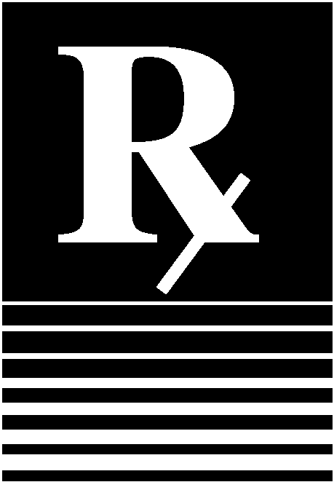  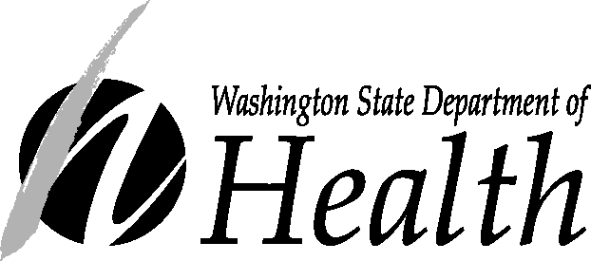  PO Box 47890  Olympia, WA 98504-7890  Web Site: www.doh.wa.gov  360-236-4027  (800) 525-0127 | Getting Medicine During  a Public Health Emergency  The Strategic National Stockpile is a federal government program that provides  medication and medical supplies to states during an emergency.
 | When help is needed fast  If a disease outbreak, bioterrorism attack or natural disaster happens in Washington State, thousands, possibly millions, of people will need medical attention to treat or prevent the spread of disease. Local medical supplies and medications will be used up quickly during such a public health emergency.  The Strategic National Stockpile (SNS) helps meet the need for additional supplies by quickly delivering large quantities of critical emergency medicines and supplies to states that request them.  Assistance for Washington and your community  In the event of a disaster, outbreak or attack, our Governor will ask the federal government to send SNS shipments to Washington. Once help is approved, the SNS will fill the request from storage facilities strategically located around the country. Supplies can be delivered to any state within 12 hours of the request.  Depending on the type of emergency, the SNS will deliver antibiotics, chemical antidotes, antitoxins or other medical or surgical items. Additional drugs and/or medical supplies can be supplied within the following 24 to 36 hours.  When SNS shipments are received, Washington State emergency response workers will immediately deliver the supplies and medications directly to the communities that need them.  Finding medication during an emergency  - Cities and towns in Washington State will set up emergency medication centers (also known as points of dispensing sites or PODS) where people can pick up the emergency medications or receive vaccinations. Medication centers will be located in large public buildings such as schools, arenas or churches in several | geographic areas to minimize the amount of time people need to travel to reach them. Local public health agencies will announce when medication centers will open, where to find them, how to get there, what to bring and what to expect. You will be able to get this important information from sources that include:  - Television and radio news; newspapers  - State and local public health and emergency management Web sites  - Community, civic and religious organizations.  Local governments are responsible for determining the location of medication centers in their areas. In many cases these sites will not be made public until an emergency occurs. Not all medication center sites will be used for every emergency, so it will be important to check the resources listed above for current information in the event of an emergency.  At the medication center  - If medication centers are opened to distribute medicine from the Strategic National Stockpile in an emergency, there will be no charge to the public.  - Trained staff will be available to assist you at the medication center.  - The process will be simple.  - Depending on the type of emergency, one person may be able to pick up medications for a household or group.  - Check the resources listed above for current information in the event of an emergency.

