Appendix A: Technical Notes

These notes describe how important terms used in this report were defined and measured. Topics are listed alphabetically, using major headings from the report or common statistical terms.
Confidence Intervals
Education (Added for the 2004 Supplement)
Geographic Variation
Healthy People 2000 and 2010
Intervention Strategies
Poverty (Added for the 2004 Supplement)
Race and Hispanic Ethnicity (Updated for the 2004 Supplement)
Rates
Small Numbers
Trend Analysis (Updated for the 2004 Supplement)
Urban and Rural

Confidence Intervals
Confidence intervals are used to account for the difference between a sample from a population and the population itself. They can also be used to account for uncertainty that arises from natural variation inherent in the world around us. As such, they provide a means of assessing and reporting the precision of a point estimate, such as a mortality or hospitalization rate or the frequency of reported behaviors. Confidence intervals do not account for several other sources of uncertainty, including missing or incomplete data, bias resulting from non-response to a survey, or poor data collection. In this report, we have used confidence levels of 95%. This level means that in 95 out of 100 cases, the confidence interval contains the true value.
This report gives confidence intervals for all survey data, such as data from the Behavioral Risk Factor Surveillance System (BRFSS), the Pregnancy Risk Assessment Monitoring System (PRAMS), and adolescent health surveys. These confidence intervals were generally calculated by multiplying the standard error by 1.96. Because of the nature of the sampling for BRFSS, PRAMS, and adolescent health surveys, standard errors for rates or frequencies using these data sources were generated using SUDAAN or STATA, software packages that account for complex sampling designs.
When data do not come from surveys but from other sources, such as birth and death records, including confidence intervals was left to the author’s discretion. Because confidence intervals around estimates developed from these sources account for natural variation, authors were encouraged to use confidence intervals in instances where rates were subject to large annual or other fluctuation. Methods used to calculate these confidence intervals are consistent with the Guidelines for Using Confidence Intervals for Public Health Assessment.
Confidence intervals are presented in narrative form, generally as a “plus or minus.” For example, in the “Obesity and Overweight” chapter there is a statement that in 2000, 18.8% (± 1.4%) of Washington residents were obese. The 1.4 was calculated by multiplying the standard error by 1.96. It can be both added to and subtracted from the observed data point (18.8) to get the 95% confidence interval of 17.4% to 20.2%.
Confidence intervals in this publication are also presented graphically, as in the time trend chart below showing obesity prevalence from 1990 through 2000. The confidence intervals are shown by the vertical lines, with the upper and lower limits shown by horizontal lines at each end of the intervals.
Confidence intervals in this publication are also presented in some of the horizontal bar graphs, as in the example below showing obesity by income and education.
While not equivalent to a formal test of statistical significance, rates are significantly different if the confidence intervals do not overlap. Thus, in the example presented above, college graduates have a statistically significantly lower rate of obesity than those with less education. Most often rates are not statistically significantly different when the confidence intervals overlap, but this is not always true. In the example given above where the confidence interval for people with incomes over $50,000 per year overlaps slightly with the confidence intervals for those with lower incomes, one would need to do a formal test of statistical significance to determine whether there are statistically significant differences in obesity for those in the highest income level compared to those at lower levels. In this example, a formal test shows statistically significant differences between those in the highest income group compared to those in the lower income groups. In contrast, the extent of the overlap in confidence intervals for the middle and lowest income group is such that we can conclude that the differences between these estimates are not statistically significant without doing a formal test.
For more detailed information on confidence intervals see Guidelines for Using Confidence Intervals for Public Health Assessment.

Education
(Added for the 2004 Supplement)
Researchers have consistently found a strong relationship between education and health. Persons with higher educational attainment generally enjoy better health. The reasons for this relationship are complex, but in general, people with higher levels of formal education are more likely to avoid high-risk health behaviors, to live in environments that support healthy life styles, to work in occupations with less exposure to toxins and physical hazards, and to take better advantage of medical services to prevent disease compared to people with lower levels of education. (See Social Determinants of Health, 2002 Health of Washington State.)
Several measures are commonly used to study the relationship between health and education, including individual years of education, whether an individual completed high school or college, and whether a person lives in a neighborhood characterized by relatively high or low educational attainment. In the 2004 Supplement to the 2002 Health of Washington State, we measured education as the proportion of adults, ages 25 and older, in a U.S. Census tract who had completed college.
Census tracts are small geographic areas within counties. They generally have from 2,500 to 8,000 residents. When first established, census tracts are designed to be as homogeneous as possible with respect to population characteristics, economic status, and living conditions. (U.S. Census Bureau, Geographic Areas Reference Manual, Chapter 10, http://www.census.gov/geo/www/garm.html)
To link educational attainment and health data, we first obtained records of health events (e.g., deaths, new diagnoses of cancer, new diagnoses of tuberculosis) with the address where the person lived when the event occurred coded to a census tract. We then used U.S. Census 2000 Summary File 3, Table P37 (Sex by Educational Attainment for the Population 25 Years and Over), available through American Fact Finder (http://factfinder.census.gov/home/saff/main.html?_lang=en), to assign to each record a number representing the proportion of adults, ages 25 and older, in the same census tract who had completed college. Finally, we divided people into five groups depending on the proportion in the census tract that had completed college. We selected 40% or more as the highest cut point, because that point resulted in about 20% of the total population being in the highest group. We then used cut points of 10%, 20%, and 30% to define four additional levels of education. The resulting five groups and the proportion of the Washington population in each group are as follows:
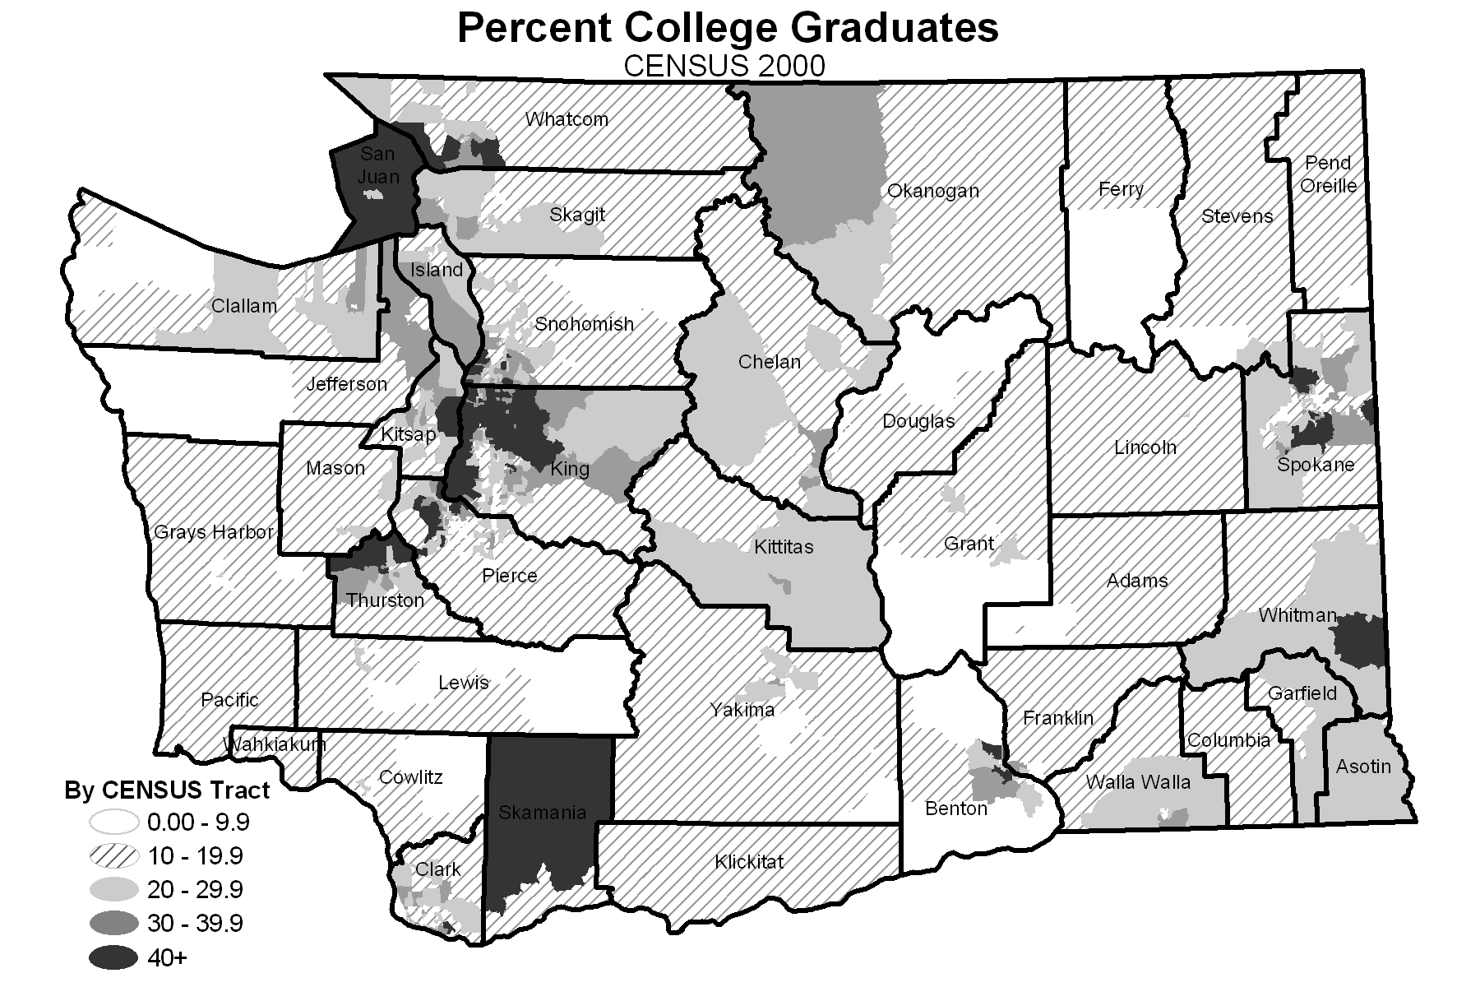
Percent College Percent Washington
Graduates Population
0 – 9.9 8.2
10 – 19.9 33.6
20 – 29.9 24.2
30 – 39.9 14.1
40 or more 19.9
Thus, education describes the general educational level of a community, which contributes to the context in which one lives. To some extent, the measure also describes individuals; an adult living in a neighborhood where a large proportion of adults have completed college is more likely to have a college degree compared to someone who lives in a neighborhood where fewer adults have completed college. Likewise, children living in neighborhoods where a large proportion of adults completed college are more likely to have parents with college educations compared to children living in neighborhoods where fewer adults completed college.
We selected a community or contextual measure of education because it is the only measure that is consistently available across the data sets used in the 2004 Supplement to the 2002 Health of Washington State. For the data sets used in this supplement, only death certificate data include individual educational level. An assessment of education as recorded on death certificates indicated possible inaccuracies for education of the decedent. Specifically, the number of high school graduates and persons with some education beyond college may be over-reported on death certificates.
We specifically chose to measure the proportion of the population who has completed college, because Washington data on individual educational attainment and major risk and protective factors for health suggest that completion of college has a stronger relationship with factors related to health than completion of high school. (See Major Risk and Protective Factors, 2002 Health of Washington State.) Additionally, since we used a measure of low economic resources (i.e., poverty) as our economic measure in the 2004 Supplement, using a measure of high education might help to broaden perspective on socioeconomic factors.
We selected a contextual measure for education for technical reasons and not with the intent of placing relatively greater importance on the context in which one lives compared to individual factors. Health researchers debate the relative importance of neighborhood and individual characteristics in relation to health, but evidence suggests that both factors are important even though the relative importance likely differs for different health indicators.
Some researchers focus on the interaction of individual and neighborhood characteristics. For example, they might assess the effect of a high level of individual education for persons living in areas characterized by relatively low educational attainment. Other health researchers believe that one cannot really distinguish contextual from individual factors, because “People create places, and places create people.” (Kawachi I and Berkman LF Introduction. In: Kawachi I and Berkman LF editors. Neighborhoods and Health. New York: Oxford University Press; 2003. p. 26.) Where possible, authors provided information from the scientific literature regarding the relative importance of individual education compared to the general level of education in the community for specific health conditions.

Geographic Variation
The maps in this report compare county rates or frequencies to the state average. Counties in darker shades have rates or frequencies above the state average, and those in lighter shades are below the state average. Counties were assigned to one of four groups using the following method:
1) County-specific rates or frequencies were calculated for the last three years for which data were available.
2) These rates or frequencies were arrayed in ascending order.
3) The rates or frequencies were divided into two groups based on whether they were above or below the state rate with “ties” broken by carrying out the rate calculation to as many significant digits as needed.
4) Each of the two groups described in step 3 were split into two equal-sized groups comprising “higher” and “lower” rates or frequencies within that group with “ties” broken as in step 3.
5) Because there are 39 counties, the first split always produced one group with an odd number. When doing the second split, the “extra” county was put in the group closest to the state average.
Caveats and limitations.
The rate for the state as a whole is strongly influenced by rates in the most populous counties (that is, King, Pierce, and Snohomish). If these counties have rates that are very different from the other counties, the distribution of counties can be skewed such that there are very few counties above the state rate, and most are below the state rate or vice versa.
The maps are presented to provide an indication of where counties rank in relation to the state as a whole, but in many instances there are not statistically significant differences among counties in the four groups. For counties in the lowest or highest groups, additional analysis is necessary to determine whether a health condition is more prevalent than in the rest of the state and, thus, might require additional attention.
While the general rule was not to provide rates or frequencies based on fewer than five events (see “Small Numbers” in this appendix), the maps might include some counties whose rates are based on fewer than five events. The authors used a number of strategies to minimize the potential for misinterpretation of data due to potential instability of rates based on a small number of events. Some authors simply advised caution in interpreting the map. Others did additional analysis to determine whether rates based on a small number of events showed stability over a 10-year period. If so, the author simply presented the data in the map with no statement of caution. Some authors did not include county maps, because many counties had fewer than five events.
County-level hospitalization data are unreliable for counties where a large proportion of the population uses military hospitals or hospitals in Idaho or, sometimes, Oergon (see below). On the maps, county rates were not provided for Island County because of the large proportion of people using military hospitals or for Asotin and Garfield counties because of the large proportion using hospitals in Idaho. Information on Washington residents hospitalized in Oregon is available, but cannot be always by combined with hospitalizations in Washington. (See “Hospitalization Data” in Appendix B for additional detail.) If data on Washington residents hospitalized in Oregon were not combined with Washington hospitalization data, maps do not include county rates for Clark, Cowlitz, Klickitat, Pacific, Skamania, and Wahkiakum counties.

Healthy People 2000 and 2010
Healthy People 2000 and Healthy People 2010 are documents that provide national health promotion and disease prevention objectives. These objectives were developed under the aegis of the United States Department of Health and Human Services incorporating input from federal, state, and local agencies and extensive public comment.
This report covers topics that correspond to objectives in Healthy People 2000 and Healthy People 2010. Where possible, we have provided information on whether we did or did not reach the Healthy People 2000 goal and whether we seem to be on track in reaching the goal for 2010. The goals in Healthy People 2000 were first established in 1990. Some of these goals were later revised in the Midcourse Review and 1995 Revisions. We have noted when the goal is based on the 1995 revisions.
The reader must be careful when assessing Washington relative to the national goals. First, many of our indicators are not identical to the indicators used in the national goals. Some of our indicators differ from the national indicators because we do not have comparable data. For example, one of the national indicators for nutrition is the proportion of people who eat at least five servings of fruit and vegetable each day. Our information only allows us to determine the number of times people eat fruit and vegetables each day and not the number of servings. Sometimes, our indicator differs from the indicator in the Healthy People documents because the Healthy People indicators are not consistent with other national standards. For example, the Healthy People uses coding conventions developed by the CDC National Center for Health Statistics to establish a goal for reducing colorectal cancer deaths, while we follow conventions established by the National Cancer Institute for defining colorectal cancer deaths. However, when we compare Healthy People indicators to Washington data, we used comparable definitions even though the definition might differ from that of the main indicator used elsewhere in the chapter.
Second, Healthy People 2000 and Healthy People 2010 are not always consistent with each other, because coding and other conventions have changed. For The Health of Washington State, changes related to age-adjustment and the coding of mortality data are most important.
- Healthy People 2000 age-adjusts many goals to the US 1940 standard population, while goals for the same health outcomes in Healthy People 2010 are age-adjusted to the 2000 US standard population. In addition, Healthy People 2000 provides goals for health-related behaviors, such as smoking and physical activity, that are not age-adjusted, while Healthy People 2010 age-adjusts these goals.
- The coding of causes of death changed in 1999 and the new coding system is not entirely comparable to the old system. Thus, we have 1999 and 2000 death data coded using one set of codes and a goals from Healthy People 2000 and 2010 based on pre-1999 codes. (See Death Certificate in Appendix B.)
While we present comparable data when making direct comparisons to Healthy People 2000 and 2010 goals, the data can differ from similar data found elsewhere in the chapter. For example, in the chapter “Alcohol and Drug Disorders,” the rate of cirrhosis deaths in 2000 is 8.7 per 100,000 age-adjusted using current conventions (that is, using the US 2000 standard population) and 6.4 per 100,000 following conventions used in Healthy People 2000 (that is, age-adjusted to the US 1940 standard population and then adjusting for changes in the coding of cause of death).
Additional information on Healthy People 2000 and Healthy People 2010 is available at http://odphp.osophs.dhhs.gov/pubs/hp2000/ and http://www.health.gov/healthypeople/default.htm.

Intervention Strategies
In determining what interventions are effective, authors were urged to follow the practices of the Guide to Community Preventive Services. The Guide recommends for or against specific interventions on the basis of systematic reviews of research studies and ranks the suitability of studies as follows:
- Most suitable: studies with concurrent comparison groups and prospective measurement of exposure and outcome
- Moderate suitability: studies with retrospective designs or multiple pre or post measurements but no concurrent comparison group
- Least suitable: single pre and post measurements and no concurrent comparison group OR exposure and outcome measured in a single group at the same point in time.
As a rule, authors needed to have multiple studies in categories 1 and 2 indicating the same outcome to conclude that the intervention was effective. If they had proven interventions from studies in categories 1 and 2, they needed to consider the extent to which the intervention could be generalized to Washington’s population and the cost-effectiveness of the intervention in the real world.
In instances where there were some, but not a sufficient number of studies in categories 1 and 2 to make strong statements of effectiveness, authors might have cited interventions that look promising based on one or two category 1 or 2 studies. If studies fell into category 3 or if there were no formal studies, authors stated that there were not interventions with proven efficacy. However, if other public health authorities, such as CDC, recommended an intervention or if there were broadly accepted reasons (such as logic models supporting the intervention) for pursuing particular interventions in the absence of empirical proof of effectiveness, the authors summarized the case for such interventions. In these instances, authors were requested to be clear that the recommendations were not evidence-based, but rather represented best practices or expert opinion in areas where evidence-based interventions are lacking.

Poverty
(Added for the 2004 Supplement)
There is a strong relationship between economic resources and health. Most commonly, people with more money enjoy better health, but for a few health measures, the opposite is true. The reasons for these relationships are complex, but people with more money generally are more successful in avoiding high-risk health behaviors, live in environments that support healthy life styles, minimize exposure to toxic chemicals, have experienced relatively low levels of physical violence, and are better able to take advantage of medical services to prevent disease compared to people with less money. (See Social Determinants of Health, 2002 Health of Washington State.)
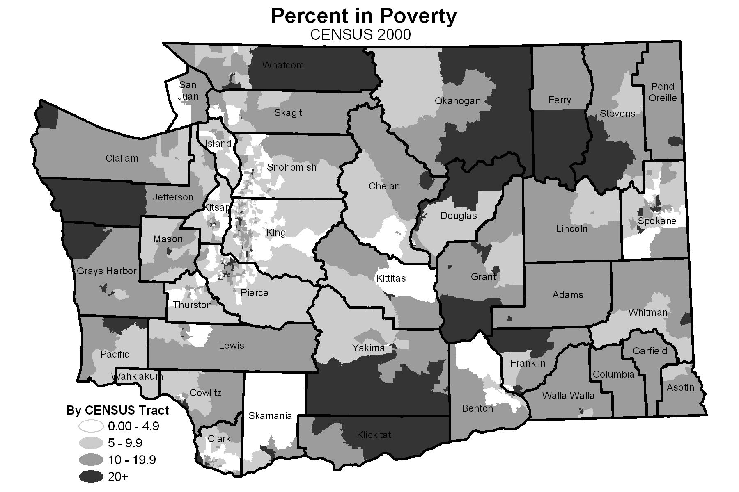
Several measures are commonly used to study the relationship between health and economic resources, including individual or household income, whether a person lives above or below the federal poverty level, or whether someone lives in a neighborhood characterized by high or low income or poverty. Research has shown that the percent of the population living in poverty at the census tract level offers a robust measure for detecting relationships between economic factors and health. (Kreiger N, Chen JT, Waterman PD, Soobader MJ, Subramanian, SV, Carson R. Geocoding and monitoring of US socioeconomic inequalities in mortality and cancer incidence: Does the choice of area-based measure and geographic level matter? Am J Epidemiol. 2002; 156(5):471-82.) Thus, in the 2004 Supplement to the 2002 Health of Washington State, we used this metric.
Census tracts are small geographic areas within counties. They generally have from 2,500 to 8,000 residents. When first established, census tract are designed to be as homogeneous as possible with respect to population characteristics, economic status, and living conditions. (U.S. Census Bureau, Geographic Areas Reference Manual, Chapter 10, http://www.census.gov/geo/www/garm.html). The proportion of the population living in poverty refers to the percent of persons in a given census tract who live at or below the federally defined poverty line. This threshold varies by the size and ages of persons living in a household. In 2000, a household with two adults and two children with a combined income of $17,050 was living at the federal poverty line.
To link poverty and health data, we first obtained records of health events (e.g., deaths, new diagnoses of cancer, new diagnoses of tuberculosis) with the address where the person lived when the event occurred coded to a census tract. We then used 2000 U.S. Census 2000 Summary File 3, Table P87 (Poverty Status in 1999 by Age), available through American Fact Finder (http://factfinder.census.gov/home/saff/main.html?_lang=en), to assign to each record a number representing the percent of persons in the same census tract who lived at or below the federal poverty line. Finally, we divided people into four groups depending on the percent of persons in the census tract who lived in poverty. We used the same groupings as those described in the appendix of Krieger et al. (Kreiger N, Chen JT, Waterman PD, Soobader MJ, Subramanian, SV, Carson R. Geocoding and monitoring of US socioeconomic inequalities in mortality and cancer incidence: Does the choice of area-based measure and geographic level matter? Am J Epidemiol. 2002; 156(5):471-82.) Using categorical cut points allows for comparison across geographic areas and time. Additionally, the federal government defines areas in which 20% of the population lives in poverty as federal poverty areas that qualify for programs such as urban empowerment zones and low-income housing programs. The groups and the proportion of the Washington population in each group are as follows:
Percent in Percent Washington
Poverty Population
0 – 4.9 24.4
5 – 9.9 35.1
10 – 19.9 30.0
20 or more 10.5
The percent of persons living at or below the federal poverty line describes the general economic level of people in one’s nearby community and the neighborhood context in which one lives. To some extent, the measure also describes individuals; people living in neighborhoods where a high proportion of the population is poor are more likely to be poor themselves compared to people who live in neighborhoods where there is less poverty.
We selected a community, or contextual, economic measure, because individual measures are generally not available for the data sets used in the 2004 Supplement to the 2002 Health of Washington State. We did not select a contextual measure with the intent of placing relatively greater importance on the context in which one lives compared to individual factors. Health researchers debate the relative importance of individual economic factors compared to the economic resources of a neighborhood in relation to health. There is evidence that both factors are important, although the relative importance likely differs for different health indicators.
Some researchers focus on the interaction of individual and neighborhood characteristics. For example, they might assess the effect that individual poverty has on health for persons living in areas with high compared to low rates of poverty. Other health researchers believe that one cannot really distinguish contextual from individual factors, because “People create places, and places create people.” (Kawachi I and Berkman LF Introduction. In: Kawachi I and Berkman LF editors. Neighborhoods and Health. New York: Oxford University Press; 2003. p. 26.) Additionally, interventions on both the individual and neighborhood levels can help to ameliorate the generally negative effects of poverty on health. Where possible, authors provided information from the scientific literature regarding the relative importance of individual economic resources compared to community-level economic factors for specific health conditions.

Race and Hispanic Ethnicity
(Updated for the 2004 Supplement)
Although there are diseases for which “race” and “ethnic group” are markers for genetic factors (such as malignant melanoma or sickle cell anemia), most scientists do not believe that race and ethnicity are biological constructs. Rather, in explaining the relationships of race and ethnicity to human health, race and ethnicity are best viewed as proxies for the effects of complex social, cultural, economic, and political factors. There are several reasons for presenting health data by race and ethnicity in The Health of Washington State. The primary reason is that there are differences in the rates of disease by race and ethnicity that probably reflect a variety of factors, such as socioeconomic status, cultural practices, and patterns of exposure to toxins. One of the national goals of Healthy People 2010 is to eliminate these disparities. To achieve this goal, rates must be tracked by race and ethnicity. (See Guidelines for Using Racial and Ethnic Groups in Data Analyses for a more detailed discussion of these issues and references.)
The U.S. Census Bureau uses the concept of race to reflect self-identification and not to denote any clear-cut scientific definition of biological stock. As with the U.S. Census, race as collected by the systems used to generate data for this document is not intended to denote a clear-cut definition of biological stock. For some systems, the race data reflect self-classification by people according to the race with which they most closely identify. For other systems, someone else reports the race of the person. These reports are most likely to reflect the race with which the person most closely identifies when the person reporting the race knows or knew the person well, such as when next-of-kin report race on a death certificate. At times, someone who does not know the person well makes a judgment about the person’s race, such as when a health care worker records race in a medical chart without first asking the person. In these instances, the race may not represent that with which the person most closely identifies.
Ethnicity, as used by the U.S. Census Bureau, refers to “the ancestry, nationality group, lineage, or country of birth of the person or the person's parents or ancestors before their arrival in the United States.” People of Hispanic or Latino ethnicity have their origins in a Hispanic or Spanish-speaking country such as Mexico or Cuba, or the Spanish-speaking countries of Central or South America. People of Hispanic ethnicity can be of any race.
Following national guidelines, most data systems currently separate Hispanic ethnicity from race. They generally first ask about Hispanic ethnicity. For example, the Behavioral Risk Factor Surveillance system asks, “Are you Hispanic or Latino?” It then asks about race.
Federal guidelines currently specify five racial categories including American Indian or Alaska Native, Asian, black or African American, Native Hawaiian or other Pacific Islander, and white. Until the 1997 revisions, federal guidelines grouped Asians and Pacific Islanders. The 1997 revisions were used in the 2000 U.S. Census, but most states, including Washington, did not adopt these conventions until 2003. Because the data presented in this report from Washington systems precede this change, we have grouped Asians and Pacific Islanders in presenting rates or frequencies by race.
Similarly, current guidelines from the federal Office of Management and Budget require that all federal systems, including the 2000 U.S. Census, allow the reporting of more than one race. These guidelines did not take effect in most states until 2003. Thus, the 2000 U.S. Census, used extensively in the 2002 Health of Washington State for calculating rates, allowed people to select more than one race, while the data collected by the state systems generally report only one race. When this situation arose (i.e., multiple race allowed in the population data and single race only in health data), we could not calculate rates by race.
In many instances where we could not develop Washington State data by race for the 2002 Health of Washington State, we provided information on differences in race from the scientific literature or from previously published Washington State reports. Readers were advised that this information needed to be interpreted with caution. Racial patterns in Washington might be different from those seen elsewhere and differences by race in previously published reports might have been due to under- or overestimating the number of people in different racial groups. Nonetheless, we included the information in the 2002 Health of Washington State, because relatively large differences by race were likely to reflect important disparities in Washington.
In September 2003, the National Center for Health Statistics released data that allocated people who chose multiple races on the 2000 Census to a single race. They provided similar files for 2001 and 2002, based on estimates of population growth. Additionally, Public Health – Seattle & King County used the 2000 data in combination with population counts from the 1990 U.S. Census and the Washington State Office of Financial Management to develop population counts by age, sex, and single race for 1991 – 1999. These population data allow us to develop rates for health events by race that were previously unavailable. The 2004 Supplement contains this new information.
For information related to the collection and use of race and ethnicity in specific data systems and for more information on the U.S. Census, the National Center for Health Statistics method for allocating people reporting more than one race to a single race, and intercensal interpolations, see Appendix B. Also see Guidelines for Using Racial and Ethnic Groups in Data Analyses for a more detailed discussion of these issues.

Rates

Crude Rates
A crude rate is the number of events (such as deaths) in a specified time period divided by the number of people at risk of these events in that period (typically, a state or county population). This figure is generally multiplied by a constant such as 1,000 or 100,000 to get a number that is easy to read and compare and is reported as “per 1,000” or “per 100,000.” In The Health of Washington State rates of infectious disease and health-related behaviors are generally reported as crude rates.
Crude rates adjust for differences in population size but not differences in population characteristics. These population characteristics also need to be considered in interpreting comparisons. For example, because death rates increase with increasing age, a county with an older population might have higher death rates just because its population is older. If this is the case, the same county would not have a higher age-adjusted death rate (see below).

Age-Adjusted Rates
Sometimes population characteristics need to be considered when comparing the health status of two groups of people, such as Washington residents and those of the US. Because many health indicators change with age, age is one of the most important characteristics to consider. We usually want to know whether our rate of disease or risk factors is higher or lower than a comparison group independent of the fact that we are older or younger than the comparison group.
Age-adjustment is a method of developing rates that eliminate the impact of different age structures in two populations. Age-adjustment also allows us to compare rates in the same population over a period of time during which the population may have aged. Age-adjusted rates are computed by multiplying the rate for a specific age group in a given population by the proportion of people in the same age group in a standard population and then adding across age groups.
Unless otherwise indicated, all age-adjusted rates in this document have been adjusted to the 2000 US standard population. While many national and state organizations currently age-adjust to the 2000 US standard population, many older documents, including the 1996 edition of The Health of Washington State, used the 1940 or 1970 US standard populations. When making comparisons, readers must be careful to compare age-adjusted rates that use the same standard population. Moreover, age-adjusted rates should not be compared to rates that are not age-adjusted (i.e. crude rates). Readers should be aware that an age-adjusted rate has no absolute meaning; it is an artificial number based on a hypothetical population and is only useful for comparing with other rates calculated in the same manner.
For more information on crude and age-adjusted rates see Guidelines for Using and Developing Rates for Public Health Assessment.

Small Numbers
Presentation and interpretation of statistics compiled for relatively small populations or when there are a small number of events in a population present several challenges. First and foremost, statistics developed for this report must preserve confidentiality. Breaches of confidentiality are usually more of an issue when the population for which the data are developed is relatively small.
A second concern involves interpreting data based on a small number of events irrespective of the size of the population, because random fluctuation can be relatively large when the number of events is small. For example, one more infant death is a larger percent change in an area with three deaths than for an area with 300 deaths. Because of these random fluctuations, rates based on small numbers might not be as stable as those based on larger numbers and so they can have limited predictive value. For example, knowing a rate for one year might not allow us to reliably anticipate the rate for another year if the number of cases is small. This instability makes it difficult to use rates based on small numbers for program planning or assessment. In fact, considerable caution should be used in interpreting any data where the number of events is small.
To ensure confidentiality and to provide relatively stable estimates of rates, we have combined three years of data for rates or frequencies that were calculated for sub-populations within the state, such as when presenting state-level data by race, income, or education, and when presenting county-level data. Moreover, rates developed from population data, such as birth and death files, are generally not presented if they are based on five or fewer events. Frequencies based on sample data are presented only if there are close to 50 responses per cell. For example, to report smoking by race from the Behavioral Risk Factor Surveillance System, there would need to be at least 50 people of each race who were current smokers and 50 people of each race who were not smokers.
For additional information, see Guidelines for Working with Small Numbers.

Trend Analysis
(Updated for the 2004 Supplement)
We conducted tests of trend to determine whether rates and frequencies were increasing, decreasing, or staying the same over time. For these analyses, we used the “joinpoint” methodology developed by the National Cancer Institute. Information on this method is available at http://srab.cancer.gov/joinpoint.
Trend analysis for mortality data was complicated by changes in coding death certificates effective in 1999. For some causes of death data before 1999 are not comparable to data from 1999 and later. In the 2002 Health of Washington State, we conducted formal trend analysis for indicators using the death data only through 1998 unless otherwise noted. We then discussed mortality rates for 1999 and 2000 qualitatively as indicating a continuation or change in the trend from previous years. In some cases coding changes did not substantially affect mortality rates and the formal trend analyses included 1999 and 2000 mortality. (See “Death Certificate System” in Appendix B for more detail.) In the 2004 Supplement, unless otherwise noted, we conducted tests of trend for 1990 – 2002 as a continuous series, adjusting for discontinuities due to coding changes if needed.
In the 2004 Supplement, we presented the trend data as three-year moving averages in the charts, but we used annual rates to determine trends and in the discussion in the text. Sources of national data presented in the trend charts in the 2002 Health of Washington State are either noted in the chapter or in the “National Data” sections of Appendix B.
We used also used joinpoint to determine whether rates of health conditions increased or decreased as levels of poverty and educational attainment increased or decreased.

Urban and Rural
The rates and frequencies presented under the heading “Urban and Rural” were developed using a modification of the Rural Urban Commuting Area (RUCA) codes developed by US Health Resources and Services Administration’s Federal Office of Rural Health Policy and the US Department of Agriculture’s Economic Research Service. In the RUCA system, population size and commuting patterns are used to classify census tracts on a ten-tiered continuum from rural to urban. For the Health of Washington State, we defined urban-rural using two methods.
For rates and frequencies that did not use census data, we collapsed the ZIP code approximation to the census tract RUCA codes into four categories (urban, suburban, large town, and small town/isolated rural). The assignment of ZIP codes can be viewed in Figure 5 of the Guideline cited below.
For rates that used census data, we assigned counties to urban, large town, and rural based on the proportion of the population living in different RUCA classifications. We were unable to use the ZIP code approximation to the RUCA codes, because we do not have population data based on the 2000 census by ZIP code. “Urban” includes counties where the majority of the population lived in urban core or suburban RUCAs in 1990; “large town” includes counties where most of the population lived in, or commuted to towns between 10,000 and 50,000; and “small town/isolated rural” includes counties where most of the population lived in or commuted to isolated rural areas or towns with fewer than 10,000 residents. County assignment in The Health of Washington State is similar to that in Figure 6 of the Guideline cited below. The Health of Washington State uses the “Urban” and “Small Town/Isolated Rural categories as seen in Figure 6, but combines “Mixed Rural” and “Large Town” due to the relatively small number of counties in these categories.
The RUCA system was last updated based on the 1990 census. We expect that the system will be updated based on the 2000 census in the fall of 2002. After that time and depending on the availability of population data at the ZIP code level, we will update the urban-rural sections of this document.
For more information, please see Guidelines for Using Rural-Urban Classification Systems for Public Health Assessment.

