Overview
As we celebrate the reopening of the Evergreen state, we have a single message for you: We are Washington Ready! And we couldn’t be here without you – so thank you.

Your work has made a difference. And it’s through your hard work that we have gotten to the point where we can safely say we are ready.

Washington Ready...for business
Washington Ready…for tourism
Washington Ready…to protect health
Washington Ready…for the challenges ahead
Washington Ready…for working together
Washington Ready…to get everyone vaccinated
But our work isn’t over. As we share this message of thanks and of gratitude, we know there’s a lot more left to do. We know that millions in our state are still unvaccinated. We need your help to reach them, to help them understand that a vaccine in their arm not only protects them, it protects everyone. So as we celebrate today, we know the work continues, but the good news is… we are Washington Ready.

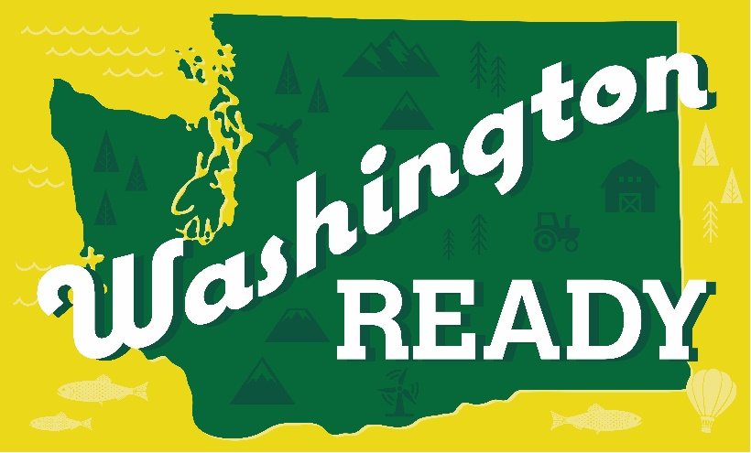
Press Releases
Masking June 29, 2021 – The new Secretary’s Order on masking clarifies the rules around when people are required to wear a mask post-reopening. Remember – respect the rules of the room you’re in.
Statewide Re-opening June 30, 2021 - The work to vaccinate Washington continues as we endeavor to re-open the state economy to pre-pandemic levels.
Call to Action:
Please join us in sharing these assets on your social platforms in any way you see fit to help share the great news of reopening and being Washington Ready.

Logos and Screenshot gallery
- Social Media images & posts
- Individual assets for customizing “Washington Ready” within your own branding/style
- Custom letterhead/Custom Email Signature
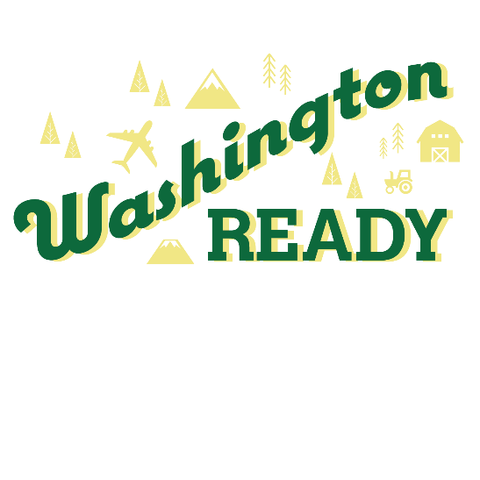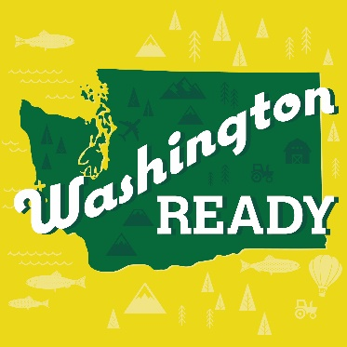
Suggested posts: (please take creative license!)
- We are thrilled to join the Washington State Department of Health, the Governor’s office, and all of our partners in saying we are Washington Ready! Washington state has been in the COVID-19 fight the longest, after the first case of coronavirus was discovered in Snohomish County. Ever since, we’ve been leading the way in keeping the people of Washington safe and protected from the virus. Now, we are Washington Ready to get back to normal again!

- This pandemic hit us hard, but with more than 4.2 million people with at least 1 shot of vaccine in their arms, we are ready for the next step – Washington Ready! That means opening the economy, that means opening for business, that means welcoming tourists whether it’s in our small towns, on the coast, on our hiking trails, or in the city.

- Washington Ready means more than reopening – it also means ready to get vaccinated! If you’re one of the millions who still needs to get a shot, please do it! Do it not just for yourself, but to protect the people around you, especially kids and other vulnerable folks who can’t get vaccinated yet.

- Washington is ready. Ready for business, ready to get back to normal, ready for life again. Find out more about the state reopening here - https://www.doh.wa.gov/Emergencies/COVID19/FrequentlyAskedQuestions

- Washington is ready to get vaccinated. Find the nearest vaccine location near you! https://vaccinelocator.doh.wa.gov/

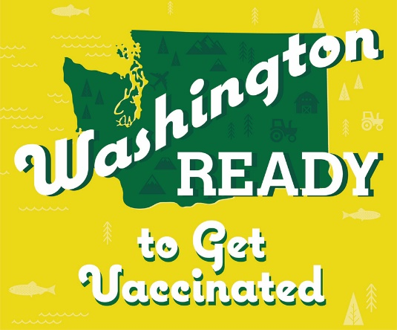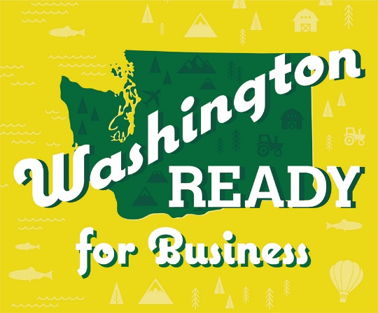
By the Numbers:
- We are at 68.8% of population 16+ with at least one dose of vaccine
- Almost 7.8M doses of vaccine have been given since vaccines arrived in December 2020
- More than 3.8M people are fully vaccinated – that’s more than 60% of population 16+
Supportive Information:
Department of Health - How do I get Vaccinated?
Department of Labor & Industries – Workplace Guidance as of June 30, 2021
Department of Health – Statewide Reopening FAQ
WA Business Signage Toolkit – Mask Requirements (English and Spanish)

