Washington State Emergency Cardiac and Stroke System

Hospital Name:

2023 Application for Level II
Cardiac Center Categorization

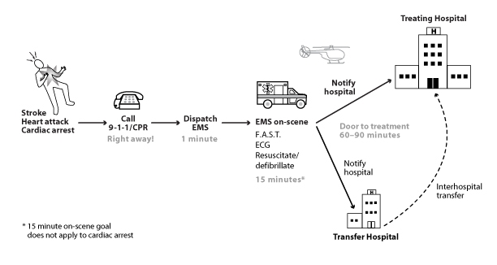

Office of Community Health Systems
111 Israel Rd. SE Mailing:
Tumwater, WA 98501-5570 PO Box 47853
www.doh.wa.gov Olympia, WA 98504-7853
800-458-5281

DOH 346-061 December 2019

The Washington State Emergency Cardiac and Stroke System
Guiding Principles

The Washington State Emergency Medical Services and Trauma Care Steering Committee convened a work group to study emergency cardiac and stroke care in 2006. The work group included emergency medical services providers, emergency physicians, cardiologists, neurologists, nurses, and representatives from the Washington State Hospital Association, American College of Emergency Physicians, and the American Heart Association/American Stroke Association. In response to the study findings, the work group made recommendations for a statewide coordinated emergency cardiac and stroke system similar to the state’s Trauma System.

These principles guided the work group in developing recommendations:

    - Prevention is the first line of defense against heart disease and stroke.
- Care is provided based on what is in the best interest of the patient.
- All Washington residents have a right to optimal care: timely identification, transport, treatment, and rehabilitation by emergency response and health care professionals trained according to best practice standards.
- Racial, ethnic, geographic, age, and socioeconomic disparities are addressed.
- Market-share is balanced by policies and strategies such as telemedicine that promote broad provider participation.
- Regional differences are recognized, but basic elements exist statewide.
- All components of the system participate in planning and quality improvement.
- Patient outcomes are valued, and data collection, analysis, and quality improvement practices demonstrate the quality that the system claims to provide.
- Cost-savings are achieved where possible.

Contents

- General Information …………………………………………………………………..………. 3
- Application Process…………………………………………………………………………….. 7
- Application ………………………………………………………………………………………… 9
- Hospital Profile and Personnel ………………………………………………………. 9
- Certification Statement ………………………………………………………..………. 11
- Categorization Level Criteria Checklist ………………….………………………. 13
- Documentation Checklist ……………………………………………………………… 17
- Appendices ……………………………………………………………………………..……...... 19
A. State of Washington Prehospital Cardiac Triage Destination
Procedure……………………………………………………………………………………… 21

B. Data Collection and Reporting Requirements………………………………… 23

C. Resources……………………………………………………………………………………… 25
D. System Activation Guidelines…………………………………………………………. 27

This page intentionally left blank

- General Information

What is the Washington State Emergency Cardiac and Stroke (ECS) System?
The ECS System is a coordinated systems approach to improving emergency response and treatment for acute coronary syndrome, cardiac arrest, and stroke patients. The goal of the system is improve patient outcomes by reducing time to treatment and getting patients into a dedicated system of comprehensive care. The ECS System is based on the same principles as the Trauma System – get the right patient to the right place in the right amount of time to save lives and reduce disability.

State law passed in March 2010 authorizes the ECS System. The law is based on recommendations of the Emergency Cardiac and Stroke Work Group convened by the Emergency Medical Services and Trauma Care Steering Committee in 2006. The law required the Department of Health to support an emergency cardiac and stroke system by 2011, including cardiac- and stroke-specific protocols and destination procedures for emergency medical services (EMS), and encouraging hospitals to voluntarily participate in the system. To participate, hospitals self-identify their cardiac and stroke resources and capabilities by applying for categorization as a Level I, II, or III Stroke Center, or Level I or II Cardiac Center. These levels are defined by the recommendations of the Emergency Cardiac and Stroke Technical Advisory Committee, as required by the law.

Why do we need a system for emergency cardiac and stroke care?
Too many people become disabled or die from heart attack, cardiac arrest, and stroke because they don’t get treatment in time.
- Most strokes (80%) are caused by clots. In 2018, only 11 percent of this type of stroke were given the clot-busting drug t-PA, and less than 5 percent were treated with mechanical thrombectomy, the two best options for treating stroke.
- Primary percutaneous coronary intervention (PCI) is the most effective treatment for most people having a heart attack. PCI includes angioplasty and stenting. In Washington, less than half of all people who have a heart attack get PCI.
- Access to resources for diagnosing and treating heart attacks and strokes varies, especially in rural areas.
- Heart attack and stroke patients are often transported to the nearest hospital only to be transferred to another hospital. This can delay treatment for hours. Cardiac and stroke patients don’t have hours.
The ECS System addresses all of these problems by reducing time to life-saving treatments. It gets patients to facilities committed to providing the most timely and optimal evaluation and care. Heart attack and stroke patients treated in time will likely need less rehabilitation, suffer fewer disabling conditions like paralysis and congestive heart failure, and can often go home after their hospitalization.
Why should my hospital participate?
- EMS needs to know what cardiac and stroke resources hospitals have so they can get their patients to the right treatment in time. By participating, you will be
- Strengthening our emergency medical services system.
- Ensuring people get the treatment they need.
- Saving lives, reducing disability, and improving quality of life.
- The destination and triage tools EMS uses to determine where to take their patients directs them to transport patients only to participating hospitals. Exceptions to the destination triage guidance are for extremely unstable patients or when there is no other option within specified transport times.
- People in your community will benefit by having a participating hospital close by. They’ll know that if they go to your hospital, whether they are brought in by family or ambulance, that you’ll do the right thing for them. In some cases, that might mean immediately transferring them. In others, EMS might take them directly to another hospital if it means getting treatment that will save their lives and get them home faster.
- You’ll be part of the statewide effort to increase access to quality emergency cardiac and stroke care through an organized system of care. Washington is the only state in the country to have a statewide system for cardiac and stroke care.

How will we know if the ECS System is successful?
The 2010 legislation, codified in RCW 70.168.150, requires participating hospitals to “participate in internal, as well as regional, quality improvement activities.” It also requires “participation in a national, state, or local data collection system that measures cardiac and stroke system performance from patient onset of symptoms to treatment or intervention, and includes, at a minimum, the nationally recognized consensus measures for stroke.”

The legislation did not include authority or funding to establish a state data collection system. Together with our many partners in the ECS System, we have instead leveraged existing data collection resources and quality improvement initiatives to evaluate the system’s impact using existing indicators. Many hospitals are participating directly or indirectly in Get With the Guidelines for stroke (GWTG-S), the Clinical Outcomes Assessment Program (COAP) for heart attack, and the Washington Cardiac Arrest Registry to Enhance Survival for cardiac arrest. The Department of Health can use aggregate reports from these sources to evaluate the ECS System.

The law also amended the EMS and Trauma System law to expand the scope of the EMS and Trauma Regional Quality Improvement (QI) programs to allow protected discussion and evaluation of regional cardiac and stroke systems and care delivery. All of the Regional QI programs have incorporated cardiac and stroke evaluation to some degree. Participating hospitals should send their cardiac and stroke coordinators to these regional QI meeting. Contact the Regional administrator listed the key on the Hospital and Personnel page.
How long is the categorization period?
Three years.

Can we change our categorization level?
Yes, you can apply to change your level anytime. Request a current application from the department contact listed below.

What if we no longer want to participate in the system?
You can withdraw at any time. Send written notice to the department contact listed below.

What if we no longer meet the categorization criteria?
Notify the department as soon as your status changes, and send written notice to the department contact.

Department Contact:

Matt Nelson, 360-236-2816
Matt.Nelson@doh.wa.gov
Department of Health
Office of Community Health Systems
Attn: Matt Nelson
PO Box 47853
Olympia, WA 98504-7853

This page intentionally left blank

II. Application Process

To apply for categorization or re-categorization in the Washington State Emergency Cardiac and Stroke System as a Cardiac Center:

- Certified Cardiac Centers: If your hospital is certified as a Cardiac Center by a national accrediting organization, complete sections A and B of the application and mail them to the department contact listed below, along with proof of certification from the accrediting organization indicating the certification period. If your hospital is not certified by an outside accrediting organization, please follow the directions at B. Non-Certified Hospitals.

- Non-Certified Hospitals: Complete all sections of the application electronically, and prepare the required documentation.

- Complete one application per hospital. One application for multiple hospitals or campuses in a hospital system is not acceptable. A completed application includes:

- Hospital and Personnel Profile
- Certification Statement
- Criteria Checklist
- Documentation Checklist
- Required Documentation

- Print out the completed application on 8 ½ x 11 white paper, double-sided where possible.

- Get the required signatures on the Certification Statement.

- Print out the required documentation in the order on the documentation checklist.

- Place a labeled divider between each section of the application, and each article of documentation.

- Make a copy for your own records.

- Mail the completed application to:

Department of Health
Office of Community Health Systems
Attn: Matt Nelson
PO Box 47853
Olympia, WA 98504-7853

Street address (for FedEx, UPS, etc.):
111 Israel Road SE
Tumwater, WA 98501-5570
We will review your application for completeness and confirm your categorization or re-categorization in writing, or contact you if we have questions within 60 days. We’ll call the contact person listed on the Hospital Profile for questions.
Questions? Please call or email Matt Nelson 360-236-2816, Matt.Nelson@doh.wa.gov.
Thank you for participating in the Emergency Cardiac and Stroke System and being a part of the statewide effort to ensure all Washington citizens have access to quality acute cardiac care.

III. Application for Level II Cardiac Center Categorization

A. Hospital and Personnel Profile

Hospital Name:
EMS/Trauma Region*:
Mailing Address: |  | City: | Zip:
Physical Address: |  | City: | Zip:
Phone: |  | County:
Application Contact and Title:
Phone: | Email:

Hospital Administrator/CEO:
Phone: | Email:
Cardiac Service Director:
Phone: | Email:
Cardiac Care Coordinator:
Phone: | Email:
ED Medical Director:
Phone: | Email:
ED Nursing Director:
Phone: | Email:

*EMS/Trauma Region Key
Region: | Includes the following counties: | Contact name - email:
Central | King | Rachel Cory – rachelcory@comcast.net
East | Ferry, Stevens, Pend Oreille, Lincoln, Spokane, Adams, Whitman, Asotin, Garfield | Rinita Cook - Rcook@ncecc.org
North | Whatcom, Skagit, San Juan Island, Snohomish | Martina Nicolas - martina@northregionems.com
North Central | Okanogan, Chelan, Douglas, Grant | Rinita Cook - Rcook@ncecc.org
North West | Clallam, Jefferson, Kitsap, Mason | Rene Perret - rene@nwrems.org
South Central | Yakima, Kittitas, Benton, Franklin, Walla Walla, Columbia | Zita Wiltgen - zitawiltgen@screms.org
Southwest | Wahkiakum, Cowlitz, Clark, Skamania, Klickitat, South Pacific | Zita Wiltgen - swems@comcast.net
West | Pierce, Thurston, Lewis, Grays Harbor, North Pacific | Anne Benoist – anne@wrems.com

This page intentionally left blank

B. Certification Statement

I, (CEO/COO), on behalf of (hospital), voluntarily agree to participate in the Washington State Emergency Cardiac and Stroke System as a Level II Cardiac Center. We will work with emergency medical services and other hospitals in our area to streamline triage and transport of cardiac patients and participate in regional quality improvement activities, as available.

I certify that:
- The information and documentation provided in this application is true and accurate.
- This hospital meets the criteria to be categorized as a Level II Cardiac Center as defined in the criteria checklist and provides these services 24/7.
- Our hospital is committed to improving emergency response and treatment of acute coronary syndrome, heart attack, and cardiac arrest.
- We will participate in a national, state, or local data collection system that measures cardiac and stroke system performance from patient onset of symptoms to treatment or intervention, as required by RCW 70.168.150.
- We will notify the Department of Health immediately if we are unable to provide the level of cardiac service we’ve committed to in this application.

Chair, Governing Entity (Hospital Board) Date

Chief Executive Officer Date

Cardiac Service Director Date

Cardiac Care Coordinator Date

Emergency Department Medical Director Date

Participation Criteria for Level II Cardiac Center | Met | Documentation Requested This will be updated to same as Level I, where applicable.
Personnel
Cardiac care coordinator as defined by hospital. Responsibilities might include ensuring cardiac protocols/order sets are in place and updated according to current guidelines, training or arranging for training, data collection, QI, coordinating with EMS and other hospitals where applicable, and public education. |  | List of cardiac care coordinator responsibilities
Cardiac team as defined by hospital. The team of staff on duty at the hospital that responds to cardiac emergencies. Each categorized hospital must have a cardiac team that responds to cardiac emergencies. An administrative or QI team at an individual hospital or for multiple hospitals in a healthcare system does not meet this criterion. |  | Description of the cardiac team (members)
Physicians or mid-level providers with current ACLS certification or equivalent, in-house or on-call and available to the emergency department 24 hours a day, seven days a week
Emergency department nurses with current ACLS certification or equivalent
Cardiac Services
Fibrinolytic therapy 24 hours a day, seven days a week
Therapeutic targeted temperature management 24 hours a day, seven days a week for appropriate patients post-cardiopulmonary arrest with return of spontaneous circulation
Resuscitation and stabilization of cardiac patients prior to transfer to higher level of care 24/7
Infrastructure
Laboratory or point of care testing 24 hours a day, seven days a week
Cardiac team activation policy and criteria based on EMS pre-arrival notification and for “walk-ins”. See ACS Activation Guidelines for hospitals in Appendix D for considerations. |  | Cardiac team activation policy
Cardiac protocols that include:  - Chest pain/discomfort (e.g., uncomfortable pressure, squeezing, fullness), usually in the center of the chest lasting more than a few minutes, or that goes away and comes back.  - Other acute coronary syndrome symptoms:  - Pain or discomfort in 1 or both arms, neck, jaws, shoulders, or back.  - Shortness of breath with or without chest discomfort.  - Other symptoms may include sweating, nausea/vomiting, lightheadedness.  NOTE: As with men, women's most common heart attack symptom is chest pain or discomfort. But women are somewhat more likely than men to experience some of the other common symptoms, particularly shortness of breath, nausea/vomiting, and back or jaw pain. Please refer to this website for more information.  - Triage for ED walk-ins presenting with acute coronary syndrome including recognition of signs and symptoms;  - Initiation of targeted temperature management for patients post-cardiopulmonary arrest with return of spontaneous circulation, i.e., a protocol for inducing hypothermia and guidelines and equipment necessary to perform;  - Use of fibrinolytics, including contraindications (fibrinolytic checklist) and immediate transfer process for situations when the cath lab is temporarily unavailable and fibrinolytics might be used;  - Transfer protocols or guidelines for patients in need of specialized care via ground or air at the highest level of care available, preferably critical care. |  | Cardiac protocols (order sets, procedures/algorithms, etc.) for each action or process listed. General EMTALA transfer protocols or guidelines that don’t specifically address cardiac transfers are not adequate documentation.
Referral to cardiac rehabilitation program. Referral policy or protocol includes referral criteria (AMI, CABG, PCI, stent, valve replacement, etc.) If you don’t have a referral policy, please include a statement explaining why in the documentation section. |  | Referral policy or protocol. If you don’t have a referral policy, please include a statement explaining why in the documentation section.
Coordination with Emergency Medical Services, e.g., working with county EMS Councils, Regional Councils, or Medical Program Directors on cardiac care and transport policy and procedures, system activation, training, data collection and quality improvement. |  | Description of how you work with EMS in your community, e.g., participation in county and/or regional EMS council meetings, training, quality improvement, and any documentation of these activities if available.
Training and Education
Current ACLS certification or equivalent for emergency department nurses
Assistance with training and clinical education of EMS in coordination with the EMS Medical Program Director, as needed, and if requested, particularly for reading ECG for STEMI patients to enable earlier activation of the team.
Public education on cardiovascular disease prevention, the signs and symptoms of heart attack, and the importance of learning CPR and calling 911 in cardiac emergencies. |  | Example from previous year, or planned for current year.
Performance Measurement and Quality Improvement
Participation in a national, state, or local data collection system that measures cardiac system performance from patient onset of symptoms to treatment or intervention. See Appendix B for information on what’s required to meet this criterion. |  | Documentation or description of the data collection system.
Participation in internal multi-disciplinary quality improvement activities related to cardiac care. Internal quality improvement (QI) means customary QI activities to improve quality of care based on process and outcome data from internal or external cardiac QI programs or registries the hospital participates in. |  | Provide a description of your cardiac QI activities. This should include:  - The type and source of data used to guide the process (e.g., internal or external patient data registries).  - Participants in the internal QI process (multi-disciplinary)  - The process, e.g., monthly meetings with case reviews, data presentations, PDSA’s, root cause analysis, etc.  - An example of a cardiac case reviewed during the previous categorization period. Please include a summary of the case, the issue identified, discussion and conclusion, action plan developed to address deficiencies or improve processes, evaluation of the action plan and issue resolution (loop closure). The example may be a system issue, a physician or nursing practice issue or an unfavorable patient outcome. Please mark as confidential, and remove all patient and practitioner identifiers.
Participate in regional quality improvement activities The ECS law amended RCW 70.168.090(2) to allow existing regional EMS and trauma quality assurance (QA) programs to evaluate cardiac and stroke care delivery in addition to trauma care delivery. |  | Description of participation in regional cardiac QI activities.

This page intentionally left blank

D. Documentation Checklist

Please attach documentation in the order specified. Place a divider, such as a piece of colored paper or tabbed divider, between each piece of documentation.

Description of the cardiac team.
Cardiac team activation policy and criteria based on EMS pre-arrival notification.
Evidence of coordination with Emergency Medical Services providers, including:
- Prehospital assessment (e.g., EKG, fibrinolytic checklist)
- Prehospital notification language and system activation (e.g., Code STEMI, cardiac arrest with ROSC)
- Prehospital treatment protocols ( e.g., medications, IVs, AED; can be EMS protocols)
- Prehospital destination planning/transport procedures (e.g., the county level transport guidance, such as in county operating procedures)
No divert policy for all patients who meet the "Immediate" or "High Risk" criteria as described in the Washington State Prehospital Cardiac Triage Destination Procedure and a back-up plan for situations when the hospital’s cardiac care resources are temporarily unavailable.
Chest discomfort protocol.
Triage protocol for ED walk-ins presenting with symptoms of acute coronary syndrome, including atypical symptoms.
Targeted temperature management protocol for appropriate post-cardiopulmonary arrest patients with return of spontaneous circulation.
Fibrinolytic checklist to assess for contraindications and immediate transfer process for situations when the cath lab is temporarily unavailable and fibrinolytics might be used;
Transfer protocols or guidelines for patients in need of specialized care via ground or air at the highest level of care available, preferably critical care.
Referral policy or protocol for cardiac rehabilitation, including referral criteria (AMI, CABG, PCI, stent, valve replacement, etc.) and how referral is to occur, e.g., prescription given to patient, paper or electronic referral sent to rehab program for follow up with patient, etc.
Documentation or description of data collection system.
Method to measure performance on door-to-balloon time.
Internal multi-disciplinary quality improvement activities or plan. Include who’s involved, how care is evaluated (e.g., case reviews, data review), what’s done about problems identified, and how often the activities occur.
IV. Appendices

- State of Washington Prehospital Cardiac Triage Destination Procedure
- Data Collection and Quality Improvement Requirements
- Resources
- Acute Coronary Syndrome Activation Guidelines

This page intentionally left blank

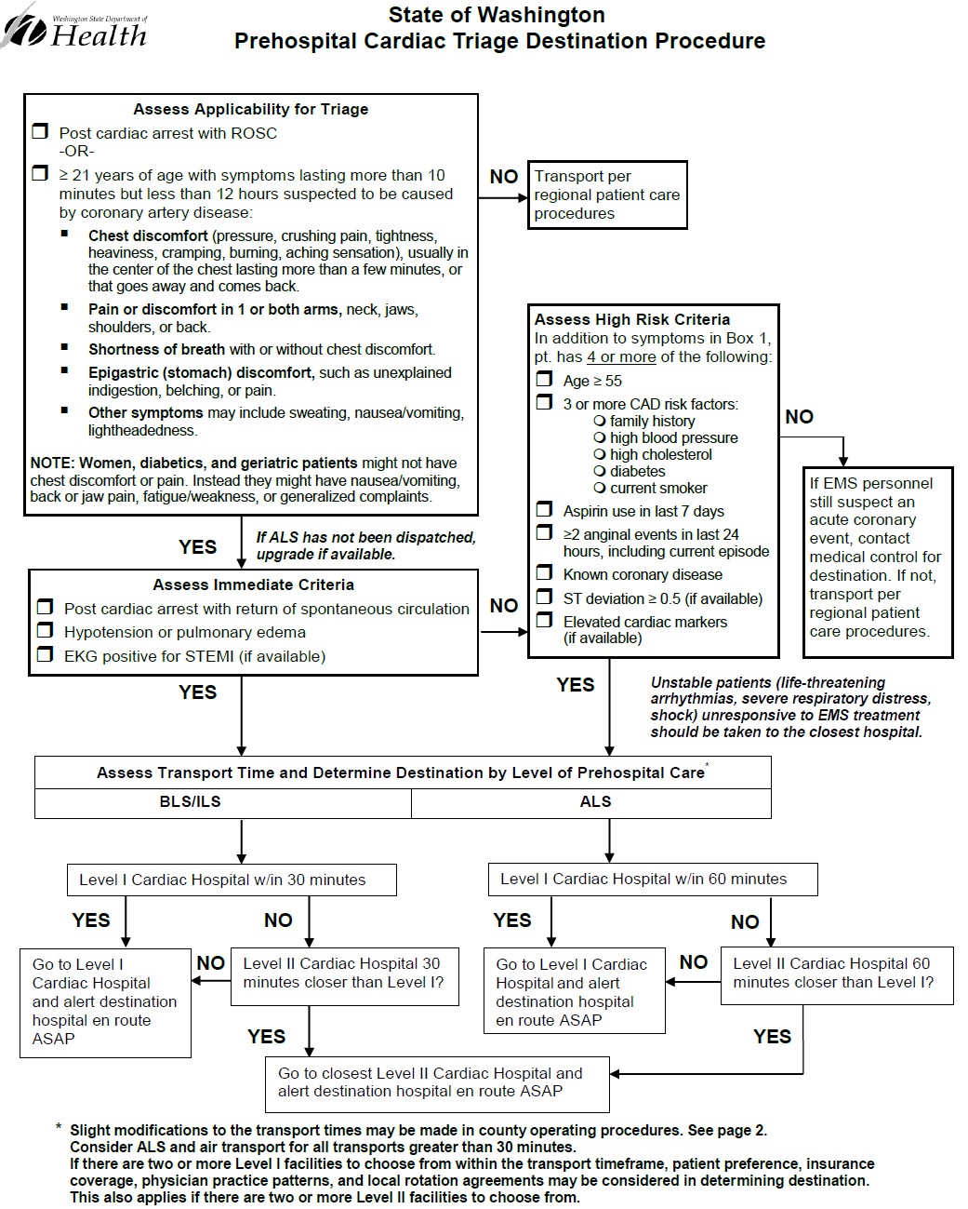
APPENDIX A
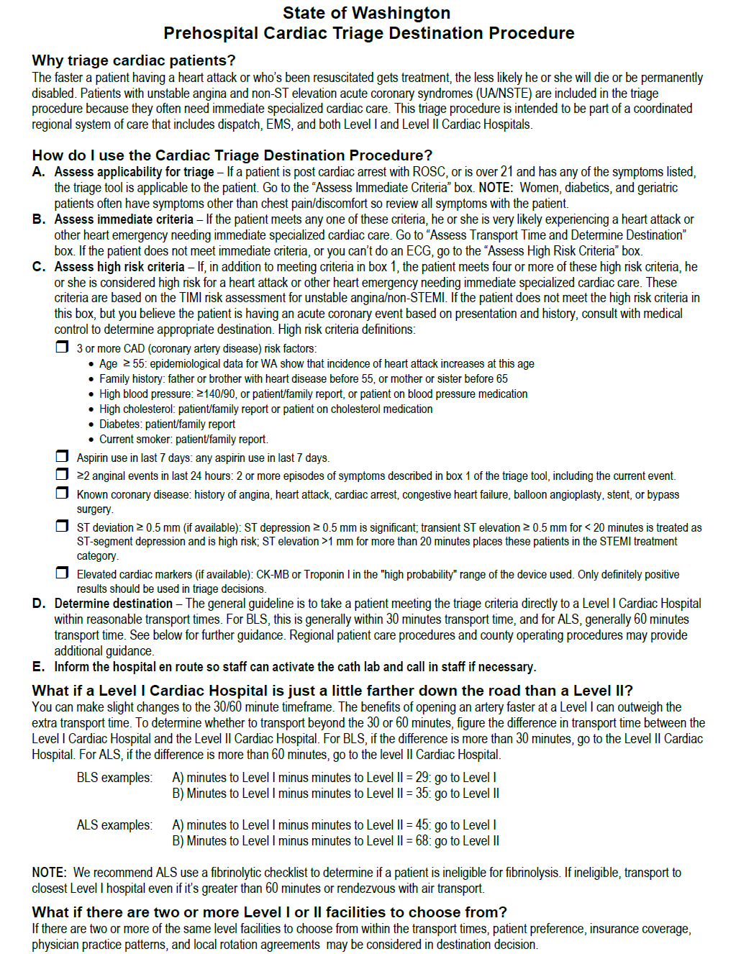

Appendix B. Data Collection and Reporting Requirements
APPENDIX B

The Emergency Cardiac and Stroke System (ECS) law requires participating hospitals to “participate in a national, state or local data collection system that measures cardiac and stroke system performance from patient onset of symptoms to treatment or intervention.” These data cover time intervals and processes along the continuum of care for the acute event: onset of symptomsdispatchEMStransfer hospitaltreating hospitalinterventionoutcome. By checking how well the system works along the entire continuum of care, we’ll find where the delays or obstacles are and target improvements where they’re needed.

Reporting to the Department of Health is not required. As noted in the introductory section of this application, the department was not funded for centralized data collection and analysis. We will get aggregate reports from Get With the Guidelines for Stroke, COAP, and PNW CARES to get a state level view of ECS System performance.

To measure how well the ECS System achieves the goals of reducing time to treatment and improving heart attack and cardiac arrest outcomes without adding significant burden to hospitals, the ECS Technical Advisory Committee recommended data elements and measures that are generally consistent with national measures and registries. Data collection systems/registries used by hospitals and regional systems should, at a minimum, be able to collect, analyze, and trend:

- Time from onset of symptoms to 911 call (from EMS)
- EMS Time on-scene (arrival at patient side to departure from scene; from EMS)
- Mode of arrival/Percent of AMI patients who arrive by EMS, walk-in/self-transport, or transfer-in from another hospital
- Pre-arrival notification/Percent of AMI patients for whom prearrival notification from EMS was received
- Reperfusion/Percent of AMI patients who get any reperfusion (PCI or lytics)
- Hypothermia/Percent of resuscitated cardiac arrest patients who are appropriate for and get therapeutic hypothermia
- Mean door to balloon time
- Median door to balloon time
- Time from first medical contact (first medical contact means EMS, or first hospital if transferred in and arrival at first hospital was self-transport) to treatment/Percent first medical contact to balloon (PCI) in less than 90 minutes
- Time in transfer hospital or “door-in-door-out” time/Percent with door-in-door-out time less than 30 minutes
- Total time from onset of symptoms to treatment/Percent time from onset of symptoms less than 120 minutes
- CMS core measures (some overlap with recommended measures)
- Outcomes (in-hospital mortality; discharge disposition, e.g., alive, dead, home, nursing home, rehab. Suggested: left ventrical ejection fraction for AMI and cardiac arrest at discharge and 60 days; neurological outcome for cardiac arrest*)
- Percent of patients with PCI post-ROS
Data collection and analysis is meant to be used by EMS and hospitals and their regional partners for internal and regional process and quality improvement, and national and state benchmarking.

The data collection tools or registries that measure onset of symptoms to treatment include:

National
NCDR’s ACTION Registry®-Get With the Guidelines™ - This QI program and patient management tool is the most comprehensive off-the-shelf data collection system available. In addition to core measures, GWTG measures time from onset, mode of arrival, advance notification from EMS, transfer status, discharge status. This option is the most comprehensive, it’s used nationally, and meets the requirements in the law. There is a limited version that might be appropriate for Level II Cardiac Centers.

State
Clinical Outcomes Assessment Program (COAP) through the Foundation for Healthcare Quality. With the addition of AR-G in 2012 to COAP’s array of registries, hospitals can now meet the data collection requirements through COAP.

Local
Local data collection systems should, at a minimum, be able to collect, analyze, and trend the same data and measures listed above. Examples of local data collection systems include:
- An internal registry, information system, electronic health record, or spreadsheet, for a regional cardiac system of care. For example, a Level I Cardiac Center collects data in a database or spreadsheet on onset of symptoms to treatment and outcomes for their own patients as well as those transferred in by a Level II Cardiac Center. The Level II Center provides the necessary process data (e.g., time of symptom onset, time of arrival at and departure from hospital, etc.) to the Level I Center.
- (For Level II only) Participation in a regional cardiac system of care, where a Level I Cardiac Center participates in one of the national or state registries.
- (For Level II only) Internal hospital process to track recommended measures relevant to the level of care and services provided, i.e., this wouldn’t include door-to-balloon time since a Level II doesn’t perform PCI. This could be an internal registry, information system, electronic health record, or spreadsheet where heart attack and cardiac arrest patient data is collected and used to evaluate process and outcomes for quality improvement purposes, internally and regionally.

Other data collection systems not listed here may also meet the reporting requirement. To determine whether a data collection system meets the requirement or for any other questions about cardiac data collection systems, please contact Matt Nelson, 360-236-2816, Matt.Nelson@doh.wa.gov.

*Cardiac Arrest Measures
In order to measure performance on cardiac arrest, we encourage hospitals to participate in the Pacific Northwest Cardiac Arrest Registry to Enhance Survival (PNW CARES) if requested by their county EMS medical program director. CARES is primarily an EMS registry, but there are four to six data elements needed from hospitals that care for resuscitated patients brought in by EMS. For information on Pacific Northwest CARES, contact Jenny Shin at 206-263-8586, jenny.shin@kingcounty.gov.

Appendix C. Resources
APPENDIX C

Emergency Cardiac and Stroke System

American Heart Association

Minneapolis Cardiac Level One Program

North Carolina RACE (Reperfusion of AMI in Carolina Emergency Departments)

National Heart Lung Blood Institute (includes Act in Time public education materials)

National Guidelines Clearinghouse

National Cardiovascular Data Registry (Info on Get With the Guidelines™ and CathPCI Registry®)

This page intentionally left blank
Appendix D. Acute Coronary Syndrome Activation Guidelines
APPENDIX D

Purpose: To ensure hospital preparedness when receiving ACS patients while limiting unnecessary use of hospital resources.

- Cardiac Activation: To be used for STEMI, CPA-ROSC from presumed ischemic heart disease, and patients with hypotension or pulmonary edema, i.e., patients who meet the Immediate Field Criteria on the Prehospital Cardiac Triage Destination Procedure.

All necessary components of the hospital-based emergency response to ACS should be initiated as soon as notified by EMS of an impending transport of these major ACS patients.

These components should include the following, according to the receiving hospital’s scope of capability:

- Identify primary nurse and physician who will meet the patient upon arrival.

- Identify most appropriate available bed in ER/cath lab to receive patient.

- Open cath lab. If not immediately available consider redirecting patient transport to another Level I Cardiac Center if capable of a more timely cath lab evaluation.

- Recruit cardiologist to respond to ER or cath lab.

- Prepare for initiation of therapeutic hypothermia for appropriate CPA-ROSC patients.

- Recruit additional team members as resources allow and are required to provide immediate care according to the level of categorization of the hospital. These may include but are not limited to the following:

- Respiratory Therapist
- Pharmacist
- Radiology Technician
- EKG Technician
- Intensivist

- Cardiac Alert (UA/NSTEMI) and patients who have a prehospital high risk score of FOUR or greater on the Prehospital Cardiac Triage Destination Procedure.

These patients should receive an immediate evaluation by the in-house elements of the cardiac team to further evaluate the possibility of a time-critical ACS being responsible for the patient’s symptoms.

The components of this initial response need not include activation of the cath lab or recruitment of a cardiologist. Response should include the following within the scope of capability of the receiving hospital:

- Identify primary nurse and physician who will meet the patient upon arrival.

- Identify most appropriate available bed in ER to receive patient.

- Recruit additional team members such as resources allow and are required to provide for the rapid evaluation and immediate care of the patient. These may include but are not limited to the following:

- Radiology Technician
- EKG Technician
- Lab Technician

- Prepare to initiate ACS ‘rapid rule out’ pathway.

The intent of this guideline is to ensure a comprehensive response to obvious critical ACS patients while avoiding excessive recruitment of resources for patients who need further, but immediate, evaluation to determine the likelihood that their symptoms are from ACS. Once that determination is made, additional personnel and interventional capabilities should be recruited as appropriate to the patient’s needs.

Acute coronary syndrome includes ST elevation myocardial infarction (STEMI), non-STEMI, and unstable angina.

