SOCIAL GRAPHICS (JPEG) – SPANISH AND ENGLISH
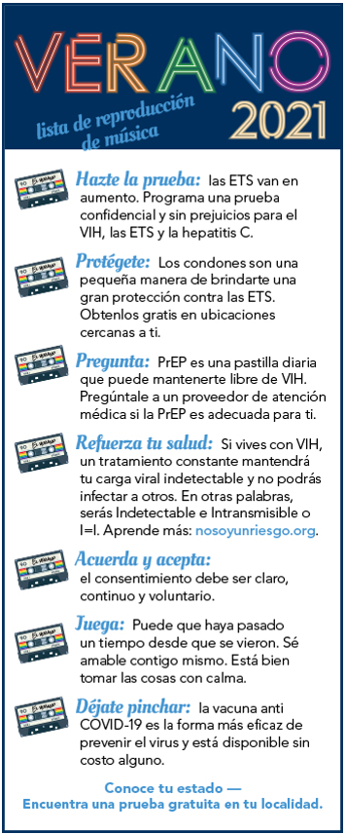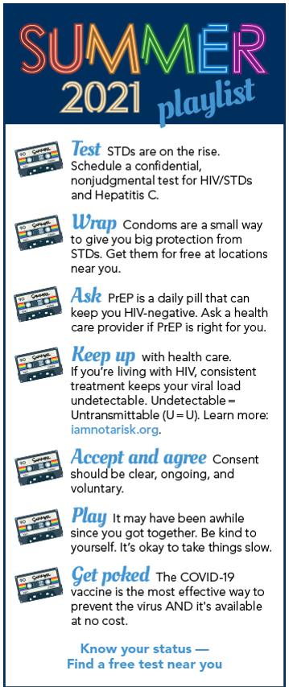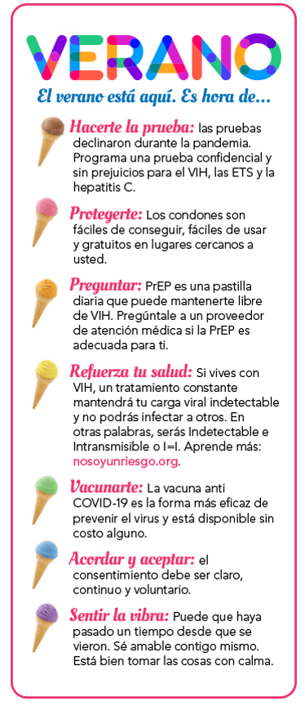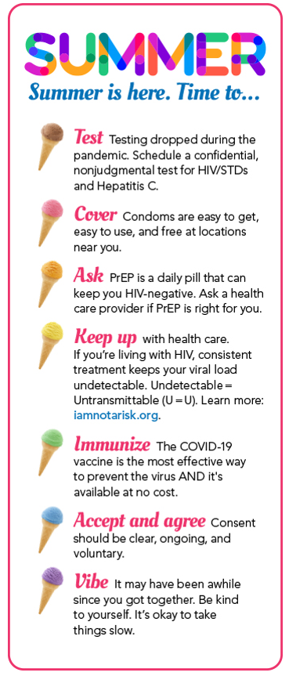
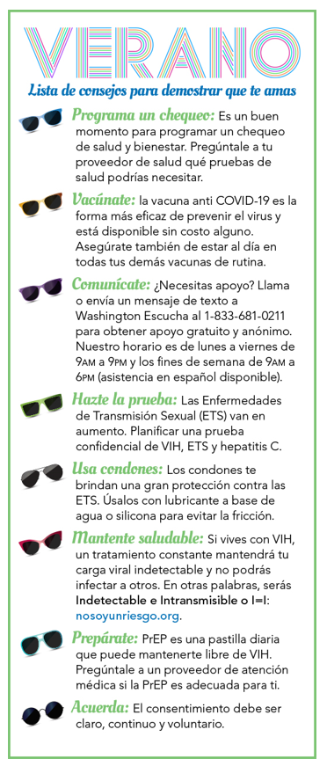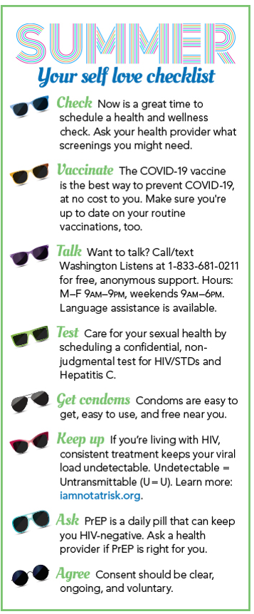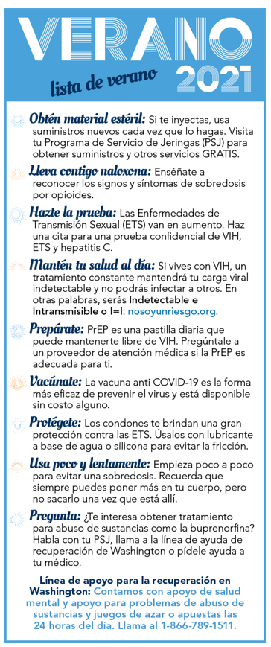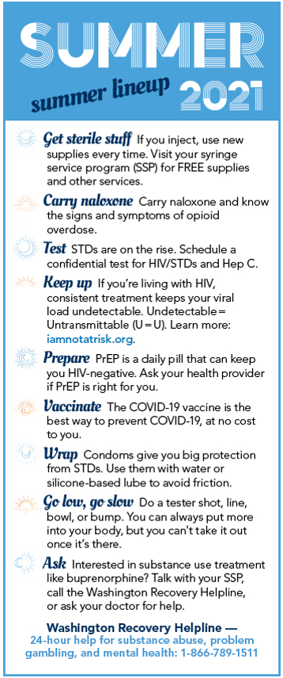
Suggested use for social media:
- Create a new post
- Choose your graphic
- Add links to local resources your clients use: testing, free condoms, PrEP providers, COVID-19 vaccines, medical care, etc.
- Add the link for I Am Not A Risk:
  - Spanish: I Am Not A Risk (nosoyunriesgo.org) / No Soy un Riesgo :: Washington State Department of Health (other campaign resources)
  - English: I Am Not A Risk / I Am Not a Risk Campaign Resources :: Washington State Department of Health (other campaign resources)
PRINT READY CHECKLISTS - SPANISH AND ENGLISH
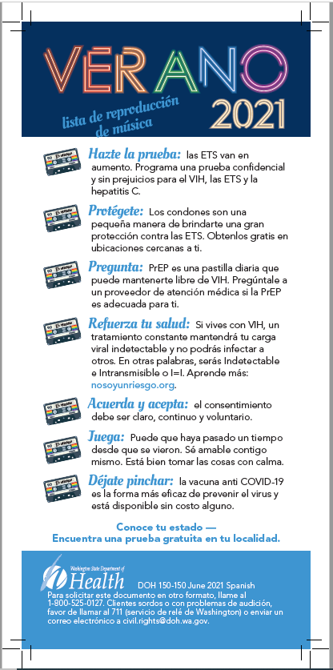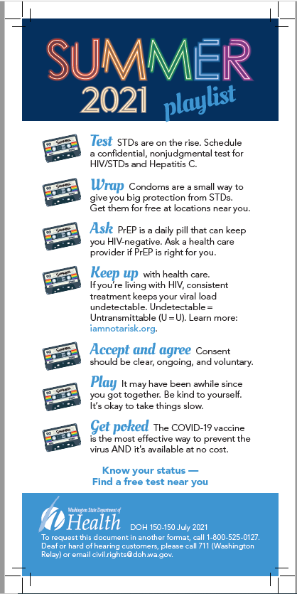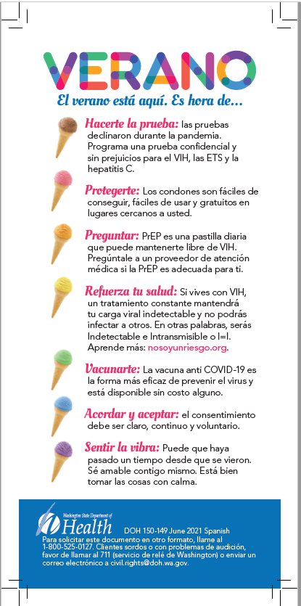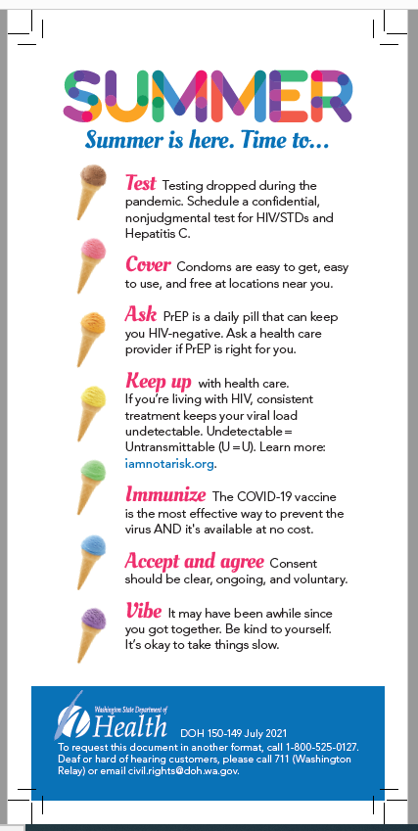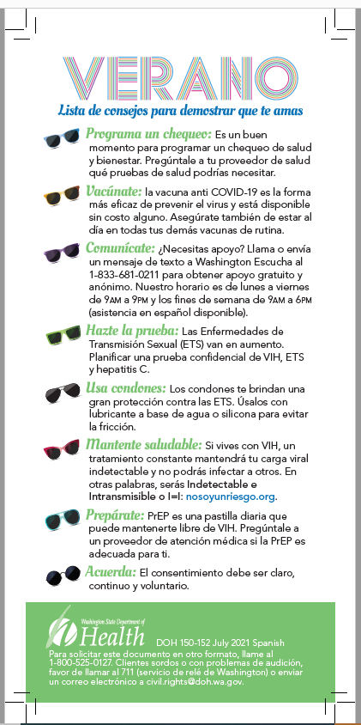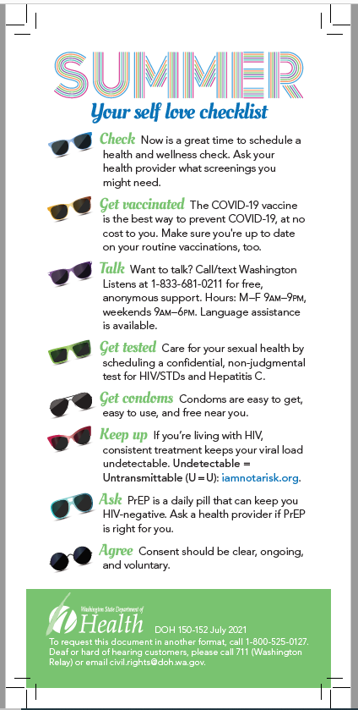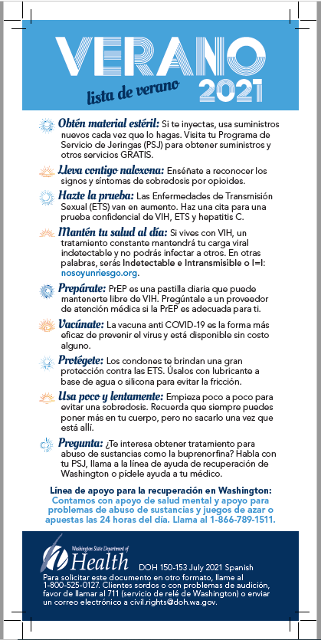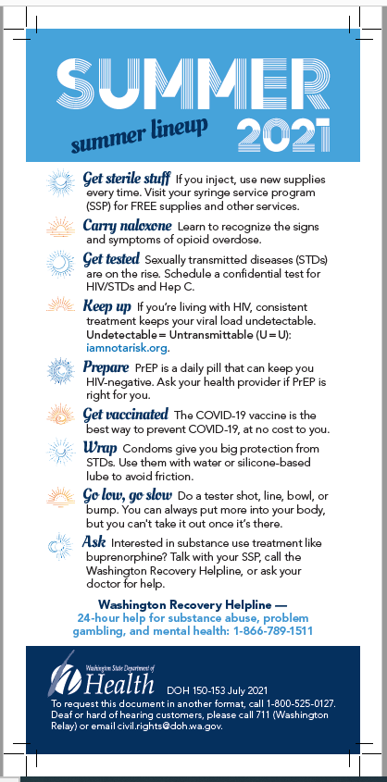
Suggested use for printed checklists:
- Send the files to your local print shop. These checklists are in CMYK color and include printer’s trim and bleed marks.
- Add your local resources:
  - Add sticker labels to the backside of the checklists with links to local resources your clients use, like testing, free condoms, PrEP providers, COVID-19 vaccines, medical care, etc.; or
  - Print out resource lists and hand out with the checklists.
  - Include the link for I Am Not A Risk:
    - Spanish: I Am Not A Risk (nosoyunriesgo.org) / No Soy un Riesgo :: Washington State Department of Health (other campaign resources)
    - English: I Am Not A Risk / I Am Not a Risk Campaign Resources :: Washington State Department of Health (other campaign resources)

INTERACTIVE PDF WITH CLICKABLE LINK - SPANISH AND ENGLISH

Suggested use for interactive PDFs:

- This is an interactive PDF with clickable link in the social media layout style.
- Share these by email or post to your website (note: you cannot share PDFs on social media platforms).
- Add your local resources in the e-mail or add as accompanying text to your website:
  - Link to local resources your clients use, like testing, free condoms, PrEP providers, COVID-19 vaccines, medical care, etc.
  - Include the link for I Am Not A Risk:
    - Spanish: I Am Not A Risk (nosoyunriesgo.org) / No Soy un Riesgo :: Washington State Department of Health (other campaign resources)
    - English: I Am Not A Risk / I Am Not a Risk Campaign Resources :: Washington State Department of Health (other campaign resources)

