Meningococcal Disease Information for First-Time Enrolled College Students

Washington state law requires all colleges to provide information on meningococcal disease to each enrolled first-time student. You are getting this information electronically. You must confirm that you have read this information before you can enroll or register. Please read and know your risk for meningococcal disease and how you can prevent it.

What is meningococcal disease?
It is a serious illness caused by bacteria. It can cause:
- Blood infections (septicemia), which causes bleeding into the skin or organs.
- Swelling of the membranes that cover the brain and spinal cord (meningitis).

Who is at risk?
College students have a higher risk of getting meningococcal disease because of everyday social contact in a small space. This is very true for students living in residence halls or group living.

How does it spread?
Meningococcal disease is spread through saliva or spit by coughing, kissing, or sharing anything by mouth with an infected person like eating utensils, lip balm, or toothbrushes. A person does not have to show signs of the disease in order to spread it to others. About 1 in 10 people are carriers of the bacteria, which means they do not get sick, but they can make other people sick.

What are the signs?
Meningococcal meningitis and meningococcal septicemia are both very serious and can be deadly in a matter of hours.

Meningococcal Meningitis
- Sudden onset of fever
- Headache
- Stiff neck
- Nausea
- Vomiting
- Sensitivity to light
- Confusion

What should I do if I have these signs?
Meningococcal Septicemia
- Fever
- Fatigue
- Vomiting
- Severe aches or pain
- Rapid breathing
- Diarrhea
- Cold chills; cold hands and feet
- In the later stages, a dark purple rash on upper and lower limbs

Seek medical help right away if you or another student get the above signs of meningococcal disease. If you don’t treat meningococcal disease quickly, it may lead to brain damage, disability, and death.

How is it treated?
The treatment for meningococcal disease is antibiotics. These work best when given as soon as signs of illness begin. People who have been close to someone with the disease should get antibiotics within 24 hours.

How is it prevented?
There are two vaccines that can help prevent meningococcal disease. Your doctor or pharmacist will tell you which ones you need. These vaccines can prevent up to 80% of meningococcal disease cases in teens and young adults.

- Meningococcal ACWY vaccine is a vaccine for all children aged 11 to 12 years with a booster for teens aged 16 to 18 years.
- Meningococcal B vaccine should be given to teens and adults aged 16 to 23 who have rare health problems or are at risk because of a meningococcal B disease outbreak. Healthy teens and adults should talk with their doctor to see if they should get this vaccine.

In addition to vaccines, it is important to take part in healthy habits:
- Cover your mouth when you cough.
- Wash your hands frequently.
- Do not share eating and drinking utensils.

Where can I find these vaccines?
Your doctor’s office is the best place to get these vaccines. You can also get them at pharmacies, community health clinics, or public health departments. Use the HealthMap Vaccine Finder at https://vaccinefinder.org/ to search for places near you that offer vaccines.

You can get the meningococcal vaccine at the [insert name of university health center or clinic]. Other vaccines are also offered at the clinic like [list other vaccines]. Plan your visit online or call the clinic at [insert phone number] to get up to date on your vaccines.

When you get any vaccine, ask the provider to record it in the state or local immunization registry. This helps to keep a record of what vaccines you have received.

Find more on Washington State’s Meningococcal Education Mandate and other resources on meningococcal disease at http://www.doh.wa.gov/YouandYourFamily/Immunization/CollegeStudents.

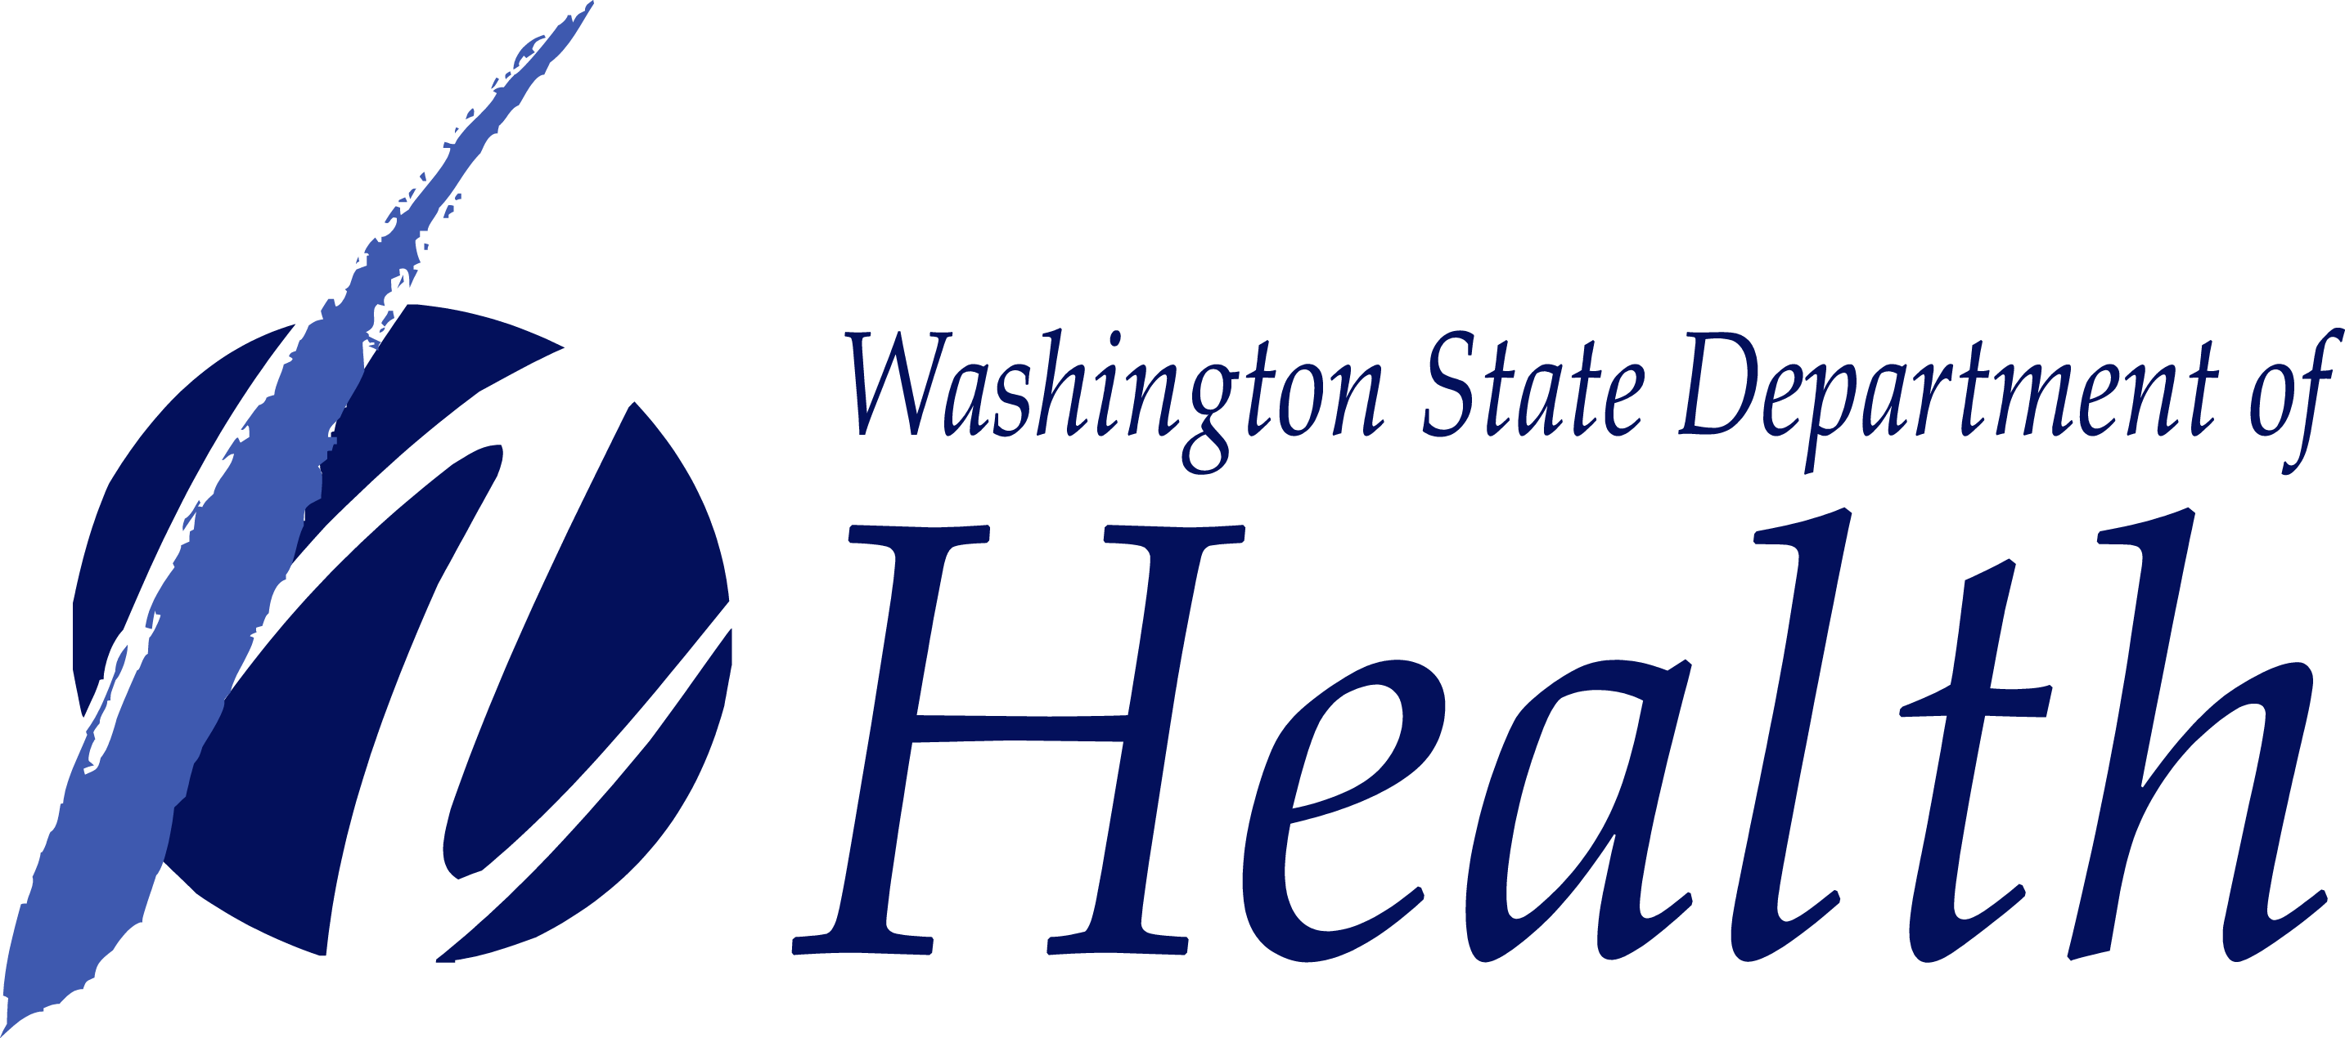

[Insert your college logo]

To request this document in another format, call 1-800-525-0127. Deaf or hard of hearing customers, please call 711 (Washington Relay) or email civil.rights@doh.wa.gov.
DOH 348-636 April 2020

