WORK PLAN TEMPLATE

FOR THE DECONTAMINATION OF

ILLEGAL DRUG MANUFACTURING SITES

A work plan consists of 4 separate documents: General work plan, Pre-decontamination sampling plan, Post-decontamination sampling plan, and Final report. Each document is submitted at the appropriate stage of the decontamination project. This is a technical document. The document needs to be complete, legible, and attachments are to be numbered and referenced in main document.

Local Health Approved: Yes No

SIGNATURE: DATE:

CONTRACTOR INFORMATION

Contractor Company Name:
Contractor Mailing Address:
Contractor Phone:
Copy of DOH CDL Contractor Certificate

Site Supervisor Name:
Supervisor DOH CDL Certification Number and Expiration Date:
Copy of DOH CDL Supervisor Certificate

Worker Name:
Worker DOH CDL Certification Number and Expiration Date:
Copy of DOH CDL Worker Certificate

I understand that before any pre-decontamination sampling and/or cleanup activities can begin, I must submit to and receive written approval of a completed sampling and/or work plan from Local Health Staff.

I understand that before any modifications to the approved work plan can be enacted, I must submit to and receive written approval of the modifications from Local Health Staff.

I understand that upon work plan approval, I will notify the local health staff 24 to 48 hours prior to starting cleanup.

I understand that I must comply with all applicable state and federal laws & regulations.

I certify that the statements in this work plan are true and accurate to the best of my knowledge.

CONTRACTOR SIGNATURE: DATE:

Table of Contents
(List categories and related page numbers)

Content Page

______________________________________________

PROPERTY INFORMATION

Property Owner Name:

Property Owner Mailing Address:

Property Owner Telephone Number:

Decontaminated Property’s Physical Address:

Legal Description of Decontaminated Property (If this is a mobile home or vehicle, include make, model, license plate number and VIN/ID number):

Assessor’s Property Account/Parcel Number:

Year Home/Structure was built:

Written detailed directions for locating the property from the nearest principal marked road:

Map: Directional map clearly showing how to get to the property.

SITE ASSESSMENT

Written evaluation of the property, vehicles, and structures to assist in determining the nature and extent of potential contamination.

Agency Reports
A recording of information from Local Health Department, Law Enforcement Agencies, Department of Ecology.

Site Description
Brief description of property and structures (For example: Property consists of a single family residence, two storage sheds, city septic and water, pond)

Site Map
A scaled drawing, that includes locations of all structures, well, septic, surface water, dump sites, burn piles, vehicles, boats, distressed vegetation, etc.

On Site Survey
Detailed description of real property, vehicles and structures. Mention; stains, spills, flooring materials, household furniture, children items, chemicals, biohazards, odors, basements, attics, crawlspaces, HVAC systems, wells, septic systems, drain fields, distressed vegetation, etc.

Floor Plans
Drawn to scale plans of each structure, indicating areas of stains, heating ducts and vents, attics, basements and crawl spaces,

Site Photos
High quality, dated photos of property, structures, vehicles, potentially contaminated areas, staining, spills, children items, burn piles, dump sites, etc.
PRE-DECONTAMINATION SAMPLING PLAN

Before any pre-decontamination sampling activity can be done, a sampling plan must be submitted to and receive signed approved from Local Health Staff.

Description of materials, equipment and techniques for sampling of methamphetamine, VOC, and pH.

Identification of analytical lab (name, address, phone number and contact person).

Pre Decontamination Sampling Table
Designates where samples will be taken, analyte sampling for, and area to be sampled. The examples shown are for sampling at the “Smith Property” – notice that the sample ID number references this by using the first two letters in the last name.

Sample ID Number | Sample Location* | Analyte | Area Sampled | Pre Decon Results | Post Decon Results
SM1 | Living room | Meth | 400 cm²
SM2 | Bathroom ceiling fan | Meth | 100 cm²
SM3 | Septic (strong solvent odor detected) | VOC (to be reported in ppm) | 1 quart
SM4 | Kitchen | Meth | 400 cm²
SM5 | Sample Blank (for QA/QC) | Meth

*Sample Location: Samples may consist of either single or composite samples. To adequately assess contamination levels, a minimum of one composite sample per room is recommended. A composite sample consists of no more than four 100 cm² sampling locations taken from the same room.

Local Health Approved: Yes No

SIGNATURE: DATE:

DECONTAMINATION PROCEDURES

Pre Decontamination Sampling Photos
Includes high quality, dated photos, showing template over sampled area with sample ID number and a point of reference.

Analytical Request Form/Chain-of-Custody Record
Includes chain of custody verification, information necessary for laboratory analysis and LHO interpretation: sample number, sample location, area sampled, analyte sampling for, detected odors at VOC sampling locations. See sample form at the end of this template.

Pre-Decontamination Sampling Results Table: (With copy of report from analytical lab.)

Sample ID Number | Sample Location | Analyte | Area Sampled | Pre Decon Results | Post Decon Results
SM1 | Living room | Meth | 400 cm² | 500 ug/ 400 cm²
SM2 | Bathroom ceiling fan | Meth | 100 cm² | 220 ug/ 100 cm²
SM3 | Septic (strong solvent odor detected) | VOC (to be reported in ppm) | 1 quart | 700 ppm Toluene
SM4 | Kitchen | Meth | 400 cm² | 117 ug/ 400 cm²
SM5 | Sample Blank (for QA/QC) | _______ | _________ | Non-detect

List methods and materials used, including equipment, name of detergent, number of washes and rinses, etc.
Describe how decontamination will occur for each structure, burn pile, etc.

Describe how you will address the following issues:
- Asbestos
- Septic system and drain field
- Well
- Household furniture
- Flooring
- Appliances
- HVAC/heating systems
- Ceilings, walls, floors
- Debris
- Burn piles and Dump sites
- Demolition
- Vehicles
- Other (list and address all other pertinent issues)

WASTE DISPOSAL PLAN

Procedures Used to Designate Waste
In your own words, discuss how you determine whether any waste is hazardous waste. (See Ecology Fact Sheet, “Identify your waste and generator requirements.”)

Identification of Waste Disposal Facilities You Will Use
Landfills may request notification that materials to be disposed of are from a drug lab.
Name:
Address:
Contact Person and Phone Number:

Disposal of Solid Wastes
Identify the waste and the name of the disposal facility.

For example:
- Household furnishings and items.
- Appliances.
- Debris from structures.
- Septic waste.
- Materials from demolitions.
- Debris from burn piles and yard.
- Cleaning rinse water.
- Other solid waste.

Disposal of Hazardous Wastes
Identify the waste and the name of the disposal facility.

For example:

Anhydrous ammonia cylinders.

HCL generators.

Opened and unopened containers of chemicals (known or unknown).

Chemicals not associated with drug manufacturing such as bleaches, toilet bowl cleaners, oven cleaners, motor oil, antifreeze, and oil based paints.
- Refrigerators/air conditioners with refrigerant.
- Soil above MTCA standards.
- Items that Ph < 2 or >12.5.
- Fluorescent light tubes.
- Computer monitors.
Procedures used to secure waste when decontamination contractor is off site:

POST-DECONTAMINATION SAMPLING PLAN

Before any post-decontamination sampling activity can be done, a sampling plan must be submitted to and receive signed approved from Local Health Staff.

Description of Materials, Equipment, and Techniques

A detailed description of how you take samples for methamphetamine, VOCs, and pH. Be thorough, describing the tools and equipment you use and the process involved.

Identification of Analytical Lab

Name:

Address:

Phone number:

Contact person:

Post Decontamination Sampling Table
Lists where samples will be taken, what you are sampling for, the area to be sampled and pre decontamination sampling results. The examples shown are for sampling at the “Smith Property”. Notice that the sample ID number references this by using the first two letters in the last name and “P” for post clean up samples.

Sample ID Number | Sample Location* | Analyte | Area Sampled | Pre Decon Results | Post Decon Results
SM1-P | Living room | Meth | 400 cm² | 40 ug/ 400 cm²
SM2-P | Bathroom ceiling fan | Meth | 100 cm² | 220 ug/ 100 cm²
SM3-P | Sample Blank |  |  | Non-detect
SM4-P | Kitchen | Meth | 400 cm² | 117 ug/ 400cm²
*Sample Location: Samples may consist of either single or composite samples. To adequately assess contamination levels, a minimum of one composite sample per room is recommended. A composite sample consists of no more than four 100 cm² sampling locations taken from the same room.

Local Health Approved: Yes No

SIGNATURE: DATE:

FINAL REPORT
Summary and documentation of actual work performed. To be submitted upon completion of decontamination project.

Summary of Decontamination Procedures (Detailed and specific)

Summary of Waste Disposal Procedures (Detailed and specific)

Receipts
Waste Disposal, Subcontractors, Septic Pumper, etc.

Post Decontamination Sampling Photos
Includes high quality photos, showing template over sampled area, a point of reference, dated and labeled.

Post Decontamination Analytical Request Form/Chain-of-Custody Record
Includes chain of custody verification, information necessary for laboratory analysis and LHO interpretation: sample number, sample location, area sampled, analyte sampling for, detected odors at VOC sampling locations. See sample form at the end of this template.

Post Decontamination Sampling Results Table: (With copy of report from analytical lab.)

Sample ID Number | Sample Location* | Analyte | Area Sampled | Pre Decon Results | Post Decon Results
SM1-P | Living room | Meth | 400 cm² | 40 ug/ 400 cm² | .08 ug/ 400 cm²
SM2-P | Bathroom ceiling fan | Meth | 100 cm² | 220 ug/ 100cm² | .09 ug/ 100 cm²
SM3-P | Sample Blank |  |  | Non-detect | .02
SM4-P | Kitchen | Meth | 400 cm² | 117 ug/ 400 cm² | .08 ug/ 400 cm²
Post Decontamination Site Photos
Photos that document the condition of the site upon completion of the decontamination project.

Statement of Compliance

I hereby certify that the statements on this final report are true and accurate to the best of my knowledge. (See Chapter 18.106 Revised Code of Washington (RCW) for false statement or material misrepresentation.)

PRINCIPAL OWNER’S SIGNATURE: DATE:

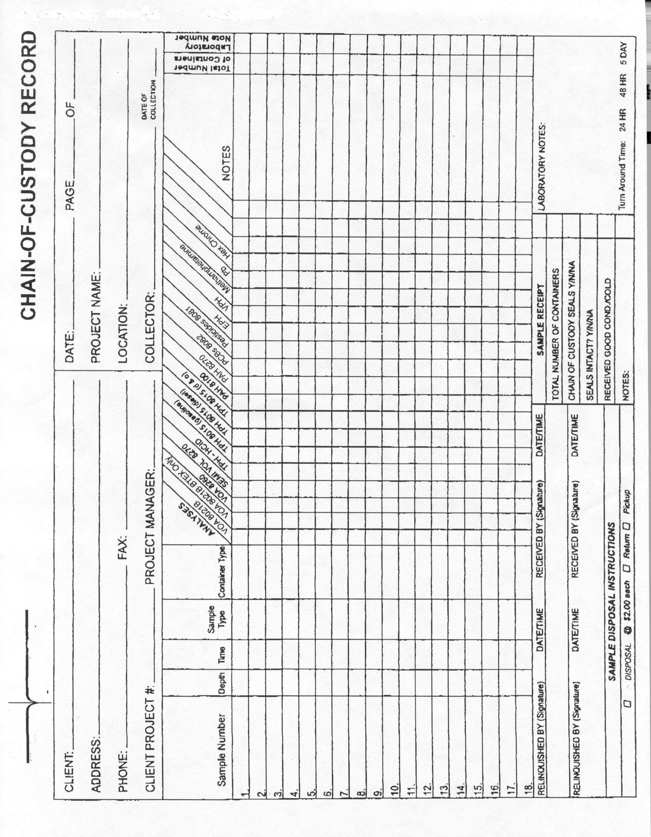
Sample: Analytical Request Form/Chain-of-Custody Record

