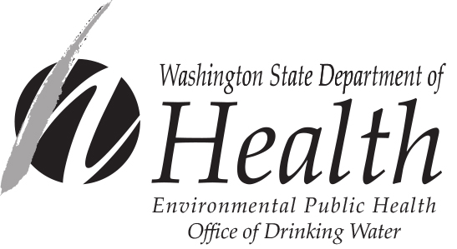
Construction Completion Report form

In accordance with WAC 246-290-120 (5), a Construction Completion Report is required for all approved construction projects. Operators must submit a Construction Completion Report to us within sixty (60) days of completion and before use of any water system facility. This includes any source, water quality treatment, storage tanks, booster pump facilities, and distribution projects.

Please type or print legibly in ink:
 |  | DOH System ID No.:
Name of Water System
 |  | DOH Project No.:
Name of Purveyor (Owner or System Contact) |  | (if applicable)
 |  | Date Construction Documents
Mailing Address |  | Approved by DOH
 |  | (If applicable)
City State Zip

project name and descriptive title:
CHECK ONE: Entire Project Completed. Description of Portions Completed.

Professional Engineer’s Acknowledgment (Complete items below–Attach additional sheets as needed)

The undersigned professional engineer (PE), or their authorized agent, has inspected the above-described project which, as to layout, size and type of pipe, valves and materials, reservoir and other designed physical facilities, has been constructed and is substantially completed in accordance with construction documents reviewed by the purveyor’s engineer or approved by the Department of Health. In the opinion of the undersigned engineer, the installation, physical testing procedures, water quality tests, and disinfection practices were carried out in accordance with state regulations and principles of standard engineering practice.

I have reviewed the disinfection procedures , pressure test results , and results of the bacteriological test(s) for this project and certify that they comply with the requirements of the construction standards/specifications approved by the Department of Health. (Check all boxes that apply that are consistent with the nature of the project.)

This project changes the physical capacity of the system to serve consumers. The system is now able to serve equivalent residential units (ERUs.) Not applicable

Date Signed

Name of Engineering Firm
P.E.’s Seal
Name of PE Acknowledging Construction

Mailing Address

City State Zip

Engineer’s Signature
State/Federal Funding Type (if any)
Please return completed form to your regional office checked below.
NWRO Drinking Water SWRO Drinking Water ERO Drinking Water
Department of Health Department of Health Department of Health
20425 72nd Ave. S, Ste 310 PO Box 47823 16201 E. Indiana Ave, Suite 1500
Kent, WA 98032-2388 Olympia, WA 98504-7823 Spokane Valley, WA 99216
253-395-6750 360-236-3030 509-329-2100
For people with disabilities, this document is available on request in other formats. To submit a request, please call 1-800-525-0127 (TDD/TTY call 711).
The operator must attach a completed Water Facilities Inventory (WFI) form in accordance with WAC 246-290-120(6), if applicable. Contact your regional office for WFI forms or additional Construction Completion Report forms.
DOH Form 331-121-F (01/10)

