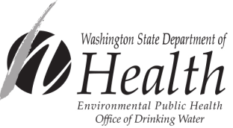
Group B Project Approval Application Form

Please fill in all project description information and check all boxes that apply below.

Project Name |  |  |  |  |  |  |  | County
Water System Name |  |  |  |  | PWS ID# |  |  | Design Engineer
System Owner |  |  |  |  |  |  |  | Engineering Firm
Street |  |  |  |  |  |  |  | Street
City | State |  |  |  |  | Zip Code |  | City |  |  | State | Zip Code
Phone Number |  |  |  |  |  |  |  | Phone Number
Project Contact if Different than Above |  |  |  | Daytime Phone Number |  |  |  |  |  | Evening Phone Number
Billing Contact Name--Required if not the same as above |  |  |  | Billing Phone Number |  |  |  |  |  | Billing Fax Number
Billing Address |  |  |  | City |  |  |  |  |  | State/Zip Code

New Group B water system (Design Report Workbook)
Expanding Group B water system (Design Report Workbook)

Please return completed form to the Office of Drinking Water regional office checked below.
Northwest Drinking Water  Department of Health  20425 72nd Ave S, Suite 310  Kent, WA 98032-2358  Phone: 253-395-6750  Fax: 253-395-6760 | Southwest Drinking Water  Department of Health  PO Box 47823  Olympia, WA 98504-7823  Phone: 360-236-3030  Fax: 360-664-8058 | Eastern Drinking Water  Department of Health  16201 E Indiana Ave, Suite 1500  Spokane Valley, WA 99216  Phone: 509-329-2100  Fax: 509-329-2104

FOR DEPARTMENT USE ONLY.
ODW Project #: Initial Fee Amount: Date Invoice Mailed:
Invoice #: Fee Received: Review Letters Sent:
Approval Date: Date Construction Report Received: Number of Approved Connections:
Area Served:

Provisions:

If you need this form in an alternate format, call 800-525-0127. For TTY/TDD, call 800-833-6388.

