NOTICE TO WATER SYSTEM USERS

QUARTERLY TOTAL TRIHALOMETHANE (TTHM)/HALOACETIC ACIDS (HAA5)

MONITORING VIOLATION FORM

We, Water System, I.D. , located in ____________County are required to monitor your drinking water for specific contaminants on a regular basis. Results of regular monitoring are an indicator of whether or not your drinking water meets health standards. During the following quarters: ____________________________, we did not monitor or test for the disinfection by-products TTHM and HAA5, and therefore cannot be sure of the quality of your drinking water during that time.

At this time:
- No action is required by the users.

- Our routine quarterly TTHM/HAA5 samples have been taken for _________ (time period).

◻ Samples will be collected in the future as required.

◻ Other information for customers:

For more information, please contact _______________ at ( )___-_____ or at ____________________.
(owner or operator) (phone number) (address)

Please share this information with all the other people who drink this water, especially those who may not have received this notice directly (for example, people in apartments, nursing homes, schools, and businesses.) You can do this by posting this notice in a public place or distributing copies by hand or mail.

This notice is sent to you by ___________________ Water System on __/__/__

Quarterly TTHM/HAA5 Monitoring Public Notice Certification Form

(This section must be completed by Water System. Signature below indicates notice contained all required elements.)

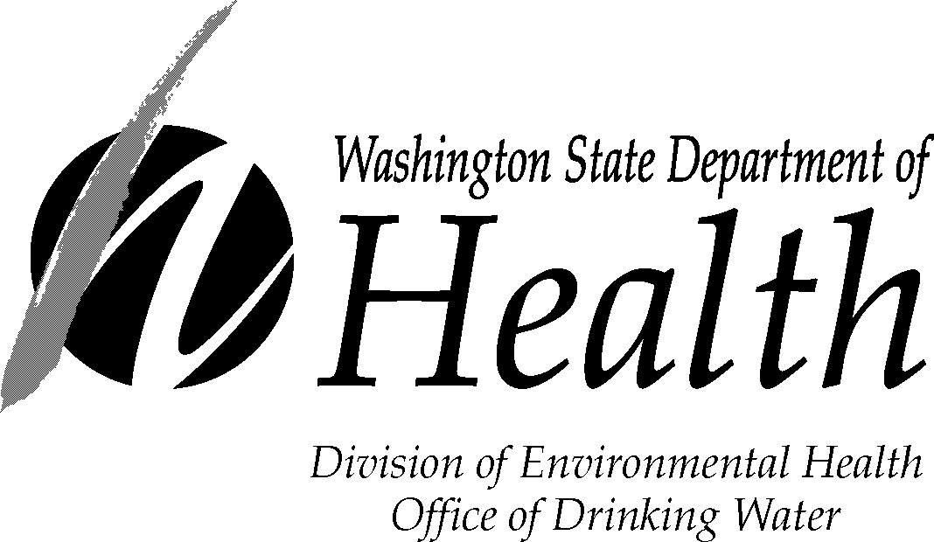
Complete the following items (check all that apply):

Notice mailed to all water customers on ____ / ____/____.

Notice hand delivered to all water customers on ___ / ___ /___.

Notice published in newspaper (attach copy)

Notice posted at ____________________________ on ___ / ___ / ____.
(By Department Approval Only)

_______________________________ ______________________ _______________
Signature of owner or operator Position Date

The Department of Health is an equal opportunity agency. For persons with disabilities, this form is available on request in other formats. To submit a request, please call 1-800-525-0127 (TTY 1-800-833-6388).
Send copy of completed notification and certification to:
Office of Drinking Water, Water System Support Section, PO Box 47822, Olympia WA 985047822 fax (360) 236-2252
DOH Form #331-395 (02/08)

