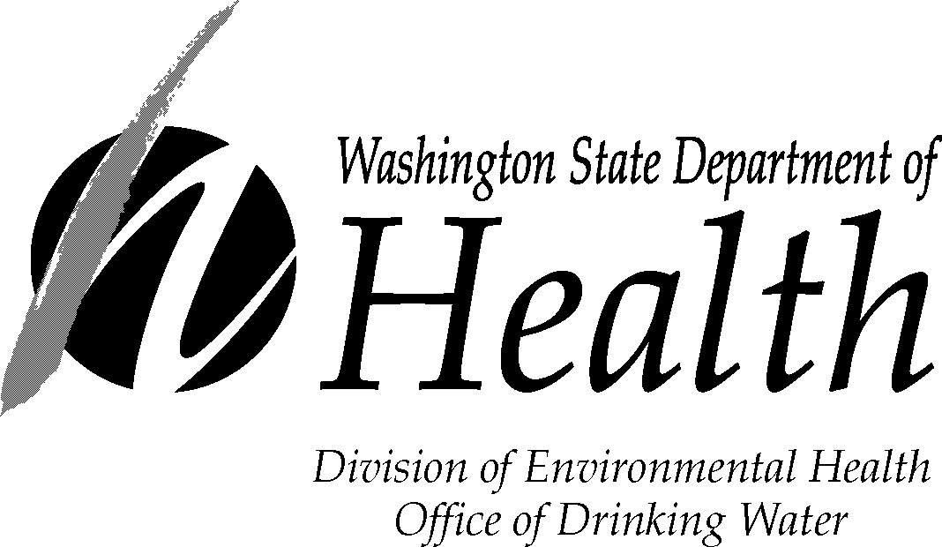

Small Water System Management Program Submittal Form

This form must be completed and submitted along with the Small Water System Management Program (SWSMP). It will expedite review and approval of your SWSMP. All water systems should contact their regional planner before developing any planning document for submittal.
1. Water System Name |  | PWS ID# or Owner ID# |  | System Owner Name
Contact Name for Utility |  | Phone Number |  | Title
Contact Address |  | City |  | State Zip
2. Project Engineer (if applicable) |  | Phone Number |  | Title
Project Engineer Address (if applicable) |  | City |  | State Zip
3. Billing Contact Name (required if not the same as #4) |  | Billing Phone Number |  | Billing Fax Number
Billing Address |  | City |  | State Zip

4. How many services are presently connected to the system? |  |  | ________________
5. If the system is private-for-profit, is it regulated by the State Utilities and Transportation Commission? |  |  | Yes No
6. Is the system located in a Critical Water Supply Service Area (i.e. have a Coordinated Water System Plan)?  7. If answer to question 6 is “yes,” have you sent a copy of the draft SWSMP to the county or agency responsible for the Coordinated Water System Plan? |  |  | Yes No  Yes No
8. Is the system a customer of a wholesale water purveyor? |  |  | Yes No
9. Is the system proposing a new intertie? |  |  | Yes No
10. Do you have projects currently under review by the Department of Health? |  |  | Yes No
11. Are you proposing a change in the place of use of your water right? |  |  | Yes No
12. If answer to question 11 is “yes”, the purveyor must send a copy of the draft SWSMP to all local governments within the service area (county and city planning departments) for a local consistency determination. Has this been completed? |  |  | Yes No
Is this plan: an Initial Submittal a Revised Submittal
Please enclose the following number of copies of the SWSMP:
3 copies for Northwest and Southwest Regional Offices OR 2 copies for Eastern Regional Office.
1 additional copy if you answered “yes” to question 5. _______ Total copies attached
Please return completed form to the Office of Drinking Water regional office checked below.
Northwest Drinking Water  Department of Health  20425 72nd Ave S, Suite 310  Kent, WA 98032-2358  Phone: (253) 395-6750  Fax: (253) 395-6760 | Southwest Drinking Water  Department of Health  PO Box 47823  Olympia, WA 98504-7823  Phone: (360) 236-3030  Fax (360) 664-8058 | Eastern Drinking Water  Department of Health  16201 E Indiana Ave, Suite 1500  Spokane Valley, WA 99216  Phone: (509) 329-2100  Fax: (509) 329-2104
If you need this publication in an alternate format, call (800) 525-0127. For TTY/TDD call (800) 833-6388.

DOH Form 331-396 (Updated 11/11)

