NOTICE TO WATER SYSTEM USERS

QUARTERLY NITRATE MONITORING VIOLATION FORM

We, Water System, I.D. , located in County are required to monitor your drinking water for specific contaminants on a regular basis. Results of regular monitoring are an indicator of whether or not your drinking water meets health standards. We are required to monitor for nitrates on a quarterly basis. We have failed to meet the monitoring requirements for nitrate for the _____ quarter(s) of _______ (year). We cannot be sure of the quality of your drinking water during that time. At this time:
- No action is required by the users.

- Our current quarterly nitrate samples have been collected.

- Samples will be collected in the future as required.

- Other information for customers:

For more information, please contact _____________________ at ( )___-_____ or at __________________.
(owner or operator) (phone number) (address)

Please share this information with people who drink this water, especially those who may not have received this notice directly (for example, people in apartments, nursing homes, schools, and businesses.) You can do this by posting this notice in a public place or distributing copies by hand or mail.

This notice is sent to you by ___________________ Water System on __/__/__

Quarterly Nitrate Monitoring Public Notice Certification Form
(This section to be completed by the Water System. Signature below indicates notice contained all required elements.)

Complete the following items (check all that apply):
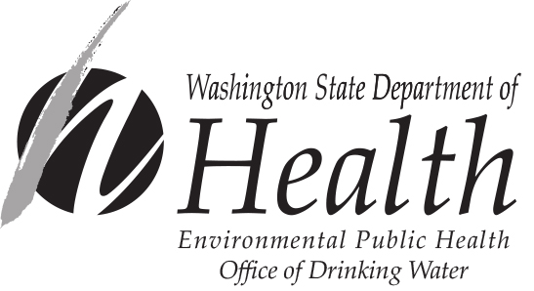
€ Notice mailed to all water customers on ____ / ____/____

€ Notice hand-delivered to all water customers on ___ / ___ /___

€ Notice published in newspaper (attach copy)

- Notice posted at ____________________________ on ___ / ___ /____
(By Department Approval Only)

_______________________________ ___________________ ____________________
Signature of owner or operator Position Date
Send copy of completed notification and certification to:
David Sternberg, Water Quality Compliance Programs Coordinator
Office of Drinking Water
PO Box 47822
Olympia, WA 98504-7822
FAX 360-236-2252

For people with disabilities, this document is available on request in other formats. To submit a request, please call 1-800-525-0127 (TDD/TTY call 711).

