NOTICE TO WATER SYSTEM USERS

Reliably and Consistently Under the Maximum Contaminant Level (MCL)

ANNUAL NITRATE MONITORING VIOLATION FORM

We, Water System, I.D. , located in ____________County are required to monitor your drinking water for specific contaminants on a regular basis. Results of regular monitoring are an indicator of whether or not your drinking water meets health standards. We are required to collect a nitrate sample for Source #____ each year, between the months of ________ and _______. During _______, we did not monitor or test for nitrate and therefore cannot be sure of the quality of your drinking water during that time. At this time:
- No action is required by the users.

- Our routine nitrate sample required to be collected between _______ and _______ (current year) has been collected.

◻ Samples will be collected in the future as required.

◻ Other information for customers:

For more information, please contact _______________ at ( )___-_____ or at ____________________.
(owner or operator) (phone number) (address)

Please share this information with all the other people who drink this water, especially those who may not have received this notice directly (for example, people in apartments, nursing homes, schools, and businesses.) You can do this by posting this notice in a public place or distributing copies by hand or mail.

This notice is sent to you by ___________________ Water System on __/__/__

R & C Under the MCL Annual Nitrate Monitoring Public Notice Certification Form

(This section must be completed by the Water System. A signature below indicates the notice contained all required elements.)

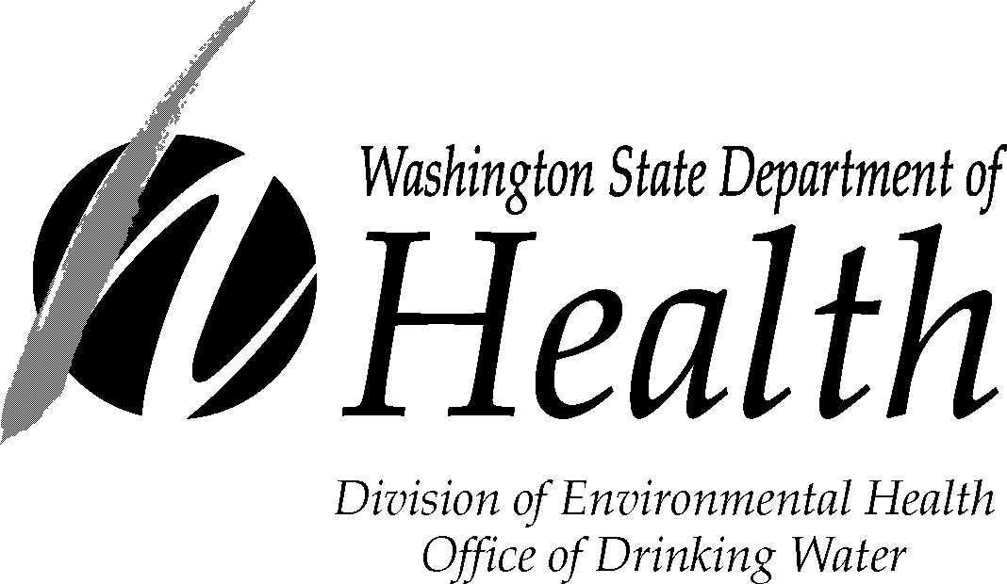
Complete the following items (check all that apply):

Notice mailed to all water customers on ____ / ____/____

Notice hand-delivered to all water customers on ___ / ___ /___

Notice published in newspaper (attach copy)

Notice posted at ____________________________ on ___ / ___ / ____
(By Department Approval Only)

_______________________________ ______________________ _______________
Signature of owner or operator Position Date
Send a copy of completed notification and certification to:
David Sternberg, Water Quality Compliance Programs Coordinator
Office of Drinking Water
PO Box 47822
Olympia, WA 98504-7822
FAX 360-236-2252

If you need this publication in an alternate format, call (800) 525-0127. For TTY/TDD, call (800) 833-6388.

