Backflow Prevention for Severe Health Hazard Facility
Annual Summary Report Year: _____
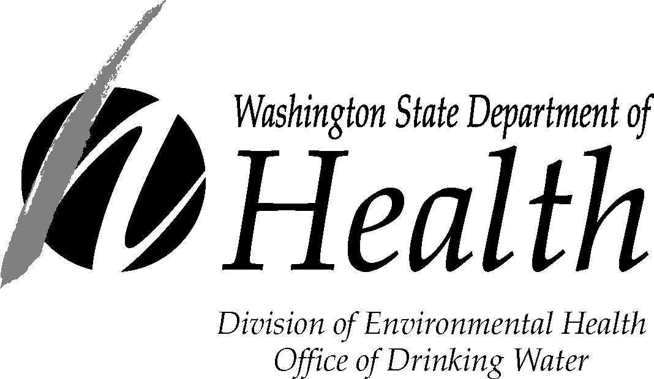

PWS ID: | PWS Name: | County:
Backflow Protection Status
Describe the backflow protection status at the end of report year for each wastewater treatment plant None served
and nuclear facility your system serves. Attach more sheets if needed.
Facility Name,  Physical Address,  And NPDES Permit Number¹ | Status of Backflow Protection at end of 2011 (check one box per row)
 | Premises Isolation  RP and  In-plant Air Gap(s)² | Premises Isolation RP  but No  In-Plant Air Gap(s) | Premises Isolation  Air Gap | Fixture Protection Only | No Protection At All | Unknown | Exception Granted | Other  (explain in Comment Section on page 2)
NPDES Permit #:
NPDES Permit #:
NPDES Permit #:
NPDES Permit #:
¹NPDES Permit Number applies to wastewater treatment facilities only. Please request from the facility being served.

²For wastewater treatment plants and nuclear facilities, air gaps(s) must be provided on potable water lines supplying process water (seal water, plant washdown water, flushing, etc.)

Comments and Clarifications
Enter comments about the information provided on page 1.
Facility Name (from page 1) | Comment

Completion Information
Enter dates in MM/DD/YYYY format.
I certify that the information provided in this questionnaire is complete and accurate to the best of my knowledge.
CCC Program Mgr. Name (Print)¹: |  |  | Title:
Signature: |  |  | Date:
Phone: (___) ___-____ | E-mail: ____________@_____________________
I certify that the information provided in this questionnaire accurately describes the status of backflow protection at the severe hazard facilities served by our system.
PWS Manager/Owner Name (Print)²: |  |  | Title:
Signature: |  | Op. Cert No: | Date:

¹ The CCC Program Manager is generally the CCS responsible for developing and implementing the PWS’s CCC program.
² The person that the CCC Program Manager reports to or other manager having direct responsibility and/or oversight of the CCC program. This person doesn’t need to be in charge of the entire water system.

If you have a question or comment regarding this form, you can find contact information at https://www.doh.wa.gov/communityandenvironment/drinkingwater or email us at CCCprogram@doh.wa.gov.

If you need this publication in an alternate format, call (800) 525-0127. For TTY/TDD, call (800) 833-6388.

