NOTICE TO WATER SYSTEM USERS

Chemical MONITORING VIOLATION

We, Water System, I.D. , located in County are required to monitor your drinking water for specific contaminants on a regular basis. Results of regular monitoring are an indicator of whether or not your drinking water meets health standards. In ________________ we did not meet our monitoring requirements for the chemicals listed below, and therefore cannot be sure of the quality of your drinking water at that time.
- Volatile Organic Contaminants (VOCs).
- Complete Inorganic Contaminants (IOCs).
◻ Pesticides.
- Herbicides.
- _______________ Other (List Test Panel or Specific IOC Analyte)

At this time:
- Our required ________________________ samples have been collected for this monitoring period.
◻ Samples will be collected in the future as required.
- Other information for customers:

For more information, please contact _____________________ at ( )____-_______ or at ____________________.
(owner or operator) (phone number) (address)

This notice is sent to you by ___________________ Water System on __ / __ / __

Chemical Monitoring Public Notice Certification Form
This section must be completed by the water system. Signature below indicates notice contained all required elements.

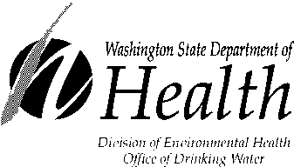
Complete the following items (check all that apply):

- Notice mailed to all water customers on ____ / ____ / ____.

- Notice hand delivered to all water customers on ___ / ___ / ___.

- Notice included in annual Consumer Confidence Report (attach copy).

- Notice posted at ____________________________ on ___ / ___ / ____.
(By Department Approval Only)

_______________________________ ___________________ ____________________
Signature of owner or operator Position Date

Send copy of completed notification and certification to:

Office of Drinking Water, Water Quality Section
PO Box 47822
Olympia, WA 98504-7822
FAX (360)236-2252

DOH Form 331-465 (03/12)

If you need this publication in alternate format, call (800) 525-0127. For TTY/TDD, call (800) 833-6388

