Office of Drinking Water
Third-Party Sanitary Survey Form Checklist
System Name: |  |  |  |  |  |  | Survey Date:
PWS ID#: |  |  |  |  | County: |  | System Type:
Persons Attending Inspection:
Inspector’s Name:

PART A: SUMMARY OF SIGNIFICANT DEFICIENCIES AND SIGNIFICANT FINDINGS
The following is a completed sanitary survey checklist and summary of inspection findings. This completed sanitary survey checklist is the basis for the cover letter you receive from your local health jurisdiction or from the Washington State Department of Health (DOH). The cover letter documents any significant deficiencies or significant findings that must be corrected. The cover letter may also summarize observations concerning compliance with certain rules and offer recommendations you can use to make improvements to the operation and management of your water system. Contact your DOH regional office with any questions you have about this survey.

Bolded and highlighted checklist items represent significant deficiencies that, if left uncorrected, create a significant public health risk. Highlighted checklist items represent significant findings that, if left uncorrected, create a significant risk to the physical safety, security, or reliability of the public drinking water supply. You will be required to take some sort of corrective action for each checklist answer that is bolded and highlighted, or highlighted.

Significant deficiencies and significant findings identified during this sanitary survey:

Significant deficiencies or significant findings identified in the previous sanitary survey that remain unaddressed:

Observations and recommendations identified during this survey

PART B: GENERAL WATER SYSTEM DESCRIPTION
Provide a general description of the water system including changes, updates, connections, source(s), storage, number of pressure zones, treatment, and control system(s) and alarm(s). Make corrections and updates to the purveyor’s water facilities inventory form (WFI).

PART C: OPERATIONS and MANAGEMENT
1. Was the system operator, who is most knowledgeable about the system’s day-to-day operations, present for the survey? |  | Yes No NA
2. Were water system records available for your review? |  | Yes No Partial
3. Has the purveyor developed and implemented either a Small Water System Management Program or a Water System Plan? |  | Yes No
3a. If no, are the following planning documents complete and up to date:
 | Service Area and Facility Map | Yes No Partial
 | Cross-Connection Control Program | Yes No Partial
 | Source Water Protection Program | Yes No Partial
 | Emergency Response Plan | Yes No Partial
 | Operation and Maintenance Program | Yes No Partial
 | Coliform Monitoring Plan | Yes No Partial
 | Component Inventory and Assessment | Yes No Partial
 | Asset Replacement and Other System Improvements | Yes No Partial
 | Budget | Yes No Partial
4. Does the purveyor plan to make capital improvements in the next 1-3 years? If yes, describe below |  | Yes No
5. Is there a backup operator available if the regular one is not available? If yes, provide contact info below |  | Yes No
6. Were the water system’s current and future water quality monitoring requirements reviewed? |  | Yes No
7. Was water quality sample results and trends reviewed with the purveyor? |  | Yes No
8. Does the system have emergency power? |  | Yes No
9. Does the system experience frequent power outages (>2 per year)? If yes, explain below |  | Yes No
10. Does the system experience frequent water outages (>2 per year)? If yes, explain below |  | Yes No
11. Does there appear to be adequate reliability provided for this system? If no, explain below |  | Yes No
Describe the general level of planning and management documents developed by this water system and any recommendations for additional development, including updates, system management practices and processes, water rates, etc.

PART D: SOURCES (This page may be reproduced to add more sources)
12. Did you observe a source connected to the water system that is NOT listed on the WFI and in active use? |  |  |  |  | Yes No
12a. If so, has the source received written DOH approval? (confirm with DOH post-survey) |  |  |  |  | Yes No
13. DOH Source Number: |  |  |  | SO # | SO #
14. Source Name from the WFI: (For example, North Well; Well #2; ABC334.)
15. Dept of Ecology Well Tag Number: (Use Well tag ID#, None or Not readable)
16. Source Use: | P - Permanent | S - Seasonal | E - Emergency
17. If this is an emergency source, should it be disconnected? |  |  |  | Yes No NA | Yes No NA
18. Is the source a potential GWI source? |  |  |  | Yes No | Yes No
WELL (if there is no well, skip to question 34)
19. Is the Sanitary Control Area (SCA) free of unmitigated potential sources of contamination? |  |  |  | Yes No | Yes No
20. Is the wellhead located in a pit or vault? |  |  |  | Yes No | Yes No
21. Is the wellhead at risk of submergence? |  |  |  | Yes No | Yes No
22. Is the well cap sealed, watertight, and free of unprotected openings? |  |  |  | Yes No | Yes No
23. Is the well casing free of any unprotected openings? |  |  |  | Yes No | Yes No
24. Is there a vent on the well? |  |  |  | Yes No | Yes No
24a. If yes, is the vent protected? (24 non-corrodible mesh screen or slots) |  |  |  | Yes No | Yes No
25. Are conduits and junction boxes sealed to prevent contaminant entry? |  |  |  | Yes No | Yes No
26. Is the well unreasonably at risk to physical damage? |  |  |  | Yes No | Yes No
27. Is there a raw water source sample tap? |  |  |  | Yes No | Yes No
28. Is the source metered? |  |  |  | Yes No | Yes No
28a. If yes, is the source meter read at least monthly? |  |  |  | Yes No | Yes No
28b. If yes, are the water production records maintained? |  |  |  | Yes No | Yes No
29. Is the wellhouse properly constructed and maintained? If no, explain below |  |  |  | Yes No | Yes No
30. Is there any evidence of infestation by rodents or other pests? |  |  |  | Yes No | Yes No
31. Is the wellhouse and well adequately protected from unauthorized access and tampering? |  |  |  | Yes No | Yes No
32. Is there a pump control valve or vacuum relief valve without an air gap on the valve discharge pipe? |  |  |  | Yes No NA | Yes No NA
33. Are the source pump and pump controls operational and adequate to prevent chronic water outages or premature pump failure? If no explain below |  |  |  | Yes No | Yes No
SPRING (if there is no spring, skip to question 41)
34. Is the springbox (structure, hatch, and overflow) constructed to prevent the entry of contaminants or direct surface drainage? If yes, describe below. |  |  |  | Yes No | Yes No
35. Is there a raw water source sample tap? |  |  |  | Yes No | Yes No
36. Is the source metered? |  |  |  | Yes No | Yes No
36a. If yes, is the source meter read at least monthly? |  |  |  | Yes No | Yes No
36b. If yes, are the water production records maintained? |  |  |  | Yes No | Yes No
37. Is the springhouse properly constructed and maintained? If no, explain below |  |  |  | Yes No | Yes No
38. Is there any evidence of infestation by rodents or other pests? |  |  |  | Yes No | Yes No
39. Is the springhouse and spring box adequately protected from unauthorized access? |  |  |  | Yes No | Yes No
40. Is the Sanitary Control Area (SCA) free of unmitigated potential sources of contamination? |  |  |  | Yes No | Yes No
Describe and evaluate the source facilities including maintenance, operations, sanitary and security observations and any major change made to the source such as pump replacement, deepening or reconstruction:

PART E: DISINFECTION (if no disinfection, answer question 41 and skip rest of Part E)
41. Does the operator batch chlorinate the source, the distribution system, or the reservoir just before collecting routine or repeat coliform samples? If yes, provide details below. |  |  | Yes No
42. Did you observe disinfection treatment connected to the water system in active use that is NOT listed on the WFI? If yes, explain below |  |  | Yes No
43. Is ultraviolet light (UV) used for disinfecting a drinking water source? If no, skip to question 46. |  |  | Yes No
44. Is the UV unit sized for the maximum flow rate, and is there a UV transmittance sensor controlling a solenoid valve or other device to shut off supply if the UV light fails? |  |  | Yes No
45. Describe the UV equipment including:
UV manufacturer and model number:  Cleaning frequency of quartz sleeve : |  | Rated capacity (gpm):  Mo/Yr UV light last replaced:
46. Is there continuous chlorination? If no, skip to Part F |  |  | Yes No
46a. If yes, please measure the free chlorine residual from a representative location in the distribution system.
Location description: | Free chlorine residual:
47. Is there a water supply line plumbed directly into a chlorine solution tank without a reduced pressure backflow assembly on the supply line? |  |  | Yes No
48. Is there a post-treatment sample tap? |  |  | Yes No
49. Does the chlorine compound meet NSF/ANSI Standard 60? - household bleach is exempted |  |  | Yes No
50. Is a backup chemical feed pump or spare parts for the operating chemical feed pump available onsite? |  |  | Yes No
51. According to the operator, is there a DOH requirement for Chlorine Contact Time? If no, skip to Part F |  |  | Yes No
51a. If yes, measure and record the free chlorine residual at the CT6 compliance location:
Describe compliance sampling location below – location must be prior to the first service connection downstream of chlorine addition.

52. Is the chlorine pump and pump controls constructed and maintained to provide uninterrupted, reliable CT6 treatment? If no, describe below. |  |  | Yes No
Describe the chlorination facilities including purpose for chlorination, concerns with maintenance or operations, purveyor’s record keeping of monthly reports, and sanitary and security observations:

PART F: TREATMENT
53. Is there any treatment other than chlorination or UV in use? If no, skip Part F. | Yes No
54. Did you observe a treatment process connected to the water system in active use that is NOT listed on the WFI? If yes, describe below. | Yes No
55. Is there a water supply line plumbed directly into a chemical solution tank (e.g., fluoride saturator) without a reduced pressure backflow assembly on the supply line? | Yes No NA
56. Are primary contaminant treatment facilities (e.g., nitrate, corrosion control, arsenic) operating properly? If no, describe below | Yes No
57. Do the water treatment chemicals meet NSF/ANSI Standard 60? | Yes No NA
58. Is there a post-treatment sample tap? | Yes No
Describe the treatment facilities including purpose for treatment, concerns with maintenance or operations, purveyor’s record keeping of monthly reports, and sanitary and security observations:

PART G: BOOSTER PUMPING FACILITIES and CONTROLS
59. Are there any booster pumps in use? If no, skip Part G | Yes No
60. Are the booster pumps in good working condition? If no, explain below | Yes No
61. Are pump and pump controls operational and adequate to prevent chronic water outages or premature pump failure? If no explain below | Yes No
62. If there is a booster pump house/pump station, is it secure against unauthorized entry? If no, explain below | Yes No NA
63. Is the booster pump house/pump station properly constructed and maintained? If no, explain below | Yes No
Describe and evaluate the pump facilities and controls including maintenance, operations, sanitary and security observations:

PART H: PRESSURE TANKS
64. Are there any pressure tanks in use? If no, skip Part H | Yes No
65. For systems using an air compressor, is the compressor an oil-free type or does it use food-grade oil? | Yes No NA
66. Are valves present to isolate pressure tanks for maintenance or repair? | Yes No
67. Is there an ASME pressure relief valve installed between each pressure tank and any shutoff valve? (see DOH publication #331-429) | Yes No
68. Are the pressure tanks in good working condition? If no, explain below | Yes No
Describe and evaluate the pressure tanks including maintenance, operational, sanitary and security observations:

PART I: FINISHED WATER STORAGE
69. Is there a finished water storage tank in use? If no, skip Part I |  |  | Yes No
70. If unable to physically inspect the storage tank hatch, vent, roof, or overflow outlet, select the method you discussed with the purveyor to document their condition:
a | Reviewed and discussed maintenance records and recent photos
b | Photos will be taken and mailed by purveyor; additional follow-up required by DOH
c | Purveyor unable or unwilling to document; additional follow-up required by DOH
Insert Tank Names
71. Is the storage tank protected from unauthorized entry or vandalism? If no, explain below |  | Yes No unk | Yes No unk
72. Is the reservoir roof free of any unprotected openings? If no, explain below |  | Yes No unk | Yes No unk
73. Is the access hatch constructed and sealed to prevent the entry of contaminants? If no, explain below |  | Yes No unk | Yes No unk
74. If able to open hatch, is the stored water free of visible contaminants? If no, explain below |  | Yes No unk | Yes No unk
75. Is there a dedicated air vent on the storage tank? |  | Yes No unk | Yes No unk
75a. If yes, is the air vent constructed to prevent the entry of contaminants? If no, explain below |  | Yes No unk | Yes No unk
76. Is the overflow line constructed to prevent contaminants from entering the tank? If no, explain below |  | Yes No unk | Yes No unk
77. Does the overflow line discharge near ground level? |  | Yes No unk | Yes No unk
78. Is the overflow line discharge area protected from potential erosion? |  | Yes No unk | Yes No unk
79. Does the overflow line discharge into a storm drain or surface water? |  | Yes No unk | Yes No unk
79a. If yes, is there an air gap at the discharge of the overflow OR does the overflow drop at least 34 vertical feet measured from the overflow connection to the reservoir down to the receiving water body? |  | Yes No unk | Yes No unk
80. Does the overflow line discharge directly into a sanitary sewer without an air gap? |  | Yes No unk | Yes No unk
81. Can the reservoir be isolated from the rest of the water system and be drained through a dedicated drain line? |  | Yes No unk | Yes No unk
82. When was the tank inspected last? Explain below if necessary
83. What is the tank cleaning frequency? Explain below if necessary
84. Does the tank size, operation, and internal piping configuration appear to provide adequate water turnover (i.e. separate inlet/outlet, baffling or mixing to reduce stagnant water)? If no, explain below |  | Yes No unk | Yes No unk
85. Does the tank show signs of excessive leakage, significant structural cracking, or an advanced concrete spalling? |  | Yes No | Yes No
Describe and evaluate the finished water storage facilities including volume, operational drawdown, configuration of the inlet/outlet piping, any concerns about operations and maintenance, and sanitary and security observations:

PART J: DISTRIBUTION SYSTEM
86. Is a complete, up to date and accurate map of the distribution system maintained? | Yes No
87. Does the system provide adequate pressure throughout the distribution system? If no, explain below. | Yes No
88. Are proper procedures followed for disinfection of new construction or repairs? | Yes No
89. Are there any air relief or vacuum relief valves subject to submersion? | Yes No
90. Does the purveyor seasonally or annually flush the distribution system? If yes, describe below | Yes No
91. Does the purveyor exercise its distribution system valves? If yes, describe below | Yes No
Describe and evaluate the distribution system including maintenance, operational, sanitary and security observations:

PART K: CROSS CONNECTION CONTROL (CCC)
92. Does the water system serve a single connection? If yes, refer the purveyor to the Uniform Plumbing Code and skip Part K | Yes No
93. Is the water system known to serve one or more high health hazard premises, such as those listed in  Table 9 in WAC 246-290-490? If yes, describe the premise(s) below. | Yes No
94. Has the purveyor established the legal authority to implement a CCC program (i.e., formally adopted an ordinance, resolution, by-laws, or other document defining the purveyor’s CCC program requirements, and empowering the purveyor to enforce them)? | Yes No
95. Has the purveyor designated a CCC Specialist (CCS) to be in responsible charge of the CCC program? | Yes No
95a. If yes, has the CCS conducted a hazard evaluation to identify high health hazard premises? | Yes No
95b. If yes, has the purveyor completed installation of a backflow prevention assembly on the service line to each identified high health hazard premise? | Yes No NA
96. Has each testable backflow prevention assembly installed for premises isolation been tested by a DOH certified backflow assembly tester (BAT) within the past 12 months? | Yes No NA
97. Did you observe the end of a hose connected to the potable water system submerged in a pool, hot tub, watering trough, or other non-potable body of water observed during the survey? | Yes No
98. This question only applies to a facility operating a sewage dump station: Is there a sewage dump station without a reduced pressure backflow assembly on the water supply at the dump station? | Yes No NA
Additional cross connection control program comments:

PART L: OPERATOR
99. Is the operator of the water system certified? | Yes No
100. Describe the operator’s certification level (if certified), duration of employment with this water system, relationship with the system (e.g., contract operator, SMA, direct hire employee, volunteer, temporary, or owner), and duties and responsibilities.

101. Does the operator conduct self-inspections of the water system? If yes, describe frequency and scope of these self-inspections below. | Yes No
102. Is the operator performing measurements and calibration of water treatment monitoring equipment consistent with manufacturer recommendations? If no, describe below. | Yes No NA
103. Is the operator using proper inputs to treatment plant operations reports, such as correct volume, peak flow rate, time, and making the proper calculations? If no, describe below. | Yes No NA
104. Does the operator take compliance water quality samples at the proper location? If no, describe below. | Yes No NA
Additional operator comments:

PART M: FIELD NOTES AND OTHER
Descriptions of any water quality tests, physical measurements, or simple repairs completed during the inspection:

PART N: SUPPLEMENTAL NOTES AND SAFETY CONCERNS
Supplemental comments from other parts of the checklist, and documentation of field safety concerns:

To request this document in another format, call 1-800-525-0127. Deaf or hard of hearing customers, please call 711 (Washington Relay) or email doh.information@doh.wa.gov. If in need of translation services, call 1-800-525-0127.

PART O: WATER SYSTEM FACILITIES FIELD SCHEMATIC
Use the space below to sketch a simple schematic of the water system facilities. You may use the templates shown below to help build your schematic. The sketch should show location of sources, treatment, pressure tanks, booster pumps, storage tanks, and a simple representation of the distribution system. Include direction of flow (directional arrows) and brief description of how the controls function.
Source Name: |  | Source Number:
Example templates you can use to build your schematic:

Pressure
Switch
Distribution
System
Booster
Pump
Pressure
Tank
Chlorine
Injection Point
Reservoir

Booster Pumps
Sample Tap
Cartridge
Filtration
Ion exchange
Pressure Tank
Meter
Reservoir

PART P: INVENTORY OF POTENTIAL SOURCES OF CONTAMINANTS WITHIN THE SANITARY CONTROL AREA
Use the graph below to locate any potential biological and chemical contaminants found within the source’s Sanitary Control Area (SCA). The SCA is the protective area within 100 feet of wells or 200 feet of springs.
Source Name: |  | Source Number:

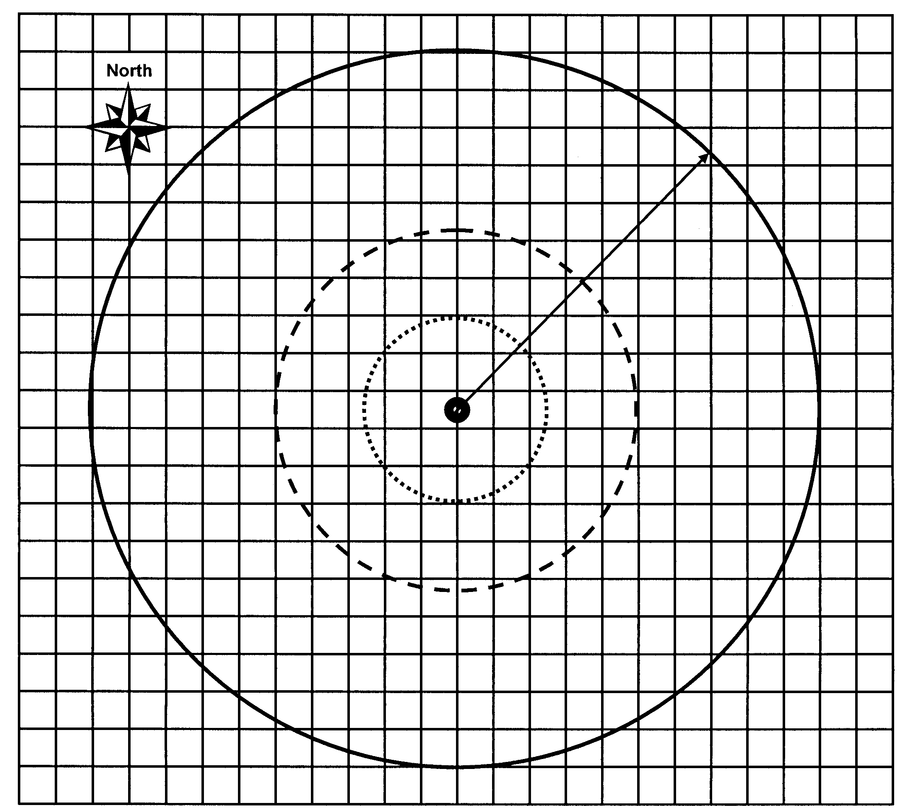
Radius (select one)
100 ft for Wells
200 ft for Springs

Description of Features Shown on the SCA Schematic
A. |  |  |  | C. |  |  |  | E.
B. |  |  |  | D. |  |  |  | F.
Sources of Contamination |  | Feet | Sources of Contamination |  |  | Feet | Sources of Contamination |  |  | Feet
Abandoned water wells |  |  | Dumpsters |  |  |  | Pesticide storage
Animal burial |  |  | Fuel tanks (above or below ground) |  |  |  | Roads and parking lots
Biological contaminants |  |  | Graveyards |  |  |  | Sewer lines, gravity or pressure
Buildings |  |  | Hazardous waste disposal site |  |  |  | Storm water catch basins
Chemical contaminants |  |  | Hazardous waste facility |  |  |  | Surface water
Drainfields and septic tanks |  |  | Irrigation canal |  |  |  | Wastewater spray irrigation
Drug lab |  |  | Landfill, dump, disposal area |  |  |  | Other:
Dry wells |  |  | Pesticide application

