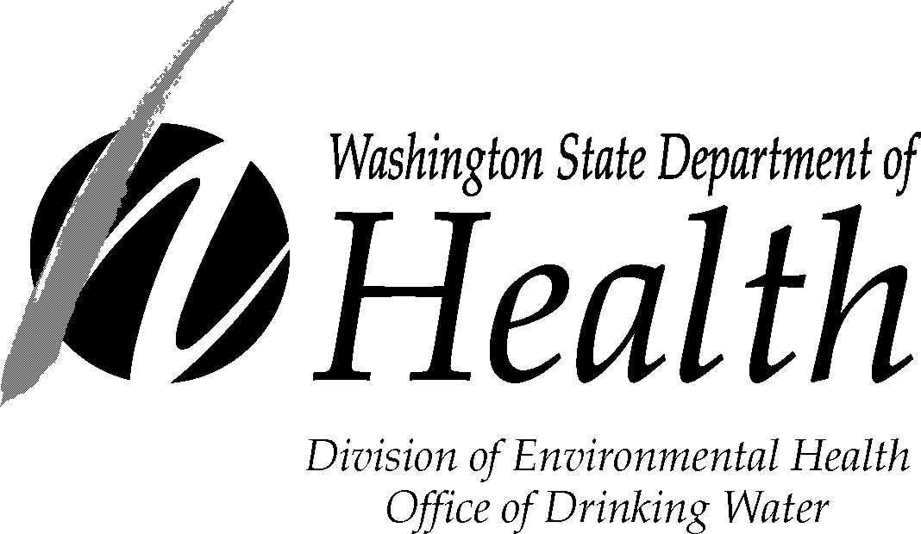

DISTRIBUTION CHLORINE RESIDUAL REPORT FORM

Water System Name: |  | Month/Year:
County: | ID#: | Report Submitted by:
Treatment Plant #: | Source(s)#: | Operator Certification #:
Requirements:  Cl₂ Residual: mg/L in distribution  Monitoring requirement: days per week |  | Telephone #:
 |  | Signature:

 | Water Production  Gallons or ft³ | Chlorine Solution Used |  | Treated Water Quality
Date | Source Meter Reading | Tank  Level  (Gallons/Pounds) | Volume  Used  (Gallons/Pounds) | Distribution  Cl₂ Residual  (mg/L) | Distribution Sample Location | Troubleshooting Notes  Also record additional residual readings following a low or zero residual reading | Sampler  Initials
1
2
3
4
5
6
7
8
9
10
11
12
13
14
15
16
17
18
19
20
21
22
23
24
25
26
27
28
29
30
31
Total |  |  |  |  | Total number of measurements collected
Max
Min

Please keep a copy for your records and send report by the 10th of the following month to your Regional Office.
See instructions page.

INSTRUCTIONS FOR DISTRIBUTION CHLORINE RESIDUAL REPORT FORM

Monitoring Requirement – Measure and record free chlorine residual from a representative location in your distribution system at least 5 days per week. Please note your required residual at the top of the form. Use a Free Chlorine Residual test kit to measure the residual.

Source Meter Reading – You should record this at least once a week. The total volume of water used is calculated as the difference between the source meter readings. Record this as the total under the Source Meter Reading.

Tank level (gallons/pounds) – The amount of chlorine solution remaining in the chemical feed tank. If you use gas chlorine, record the pounds remaining. You should record this at least once a week.

Volume Used (gallons/pounds) – The amount of chlorine solution used since the last time it was checked. If you use gas chlorine, record the pounds used. You should record this at least once a week.

Distribution Chlorine Residual (in mg/L) – The measurement of free chlorine residual at a representative location in your distribution system.

Distribution Sample Location – The location where the distribution chlorine residual sample was collected, such as a home or business that is a representative point within the distribution system.

Troubleshooting Notes – Note troubleshooting activities and additional residual readings following an initial low or zero residual reading.

Coliform sampling – You must test the chlorine residual at the same time and location that you collect a routine or repeat coliform sample. Be sure to mark the chlorine residual on the coliform lab slip.

Return to your regional office by the 10th of the following month.
We encourage you to submit your monthly treatment plant report form electronically to the appropriate email address.
Eastern Region | 16201 East Indiana Avenue, Suite 1500  Spokane Valley, WA 99216 | Phone: 509.329.2100  Fax: 509.329.2104  Email: DOHDWChlorination@doh.wa.gov
Counties Served: Adams, Asotin, Benton, Chelan, Columbia, Douglas, Franklin, Ferry, Garfield, Grant, Kittitas, Klickitat, Lincoln, Okanogan, Pend Oreille, Spokane, Stevens, Walla Walla, Whitman and Yakima.
Northwest Region | PO Box 47800  Olympia WA 98504 | Phone: 253.395.6750  Fax: 253.395.6760  Email: DW.NWRO@doh.wa.gov
Counties Served: Island, King, Pierce, San Juan, Skagit, Snohomish, and Whatcom.
Southwest Region | PO Box 47823  Olympia, WA 98504 | Phone: 360-236-3030  Fax: 360-236-3029  Email: SW.Treatment.Reports@doh.wa.gov
Counties Served: Clallam, Clark, Cowlitz, Grays Harbor, Jefferson, Kitsap, Lewis, Mason, Pacific, Skamania, Thurston, and Wahkiakum.

If you need this publication in an alternative format call 800.525.0127 (TDD/TTY call 711).
This and other publications are available at doh.wa.gov/drinkingwater.

DOH Form 331-593 (Updated 4/2019)

