Large On-site Sewage System (LOSS)
Model Operation and Maintenance Manual

September 2021

Large On-site Sewage Systems (LOSS)
Model Operation and Maintenance Manual

September 2021

For information or additional copies of this report contact:
Wastewater Management Program
Physical address: 101 Israel Road SE, Tumwater, WA 98501
Mailing Address: PO Box 47824, Olympia, Washington 98504-7824

Phone: (360) 236-3330
FAX: (360) 236-2257
Webpage: www.doh.wa.gov/wastewater
Email: wastewatermanagement@doh.wa.gov

Umair A. Shah, MD, MPH
Secretary of Health

To request this document in another format, call 1-800-525-0127. Deaf or hard of hearing customers, please call 711 (Washington Relay) or email civil.rights@doh.wa.gov.

Para solicitar este documento en otro formato, llame al 1-800-525-0127. Clientes sordos o con problemas de audición, favor de llamar al 711 (servicio de relé de Washington) o enviar un correo electrónico a civil.rights@doh.wa.gov.

DOH 337-111

Preface

This Model Operation and Maintenance (O&M) Manual has been developed to assist design engineers in preparing the Large On-site Sewage System O&M Manual to meet the requirements of WAC 246-272B-04200.

This manual was formatted and developed specifically for new installations.

For existing systems that are required to develop an O&M manual, the engineer should complete the manual using the best available information. Information may be available from the design engineer, the installer, the reviewing agency (local health or Department of Ecology) and the owner.

The objective in preparing the O&M manual is the same – O&M documentation should be located in one place and the manual should provide a guide for operators and owners to provide proper management of the LOSS. Multiple copies can be made and shared as needed.

The O&M Manual must be signed and stamped by a licensed engineer.

Cover Page
[Insert a cover page with the LOSS name, date of O&M Manual and Engineer information. Include a block for both the P.E. Stamp and the DOH Approval stamp.]

Operation and Maintenance Manual

[LOSS System Name]

[Date]

Prepared by:

[Engineer’s Name and Company]

Engineer’s Stamp

DOH Engineer’s Approval Stamp

Contents

- General Information
- LOSS Operating Permit 9
- Key Contact Information 14
- Owner Responsibilities 19
- Operator Responsibilities 21
- Management Contract / Other Legal Documents 22

- Design Information
- Design Description 23
- Flow Diagram or Schematic 27
- Design Criteria 28

- Operation and Maintenance
- Operating Permit Conditions 29
- Flow Determination 31
- Recommended Component Settings 33
- Process Control Information 34
- Maintenance Schedule (Facilities Inspection Schedule) 35
- Tanks 37
- Pumps, Motors, and Switches 39
- Calibration of Sampling and Measuring Devices 41
- Repairs and Replacement 42
- Drainfield 43
- Other Activities 46

- Troubleshooting Guide 47

- Emergency (Abnormal Operating) Procedures
- Emergency Contacts 49
- Emergency Procedures 54

- Recordkeeping and Forms
- Recordkeeping Procedures 55
- Recordkeeping Sample Forms 56

- Safety Procedures
Labor and Industry Rules 77

APPENDICES
- Electrical Component Information and Wiring Diagrams 78
- Cut Sheets and Manufacturer’s Information 79
- LOSS Documents 85
- Initial Component Testing Information Settings (Start-up) 86
- Monitoring and Reporting Plan 87
- Department of Health Guidance Documents 99

Acronyms

The following acronyms apply throughout this document unless the context clearly requires otherwise:

“B” means a treatment level that provides the following maximum annual average effluent parameters: 15 mg/L CBOD_{5,} 15 mg/L TSS, and 1,000 fecal coliform/100 mL.
“BOD₅” means biochemical oxygen demand, measured after 5 days, typically expressed in mg/L.
“C” means a treatment level that provides the following maximum annual average effluent parameters: 25 mg/L CBOD_{5,} 30 mg/L TSS, and 50,000 fecal coliform/100 mL.
“CBOD₅” means carbonaceous biochemical oxygen demand, measured after 5 days, typically expressed in mg/L.
“CFU” means colony forming units of fecal coliform bacteria.
“DOH” or “the department” means Washington State Department of Health.
“E” means a treatment level that provides the following maximum annual average effluent parameters: 125 mg/L CBOD_{5,} 80 mg/L TSS, and 20 mg/L O&G.
“ETM” means elapsed time meter.
“ft” means feet or foot.
“ft²” means feet squared.
“gal” means gallons.
“gpd” or “GPD” means gallons per day.
“HQE” means a treatment level higher than Treatment Level B as established in WAC 246-272B-06250.
“L&I” means Washington State Department of Labor and Industry.
“lf” means linear feet.
“LMR” means LOSS monitoring report.
“LOSS” means Large On-site Sewage System.
“mg/L” means milligrams per liter.
“mL” means milliliter.
“MW” means monitoring well.
“N₁₀” means a treatment level of 10 mg/L maximum annual average total nitrogen.
“N₂₀” means a treatment level of 20 mg/L maximum annual average total nitrogen.
“O&G” means oils and grease.
“O&M” means Operation and Maintenance.
“PVC” means polyvinylchloride.
“psi” means pounds per square inch.
“RCW” means Revised Code of Washington.
“RS&G” means Recommended Standards and Guidance.
“STE” means septic tank effluent.
“TSS” means total suspended solids.
“UV” means ultraviolet and usually refers to ultraviolet radiation disinfection treatment.
“WAC” means Washington Administrative Code.

      - General Information

- Current Annual LOSS Operating Permit

[Keep a copy of your current permit here.]

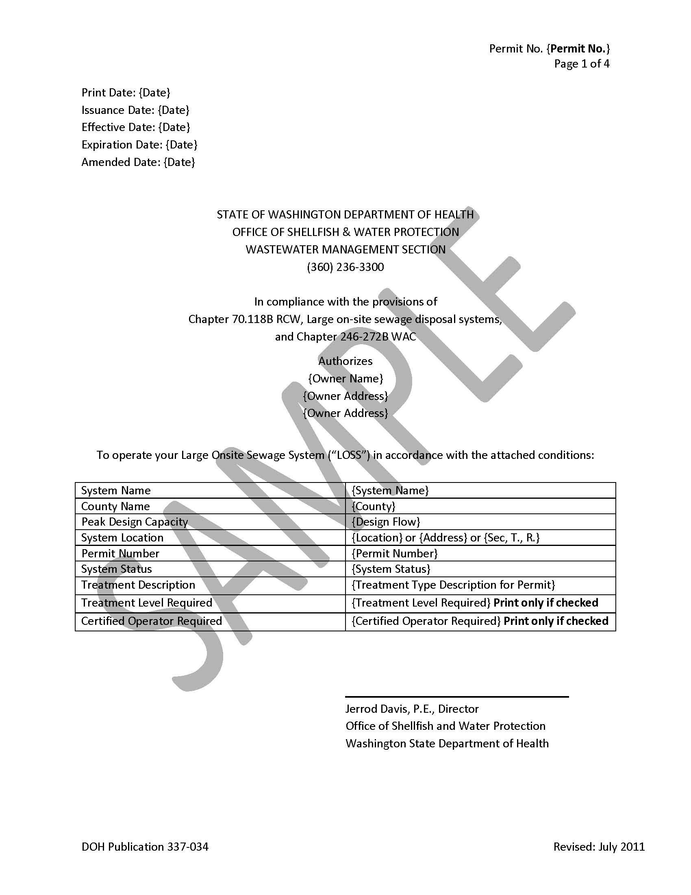

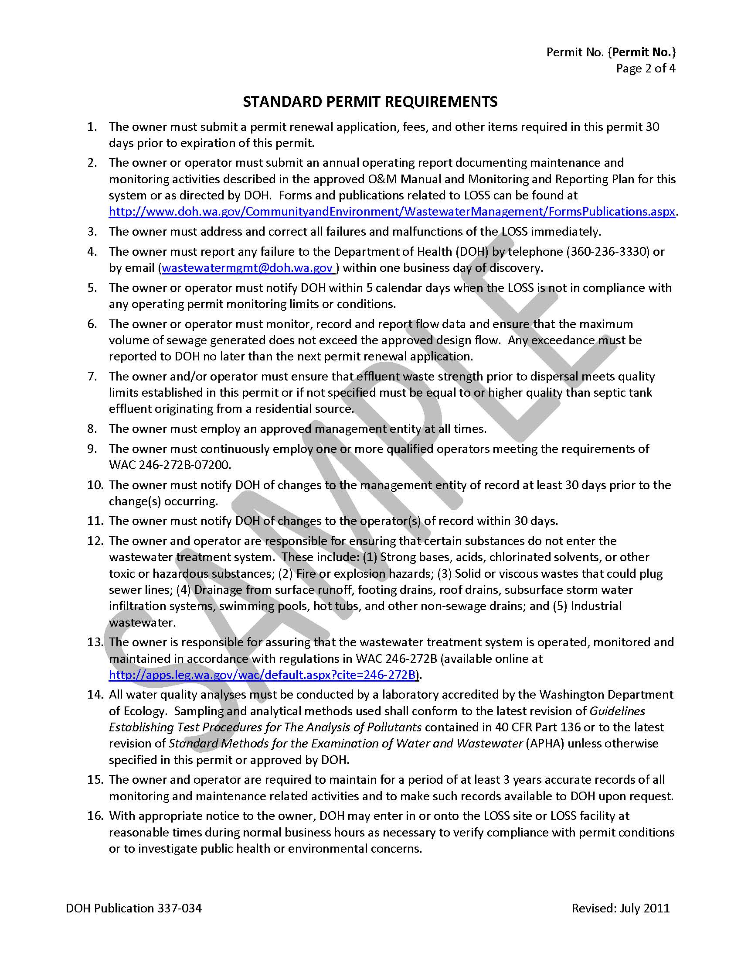

Note: The following are examples of the conditions that DOH may impose.
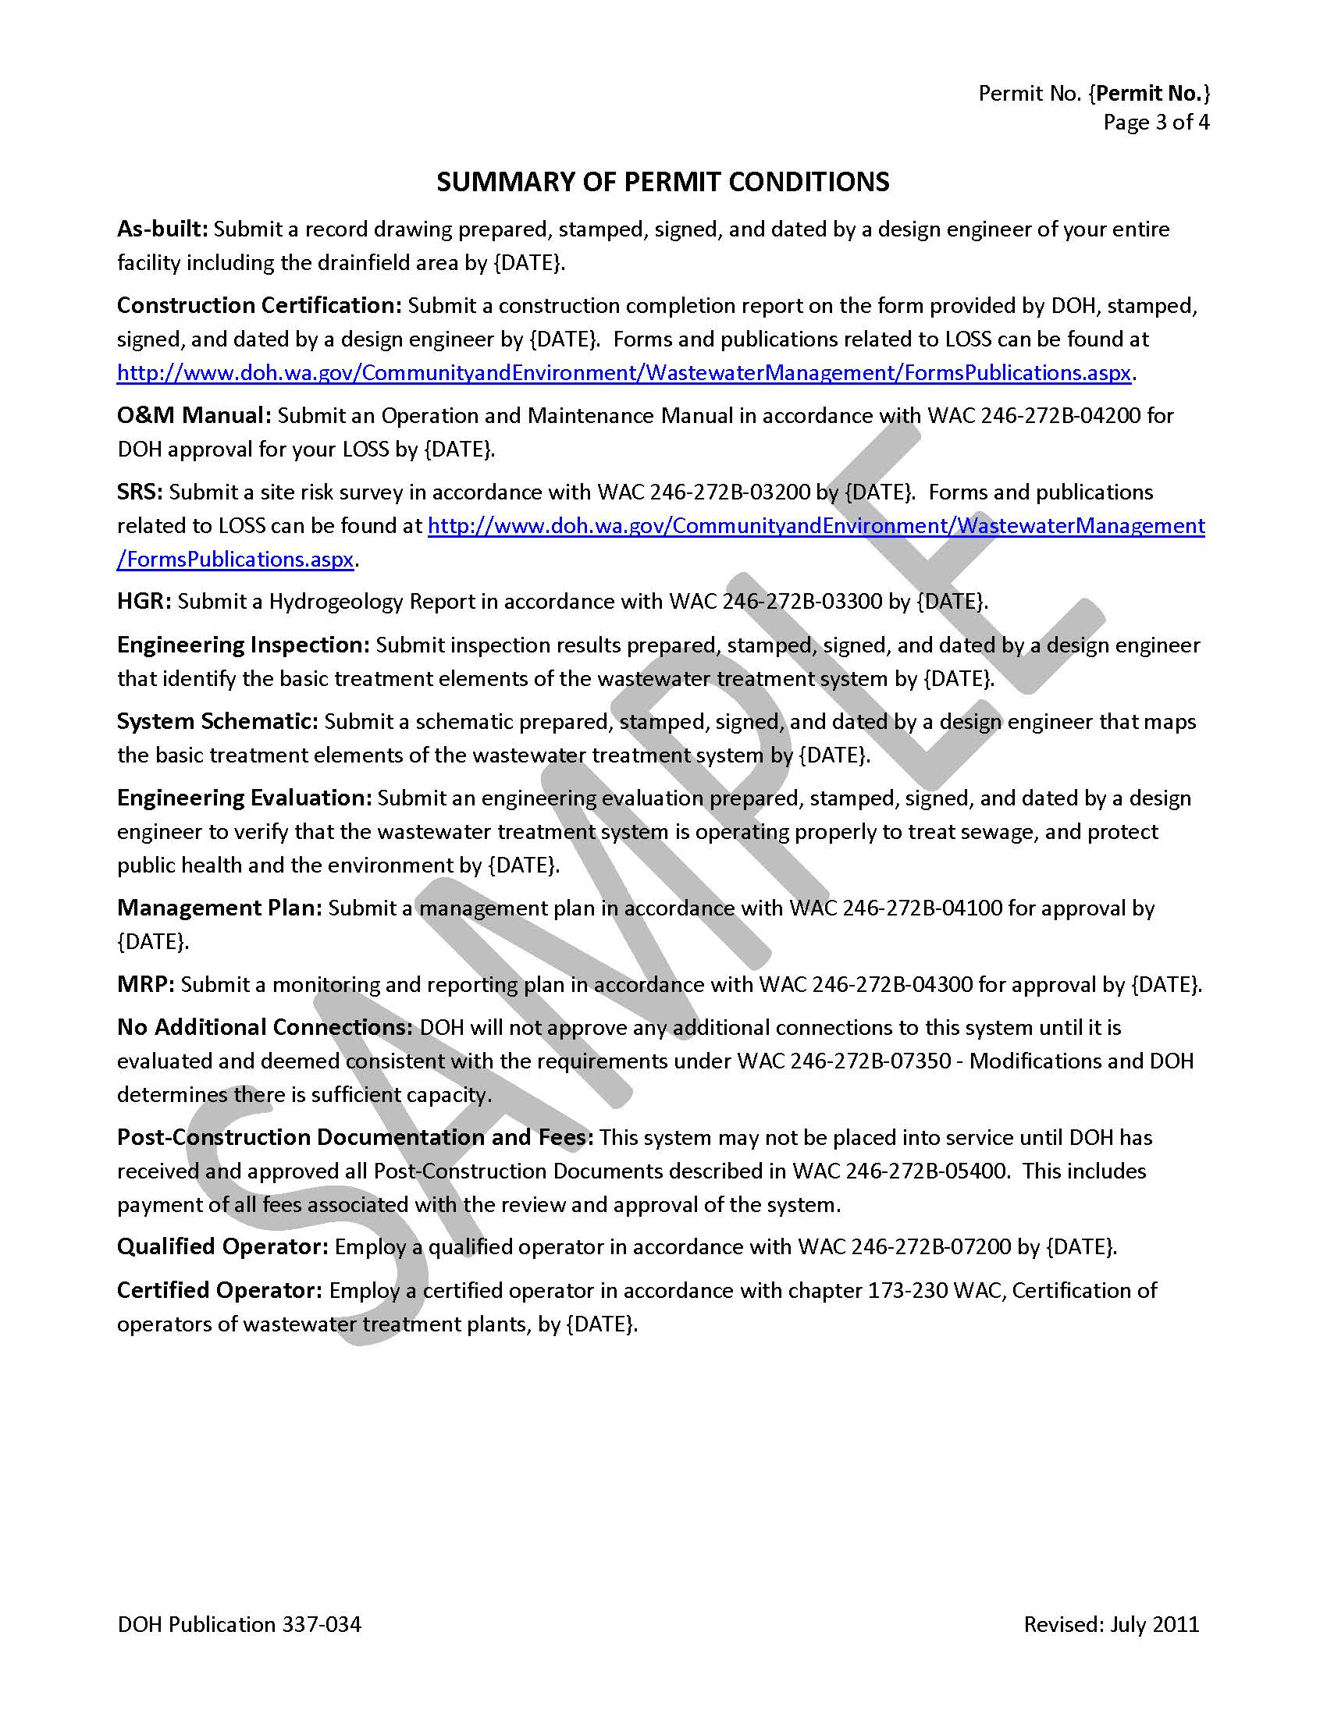

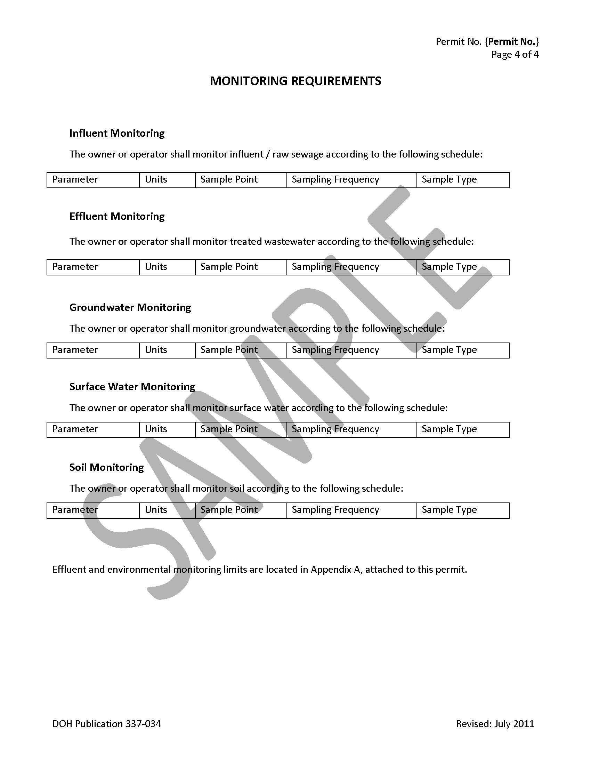

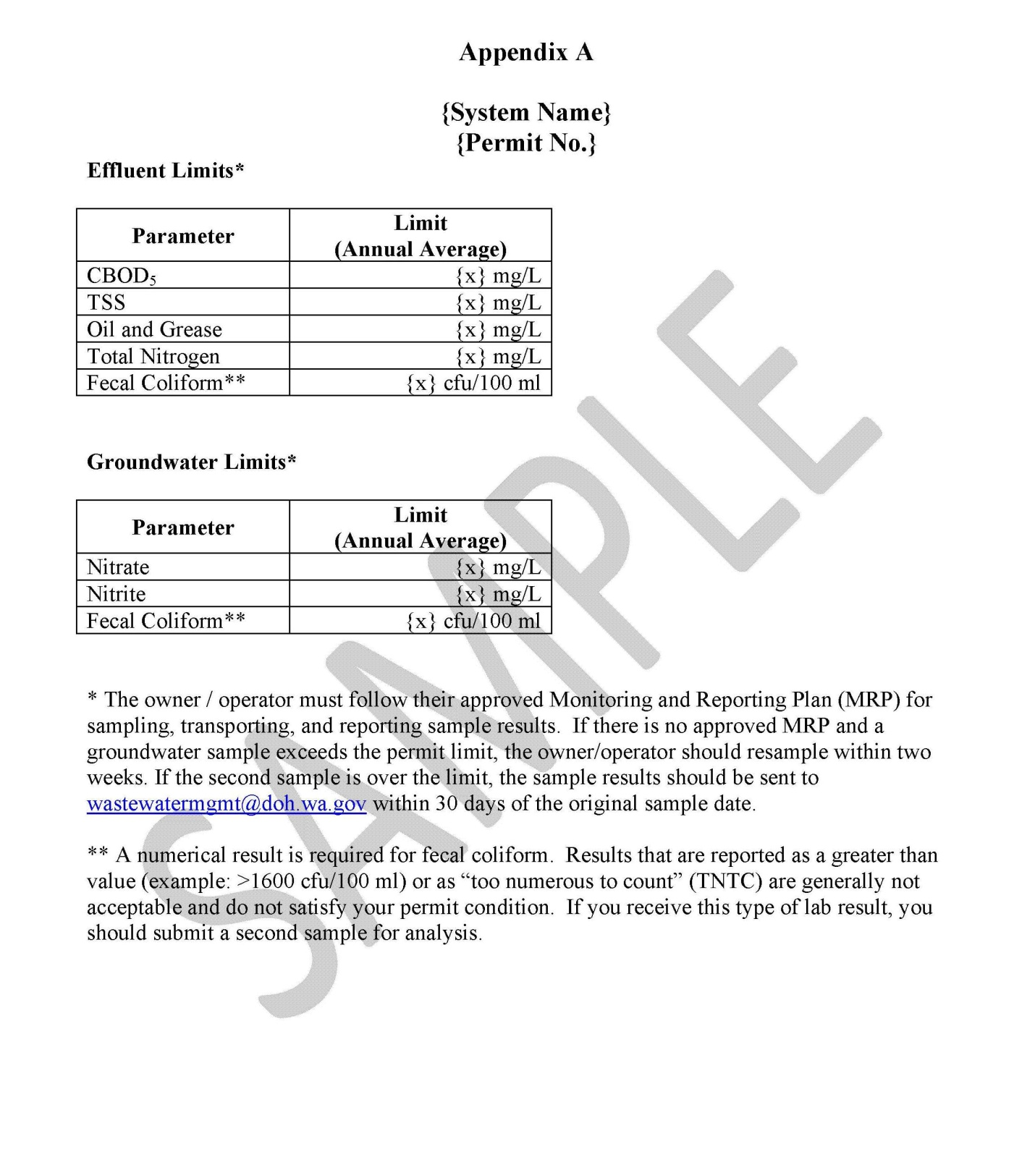

      - General Information

2. Key Contact Information

[Include the following information. Update as necessary. If you don’t have one of the persons listed below, enter “N/A”. An individual may serve in more than one capacity.]

Operator:

(Name of Operator)

(Mailing Address)

(City) (State) (Zip Code)

(Daytime Phone Number) (Fax Number) (Cell Phone Number)

(Email)

Owner:

(Name of Owner)

(Mailing Address)

(City) (State) (Zip Code)

(Daytime Phone Number) (Fax Number) (Cell Phone Number)

(Email)

Design Engineer:

(Name of Design Engineer)

(Mailing Address)

(City) (State) (Zip Code)

(Daytime Phone Number) (Fax Number) (Cell Phone Number)

(Email)

Installer:

(Name of Installer)

(Mailing Address)

(City) (State) (Zip Code)

(Daytime Phone Number) (Fax Number) (Cell Phone Number)

(Email)

Electrician:

(Name of Electrician)

(Mailing Address)

(City) (State) (Zip Code)

(Daytime Phone Number) (Fax Number) (Cell Phone Number)

(Email)

Septic Tank Pumper:

(Name of Pumper)

(Mailing Address)

(City) (State) (Zip Code)

(Daytime Phone Number) (Fax Number) (Cell Phone Number)

(Email)

Management Entity:

(Name of Management Entity)

(Mailing Address)

(City) (State) (Zip Code)

(Daytime Phone Number) (Fax Number) (Cell Phone Number)

(Email)

Primary Contact Person for Management Entity:

(Name of Primary Contact Person for Management Entity)

(Mailing Address)

(City) (State) (Zip Code)

(Daytime Phone Number) (Fax Number) (Cell Phone Number)

(Email)

Third Party Guarantor (if any):

(Name of Third Party Guarantor)

(Mailing Address)

(City) (State) (Zip Code)

(Daytime Phone Number) (Fax Number) (Cell Phone Number)

(Email)

Washington State Department of Health (DOH):

(Name of Approving Engineer or DOH Engineer you now work with)

(Mailing Address)

(City) (State) (Zip Code)

;360-236-3330
(DOH Engineer Number; Mainline) (Fax Number) (Cell Phone Number)

; wastewatermgmt@doh.wa.gov
(DOH Engineer Email; WWMS Generic Email)

    - General Information

3. Owner Responsibilities

[Include the following statement in this section.]

CALL BEFORE YOU DIG:
Owners of LOSS (defined by L&I as facility operators) must subscribe to a one-number locator service per RCW 19.122 (see Section G of this manual). ‘Call Before You Dig’ requirements apply when repairing or replacing buried LOSS components. You will also be notified to identify where your lines and tanks are buried if underground work is going to be done in your area.

[Include these following requirements from the LOSS Rule.]

- The owner shall obtain an operating permit from the department and shall renew it annually as long as the LOSS is in service.

- The owner shall employ a qualified operator(s) at all times.

- The owner shall submit an annual operating report prepared and signed by the qualified operator.

- The owner shall employ an approved management entity at all times.

- The owner shall ensure that reliable and representative monitoring following operating permit requirements is conducted and that results are provided to the department.

- The owner shall notify the department within five calendar days when the LOSS is not in compliance with an operating permit monitoring limit or condition.

- The owner shall address and correct all failures immediately and shall report the condition to the department within one business day of discovery.

- The owner shall ensure that financial resources are sufficient for O&M of the LOSS.

- The owner, along with the operator is responsible for ensuring that certain substances do not enter the LOSS collection system. These include:
- Strong bases, acids, chlorinated solvents, or other toxic or hazardous substances
- Fire or explosion hazards
- Solid or viscous wastes that could plug sewer lines
- Drainage from surface runoff, footing drains, roof drains, subsurface storm water infiltration systems, swimming pools, and other non-sewage drains
- Industrial wastewater

- The owner shall respond to customer concerns and service complaints in a timely manner.

- The owner shall use reasonable security measures to protect the LOSS treatment processes and components, including the soil profile, from possible damage or harm by unauthorized persons, vehicles, animals, vegetation, or other sources.

[Include the following requirement from the LOSS Rule, if applicable.]

- The owner shall ensure that the operator of a LOSS using proprietary treatment is trained by the proprietary treatment manufacturer and authorized in writing by and in good standing with the manufacturer to operate that treatment.

Note: A copy of the written authorization from the proprietary treatment manufacturer must be included in Section A.5.

[Add any additional Owner responsibilities.]

- General Information

4. Operator Responsibilities

[Include the following requirements from the LOSS Rule.]

- The operator shall be certified by the Department of Ecology or approved by a local health jurisdiction or otherwise acceptable to the department in accordance with 246-272B-07200 WAC.

- The operator shall be responsible for safely and lawfully operating the LOSS and ensuring that it consistently and reliably treats sewage as directed in the operating permit.

- The operator shall prepare, sign and submit monitoring reports prepared in accordance with the Monitoring and Reporting Plan (Appendix 5), certifying that the results are correct and the report is complete.

- The operator, along with the owner, is responsible for ensuring that certain substances do not enter the LOSS collection system. These include:
- Strong bases, acids, chlorinated solvents, or other toxic or hazardous substances
- Fire or explosion hazards
- Solid or viscous wastes that could plug sewer lines
- Drainage from surface runoff, footing drains, roof drains, subsurface storm water infiltrations systems, swimming pools, and other non-sewage drains
- Industrial wastewater

[Include the following requirement from the LOSS Rule, if applicable.]

- The operator of a LOSS using proprietary treatment must be trained by the proprietary treatment manufacturer and be authorized in writing by and in good standing with the manufacturer to operate that treatment.

Note: A copy of the written authorization from the proprietary treatment manufacturer must be included in Section A.5.

[Add any additional operator responsibilities.]

- General Information

5. Management Contract / Other Legal Documents

[Insert a copy of the signed contract between the owner and the management entity here.]

Note: When the LOSS has a single owner, the owner may act as the management entity.

[Insert any additional applicable legal documents here.]

- Service contract with maintenance provider.
- Connection agreement or contract.
- Copy of recorded easements for septic tanks, drainfields, or other facilities.
- Written authorization of operator from proprietary treatment manufacturer.
- Copy of recorded easements or franchise agreements for sewer lines.
- Copy of property title to land owned and used for the LOSS components.
- Rules, ordinances, fee structures.
- List of customers, service addresses, and mailing addresses.

- Design Information

- Design Description

[Provide information on the LOSS design]

  - At a minimum this section should provide a narrative that describes:
    - How the system works
    - Its intended performance
    - Operating limits of the design

  - The narrative should include a brief description of each major process or component and discuss its function in the LOSS and its expected performance. Performance could be described in terms of treatment performance, pumping capacity, loading capacity, or other measurement used to design the system.

Example – LOSS Narrative:
This LOSS facility has an approved design flow of 5,000 gallons per day (gpd) and is served by an advanced on-site wastewater treatment/dispersal system consisting of a collection system, septic tanks, treatment via recirculating gravel filter (RGF) and a pressure distribution drainfield.
Raw sewage from the gravity collection system pipes flows by gravity to a 15,000 gallon, two compartment septic tank. The septic tank provides primary treatment of the raw sewage by (1) allowing the solids and floatable material (scum) to separate from the liquid portion of the raw effluent and (2) allowing preliminary anaerobic biological decomposition to occur. A filter in the tank outlet provides additional screening of solids. The septic tank is expected to reduce BOD by 30-40% and TSS by up to 70%.
The clarified liquid effluent from the septic tank flows by gravity to the 7,500 gallon recirculation tank of the RGF. The effluent receives additional treatment via the RGF which is designed to reduce the effluent strength to 25 mg/L CBOD₅, 30 mg/L TSS and 50,000 fecal coliform/100 ml. The RGF has a design capacity of 5,000 gpd.
Following treatment in the RGF, the effluent is pumped via a 9,000 gallon dose tank to the pressure distribution drainfield for final dispersal and treatment by the native soil.
The pressure distribution drainfield is sized for a flow of 5,040 gpd with a loading rate of 1 gpd/day/ft². The drainfield consists of three 50% drainfields each containing 3 zones with 5 laterals. A typical lateral trench is 3’ x 56 ‘. Spacing between trenches is 4.5 feet. The drainfield is designed so that each lateral is dosed 6 times per day. The active drainfields are alternated every 4 months so that two of the three 50% drainfields are in use at any given time.

  - It may also be helpful to include a component list.

Example – LOSS Component List:
The following is an example of information that could be included in a component list. More detailed information for each of the components should be included in Appendix 2.

LOSS Component List
Tanks | No. | Description | Location
Septic Tank(s) |  | Manufacturer:  Material:  Capacity:  Effluent Filter:
Grease Interceptor(s) |  | Manufacturer:  Material:  Capacity:  Screen:
Pump Tank(s) |  | Manufacturer:  Material:  Capacity:  Filter:  Pumps:  Manufacturer:  Model:  Horsepower:  Discharge Rate:  Head:  Floats/Sensors:  Type:  Manufacturer:  Model:

Tanks | No. |  | Description |  | Location
Other Tank(s) |  |  |  | Manufacturer:  Material:  Capacity:  Filter:  Pumps:  Manufacturer:  Model  Horsepower:  Discharge Rate:  Head:  Floats/Sensors:  Type:  Manufacturer:  Model:
Treatment Component |  | No. |  | Description | Location
Recirculating Media Filter |  |  |  | Dimensions:  Number of Zones:  Number of Laterals per Zone:  Lateral Diameter:  Orifices:  Infiltrators:  Distribution Valve:
Disinfection |  | No. |  | Description | Location
Disinfection System (Type) |  |  |  | Manufacturer:  Capacity:

Dispersal | No. | Description | Location
Pressure Distribution |  | Infiltrative Area:  Trenches or Beds:  Spacing:  Number of Zones:  Pipe Material:  Length of Laterals:  Lateral Diameter:  Orifice Spacing:  Orifice Diameter:  Distribution Valve:  Other:
Control Panel | No. | Description | Location
Control Panel |  | Manufacturer:  Model:  Special Features:  Control Switch (HMO):  Programmable Timer:  Elapsed Time Meter:  Cycle Counter:  Audible/Visual Alarm:  Redundant Off Alarm Relay:  Wiring Diagram:
Other Processes | No. | Description | Location

B. Design Information

2. Flow Diagram or Schematic

[Provide a flow diagram or schematic of the LOSS.]

Example:

Recirc Tank
7,500 gallon
Recirculating
Gravel Filter
Dose Tank
9,000 gallon
Septic Tank
15,000 gallon
2 compartments
Drainfield

B. Design Information

3. Design Criteria

[Provide the criteria necessary for the LOSS design]

- At a minimum, include the following information:
- Type of Facility Served
(i.e. single family residence, mobile home park, church, school, campground)
- Number of Units (Customers) Served
- Design Flow (gpd)
- Septic Tank Capacity (gallons)
- Design Waste Strength
(residential or high strength)
- Treatment Level
(STE, E, C, B, HQE, N20, other)
- Soil Type*
- Vertical Separation (ft)
- Approved Loading Rate
(gpd/ft² - conventional drainfield)
(gpd/emitter** - subsurface dripfield)
- Dose Volume (gallons)
- Doses per Day
- Drainfield Infiltrative Area (ft²)
- Drainfield Capacity (gpd)
- Drainfield Type (beds/trenches/drip)

* Attach sieve analysis, if any
** Determined from soil type, emitter spacing and dripline spacing

- Include any other site specific design criteria – i.e. criteria required by specific treatment technologies

C. Operation and Maintenance

1. Operating Permit Conditions

[Provide a summary of permit conditions with a schedule of permit due dates.]

a. Permit monitoring conditions may include limits on, and/or monitoring and reporting of:
- Influent and/or effluent quality
- Groundwater quality
- Surface water quality
- Soil quality
b. Monitoring requirements and permit limits will be described in the operating permit.

c. Other permit conditions may include:
- Additional environmental monitoring
- No additional connections
- Hire qualified operator
- Hire certified operator
- Submittal of:
  - Record (as-built) drawings
  - Construction certification from design engineer
  - O&M manual
  - Site risk survey
  - Hydrogeology report
  - Engineering inspection
  - System schematic
  - Engineering evaluation
  - Management plan
  - Monitoring and reporting plan
  - Post-construction documentation from design engineer and fees
Example:
Permit Conditions Summary and Reporting Schedule
LOSS Name |  |  | XYZ Development |  |  | Permit No. | ABC001
Permit Renewal Day |  |  | July 1 |  |  | Design Flow | 5,000 GPD
 |  |  | Influent
Parameter |  |  | CBOD5 | TSS | O&G |  | TN
Sample Point |  |  | Septic Tank Inlet
(units) |  |  | (mg/L) | (mg/L) | (mg/L) |  | (mg/L)
Sampling Schedule |  |  | annual | annual | annual |  | quarterly
Sample by | Report by*
Jan 31 | Feb 28 |  |  |  |  |  | X
April 30 | May 31 |  |  |  |  |  | X
July 31 | Aug 31 |  | X | X | X |  | X
Oct 31 | Nov 30 |  |  |  |  |  | X
 |  |  | Effluent
Parameter |  |  | CBOD5 | TSS | O&G | Fecal | TN
Sample Point |  |  | Dose Tank
Permit Limit |  |  | 25 | 30 | 20 | 50000 | 20
(units) |  |  | (mg/L) | (mg/L) | (mg/L) | (CFU/100 mL) | (mg/L)
Sampling Schedule |  |  | quarterly | quarterly | quarterly | quarterly | quarterly
Sample by | Report by*
Jan 31 | Feb 28 |  | X | X | X | X | X
April 30 | May 31 |  | X | X | X | X | X
July 31 | Aug 31 |  | X | X | X | X | X
Oct 31 | Nov 30 |  | X | X | X | X | X
 |  |  | Groundwater
Parameter |  |  | NO2 | NO3
Sample Point |  |  | MW 1 and MW 2
Permit Limit |  |  |  | 10
(units) |  |  | (mg/L) | (mg/L)
Sampling Schedule |  |  | quarterly | quarterly
Sample by | Report by*
Jan 31 | Feb 28 |  | X | X
April 30 | May 31 |  | X | X
July 31 | Aug 31 |  | X | X
Oct 31 | Nov 30 |  | X | X
* Submit Results to DOH by Date Shown

C. Operation and Maintenance

2. Flow Determination

[Provide instructions and describe activities for determining wastewater flow.]

Note: Sample forms for recording operation and maintenance activities are provided in Section F.2

  - Flow may be determined using:
- Flowmeter readings,
- Elapsed time meters and pump run times,
- Event counters and dose volume,
- Calculation methods provided by the design engineer, or
- Other methods if approved by the department (e.g. water usage data)

  - Average Daily Flow should be calculated and reported. The ‘Annual Maintenance and Monitoring Report’ form in Section F.2 contains instructions for calculating and reporting ‘Average Daily Flow’.

Note:
Average daily flows determined from event counters and dose volume or elapsed time reading and pump capacities can be used to check flow meter readings if recorded on the same day.
If flows exceed the design flow, the owner must notify the department no later than the next permit renewal application date. (This requirement can be met by sending in the completed Annual Maintenance and Monitoring Report form).
Unexpected major variations or discrepancies in flow need to be investigated to determine the cause. They could indicate a problem in the collection system.

Example 1 - Flowmeter Readings (sample form 3a):
- Record the flow reading from the meter (the department suggests weekly readings).
- If the flow is not in gallons, perform the required conversion (example: to convert from cubic feet to gallons, multiply by 7.48).
- Subtract the previous reading to obtain the gallons pumped during the period between readings.
- At the end of the month, add the gallons measured for the month and divide by the number of days measured to determine the ‘Average Daily Flow’ for the month.
- Record the ‘Average Daily Flow’ for the month on the Annual Maintenance and Monitoring Report form (sample form 1).

Example 2 - Elapsed Time Meters and Pump Run Times (sample form 3b):
- Record the elapsed time meter (ETM) reading and the event counter (CT) reading for each pump from the control panel (the department suggests weekly readings).
- Determine the elapsed time (run time) since the previous entry for each pump.
- Add the run times for each pump to get [run time 1+2].
- Multiply [run time 1+2] by the average dose pump rate (Section C.3) to get the flow (in gallons) for the time period measured.
- At the end of the month, add the flows measured for the month and divide by the number of days measured to determine the ‘Average Daily Flow’ for the month.
- Record the ‘Average Daily Flow’ for the month on the Annual Maintenance and Monitoring Report form (sample form 1).

Run times and event counts should be approximately the same for both pumps.

The department provides further guidance for determining flow with elapsed time meters at this link: http://www.doh.wa.gov/Portals/1/Documents/Pubs/337-119.pdf

Example 3 - Event Counters and Dose Volume (sample form 3c):
- Record the elapsed time meter (ETM) reading and the event counter (CT) reading for each pump from the control panel (the department suggests weekly readings).
- Determine the number of events (dose cycles) since the previous entry for each pump.
- Add the number of dose cycles for each pump to get [dose cycles 1+2].
- Multiply [dose cycles 1+2] by the dose volume (Section C.3) to get the flow
(in gallons) for the time period measured.
- At the end of the month, add the flows measured for the month and divide by the number of days measured to determine the ‘Average Daily Flow’ for the month.
- Record the ‘Average Daily Flow’ for the month on the Annual Maintenance and Monitoring Report form (sample form 1).
Run times and event counts should be approximately the same for both pumps.

The department provides further guidance for determining flow with event counters (dose counters) at this link: http://www.doh.wa.gov/Portals/1/Documents/Pubs/337-118.pdf
C. Operation and Maintenance

3. Recommended Component Settings

[Provide a list or table of all recommended component settings.]

Example
Initial Component Settings: Example settings
- Dose Pumps
Dose volume 250 gallons
Doses per day 24
Pump ‘on’ 10 minutes
Pump ‘off 50 minutes
Average dose pump rate 25 gallons per minute

- Float on/off settings (measured to clamp on float tree)
On/off 30 inches from bottom of tank
Redundant off 24 inches from bottom of tank
High level alarm 60 inches from bottom of tank
Float tether length 6 inches

- Recirculating gravel filter
Recirculation ratio 5
Dose volume 60 gallons
Doses per day 48
Pump ‘on’ 3 minutes
Pump ‘off’ 27 minutes
Average recirculating pump rate 20 gallons per minute
Float on/off settings (measured to clamp on float tree)
- On/off 32 inches from bottom of tank
- Redundant off 22 inches from bottom of tank
- High level alarm 59 inches from bottom of tank
- Float tether 6 inches

    - Drainfield
Squirt height 5 feet

- Proprietary treatment
See manufacturer’s information

- Disinfection
See manufacturer’s information

C. Operation and Maintenance

4. Process Control Information

[Provide a description of activities and settings for routine operation and monitoring of the control panel.]

  - Include information on the following:
- Control switch (Hand Off Auto)
- Programmable timer
- Elapsed time meter
- Dose / Cycle counter
- Audible alarm
- Visual alarm
- Redundant-off / low level alarm relay

  - Include the manufacturer’s complete instructions for operation of the control panel in Appendix 2.E.

C. Operation and Maintenance

5. Maintenance Schedule (Facilities Inspection Schedule)

[Provide a schedule list or spreadsheet of operation and maintenance activities.]

Example 1 - O&M Facilities Inspection Schedule List:
Septic Tanks
- 2 times per year
  - Record solids and scum measurements
  - Check and clean effluent screen
  - Check inlet and outlet
- As needed
  - Have tanks pumped out
Pump Tank
- 2 times per year
  - Record solids and scum measurements
  - Check and clean filter
  - Check inlet and outlet
  - Check floats and alarms
  - Test run pumps
- Every 2 years
  - Determine pump rate by tank draw down
- As needed
  - Have tanks pumped out
Control Panel
- Weekly
  - Monitor operation
  - Record events counter
  - Record elapsed time
- As needed
  - Check battery
Flow Meters
- Weekly
  - Monitor and record reading
Treatment Component
- Monitor and maintain as required by manufacturer or recommended standards and guidance (RS&G).
Drainfield
- Monthly
  - Monitor observation ports
  - Monitor drainfield for ponding
- 2 times per year
  - Monitor / rotate distribution valve for drainfield rotation
  - Flush laterals and reset squirt height

Example 2 - O&M Facility Inspection Schedule Spreadsheet
Component | Task | Months
 |  | J | F | M | A | M | J | J | A | S | O | N | D
Septic Tanks | Check & Record Scum & Sludge Levels |  |  |  |  |  | x |  |  |  |  |  | x
 | Pump as Needed
 | Clean Filters as Needed |  |  |  |  |  | x |  |  |  |  |  | x
 | Check Inlets and Outlets |  |  |  |  |  | x |  |  |  |  |  | x
Pump Tanks | Check & Record Scum & Sludge Levels |  |  |  |  |  | x |  |  |  |  |  | x
 | Pump as Needed
 | Clean Filters as Needed |  |  |  |  |  | x |  |  |  |  |  | x
 | Check Inlets and Outlets |  |  |  |  |  | x |  |  |  |  |  | x
 | Check Float Function |  |  |  |  |  | x |  |  |  |  |  | x
 | Test Run Pumps |  |  |  |  |  | x |  |  |  |  |  | x
 | Draw Down | once every 2 years
Control Panel | Monitor Operation* | x | x | x | x | x | x | x | x | x | x | x | x
 | Record Dose Counters* | x | x | x | x | x | x | x | x | x | x | x | x
 | Record Elapsed Time* | x | x | x | x | x | x | x | x | x | x | x | x
 | Check Battery | x
Flow Meter | Check and Record Reading* | x | x | x | x | x | x | x | x | x | x | x | x
Treatment Component | Monitor and Maintain per Manufacturer Requirements or RS&G
Drainfield | Monitor/Rotate Distribution Valve |  |  |  |  |  | x |  |  |  |  |  | x
 | Monitor Observation Ports | x | x | x | x | x | x | x | x | x | x | x | x
 | Check Drainfield for Ponding | x | x | x | x | x | x | x | x | x | x | x | x
 | Flush Laterals & Reset Squirt Height |  |  |  |  |  | x
* Monitor and record weekly

C. Operation and Maintenance

6. Tanks

[Include a warning on confined space entry.]

Note: You may want to contact a Department of Labor and Industries consultant for help with an appropriate warning for your system. They have six regional offices. Search their website (www.lni.wa.gov) for “request consultation”.

Example:

WARNING:
People have died in septic tanks. These tanks contain toxic gases and little or no oxygen. Septic tanks are a confined space – DO NOT ENTER unless following all confined space procedures (See Section G – Safety Procedures and Chapter 296-809 WAC, Confined Spaces). Contact a Labor and Industries consultant for help.

[Describe activities for operation and maintenance of sewage tanks and schedule of activities.]

Note: Sample forms for recording operation and maintenance activities are provided in Section F.2

  - Provide a schedule of activities for tank maintenance (see Section C.5).
  - Discuss basic maintenance activities for sewage tanks:
- Describe the procedure for determining the sludge and scum levels in both compartments
  - Use of a sludge judge
  - Use of “L-shaped” tool for lifting scum blanket
  - Use of towel wrapped stick
- Describe procedures for checking (and cleaning) effluent filter for plugging.
- Describe procedures for checking the inlet and outlet tees.
- Describe how information will be recorded (logbook, database, or other tracking method)
- Describe criteria that will determine when the tank needs to be pumped:
  - sludge and/or scum thickness,
  - tank clear area, or
  - sludge and/or scum layer within a specified distance from the effluent filter inlet.

- Describe the items to be included in the pumper’s report. Upon completion of pumping, the pumper should provide the owner with a report detailing the service provided. The owner must retain a copy of the pumping report on file at the LOSS. The report should include:
  - Name, address, and phone number of the pumping firm;
  - Date service performed;
  - Depth in inches of scum mat and sludge layer;
  - Type of tanks and number of compartments pumped;
  - Number of gallons pumped;
  - General tank conditions observed;
  - Condition of baffles noting whether filter baffle was cleaned;
  - Description of any other service performed; and
  - Signature and license number of person performing the work
  - Discuss any specific considerations of other types of sewage tanks including:
- grease interceptors
- pump tanks
  - care taken to not damage floats and switches during cleaning and pump-out
- recirculation tanks
- siphon chambers
- manholes and lift stations

C. Operation and Maintenance

7. Maintenance of Pumps, Motors, and Switches

[Describe activities for ensuring maintenance of pumps, motors, and switches.]

[Include a warning on lock-out, tag-out to ensure machinery is de-energized before work begins.]

Note: You may want to contact a Department of Labor and Industries consultant for help with an appropriate warning for your system. They have six regional offices. Search their website (www.lni.wa.gov) for “request consultation.

Note: Sample forms for recording operation and maintenance activities are provided in Section F.2

a. Provide a schedule for pump maintenance (see Section C.5).
b. Discuss basic maintenance considerations for pumps and switches.

Example:
- A system check should be done per the O&M schedule and especially at the beginning of a heavier use season, to verify that the pumps and alarms operate properly. Check for any corrosion of metal parts or wires, and the general condition of the float switches. Manually lift the float switches to ensure they activate.

- Special consideration should be taken for float switches when the tanks are pumped out to insure that they are not damaged during cleaning.

- Servicing of pumps and related controls should be done by qualified personnel. Consult the manufacturer’s O&M instructions and wiring diagrams for more detailed information (Appendix 2.B).

- Valves at the pump tank should be inspected per the O&M schedule. Check for leaks and other signs of failure. Exercise each valve by opening and closing it. To prevent damage to the system, pumps should be manually shut off when exercising the valves.

c. Provide procedures for checking the floats and alarm functions.

Example:
- Use the ‘Manual On’ switch at the control panel to turn on each pump.
Verify that pumps turn on.
- Pull the float tree and verify that:
  - when all floats are in the down position, the pumps do not turn on in the manual mode (redundant off), and
  - when the highest float is lifted, the high level alarm sounds and the alarm light turns on.
- Record float function (sample form 5a).

d. Provide procedures for checking the pump rates.

Example:
Determine the pump rate by conducting a drawdown test of the pump tank. You must have the tank calibration factor (gallons per inch of depth) provided by the tank manufacturer (Appendix 2.A).

- Measure the distance from the wastewater surface to a reference point on the riser lip of the pump tank (mark the point used to measure).
- Turn on one pump and start timer.
- Run pump for a minimum of 5 minutes.
- Turn off pump, stop timer, and measure the distance from the reference point to the water surface.
- Calculate flow in gallons per minute: Flow = (difference in measurements / number of minutes) x tank calibration factor (gallon/inch) for the pump tank.
- Repeat steps 1-5 and average the two flows. Record all information (sample form 5b).
- Compare this number to the recommended component setting pump rate (Section C.3). If significantly different, this may be an indication of pump wear.
Record the Event Counts and Elapsed Time Meter readings on sample form 3b or 3c with a comment that these readings are for the pump rate check. This will allow you to subtract the additional number of pump events when determining the ‘Average Daily Flow’.
Additional guidance for determining pump flow rate is available at this link: http://www.doh.wa.gov/Portals/1/Documents/Pubs/337-119.pdf

C. Operation and Maintenance

8. Calibration of Sampling and Measuring Devices

[Provide a description of the activities and a schedule for calibration of any sampling and measuring devices.]

Provide information for the calibration of devices such as:
- Composite samplers
- Dissolved oxygen meters
- pH meters
- Thermometers
- Flow meters
- Pressure meters

C. Operation and Maintenance

9. Repairs and Replacements

[Include information on utility locate requirements for facilities subject to this regulation]

Example:

CALL BEFORE YOU DIG: (811 or 1-800-562-6150)

Owners of LOSS (Defined as by L&I as Facility Operators)
must subscribe to a One-Number Locator Service
per RCW 19.122 (See Section G)

CALL BEFORE YOU DIG requirements apply
when repairing or replacing buried LOSS components.

[Provide a description and schedule of the procedures for repair and replacement of components.]

Note:
Sample forms for recording operation and maintenance activities are provided in Section F.2.
It is expected that equipment will eventually wear out and need replacement. When replacing equipment it is important to select items that will not cause the system to malfunction.
Material specifications vary in their importance; some items can be exchanged easily, for example, brands of PVC pipe. Other items, such as pumps, filter media, or custom-wired electrical panels, would all be specific for a particular design and must be followed exactly.
Pumps should be replaced with pumps that have the same head/flow characteristics as the originally specified pumps.
Filters should be replaced with filters that have the same size mesh as the originally specified filters.
When replacing float switches, the new float switches should not change the operating levels or the mode(s) of operation of the pump stations.
Electrical parts in the pump control panels should be replaced in kind by a licensed electrician. Replacement of parts in the pump control panels should not cause the operation of the pump station to change.
It is important to keep a record of all equipment that is repaired or replaced (sample form 9). Recordkeeping makes it easier to troubleshoot the system in case of a malfunction and provides a basis for an inventory record.

C. Operation and Maintenance

10. Drainfield

[Provide a schedule and description of the activities for operation and maintenance of the drainfield or dripfield.]

Note: Sample forms for recording operation and maintenance activities are provided in Section F.2

a. Drainfield – Operation

- Dosing
Describe the layout of the drainfield (zones, beds, number of laterals or dripline etc). Describe how the valves at the drainfield function to ensure that the zones receive the proper number of doses per day.

- Rotation
Describe how the doses will be distributed among the active drainfield sectors.

[Provide a simple schematic showing valve arrangement for drainfield rotation.]

Example:
pump 1

pump 2
To zone A
To zone B
To zone C

[Provide a schedule for drainfield rotation]

Example:

Drainfield Rotation Schedule
From | To | Drainfield
 |  | A | B | C
1-Jan | 30-Apr | Active | Active | Rest
1-May | 31-Aug | Rest | Active | Active
1-Sep | 31-Dec | Active | Rest | Active

b. Drainfield – Maintenance

  - Describe the routine maintenance required for the drainfield or dripfield.

Example:
Conventional Pressure Distribution Drainfield:

The drainfields should be observed monthly. Check each of the monitoring ports and note the presence of any ponding in the drainfield trenches. To check for ponding in the drainfield trenches, it is necessary to remove the monitoring port caps and inspect the monitoring ports. If no water is observed in the bottom of the port, record “dry” on the recording form (sample form 6a). If water is observed in the port, measure and record the depth from the ground surface to the water level. Ponding above the lateral is a sign of drainfield failure and must be immediately reported to DOH. (See Section D – Troubleshooting).

The drainfield laterals should be flushed annually. The procedure for flushing the laterals is as follows:
- At the control panel, flip the toggle switch for the pumps from ‘auto’ to ‘off’.
- Shut all isolation valves for all drainfield zones.
- Hook up a hose to the threaded plug in the clean-out port and direct the flow to a septic system pumper truck or suitable tank.
- Open the isolation valve for each lateral. Flush the laterals until the laterals run clear.
- Repeat for all laterals.

After flushing the laterals, check the residual pressure in each zone by the following procedure:
- Measure the height of water at the end of each lateral.
- Adjust the isolation valves for each lateral until all heights are equal.
- Repeat for the other zones with all zones having equal squirt heights.
- Record maintenance (sample form 6a).
- Be sure to place system back in automatic operation (flip the toggle switch for the pumps from ‘off’ to ‘auto’).

The drainfields are designed on the basis that the active sectors will receive a periodic ‘resting’ period. Any change in use of the LOSS that would cause the drainfield sectors to be used without the designed rotation is not allowed unless written approval is obtained from the department.

Example:
Subsurface Dripfield:

The subsurface dripfield should be monitored and maintained as follows:

- Check the dripfield monthly for ponded water, broken dripline, wet soggy areas

- Check the headworks two times per year:
  - Turn the dose pumps on manually
  - Check the pressure head upline of the filter, downline of the filter and at the return. Refer to the manufacturer’s guidance for filter maintenance as needed.

- Perform a system check two times per year:
  - Record the flow meter reading.
  - Turn on the dose pump and start stopwatch.
  - Check to see that air/vacuum breaker seats when pressure builds,
  - Run the pump for 4-5 minutes.
  - Stop the stopwatch and turn off the pump. Record the flow meter reading and elapsed time.
  - Check to see it the air/vacuum breaker released with the pump off.
  - Check to see that the flush return valve closed properly.
  - Calculate the flow for the observed zone.
  - Repeat for each zone, using each pump twice.
  - Calculate the average flow for the pumps.
  - Manually operate the field flush for each zone.
  - Record the event counter and elapsed time meter readings for the dose pumps (sample form 3b or 3c).
  - Record maintenance observations (sample form 6b).

C. Operation and Maintenance

11. Other Activities

[Provide a schedule and description of other activities necessary for the operation and maintenance of the LOSS.]

Note: Sample forms for recording operation and maintenance activities are provided in Section F.2

  - Maintaining cleanouts
  - Procedures for start-up and shut-down of seasonal LOSS
  - RV dump station O&M (including backflow prevention)

Example:

Maintaining collection line cleanouts.

The cleanouts should be located once a year to verify their location and to prevent them from becoming overgrown, buried, or paved over. The interior of cleanouts should be inspected to make sure material is not restricting flow. If solids accumulate, flush with high-pressure water from a pump and tank (not from a hose connected to a faucet). Document the annual maintenance.

D. Troubleshooting Guide

[Provide a troubleshooting guide that addresses problems that may arise with each component of the LOSS.]

Example: LOSS Troubleshooting Guide
 | Problem | Cause | Remedy
Tanks | High Liquid Level | Loss of power | Restore power, minimize water use, or use septic pumper to pump tanks.
 |  | Scum layer plugging inlet | Pump septic tank
 |  | Clogged baffle or filter | Inspect baffles or filter, repair or pump as required
 |  | Excess water entering the LOSS | Find source and divert or repair
 | Low Liquid Level | Tank leaking | Find leak and repair
 |  | Redundant Off Float Faulty | Check float switch controls and pump
 | Odor – Hydrogen sulfide aroma (rotten eggs) | Break in lines, check pipe shear due to differential settlement or excavation damage | Repair
 |  | Riser lid not sealing properly | Repair

Pumps | Alarms activated | Circuit breaker tripped | Reset breaker
 |  | Pump has failed | Have a professional replace pump with proper sized unit
 |  | Controls have malfunctioned | Check float switch controls and pump

Treatment Component | Inappropriate growth, odor or liquid color | Neglect, overloading, lack of O&M, chemicals put down plumbing | Reduce loading, provide on-going O&M, resize and replace unit

Disinfection | High fecal coliform numbers | Dirty or broken UV lamp | Clean or replace

LOSS Troubleshooting Guide (Continued)
 | Problem | Cause | Remedy
Drainfields | Surfacing effluent / Ponding in monitoring ports | Hydraulic overload | Check tanks for water tightness, fix leaks, conserve water use, add additional drainfield
 |  | Solids carryover | Clean screens and filters
 |  | Broken pipes | Locate and replace.
 |  | Plugged emitters or orifices | Pressure jet laterals. Terra-lift drainfield. Add treatment to reduce waste strength

Other | Contaminated surface water in vicinity of LOSS | Broken transport pipe or loose connection | Dye test and repair
 | Sewage odors | Plugged sewer vent (soil stack) | Clear plugged vents
 |  | Inspection pipe caps damaged or removed | Replace and secure caps

E. Emergency (Abnormal Operating) Procedures

1. Emergency Contacts

[Include the following information formatted so that this section could be pulled out of the manual and be used by itself.]

Owner:

(Name of Owner)

(Mailing Address)

(City) (State) (Zip Code)

(Daytime Phone Number) (Fax Number) (Cell Phone Number)

(Email)

Management Entity:

(Name of Entity & Contact Person)

(Mailing Address)

(City) (State) (Zip Code)

(Daytime Phone Number) (Fax Number) (Cell Phone Number)

(Email)

Operator:

(Name of Operator)

(Mailing Address)

(City) (State) (Zip Code)

(Daytime Phone Number) (Fax Number) (Cell Phone Number)

(Email)

Septic Tank Pumper:

(Name of Pumper)

(Mailing Address)

(City) (State) (Zip Code)

(Daytime Phone Number) (Fax Number) (Cell Phone Number)

(Email)

Design Engineer:

(Name of Engineer)

(Mailing Address)

(City) (State) (Zip Code)

(Daytime Phone Number) (Fax Number) (Cell Phone Number)

(Email)

Local Health Jurisdiction:

(Name of Sanitarian)

(Mailing Address)

(City) (State) (Zip Code)

(Daytime Phone Number) (Fax Number) (Cell Phone Number)

(Email)

Or call local emergency responders (911) if appropriate.

Washington State Department of Health (DOH):

(Name of Approving Engineer or DOH Engineer you now work with)

(Mailing Address)

(City) (State) (Zip Code)

;360-236-3330
(DOH Engineer Number; Mainline) (Fax Number) (Cell Phone Number)

; wastewatermgmt@doh.wa.gov
(DOH Engineer Email; WWMS Generic Email)

Maintenance (Service) Provider:

(Name of Service Provider Company and Contact Person)

(Mailing Address)

(City) (State) (Zip Code)

(Daytime Phone Number) (Fax Number) (Cell Phone Number)

(Email)

Other Contractors or Suppliers:

(Name of Contractor Business and Contact Person)

(Mailing Address)

(City) (State) (Zip Code)

(Daytime Phone Number) (Fax Number) (Cell Phone Number)

(Email)

E. Emergency (Abnormal Operating) Procedures

2. Emergency Procedures

Example:
In the event of surfacing sewage or sewer back up:
- Notify Department of Health within 1 business day.
- Notify your local health jurisdiction.
- Notify the maintenance provide that assistance is needed.
- Disinfect or otherwise cover ponded sewage.
- Avoid contact with the sewage.
- Barricade the affected area to keep animals and humans from the area.
- Post warning signs as needed.
- Implement water conservation measures in facilities served.
- Pump the septic tank if required – send copy of pumping receipts to DOH.
- As a last resort, close the facility.

In the event of a prolonged power outage:
- Notify your local health jurisdiction and DOH that system is still down and can’t treat sewage.
- Notify press if appropriate.
- Notify customers to minimize water use or to stop using LOSS
(if businesses or school, may notify them that they should close).
- Notify power provider and explain importance of getting power back on.
(NOTE: Operator may need to notify owner and others may need to assist in cleaning or restoring service).
- Consider bringing temporary power to the system.
- Shut off pump at the control panel.
- Monitor liquid levels in the sewage tanks.

In the event of flooding:
- Notify Department of Health within 1 business day.
- Notify your local health jurisdiction.
(NOTE: Watch for press releases about contaminated flood waters.)
- Notify customers to minimize water use. They may experience sewer back up if the sewage tank(s) fill(s) up.
- Shut off pump at the control panel.
- Septic tank systems that are flooded should not be used.
- Before restoring the flooded LOSS, troubleshoot the system: determine the tank level; check the drainfield to see if it can receive effluent; check the electrical system.

F. Recordkeeping and Forms

1. Recordkeeping Procedures

[Provide a description of the recordkeeping procedures to be followed.]

Note: Yearly submittal of a Large On-site Sewage System (LOSS) Maintenance Log / Annual Reporting Form (Annual Report) is required for renewal of the operating permit. Data should be recorded throughout the year on that form or a similar one developed for the LOSS.

Page 1 of the Annual Report (sample form 1) has instructions on the reporting period and the due date for the report. Contact the department for information concerning the due date for submitting the Annual Report for a particular LOSS.

This section should also include samples of supporting forms. The supporting forms should be filled in as the monitoring, maintenance and repair work as described in Section C (Operation and Maintenance) is completed. All supporting forms must be kept on file at the LOSS.

Example:

The permit for this LOSS expires each year on June 30.

The Large On-site Sewage System (LOSS) Maintenance Log / Annual Reporting Form (Annual Report) (sample form 1) for this LOSS must be submitted each year by May 31. The Annual Report must cover the period from May 1 of the previous year through April 30 of the current year.

This LOSS is required to submit quarterly monitoring reports as directed by the permit. Samples should be collected near the end of the first month of each quarter (January, April, July, and October). The LOSS Monitoring Reports (with attached laboratory results) (sample form 2) should be submitted to DOH within 30 days of sampling (by the end of February, May, August and November).

The following supporting forms for recording monitoring and maintenance are provided in this section:
- LOSS Average Daily Flow – sample form 3b
- Septic Tank Monitoring Form – sample form 4
- Pump Tank Monitoring Form – sample form 5a
- Pump Rate Check Form - sample form 5b
- Drainfield Monitoring Form– sample form 6a

F. Recordkeeping and Forms

2. Recordkeeping Forms

[Provide a list and samples of all forms created to document the operation and maintenance of the LOSS.]

Note: The owner receives the Large On-site Sewage System (LOSS) Maintenance Log / Annual Reporting Form every year. The owner may use a similar form that provides the same (and more) information. A copy of this form is available at http://www.doh.wa.gov/Portals/1/Documents/Pubs/337-049.doc.

Example:

a. Forms to be submitted to DOH:
- Annual Maintenance and Monitoring Report Form
- LOSS Monitoring Report Form
b. Supporting Forms:
- a. LOSS Average Daily Flow Form - using Flowmeter Readings
b. LOSS Average Daily Flow Form - using Elapsed Time and Pump Rate
c. LOSS Average Daily Flow Form - using Events/Counts and Dose Volume
- Septic Tank Monitoring Report Form
- a. Pump Tank Monitoring Form
b. Pump Rate Check Form
- a. Drainfield Monitoring Form
b. Subsurface Dripfield Monitoring Form
- Recirculating Treatment Component Dose Check Form
- a. Recirculating Tank Monitoring Form
b. Recirculating Pump Rate Check Form
c. Media Filter Monitoring Form
- Record of Repairs / Modifications Form
- Component Testing Schedule Form
- Incident Report Log Form

Sample Forms

The following pages contain copies of Sample LOSS forms. If you would like to download these forms for your use you can find them at http://www.doh.wa.gov/Communityand
Environment/WastewaterManagement/FormsPublications.aspx#LOSS

Form 1: Annual Maintenance and Monitoring Report Form
Form 2: LOSS Monitoring Report Form (for LOSS with monitoring requirements, DOH will supply the owner site specific LOSS Monitoring Report Forms with the LOSS Operating Permit)
Form 3a: LOSS Average Daily Flow Form - using Flowmeter Readings
Form 3b: LOSS Average Daily Flow Form - using Elapsed Time and Pump Rate
Form 3c: LOSS Average Daily Flow Form - using Events/Counts and Dose Volume
Form 4: Septic Tank Monitoring Report Form
Form 5a: Pump Tank Monitoring Form
Form 5b: Pump Rate Check Form
Form 6a: Drainfield Monitoring Form
Form 6b: Subsurface Dripfield Monitoring Form
Form 7: Recirculating Treatment Component Check Form
Form 8a: Recirculation Tank Monitoring Form
Form 8b: Recirculating Pump Rate Check Form
Form 8c: Recirculating Gravel Filter Monitoring Form
Form 9: Record of Repairs / Modifications Form
Form 10: Component Testing Schedule Form
Form 11: Incident Report Log Form

Annual Maintenance and Monitoring Report Form
This form can be used to track the maintenance of your Large On-site Sewage System (LOSS). We expect you to perform all maintenance and monitoring listed in your Department of Health-approved Operation and Maintenance (O&M) Manual, Monitoring and Reporting Plan, and operating permit. This form was developed for the most common treatment system components: septic tank, pump chamber, pressure drainfield. It may not cover the scope of the O&M activities for your LOSS, or reporting required in your operating permit. Also, list significant repairs or replacements you accomplished in the 12 months and any operating problems.
Is this form required?
No. You can create your own form to report the basic monitoring and maintenance your system needs through the year. You must report on items required in your current operating permit, including any effluent or groundwater monitoring. In addition, describe any operating problems, and repairs and replacements.
All owners are required to submit an annual maintenance and monitoring report with their annual operating permit renewal application, and permit fee.
You must submit data for the 12 months prior to the date your permit renewal application is due. If, for example, your permit expires June 30, 2011, we must receive your renewal paperwork by May 30, 2011. The data on this reporting form would cover the period from May 2010 through April 2011.
If you use this form, record the dates the maintenance was performed on this log (but list Average Daily Flows as gallons per day (gpd). Keep the data, such as scum and sludge levels, in your LOSS files in case of audit.
Who may complete this form?
You or your operator may complete this form, but it must be signed by your LOSS operator or your O&M provider. You (the owner) must sign the operating permit renewal application.
How do I calculate and report Average Daily Flows?
If you have a meter on your sewage influent, just read it every week on the same day. If it reads in cubic feet, you will have to multiply by 7.48 to get gallons. If you have a master water meter, you can use weekly readings from it – but let us know that, since it will overestimate your use a little bit. It also probably measures in cubic feet.
If you don’t have a meter, there are other ways to calculate average daily flows by collecting data every week. They may involve reading the pump(s) hour meters, event counters, and/or dose counters for the drainfield. If you don’t know how to do that, check your O&M manual; it may be explained there. Otherwise, check with your design engineer and get instructions.
For all methods, at the end of the month, add up your weekly readings and divide by the number of days you’ve measured. You should end up filling this form out with a number in gallons per day. Keep it simple – use the full weeks of the month you’re reporting on; include any days that overlap with the next month.
REMEMBER, these average daily flow numbers are not the same as the peak daily flow your LOSS is approved for. Your readings should NEVER exceed your approved flow. In fact, we recommend that if any average daily number is as high as 75- 85% of your approved peak flow, you should begin planning for an upgrade/expansion, or find a way to reduce flow. Your system won’t perform as it should if it is overloaded.
Can I submit this form electronically?
No, not directly. This form requires an original signature. You can scan and email it, or fax it to us. You may also mail this together with your other operating permit renewal paperwork.
Completing this form on the computer:
- This form can be found at http://www.doh.wa.gov/Portals/1/Documents/Pubs/337-049.doc
- Before you begin filling in the form, be sure and save it. (You may fill out a paper copy by hand, if you wish.) If you close the form without saving it to your hard drive, your changes will be lost.
- Fill in the form by clicking in the gray boxes. You can also use your tab key to go to the next box or shift+tab to reverse.
- Insert dates when the task was completed, EXCEPT insert average daily flow data in gallons per day (gpd) in the blue highlighted row.
- Save your file.
- Print the completed form, have your operator or O&M provider sign it, and make a copy for your records.
- Scan and email, or fax a copy of the signed form to us. Or mail the signed original with your annual operating permit renewal application, renewal fee, and all other required documents as instructed on the renewal application and in your operating permit.

YOU DO NOT HAVE TO RETURN THE INSTRUCTION PAGES TO DEPARTMENT OF HEALTH.

Whom do I contact if I have questions?
Washington State Department of Health  Office of Shellfish and Water Protection  Wastewater Management Section, LOSS Program | Phone: 360-236-3330; FAX 360-236-2257  E-mail: wastewatermgmt@doh.wa.gov  Web: www.doh.wa.gov/CommunityandEnvironment/WastewaterManagement/LOSSProgram.aspx

*********LIST OPERATING PROBLEMS AND REPAIRS AND REPLACEMENTS ON A SEPARATE SHEET********
System Information: | System Permit Number:
 | System Name:

Recommended  Frequency | System Component /  Maintenance Task | Date Maintenance Task Performed  (Insert date or measurement when task is completed)
 |  | Jan | Feb | Mar | Apr | May | Jun | Jul | Aug | Sep | Oct | Nov | Dec

Pump and Pump Chamber
Monthly | Visual Inspection
Twice/yr | Check / Clean Screen(s)
Twice/yr | Test / Run Pumps
Twice/yr | Check Float Switch Operation

Pump Controls and Electrical Panel
Twice/yr | Manually Operate Controls
Twice/yr | Check for Moisture & Corrosion
Twice/yr | Test Alarm(s)
 | Insert average daily flow data in gallons per day (gpd) in the blue highlighted row.
Monthly | Calculate Average Daily Flows (gpd) and record on this form
Distribution System and Drainfields
Monthly | Inspect Monitor Ports
Monthly | Inspect Drainfields for Ponding; Mow Grass & Remove Brush
Twice/yr | Inspect and Exercise Valves
Twice/yr | Rotate Drainfield Sectors

Septic Tanks and Pump Chambers
Twice/yr | Measure and Record Sludge Level
Twice/yr | Measure and Record Scum Level
Twice/yr | Check / Clean Effluent Filters
Twice/yr | Check Inlets / Outlets
As Needed | Pump Out Tanks and Chambers
I hereby certify that the information on this form is true, complete, and accurate.
System Operator’s Signature: DATE:
Mail signed original with renewal application, fee, and other required paperwork. You may wish to keep a copy for your records.

LOSS Monitoring Report Form
LOSS Name |  |  | Design Flow
System ID |  |  | Month /Year

 |  | (Sample Location)
Parameter* |  | (parameter) | (parameter) | (parameter) | (parameter) | (parameter) |  | Flow
Permit Limit** |  | (value) | (value) | (value) | (value) | (value)
(units) |  | (units) | (units) | (units) | (units) | (units) |  | (GPD)
Sampling Schedule |  | (interval) | (interval) | (interval) | (interval) | (interval) |  | (interval)
Sampling Date
Annual Average
Other
* Attach Laboratory Results ~ Submit results quarterly unless directed otherwise.
** Permit limits are annual average unless otherwise indicated.
*** Record value other than annual average - example 'geometric mean' of quarterly results for fecal coliform.

Comments
Form No 2
LOSS Average Daily Flow Form
LOSS Name |  |  | Design Flow
System ID |  |  | Month / Year

Date | Time  of Day | Totalizer  Reading* | Total Flow  to Date | Flow from  Previous Reading | Average daily Flow**
 | (24 hrs) | (#) | (gallons) | (gallons) | (gpd)
1
2
3
4
5
6
7
8
9
10
11
12
13
14
15
16
17
18
19
20
21
22
23
24
25
26
27
28
29
30
31
- Record the totalizer number in this column and convert to gallons (next column) if necessary
- Average Daily Flow = Flow from previous reading/elapsed days
Form No 3A
LOSS Average Daily Flow
LOSS Name |  |  | Design Flow
System ID |  |  | Month / Year

Date | Time  of Day  (24 hrs) | Dose Pump 1 |  |  | Dose Pump 2 |  |  |  | Run Time  1 + 2 |  | Flow
 |  | Event  Counter | ETM  Reading | Run Time  1 | Event  Counter | ETM  Reading | Run Time  2
 |  | (#) | (minutes) | (minutes) | (#) | (minutes) | (minutes) |  | (minutes) |  | (gallons) | Initial
1
2
3
4
5
6
7
8
9
10
11
12
13
14
15
16
17
18
19
20
21
22
23
24
25
26
27
28
29
30
31
Total Flow
*Flow = (Run Time 1+2) x (Average Dose Pump Rate)
Average Dose Pump Rate = xxx gpm (See Section 3.C)
Average Daily Flow = Total Flow / days measured
Form No 3B
LOSS Average Daily Flow Form
LOSS Name |  |  | Design Flow
System ID |  |  | Month / Year

Date | Time  of Day  (24 hrs) | Dose Pump 1 |  |  | Dose Pump 2 |  |  |  | Dose Cycles  1 + 2 |  | Flow
 |  | ETM  Reading | Event Counter | Dose Cycle  1 | ETM  Reading | Event Counter | Dose Cycle  2
 |  | (minutes) | (#) | (#) | (minutes) | (#) | (#) |  | (#) |  | (gallons) | Initial
1
2
3
4
5
6
7
8
9
10
11
12
13
14
15
16
17
18
19
20
21
22
23
24
25
26
27
28
29
30
31
Total Flow
*Flow = (Dose Cycles 1+2) x Dose Volume
Dose Volume = xxx gallons (See Section 2C – Design Criteria)
Average Daily Flow = Total Flow / days measured
Form No 3C
Septic Tank Monitoring Report Form
Monitor 2 times per year
LOSS Name |  |  | Design Flow
System ID |  |  | Month /Year

Date | Compartment 1 |  | Compartment 2 |  | Filter | Check | Pump-out (as needed) | Initial
 | Sludge | Scum | Sludge | Scum | Cleaned | Inlets/Outlets | Volume
 | (inches) |  | (inches) |  | (Y/N) | (Y/N) | (gal)
* Attach Laboratory Results ~ Submit results quarterly unless directed otherwise.
** Permit limits are annual average unless otherwise indicated.
*** Record value other than annual average - example 'geometric mean' of quarterly results for fecal coliform.

Comments
Form No 4
Pump Tank Monitoring Form
Monitor 2 times per year
LOSS Name |  |  | Design Flow
System ID |  |  | Month /Year

Date | Sludge | Scum | Filter  Cleaned | Pump-out  (as needed) |  | Floats Function | Alarms Tested |  | Initial
 |  |  |  |  |  |  | Redundant Off | High Level
 | (inches) |  | (Y/N) | (gal) |  | OK (Y/N) | OK (Y/N) | OK (Y/N)

Comments
Form No 5A

Pump Rate Check Form
Monitor once every 2 years
LOSS Name |  |  | Design Flow
System ID |  |  | Month /Year

Date | Dose Pump 1 |  |  |  | Dose Pump 2 |  |  |  |  | Average  Pump Rate | Initials
 | Tank Depth |  | Elapsed  Time | Pump Rate*  1 | Tank Depth |  | Elapsed  Time | Pump Rate*  2
 | Initial | Final |  |  | Initial | Final
 | (inches) |  | (min) | (gpm) | (inches) |  | (min) | (gpm) |  | (gpm)
* Flow = (Initial Depth - Final Depth/Elapsed time) x Tank Calibration**
** Tank Calibration = xxx gallons per inch or see calibration chart in Appendix D.3

Comments
Form No 5B
Drainfield Monitoring Form
Monitor at Frequency Indicated
LOSS Name |  |  | Design Flow
System ID |  |  | Year

Date | Monitoring Frequency |  |  |  |  | Other | Initial
 | Twice Yearly | Yearly |  | Monthly
 | Distribution  Valve  Alternates | Flush Laterals | Squirt Height | Observation Ports
 |  |  |  | Odors | Ponding
 | (Y / N) | (Y / N) | (Y / N) | (Y / N) | (Y / N) (inches)

Comments
Form No 6A
Subsurface Dripfield Monitoring Form
Monitor at Frequency Indicated
LOSS Name |  |  | Design Flow
System ID |  |  | Year

Date | Monitoring Frequency |  |  |  |  |  |  |  |  | Initial
 | Twice Yearly |  |  |  |  |  |  |  | Monthly
 | Pressure |  |  | Valves Operational? |  |  | Air / Vacuum  Breaks  Operational | Field Flush  Excessive  Sediment | Wet/Soggy  Areas
 | Into  Filter | Out of  Filter | Return | Alternating | Flush
 |  |  |  |  | Filter | Field
 | psi | psi | psi | Y / N | Y / N | Y / N | Y / N | Y / N | Y / N

Comments
Form No 6B
Recirculating Treatment Component Check Form
LOSS Name |  |  | Design Flow
System ID |  |  | Month /Year

Date | Time | Recirc Pump 1 |  |  | Recirc Pump 2 |  |  |  | Change in | Days since |  | Counts | Initial
 | of Day | ETM | Event | Change in | ETM | Event | Change in |  | Counts | previous |  | (doses)
 | (24 hrs) | Reading | Counter | Counts 1* | Reading | Counter | Counts 2* |  | 1 + 2 | reading |  | per day**
 |  | (minutes) | (#) | (#) | (minutes) | (#) | (#) |  | (#) | (days) |  | (#)
1
2
3
4
5
6
7
8
9
10
11
12
13
14
15
16
17
18
19
20
21
22
23
24
25
26
27
28
29
30
31
* The counts (doses) for each pump should be roughly equal.
** Counts (doses) per day should agree with the design criteria.
Form No 7
Recirculation Tank Monitoring Form
Monitor 2 times per year
LOSS Name |  |  | Design Flow
System ID |  |  | Month /Year

Date | Sludge | Scum | Filter  Cleaned | Pump-out  (as needed)  Volume |  | Floats Function | Alarms Tested |  | Initial
 |  |  |  |  |  |  | Redundant Off | High Level
 | (inches) |  | (Y/N) | (gal) |  | OK (Y/N) | OK (Y/N) | OK (Y/N)

Comments
Form No 8A

Recirculating Pump Rate Check Form
Monitor once every 2 years
LOSS Name |  |  | Design Flow
System ID |  |  | Month /Year

Date | Recirculating Pump 1 |  |  |  | Recirculating Pump 2 |  |  |  |  | Average  Pump Rate | Initials
 | Tank Depth |  | Elapsed  Time | Pump Rate*  1 | Tank Depth |  | Elapsed  Time | Pump Rate*  2
 | Initial | Final |  |  | Initial | Final
 | (inches) |  | (min) | (gpm) | (inches) |  | (min) | (gpm) |  | (gpm)
* Pump Rate = (Initial Depth - Final Depth/Elapsed time) x Tank Calibration**
** Tank Calibration = xxx gallons per inch or see calibration chart in Appendix D.3

Comments
Form No 8B
Recirculating Gravel Filter Monitoring Form
Monitor 2 times per year
LOSS Name |  |  | Design Flow
System ID |  |  | Month /Year

Date | Pit Boxes | Filter Media Ports |  | Media Surface Ports |  | Underdrains |  | Indexing Valve | Initial
 | Intact | Odors | Ponding | Odors | Ponding | Flowing | Sediments | Alternates?
 | (Y / N) | (Y / N) | (Y / N) | (Y / N) | (Y / N) | (Y / N) | (Y / N) | (Y / N)

Comments
Form No 8C
Record of Repairs / Modifications Form
LOSS Name |  |  | Design Flow
System ID |  |  | Month /Year

Date | Nature of Repair / Modification | Probably Reason for Failure | Initials

Comments
Form No 9
Component Testing Schedule Form
LOSS Name |  |  | Design Flow
System ID |  |  | Month /Year

Date | Component | Action Taken | Initials

Comments
Form No 10
Incident Report Log Form
LOSS Name |  |  | Design Flow
System ID |  |  | Month /Year

Date | Name of Incident | Action Taken | Initials

Comments
Form No 11

G. Safety Procedures

Applicable Labor and Industry Rules

[Provide instructions for finding applicable safety rules.]

The following Labor and Industry rules can be obtained by contacting:

Washington State Department of Labor and Industries at:
PO Box 44000
Olympia WA 98504-4000
1-866-219-7321

Or on-line at:
http://apps.leg.wa.gov/wac/
- 296-155, Part N WAC, Construction Safety
- 296-809 WAC, Confined Spaces
- 296-62 WAC, General Occupational Health Standards
- 296-823 WAC, Occupational Exposure to Blood borne Pathogens
- 296-803 WAC, Lockout/tag out (control of hazardous energy)
- 19.122 RCW, Underground Utilities (call before you dig)
- Other regulations may apply

[Identify procedures and guidance for following pertinent laws and rules.]

Appendix 1 – Electrical Component Information and Wiring Diagrams

[Include electrical component information and wiring diagrams for the LOSS, including for any alarm systems.]

Appendix 2 - Cut Sheets and Manufacturer’s Information

[Include all pertinent information for components requiring routine or periodic maintenance.]

Appendix 2.A Tanks

Appendix 2.B Pumps, Motors and Switches

Appendix 2.C Treatment Components

Appendix 2.D Drainfield / Dripfield Components

Appendix 2.E Control Panel

Appendix 2 - Cut Sheets and Manufacturer’s Information

A. Tanks

Examples:

Septic Tank

Dipstick calibration chart
Effluent filter manufacturer information
Septic tank manufacturer information
Gallons per inch of depth

Recirculation Tank

Pump manufacturer information
Tank manufacturer information
Float manufacturer information
Gallons per inch of depth

Dose Tank

Pump manufacturer information
Tank manufacturer information
Float manufacturer information
Gallons per inch of depth

Appendix 2 - Cut Sheets and Manufacturer’s Information

B. Pumps, Motors and Switches

Examples:
Pump(s) specifications and cut sheets
Pump curve(s)
Motor specifications
Switch specifications and technical information
Installation / replacement information

Appendix 2 – Catalog Cuts and Manufacturer’s Information

C. Treatment Components

Examples:

Recirculating Gravel Filter
Department of Health Recommended Standards and Guidance
Gravelless Technology - Manufacturer’s Information
Distribution Valve – Manufacturer’s Information

Proprietary Advanced Treatment Unit
Manufacturer’s Specification Sheet / Technical Information
Manufacturer’s Operation and Maintenance Manual

Appendix 2 - Catalog Cuts and Manufacturer’s Information

D. Drainfield / Dripfield

Example:

Subsurface Drip

Subsurface Drip System Information
Manufacturer’s Installation Worksheet
Manufacturer’s Installation Information
Manufacturer’s Operation and Maintenance Manual
Department of Health Recommended Standards and Guidance Document
Distribution and Indexing Valve – Manufacturer’s Information

Conventional Trench Drainfield
Gravelless Drainfield - Manufacturer’s Information
Siphon Sitters – Manufacturer’s Information
Distribution and Indexing Valves – Manufacturer’s Information
Department of Health Recommended Standards and Guidance for Pressure Distribution

Appendix 2 - Catalog Cuts and Manufacturer’s Information

E. Control Panel

Example:
Installation instructions
Programming instructions
Operating Instructions

Appendix 3 - LOSS Documents

[Include the following LOSS information and documents]

- Permit renewal information
- Renewal schedule
- Include date for submitting permit renewal documents
- Fee schedule
- WAC 246-272
- Permit application form (LOSS Wastewater Facility Inventory form)
- DOH Form Number 337-109.
- Reminder to notify the department of changes in contact names, addresses, phone numbers, and email addresses.

- LOSS documents
- Approval letters
  - Engineering report
  - Plans and specifications
  - O&M manual
  - Public notice
  - Final inspection
- Copy of construction completion report
- Record drawings showing locations of all easements

Appendix 4 – Start-up/Shut-down Procedures

[Include documentation of the following procedures.]

Start-up
- Perform and document water tightness testing of all sewage tanks per WAC
246-272B-5200.
- Perform and document pressure testing of pipes per an acceptable industry standard.
- Perform and document pump tank drawdown (or flow meter calibration?)
- Drainfield testing (A department representative must witness final inspection).
  - Perform and document squirt height of pressure distribution systems.
  - Initial pressures and flow rates for subsurface dripfields.

Shut down
- Notify customers if service will be out.
- Turn off power to pumps and controls.
- Flush sewers, and basins.
- Pump out tanks.

Abandon LOSS
- See Department of Health guidance, consult with a department engineer.
- Hire county approved installer to decommission.

Appendix 5 – Monitoring and Reporting Plan

[Include the following information in a monitoring and reporting plan.]

Introduction

This Monitoring and Reporting Plan (MRP) template can be used to prepare an MRP to meet the requirements of WAC 246-272B-04300. All new large on-site sewage systems (LOSS) are required to have an MRP. Department of Health (DOH) may also require an MRP for an existing LOSS.

The purpose of the MRP is to ensure that monitoring results are representative of the effluent quality. To obtain a representative sample, the sample must be taken at an appropriate time and place, collected with the right equipment and procedures, and analyzed by a certified laboratory.

The MRP template is for influent and effluent monitoring. If groundwater monitoring is required, a separate monitoring plan must be prepared by a Washington State Licensed Hydrogeologist.

The MRP is a part of the LOSS Operation and Maintenance Manual but is written to also be a stand-alone document.

DOH uses the monitoring data to determine permit compliance, evaluate impacts to health and the environment, and make future decisions concerning permit conditions.

The MRP template can be completed online but must be mailed in as a hardcopy. This template includes text, instructions, and examples. The use of the MRP template is optional. Whether or not the template is used, your MRP must include similar information in a similar format to the template.

Instructions for using the MRP template:

- Before you begin filling in the template, be sure to save it to your hard drive. If you close the template without saving it to your hard drive your changes will be lost.
- MRP text is written in black in the template. The text is generic and should be modified to fit your LOSS. Instructions for the template are in red. Examples are in text boxes.
- Delete all the template instructions and examples when you’ve completed your MRP.
- Add page numbers and a header or footer identifying your LOSS name and permit number.
- Upon completion, print the MRP and mail to the DOH address listed on the front of this document.
- For questions on using the MRP template you can contact Nancy.Darling@doh.wa.gov or call 360.236.3301.
Appendix 5 – Monitoring and Reporting Plan continued

[Insert Name of LOSS]

Large On-Site Sewage System

Monitoring and Reporting Plan
[Insert Date]

Prepared for
[Insert LOSS Owner Name and Address]

Prepared by
[Insert Name, Title, and Address]

Appendix 5 – Monitoring and Reporting Plan continued

1.0 General Information

  - Check One: New LOSS Existing LOSS

  - LOSS Name and Location:

Name of LOSS

LOSS Address

City State Zip Code County

  - Name and Contact Information of Person Responsible for Sample Collection:

Name, if different from owner (Title)

Company or organization

Daytime Phone Number Email

1.4 LOSS Description

Type of facility [Ex: school, restaurant, office, campground, etc.]

Type of advanced treatment [Ex.: none, sand filter, Nibbler, etc.]

Flow (gpd) [Identify if the flow is design flow or peak/average measured flow]

Appendix 5 – Monitoring and Reporting Plan continued

2.0 Sample Schedule

[Complete Table 1. Consult DOH for your sampling schedule and add or delete parameters as needed for your LOSS.]

Table 1: Sampling Schedule
Parameter¹ | Source² - check one |  | Sample Frequency³ | Time or Day Requirements⁴ | Reporting Frequency⁵
 | Influent | Effluent
CBOD5
BOD5
TSS
Nitrate/nitrate
TKN
Oils & Grease
COD
Field Parameters
[List]
¹Table 1 should include all monitoring required in the permit. Process monitoring not required by DOH should also be listed in Table 1.
² When testing both influent and effluent, the relationship between the LOSS’s flow variation and detention time should be considered so that analyses are performed on samples taken from the same waste.
³Sample frequency is quarterly, monthly, seasonal, event specific, or daily.
⁴Time or day requirements – sampling should be done when the system is being used. For some facilities such as churches and schools, this means samples should be taken on specific days and at specific times.
⁵Reporting Frequency – Reporting frequency is usually the same as your sampling frequency.
MRP TIP: Check with your lab on the best day to deliver your samples. This might affect your sample schedule. For some parameters, the day your lab receives your samples may influence the cost of analysis.

3.0 Sample Location

[Describe your sample locations and insert or attach a diagram or labeled photos clearly showing the sample locations.]

Influent samples are taken prior to treatment. Effluent samples are taken at the last practical location prior to discharge to the drainfield.

Influent samples are taken at _________________________.
Effluent samples are taken at _________________________.

Appendix 5 – Monitoring and Reporting Plan continued

4.0 Laboratory Name and Contact Information

Samples for analysis will be sent to the following certified laboratory:

[Provide the name, address, contact name and number for the laboratory you are using to analyze your samples.]
MRP TIP: A list of certified labs can be found at www.ecy.wa.gov/programs/eap/labs/
search.html. You can also contact DOH for help in finding a certified lab.

5.0 Laboratory Test Methods

[Complete Table 2 – Table 2 contains the most common parameters sampled for at a LOSS. Delete or add parameters specific to your LOSS. Revise this table as needed if your lab has different detection limits, methods or holding times.]

Table 2 - Laboratory Test Methods
Parameter | Detection Limit | Standard Method¹ and EPA Methods² | Holding Time³
CBOD5 | 2.0 mg/L | Method #5210B | 48 hrs
BOD5 | 2.0 mg/L | Method #5210B | 48 hrs
COD | 50.0 mg/L | Method #5220 D | 28 days
TSS | 1.0 mg/L | Method #2540D | 7 days
Oils & Grease | N/A | Method #5520D | 28 days
Nitrate + Nitrite | 0.5 mg/L | Method #4500F | 48 hrs
TKN | 1.0 mg/L | EPA Method #351.3 | 28 days
Fecal Coliform | TBD⁴ | Method #9222D | 24 hrs
¹Standard Methods for the Examination of Water and Wastewater, APHA, 21th ed., (2005)
² Methods for the Chemical Analysis of Water and Wastes (EPA/600/4-79/020)
³ This is the amount of time the lab has to analyze your sample. This is not the amount of time available to submit the sample to the lab. The clock starts when you take the sample. The lab must complete its analysis within the holding time. If not delivered to the lab in a timely fashion, the sample/results will be invalid.
⁴ Your detection limit for Fecal Coliform will depend partly on your permit limit.

Appendix 5 – Monitoring and Reporting Plan continued

6.0 Equipment List

[Include a list of equipment that will be needed in the field. Delete or add from the following list as needed for your MRP].

6.1 General Equipment

- Copy of DOH approved Monitoring and Reporting Plan
- Tools to remove lids (pump chamber, monitoring port, etc.)
- Shovel
- Flash light
- Tape Measure
- Rubber gloves
- Protective glasses
- Duct tape
- Field Logbook
- Sample Record Form
- Hand towel or paper towels
- Chain- of-custody forms
- Pencil
- Clear tape
- Zip Lock Bags
- Permanent Marker
- Antibacterial hand sanitizer
- Cell Phone
- First Aid Kit

6.2 Sampling Equipment

- Field Measurement Device [List specific devices]
- [Fill in number of sample bottles] Lab issued sample bottles
- Labels
- Ice chest with ice
- Tool for gathering sample from LOSS [Describe tool - such as “container attached to dipstick”]
- Funnel

6.3 Decontamination Equipment

- Scrub brush
- Alconox or equivalent soap
- Deionized water
- Bucket

Appendix 5 – Monitoring and Reporting Plan continued

7.0 Field Instrument Calibration

All field meters must be calibrated according to manufacturer’s guidelines and specification before each day of field use. A calibration log must be kept and must be provided to the Department of Health upon request. Rented equipment that comes calibrated must be noted.

[If you will not be using field meters, delete the above wording and insert a statement that field meters will not be used].

8.0 Decontamination

Sampling equipment and field measuring instruments must be decontaminated. Equipment must be cleaned prior to sampling, in between sample locations, and on completion of each sampling event. Decontamination steps include:

- Remove gross contamination by brushing or wiping off equipment.
- Scrub with Alconox or an equivalent soap.
- Rinse with deionized water.
- All gross contamination and rinse water will be rinsed back into the tank or pump chamber or contained and disposed of properly.
- Allow equipment to air dry.

[Add or delete steps to fit your decontamination procedure.]

9.0 Sample Bottles and Labels

Sample bottles are provided by the laboratory. Sample bottles will include a preservative if needed. Do not rinse bottles prior to taking a sample.

Prepare sample labels prior to collecting a sample. Sample labels must include:
MRP TIP: It is best to prepare labels before you leave for the field.
- LOSS name
- Sample number
- Source (effluent or influent)
- Date and time sample was taken

A waterproof or permanent marker must be used to fill out labels. Completed labels must be affixed to sample containers with clear tape so they will not become loose and fall off.

Appendix 5 – Monitoring and Reporting Plan continued

10.0 Sample Methods

[Insert your sampling protocols for laboratory samples and field measurements here or attach as an appendix. The following method is only an example to show the kind of detail that should be included in this section.]

Example 1. Grab Sample Method for CBOD₅, BOD5, TSS, Nitrogen

- Decontaminate sample equipment prior to use per procedure in Section 8.0.
- Prepare sample label(s).
- Do not rinse sample bottles.
- Locate the pump chamber per the diagram in Section 3.0.
- Remove the pump chamber lid and set aside.
- Use a dipstick with attached container to grab a sample.
  - Collect samples where the wastewater appears to be well mixed.
  - Avoid floating materials, debris, and particles larger than ¼-inch in the sample.
- Use a funnel to pour the sample into the sample bottle. Do not overfill bottles.
- Wipe off bottle, close, and attach completed label. Cover the label with clear tape.
- Place the sample bottle in a ziplock bag to protect the label.
- Immediately place samples in a cooler with ice.
- Repeat this procedure for all samples.
- Decontaminate sample equipment per procedure in Section 8.0.
- When all samples are collected, put pump chamber lid back in place and secure.
- Fill out field log book.
- Review sample holding times and prepare for transport.

MRP TIP: Fecal Coliform samples are especially susceptible to contamination. If a Fecal Coliform sample is taken, care should be used at all times to avoid contamination of the inside of the sample bottle, neck of the bottle, and inside the bottle cap. Avoid touching these areas of the sample bottle.
Appendix 5 – Monitoring and Reporting Plan continued

11.0 Sample Transport to a Certified Lab

All samples must be transported in such a way such that the sample remains unchanged until analyzed. The cooler used for sample transport will maintain the samples at 4 degrees C (39 degrees F). Samples will be delivered to the laboratory within [insert hours.]

All sample shipments will be accompanied by a chain-of-custody record. The chain-of-custody form is provided by the laboratory. The form is used to record the contents of each shipment, identify who had custody of the shipments, and record transport times. The completed chain-of-custody form will be submitted to the laboratory with the samples.

A sample chain of custody form is in Section 18. [Insert a blank form from your lab]
MRP TIP: Some laboratories provide a courier service or drop-off location at no additional cost.
[Describe in detail how you will package and transport your samples to the laboratory within the required holding time.]

12.0 Recordkeeping

Each sampling event will be recorded in a field notebook. The field notebook will be bound with numbered, water resistant pages. A description of the collection and handling of samples will be sufficiently detailed to allow the data user to understand and evaluate the procedures if needed. All field notes will be initialed and dated.

[Include a list of the information that will be included for each sampling event.]

Appendix 5 – Monitoring and Reporting Plan continued
Example 2. Field Notebook Information
- LOSS name and location
- Identity of field personnel
- Site and weather conditions
- Number and types of samples collected
- Date, time, location, identification, and description for each sample including holding times and transport information
- Instrument calibration procedures
- Field measurement results
- Identity of quality control (QC) samples if any
- Unusual circumstances which may affect interpretation of the data
- Initials of recorder

13.0 Sample Reporting

Monitoring results must be sent to DOH according to the reporting frequency listed in Table 1. Results must be submitted to DOH on the LOSS Monitoring and Reporting (LMR) Form. A copy of the LMR form is in Section 17.0. Copies of the original lab results must be submitted with the LMR. Submit hardcopy sample data to:

Large On-Site System Monitoring Program
Department of Health
PO Box 47824
Olympia, WA 98504-7824

Or send electronic pdf copies to:
wastewatermgmt@doh.wa.gov

14.0 Response Plan for an Elevated Result

An elevated result is defined as a single laboratory result that is 50% higher than an average of the three previous results or one that exceeds a permit limit or permit early warning value. If an elevated result is found, the operator will submit another sample to the laboratory within 5 days of receiving the original result. If the second sample is elevated, notify DOH within 10 days of receiving the second sample results. Within that same time, the operator will investigate the cause and report to DOH what actions are being taken to address the elevated result.

15.0 Quality Assurance and Quality Control (QA/QC)

The QA/QC program for the MRP is three-part: 1) Field notebook 2) Chain of Custody Form, and 3) laboratory QA/QC. The field notebook records details of each sampling event and documents that samples were taken and shipped consistent with methods and requirements listed in this MRP. The completed Chain of Custody Form documents whom had custody of the samples from the time they were taken through delivery at the laboratory. Laboratory QA/QC are internal procedures the laboratory uses to ensure the samples are analyzed properly. Laboratory QA/QC results will be included with the monitoring results that are sent to DOH.

[Add or delete QA/QC information as needed for your LOSS].

16.0 Training

All persons implementing the MRP must have read the MRP and must be trained on sampling methods, transport, and chain of custody prior to taking samples. Training must be documented and submitted with the annual report.

[Include additional information as needed for your LOSS.]
Appendix 5 – Monitoring and Reporting Plan continued

17.0 LOSS Monitoring and Reporting Form (LMR)

LOSS Monitoring Report Form
LOSS Name |  |  | Design Flow
System ID |  |  | Month /Year

 |  | [Sample Location]
Parameter* |  | [parameter] | [parameter] | [parameter] | [parameter] | [parameter] |  | Flow
Permit Limit** |  | [value] | [value] | [value] | [value] | [value]
(units) |  | [units] | [units] | [units] | [units] | [units] |  | [GPD]
Sampling Schedule |  | [interval] | [interval] | [interval] | [interval] | [interval] |  | [interval]
Sampling Date
Annual Average
Other
* Attach Laboratory Results ~ Submit results quarterly unless directed otherwise.
** Permit limits are annual average unless otherwise indicated. Note what the permit limit is if other than annual average (example: maximum, geometric mean, etc.)

Comments
Appendix 5 – Monitoring and Reporting Plan continued

18.0 Chain of Custody Form

[Insert a copy of your lab’s chain of custody form]

Appendix 6 – Department of Health Guidance Documents

[Include any applicable Department of Health Recommended Standards and Guidance and other department guidance documents if not included elsewhere. You may want to add some of these links to your “favorites” list.]

a. Recommended Standards and Guidance
- Gravelless Distribution
http://www.doh.wa.gov/Portals/1/Documents/Pubs/337-005.pdf
      - Pressure Distribution
http://www.doh.wa.gov/Portals/1/Documents/Pubs/337-009.pdf
  - Subsurface Drip
http://www.doh.wa.gov/Portals/1/Documents/Pubs/337-015.pdf
  - Recirculating Gravel Filters
http://www.doh.wa.gov/Portals/1/Documents/Pubs/337-011.pdf
  - Intermittent Sand Filter
http://www.doh.wa.gov/Portals/1/Documents/Pubs/337-007.pdf
- Sand Lined Trench
http://www.doh.wa.gov/Portals/1/Documents/Pubs/337-013.pdf
- Stratified Sand Filter
http://www.doh.wa.gov/Portals/1/Documents/Pubs/337-014.pdf

b. Other Department of Health Guidance
- How to Calculate Your Wastewater Flows Using Your Dose Counter
http://www.doh.wa.gov/Portals/1/Documents/Pubs/337-118.pdf
- How to Calculate Your Wastewater Flows Using Your Elapsed Time Meter Readings
http://www.doh.wa.gov/Portals/1/Documents/Pubs/337-119.pdf
- LOSS Permit Renewal Process
http://www.doh.wa.gov/Portals/1/Documents/Pubs/337-091.pdf
- Project Submittal Form
http://www.doh.wa.gov/Portals/1/Documents/Pubs/337-055.pdf
- Print Friendly Version of Chapter 246-272B WAC (LOSS Rule)
http://www.doh.wa.gov/Portals/1/Documents/Pubs/337-066.pdf

Department Forms and Guidance documents are available at http://www.doh.wa.gov/CommunityandEnvironment/
WastewaterManagement/FormsPublications.aspx

