Heart Disease, Stroke, and Diabetes Prevention
Order Form
August 2017 345-352

To order materials, email this form to Marissa Floyd at Marissa.Floyd@doh.wa.gov or mail it to: Washington State Department of Health, ATTN: Marissa Floyd (PPE), 310 Israel Road SE, Tumwater WA 98501.

Call 360-236-3677 if you have questions or need assistance filling out the form.

For persons with disabilities, this document is available on request in other formats. To submit a request, please call 1-800-525-0127 (TDD/TTY 711).
Pub # | Description | Size | # of Laminated | # of Non-Laminated | Picture | Language & Quantity
345-274 | Blood Pressure Tracker: This pocket-sized publication is for individuals to track blood pressure readings. | 8.5x5.5 card  (Print on 8.5x11 paper, then fold.) | N/A |  | 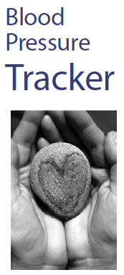 | English ________  Spanish ________  Chinese ________  Vietnamese ________  Russian ________
345-273 | How to Check Your Blood Pressure: This publication describes the steps for someone to take their own blood pressure. The manual includes a tear-out wallet card to track blood pressure readings. | 8.5x5.5 booklet | N/A |  | 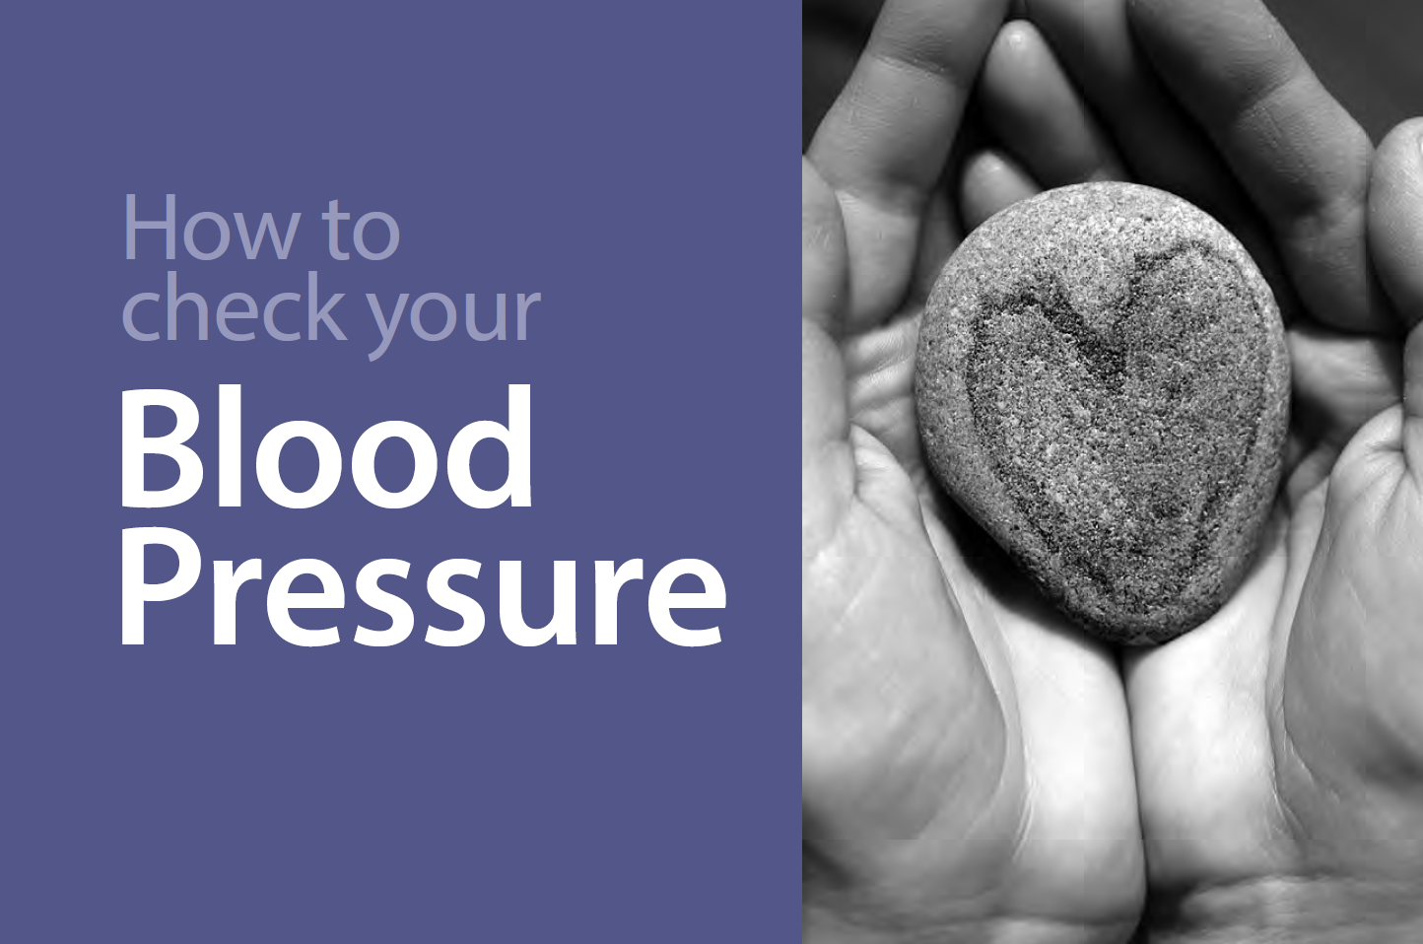 | English ________  Spanish ________  Chinese ________  Vietnamese ________  Russian ________
340-272 | What is Blood Pressure?: This publication will be available for patients in health clinics. It outlines the importance of improving your blood pressure and the risks associated with having high blood pressure. The publication also includes questions to ask your medical provider, ideas for making healthy lifestyle changes and online resources. | 8.5x11 brochure | N/A |  |  | English ________  Spanish ________  Chinese ________  Vietnamese ________  Russian ________
340-268  (Front)  340-269  (Back) | Know Your Blood Pressure Numbers: This poster, designed to be used in a health clinic setting, gives information about blood pressure numbers and why it is important to keep track of blood pressure. | 8.5x11  (Front & back) |  | N/A | FRONT:  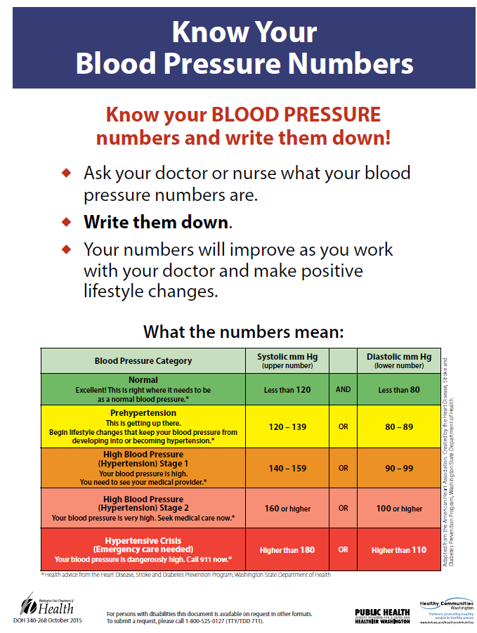  BACK:  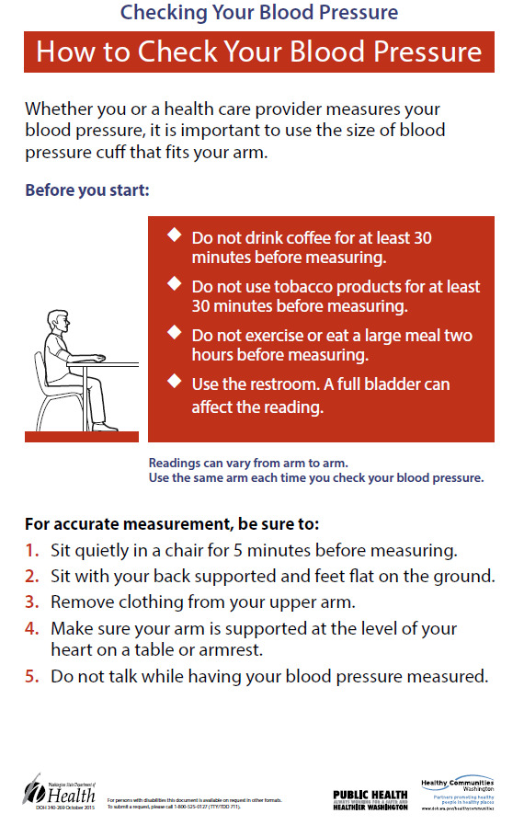 | English ________  Spanish ________  Chinese ________  Vietnamese ________  Russian ________
340-268 | Know Your Blood Pressure Numbers: This poster, designed to be used in a health clinic setting, gives information about blood pressure numbers and why it is important to keep track of blood pressure. | 11x17  (Front only) |  |  |  | English ________  Spanish ________  Chinese ________  Vietnamese ________  Russian ________
340-269 | Checking Your Blood Pressure: How to Check Your Blood Pressure: This poster shows the steps to take for accurate measurement of your blood pressure and is designed to be used by health care providers. | 11x17  (Front only) |  |  |  | English ________  Spanish ________  Chinese ________  Vietnamese ________  Russian ________
340-267 | Checking Your Blood Pressure: Taking Your Blood Pressure Poster: This poster shows how to take your blood pressure and is designed to be used by health care providers. | 11x17  (Front only) |  |  | 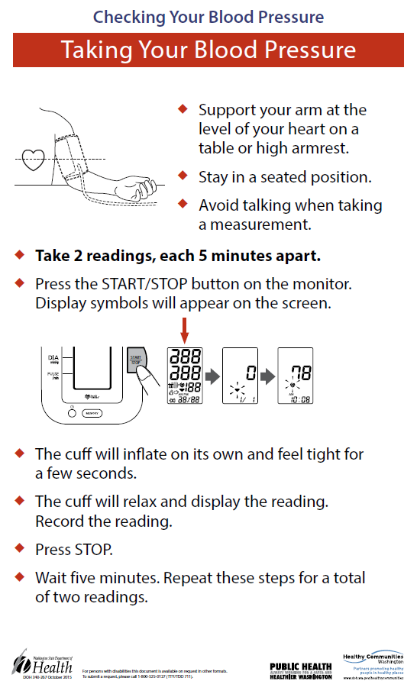 | English ________  Spanish ________  Chinese ________  Vietnamese ________  Russian ________
345-288 | What's the Big Deal About Controlling My Blood Pressure?: This poster, designed to be used in a health clinic setting, gives suggestions for making lifestyle changes that can lower blood pressure | 11x17  (Front only) |  |  | 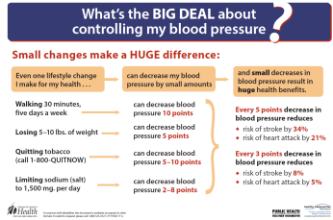 | English ________  Spanish ________  Chinese ________  Vietnamese ________  Russian ________
340-265 | Checking Your Blood Pressure: Before You Begin: This poster shows the steps to take for accurate measurement of your blood pressure and is designed to be used by health care providers | 11x17  (Front only) |  |  | 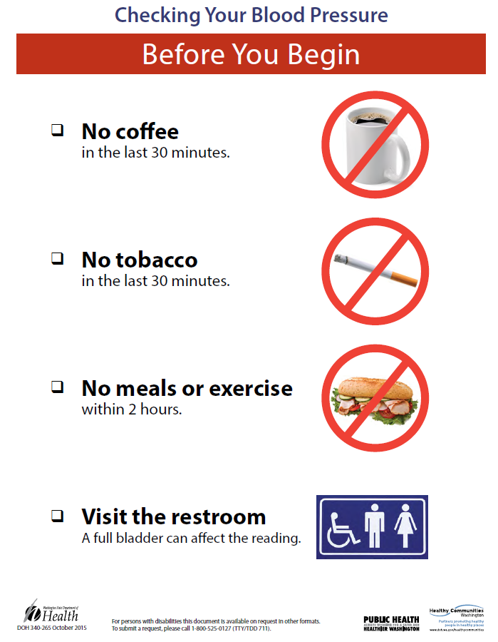 | English ________  Spanish ________  Chinese ________  Vietnamese ________  Russian ________
345-306 | Blood Pressure Measurement Training Kit: This kit provides information necessary to evaluate, organize, and train staff on the accurate measurement of blood pressure for the adult patient. It consists of a Training Guide, PowerPoint presentation, and training video, all packaged on a CD. The kit is available to any healthcare agency or medical professional and for training of healthcare staff. *CD includes Pub No. 345-283: Improving the Screening, Prevention, and Management of Hypertension- An Implementation Tool for Clinic Practice Teams* |  |  |  |  | English ________

Name: __________________________________________________________________________
Organization: ____________________________________________________________________
Shipping Address: _________________________________________________________________
Email: ___________________________________________________________________________
Phone Number: ___________________________________________________________________

