Washington Disease Reporting System

Hepatitis and GCD Local Health Jurisdiction Workflow Instruction Manual
Washington State Department of Health Hepatitis Program and Office of Communicable Disease Epidemiology

DOH 420-229 May 2018

2018

Table of Contents
Workflows……………………………………………………………………..…………..................…….……..4
Checking Workflows………………..………………………………………………………….………….…….4
Workflow Columns………………………...................................................................................................5
Bulk Actions…………………………………………….………………………………………………….……….6
Print Templates……………………………………….…………………………………………………….…….6
Assigning Events in a Workflow………………..………………………………………………….……….7
Case Specific Monitors and Task Specific Monitors……………………………………….………..8
GCD Workflows……………………………………………………….………………………………………….9
GCD Workflow Columns…………………………………………………………………………….…………9
GCD Workflow Categories………………………………………………………………………….…………9
GCD.004 Open events [LHJ]……………………………………….……………………….………9
GCD.005 Action required [LHJ]……………………………….………………………..………10
GCD.006 Missing fields [LHJ]…………………………………..………………………………..11
Hepatitis Workflows…………………………………………………………..…..…………...………...…16
Hepatitis Workflow Columns…………………………………………………………………….………..16
Hepatitis Workflow Categories…………………………………………………………………….……..16
Summary of Hepatitis Workflows and Expected User Actions…………..……………..…...17
HEP.005 Potential chronic hepatitis cases – action required [LHJ]….……...…..20

Questions?

Contact the Washington State Department of Health

Office of Communicable Disease Epidemiology
Email: CommDisEpi@doh.wa.gov | Phone: (206) 418-5500

Washington Department of Health Hepatitis Program
General Hepatitis C Email hepatitis@doh.wa.gov
General Hepatitis B/D Email: CommDisEpi@doh.wa.gov

Disclaimer: The examples used in this reference guide are fictitious. Any resemblance between any person or case illustrated in this reference guide and an actual person or case is purely coincidental.
Workflows

Washington Disease Reporting System (WDRS) includes workflows that organize events and the work that needs to be done on them. Each workflow is a specific question or query asked about events in WDRS. For example, the workflow titled ‘GCD events that need investigator assigned [LHJ]’ is the result of a query about all of the LHJ’s cases where the investigator field has not been entered. The system searches through LHJ events in WDRS and finds every event for which an investigator has not yet been entered. Once the necessary action is performed for the event (such as entering the name of the investigator), the query no longer identifies that event and it will be removed from the workflow. Workflows may ask general questions about all events or may ask questions specific to a disease or condition.

Most workflow queries update every 10 minutes. The frequency is based on the criticality of the workflow, as well as the burden on the system. Please allow 10 minutes before looking for changes that should cause an event to enter or exit a workflow.

Checking Workflows
To see your workflows, click on the workflow icon (cog wheels) at the top of the dashboard.
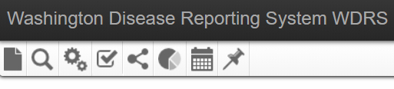

Workflows for the LHJ are normally listed even if there are no events in the workflow. You may reduce your workflow screen to only show those with events in them by selecting ‘Hide empty workflows’ at the top of the screen.
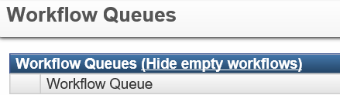

An event may be in zero, one, or many workflows. To view a complete list of all the workflows an event is in, select [View List] next to Notices under the event’s Basic Information panel.
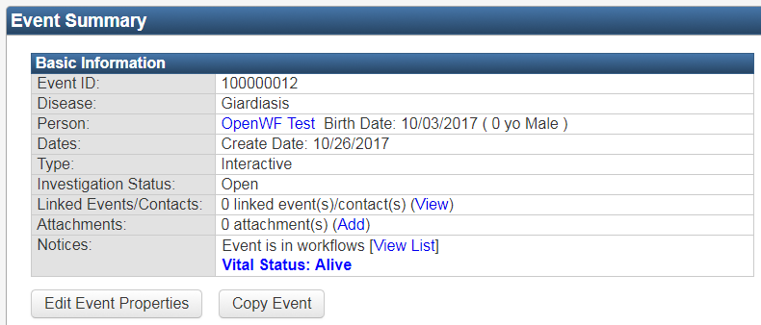

Workflow Columns
When you open a workflow, several columns display information for each event. You can sort events in your workflow by clicking on any column header. You can filter events that appear in the workflow by selecting a ‘Filter:’ dropdown option, selecting the field for the filter, entering a condition, and clicking ‘Apply’. For example, you could filter for the disease as Hepatitis (includes all types) and then add an additional condition for last name. Click ‘Clear’ to remove the filter.
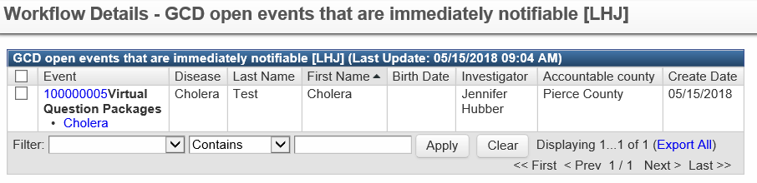
Sort
Filter

Bulk Actions
Some workflows contain a bulk action, allowing you perform a set action on multiple events by selecting all that apply. The workflow information window, accessed by clicking on the information icon , should provide details of the bulk action.
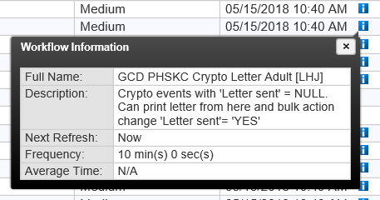

Print Templates
Some workflows may link to print templates. Select the event(s) you’d like to print, click on ‘Print Template’ and choose from the options: Save to computer, Save & attach, or Attach to case. The latter two will attach the print template to the event, viewable next to ‘Attachments’ on the Event Summary Screen.
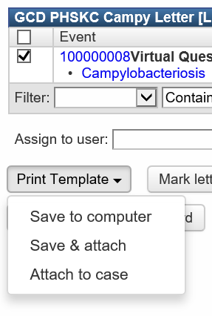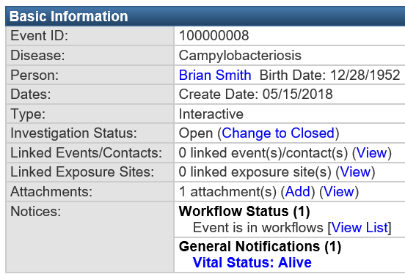
Assigning Events in a Workflow
You may assign a specific user or group to one or more events in a workflow. To assign an event, check the box(es) to the left of the ‘Event’ column and select a user or group using the party picker magnifying glass icons. Click the ‘Assign’ button. The main workflow page will now indicate which workflows contain events assigned to the user or group you have selected.
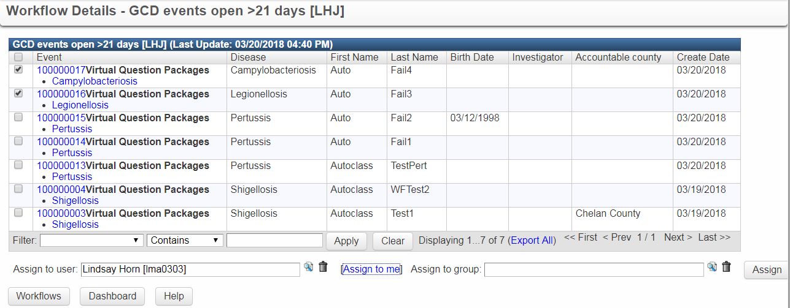

This functionality will effectively assign the user or group a Task, as shown on the WDRS Home Page. View the Tasks quick reference guide for more information.
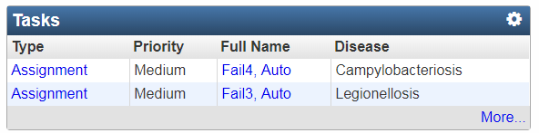

Case Specific Monitors and Task Specific Monitors
On the Workflow Queues screen, Case Specific Monitors and Task Specific Monitors are types of workflows that are not associated with a specific disease model, and are differentiated from one another. Case Specific Monitors are triggered automatically by something in the system (such as missing data) and don't have a specified due date. Task Specific Monitors usually have a due date and are often manually created.
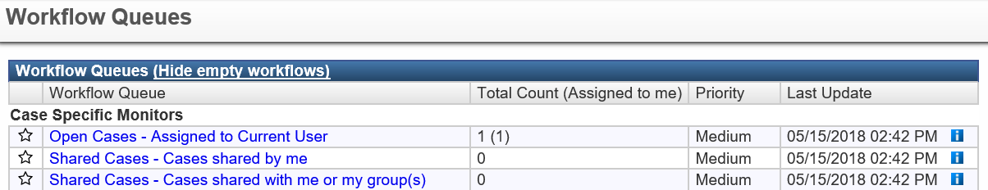
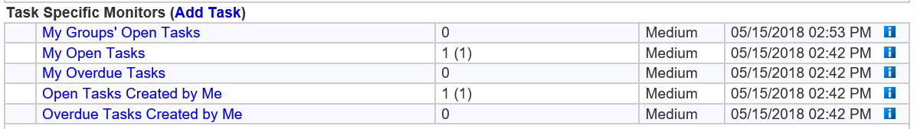

GCD Workflows

GCD Workflow Columns
The display for each General Communicable Disease (GCD) workflow has a list of events that meet the criteria for the workflow. The columns of the display provide the identifying information for each event:
- Event – the case ID is an active link that will take you directly to the Event Summary screen. Workflows may also present a link to the wizard (virtual question package) where most data entry will occur.
- Disease – condition associated with the event
- Last name – last name for case
- First name – first name for case
- Birth Date
- Investigator
- Accountable County
- Create Date – the date the event was created in WDRS

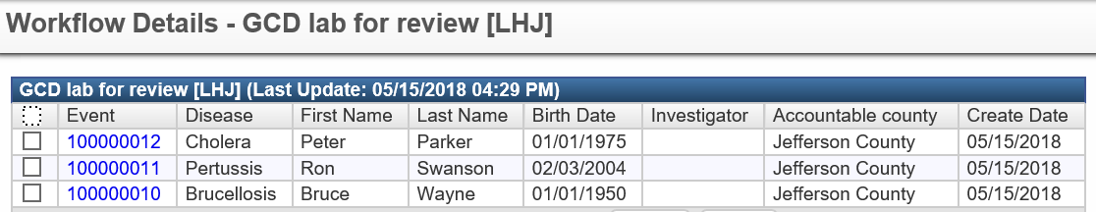

GCD Workflow Categories
Each workflow display shows the workflow queues, the total count of events in the workflow, the priority, and when the workflow was last updated. GCD and Hepatitis events are in separate workflows. The categories of workflows are Open events, Action required, and Missing fields.

All workflows exclude events with a case classification of ‘Not reportable’ and ‘Ruled out.’

GCD.004 Open events [LHJ]

The ‘Open events’ workflow category contains open events visible to the user. Events will remain in these workflows until the necessary condition is met, for example an investigator is assigned or the event is closed as indicated by a case complete date being entered.

Table 1. GCD.004 Open events [LHJ]
Workflow | Diseases included in workflow | Description | Expected User Action
GCD all open events [LHJ] | All | All open GCD events | Case complete date is not NULL (blank)
GCD open events that are immediately notifiable [LHJ] | Anthrax, Botulism, Burkholderia infection, Cholera, Diphtheria, Influenza novel, Measles, Plague, Polio, Rabies (human), Coronavirus, Shellfish poisoning, Tularemia, Viral hemorrhagic fever, Yellow fever | All open immediately notifiable GCD events | Case complete date is not NULL
GCD events that need investigator assigned [LHJ] | All | Open GCD events without an investigator assigned, primarily newly created events yet to be assigned. | Investigator is not NULL

GCD.005 Action required [LHJ]
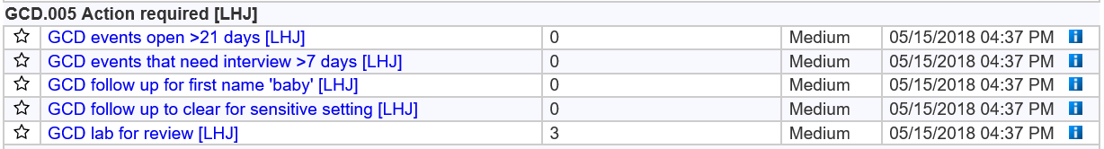

The ‘Action required’ workflow category contains events requiring user attention for various reasons. Depending on the workflow, it may contain events with or without a case complete date entered and may require actions such as a specific change or entry in order to be removed from the workflow, as indicated in Expected User Action (see Table 2).

Table 2. GCD.005 Action required [LHJ]
Workflow | Diseases included in workflow | Description | Expected User Action
GCD events open >21 days [LHJ] | All | GCD events open without a 'Case complete date' >21 days from 'LHJ notification date' | ‘Case complete date’ is not NULL
GCD events that need interview >7 days [LHJ] | All | GCD events that do not have 'Date of interview attempt' >7 days from 'LHJ notification date' | ‘Date of interview attempt’ is not NULL or  Case complete date is not NULL
GCD follow up for first name 'baby' [LHJ] | All | 'First Name' is 'baby' after > 90 days from 'LHJ notification date' | Update person page – change ‘First name’ from ‘baby’
GCD follow up to clear for return to sensitive setting [LHJ] | Shigellosis, STEC, Typhoid | Shigellosis, STEC, and Typhoid events excluding individuals in sensitive occupations and settings, requiring 'Case cleared' | ‘Case cleared’ is not NULL
GCD lab for review [LHJ] | All | GCD event lab that has not been reviewed by the LHJ ('Lab report reviewed - LHJ' is not 'YES') | ‘Lab report reviewed’ - LHJ is YES
GCD possible pregnancy case [LHJ] | All | Review lab for DRIVE-populated field for pregnancy indicated | Lab report reviewed - LHJ is YES

GCD.006 Missing fields [LHJ]
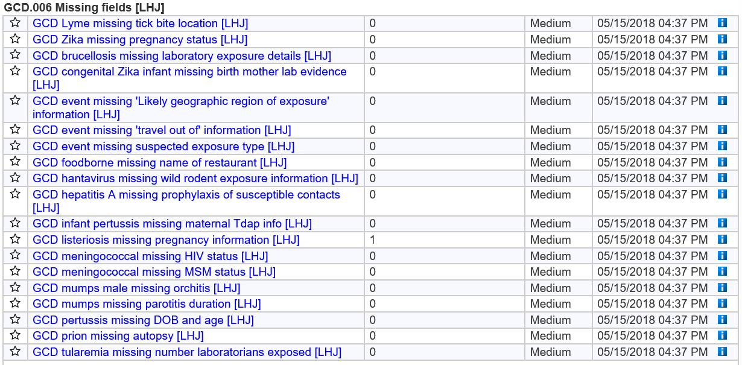

The ‘Missing fields’ workflow category contains events for which an ‘Investigation complete date’ has been entered but critical fields remain missing (NULL). These fields are identified by DOH subject matter experts (SME) and LHJs for specific conditions. If you have questions or concerns as to why a workflow exists, please contact the DOH subject matter expert for the disease.

To avoid inapplicable events from appearing in these workflows, whether because an interview was not possible or the case was ruled out, the following criteria will exclude an event from appearing in the ‘Missing fields’ workflow:
- The patient could not be interviewed
  - Patient could not be interviewed is TRUE
- Final case classification is ‘Not reportable’ or ‘Ruled out’
- The question driving the workflow has an entry (including ‘Unknown’)

Table 3. GCD.006 Missing fields [LHJ]
Workflow | Diseases included in workflow | Description | Expected User Action
GCD Lyme missing tick bite location [LHJ] | Lyme | 'Tick bite' is Yes, but 'Specify location' is NULL | ‘Specify location’ is not NULL
GCD Zika missing pregnancy status [LHJ] | Arboviral | Events among females ages 12-49 with 'Pregnancy status at time of symptom onset' is NULL | ‘Pregnancy status at time of symptom onset’ is not NULL
GCD brucellosis missing laboratory exposure details [LHJ] | Brucellosis | 'Did possible laboratory exposure occur' is Yes, but child questions is NULL | One of the following is not NULL:  - Number of high risk exposed persons taking PEP  - Number of high risk exposures  - Number of low risk exposed persons taking PEP  -Number of low risk exposures
GCD congenital Zika infant missing birth mother lab evidence [LHJ] | Arboviral | Infant arbo Zika congenital event with 'Birth mother had lab evidence of Zika or unspecified flavivirus during pregnancy' is NULL | ‘Birth mother had lab evidence of Zika or unspecified flavivirus’  during pregnancy is not NULL
GCD event missing 'Likely geographic region of exposure' information [LHJ] | Cryptococcus gattii, Hepatitis A, Malaria | ‘Likely geographic region of exposure’ is NULL | ‘Likely geographic region of exposure’ is not NULL
GCD event missing 'travel out of' information [LHJ] | Arboviral, Brucellosis, Lyme, Coccidiodomycosis, Tickborne, West Nile Virus | ‘Travel out of’ is NULL | ‘Travel out of’ is not NULL
GCD event missing suspected exposure type [LHJ] | Hepatitis A | ‘Suspected exposure type’ is NULL | ‘Suspected exposure type’ is not NULL
GCD foodborne missing name of restaurant [LHJ] | Campylobacteriosis, Cryptosporidiosis, Cyclosporiasis, Giardiasis, Salmonellosis, Shigellosis, STEC, Trichinosis, Typhoid, Vibriosis, Yersiniosis | Events with ‘During food exposure timeframe, did you eat food outside the home (including take-out)' is Yes and 'Restaurant' is Yes, but 'Name/location' is NULL | Name/location is not NULL
GCD hantavirus missing wild rodent exposure information [LHJ] | Hantavirus | 'Wild rodent or wild rodent excreta exposure' is NULL | ‘Wild rodent or wild rodent excreta exposure’ is not NULL
GCD hepatitis A missing prophylaxis of susceptible contacts [LHJ] | Hepatitis A | 'Prophylaxis of appropriate contacts recommended' is NULL | ‘Prophylaxis of appropriate contacts recommended’ is not NULL
GCD infant pertussis missing maternal Tdap info [LHJ] | Pertussis | Events among infants <12 months old with 'Did mother receive TDAP during this pregnancy' is NULL | ‘Did mother receive TDAP during this pregnancy’ is not NULL
GCD listeriosis missing pregnancy information [LHJ] | Listeriosis | Events among females ages 12-49 years with 'Is the Listeria case associated with pregnancy' is NULL | ‘Is the Listeria case associated with pregnancy’ is not NULL
GCD meningococcal missing HIV status [LHJ] | Meningococcal | Events with 'HIV positive/AIDS' is NULL | ‘HIV positive/AIDS’ is not NULL
GCD meningococcal missing MSM status [LHJ] | Meningococcal | 'During the last 12 months, have you had sex with only males, only females, or with both males and females' is NULL | ‘During the last 12 months, have you had sex with only males, only females, or with both males and females’ is not NULL
GCD mumps male missing orchitis [LHJ] | Mumps | Events among males with 'Orchitis' is NULL | ‘Orchitis’ is not NULL
GCD mumps missing parotitis duration [LHJ] | Mumps | 'Parotitis or other salivary gland swelling' is Yes, but 'Acute parotitis or other salivary gland swelling lasting at least 2 days' is NULL (case defining) | ‘Acute parotitis or other salivary gland swelling lasting at least 2 days’ is not NULL
GCD pertussis missing DOB and age [LHJ] | Pertussis | ‘Age’ is NULL and ‘Birth Date’ is NULL | ‘Age’ is not NULL or ‘Birth Date’ is not NULL
GCD prion missing autopsy [LHJ] | Prion | 'Brain autopsy performed' is NULL | ‘Brain autopsy performed’ is not NULL
GCD tularemia missing number laboratorians exposed [LHJ] | Tularemia | 'Follow-up to assess exposure of laboratorians to specimen' is Yes but 'Number of persons exposed' is NULL | ‘Number of persons exposed’ is not NULL

Hepatitis Workflows

Hepatitis Workflow Columns
The display for each Hepatitis (HEP) workflow has a list of events that meet the criteria for the workflow. The columns of the display provide the identifying information for each event:
- Event – the case ID is an active link that will take you directly to the Event Summary screen.
- Full Name – last name and first name for case
- Status – whether the case is open or closed
- Create Date – the date the event was created in WDRS
- Disease – condition associated with the event
- Last Update – last date any update was made
- Assigned To – person(s) to whom tasks for the event are assigned. (This is different from “Investigator”. This column displays the people to whom Tasks are assigned for the event.)
- Assigned To Group – group to whom the event is assigned

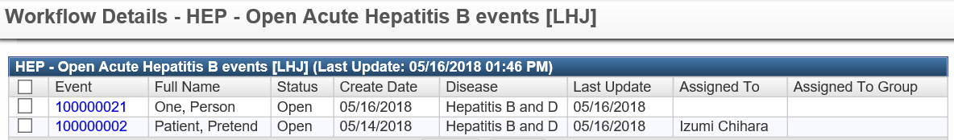

Hepatitis Workflow Categories
Each workflow display shows the workflow queues, the total count of events in the workflow, the priority, and when the workflow was last updated. GCD and Hepatitis are in separate workflows. The categories of workflows for hepatitis are Open events, Lab reports for review – action required, and Potential chronic hepatitis cases – action required.

Below are all workflows available to Hepatitis investigators.
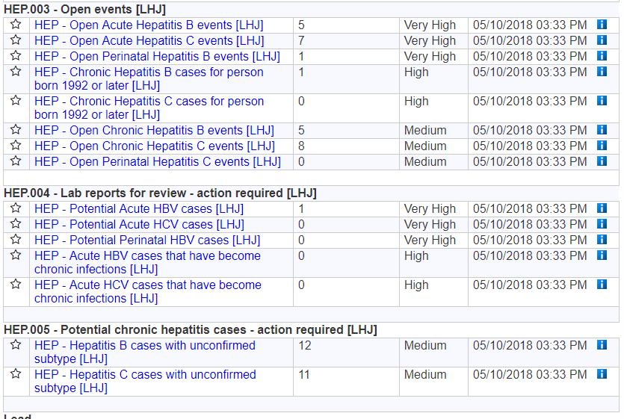

Summary of Hepatitis Workflows and Expected User Actions
There are 3 different categories of Hepatitis workflows for the local health jurisdiction user:
- Open events
- Lab reports for review
- Potential chronic hepatitis cases

Tables 4, 5, and 6 describe workflows found in each category, expected user actions, and workflow priority level.

Table 4. HEP.003 Open events [LHJ]
Workflow | Description | Expected User Action | Priority
HEP - Open Acute Hepatitis B events [LHJ] | Acute cases that need to be investigated. Enters when Acute HBV cases are created. | Exits when "LHJ record complete date" is entered. | Very High
HEP - Open Acute Hepatitis C events [LHJ] | Acute cases that need to be investigated. Enters when Acute HCV cases are created. | Exits when "LHJ record complete date" is entered. | Very High
HEP - Open Perinatal Hepatitis B events [LHJ] | Perinatal HBV cases that need to be investigated. Enters when Perinatal HCV cases are created. | Exits when "LHJ record complete date" is entered. | Very High
HEP - Chronic Hepatitis B cases for person born 1992 or later [LHJ] | Chronic HBV cases that may warrant investigation, due to potentially having a higher risk of transmitting disease. Enters when Chronic HBV cases with a date of birth of 1/1/92 or later are created. | Exits when "LHJ record complete date" is entered. | High
HEP - Chronic Hepatitis C cases for person born 1992 or later [LHJ] | Chronic HCV cases that may warrant investigation, due to potentially having a higher risk of transmitting disease. Enters when Chronic HCV cases with a date of birth of 1/1/92 or later are created. | Exits when "LHJ record complete date" is entered. | High
HEP - Open Chronic Hepatitis B events [LHJ] | Enters when Chronic B cases are created. | Exits when "LHJ record complete date" is entered. | Medium
HEP - Open Chronic Hepatitis C events [LHJ] | Enters when Chronic C cases are created. | Exits when "LHJ record complete date" is entered. | Medium
HEP - Open Perinatal Hepatitis C events [LHJ] | Perinatal HCV cases that need to be investigated. Enters when Perinatal HBV cases are created. | Exits when "LHJ record complete date" is entered. | Medium

Table 5. HEP.004 Lab reports for review – action required [LHJ]
Workflow | Description | Expected User Action | Priority
HEP - Potential Acute HBV cases [LHJ] | Potential HBV cases that may be acute based on lab information. | Exits when subtype is confirmed. | Very High
HEP - Potential Acute HCV cases [LHJ] | Potential HCV cases that may be acute based on high ALT values. Enters when a case with unconfirmed subtype has an ALT of greater than or equal to 200. | Exits when subtype is confirmed. | Very High
HEP - Potential Perinatal HBV cases [LHJ] | Potential HBV cases that may be perinatal based on lab information, and age is less than or equal to 24 months. | Exits when subtype is confirmed. | Very High
HEP - Acute HBV cases that have become chronic infections [LHJ] | Acute HBV cases that may have become chronic infections based on new lab information. | Exits when subtype is confirmed as "Chronic." | High
HEP - Acute HCV cases that have become chronic infections [LHJ] | Acute HCV cases that may have become chronic infections based on new lab information. | Exits when subtype is confirmed as "Chronic." | High

Table 6. HEP.005 Potential chronic hepatitis cases – action required [LHJ]
Workflow | Description | Expected User Action | Priority
HEP - Hepatitis B cases with unconfirmed subtype [LHJ] | Use this workflow to review Hepatitis B cases that may be chronic. | Exits when subtype is confirmed. | Medium
HEP - Hepatitis C cases with unconfirmed subtype [LHJ] | Use this workflow to review Hepatitis C cases that may be chronic. | Exits when subtype is confirmed. | Medium

Additional notes for workflows in: HEP.005 Potential chronic hepatitis cases – action required [LHJ]
There is a function—“Mark as chronic”—that allows users to batch confirm cases as chronic in 1) HEP - Hepatitis B cases with unconfirmed subtype [LHJ] and 2) HEP - Hepatitis C cases with unconfirmed subtype [LHJ]:
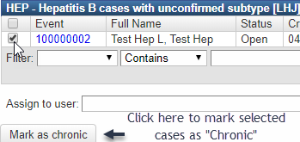
However, you must clear certain workflow queues (see below for further instructions) before using the “Mark as chronic” button. This is because cases that appear in the potentially acute or perinatal workflows are also present in the potentially chronic workflows for each condition (Hepatitis B and C). It may take several minutes for the workflows to refresh and update.
WARNING: You MUST clear certain workflows (see below for further instructions) FIRST before batch marking cases as chronic in these workflows. If not, you run the risk of incorrectly classifying acute or perinatal cases as chronic.

If you are not comfortable using the “Mark as chronic” function, please review cases individually and/or contact the Hepatitis team for assistance.

Hepatitis B
- You can mark groups of potential chronic hepatitis B cases as “Chronic” AFTER clearing the following workflow queues.
  - HEP - Potential Acute HBV cases [LHJ]
  - HEP - Potential Perinatal HBV cases [LHJ]
- Clearing a workflow queue means that the number of cases in the workflow should equal 0. It may take several minutes for the workflows to refresh and update:

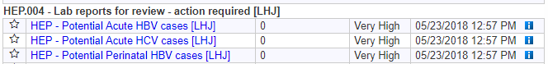

Hepatitis C
- You can mark groups of potential chronic hepatitis C cases as “Chronic” AFTER clearing the following workflow queues:
- HEP - Potential Acute HCV cases [LHJ]
- Clearing a workflow queue means that the number of cases in the workflow should equal 0. It may take several minutes for the workflows to refresh and update:

Revision History

Date | Version | Author | Reason for change
6/25/2018 | 1 | Lindsay Horn | Initial posting
9/21/2018 | 2 | Lindsay Horn | Updates to reflect Barium 2.2 production build (e.g. excluding not reportable and ruled out events)

